Survival extrapolation - comparison of methods

NCPE

July 2023

# Fit the models etc  
source("setup.R")

##   
## Attaching package: 'Hmisc'

## The following objects are masked from 'package:dplyr':  
##   
## src, summarize

## The following objects are masked from 'package:base':  
##   
## format.pval, units

source("run_all.R")

## Expert opinion and construction of a prior distribution

Published NICE committee slides, see slide 24 of <https://www.nice.org.uk/guidance/ta650/documents/1>, provides a summary of clinical experts’ opinion on 5-year OS:

* Company: 50%
* ERG: 50% is optimistic
* NICE technical team: 30%

For the NCPE assessment (data on file), experts were presented with OS predictions from the six standard parametric distributions and asked to comment on their plausibility:

* Expert 1 stated that the curves giving estimates of 20% and 39% were plausible, said nothing about model 3 (45%), and considered all higher estimates of 5-year OS to be implausible.
* Expert 2 identified the curve giving a 5-year OS of 45% as the most appropriate, with other ‘plausible’ curves giving a range of 20% to 54%.

The authors considered a range of 20% to 55% to give a reasonable summary of experts’ expectations of 5-year overall survival. For simplicity, a normal distribution was selected for the prior, with 95% prior density contained in the range 20% to 55%.

## Importance sampling: model diagnostics, parameter distributions, and survival estimates

We can now examine importance sampling diagnostics, comparisons of likelihood and posterior parameter distributions, and survival time distributions, using the function expert_surv_viz_gg.

for (dist in dists) {  
 print(knitr::kable(is.models[[dist]][["orig"]]$coefficients,  
 caption = "MLE Parameter Estimates"))  
 print(knitr::kable(is.models[[dist]][["orig"]]$cov, caption = "MLE Covariance Matrix"))  
  
 # print(knitr::kable(  
 # list(is.models[[dist]][['orig']]$coefficients,is.models[[dist]][['orig']]$cov),  
 # caption = 'MLE parameter estimates and covariance  
 # matrix'#, booktabs = TRUE, valign = 't' ))  
  
 print(knitr::kable(is.models[[dist]]$post_mean, caption = "IS Parameter Estimates"))  
 print(knitr::kable(is.models[[dist]]$post_cov, caption = "IS Covariance Matrix"))  
  
 is_surv_viz_gg(is.models[[dist]], tseq2, tstar, what = 1:3,  
 dist = dist)  
}

MLE Parameter Estimates

| x |
| --- |
| -4.562874 |

MLE Covariance Matrix

|  | rate |
| --- | --- |
| rate | 0.0169491 |

IS Parameter Estimates

| x |
| --- |
| -4.467088 |

IS Covariance Matrix

|  |
| --- |
| 0.0138444 |

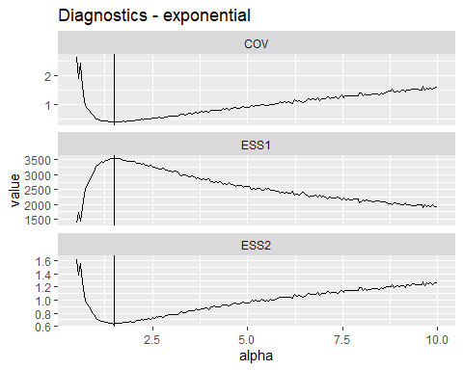

## Warning: Removed 5000 rows containing non-finite values (`stat_density()`).

## Warning: Removed 5000 rows containing non-finite values (`stat_boxplot()`).

## `stat_bin()` using `bins = 30`. Pick better value with `binwidth`.

## Warning: Removed 5000 rows containing non-finite values (`stat_bin()`).

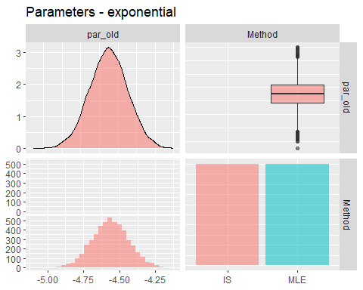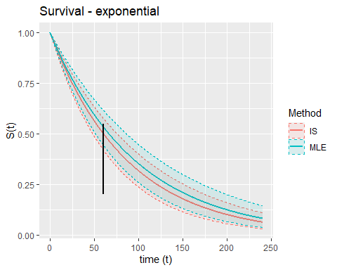

MLE Parameter Estimates

|  | x |
| --- | --- |
| shape | 0.2028128 |
| scale | 4.2127617 |

MLE Covariance Matrix

|  | shape | scale |
| --- | --- | --- |
| shape | 0.0147844 | -0.0228526 |
| scale | -0.0228526 | 0.0466213 |

IS Parameter Estimates

|  | x |
| --- | --- |
| shape | 0.2199019 |
| scale | 4.1750757 |

IS Covariance Matrix

|  | shape | scale |
| --- | --- | --- |
| shape | 0.0094518 | -0.0118402 |
| scale | -0.0118402 | 0.0235769 |

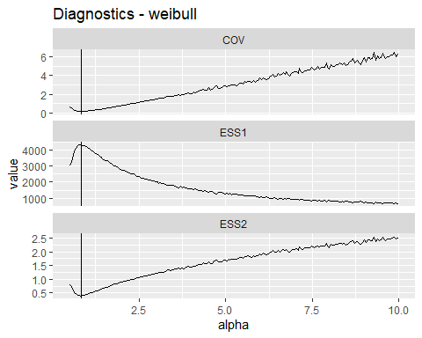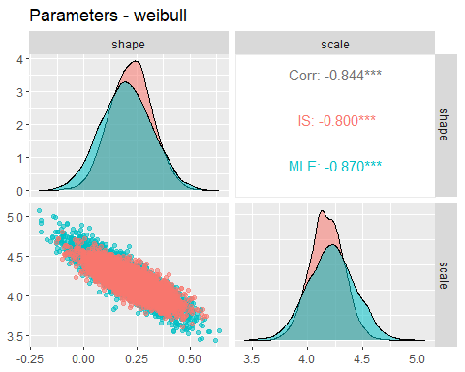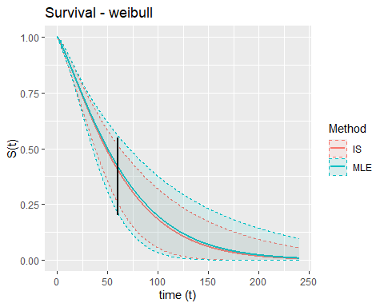

MLE Parameter Estimates

|  | x |
| --- | --- |
| shape | 0.0389625 |
| rate | -4.8682858 |

MLE Covariance Matrix

|  | shape | rate |
| --- | --- | --- |
| shape | 0.0006747 | -0.0056125 |
| rate | -0.0056125 | 0.0636359 |

IS Parameter Estimates

|  | x |
| --- | --- |
| shape | 0.0197027 |
| rate | -4.7220927 |

IS Covariance Matrix

|  | shape | rate |
| --- | --- | --- |
| shape | 0.0000970 | -0.0013281 |
| rate | -0.0013281 | 0.0316264 |

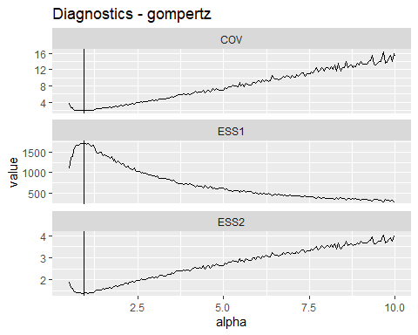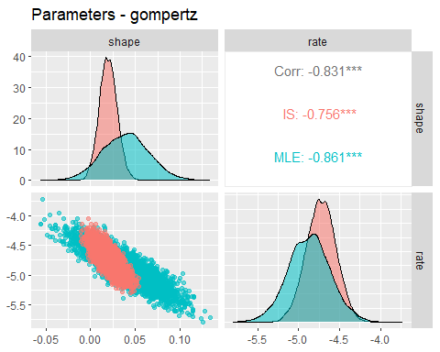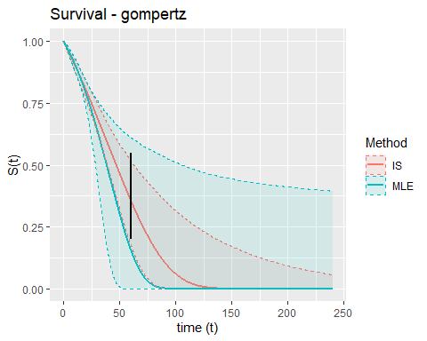

MLE Parameter Estimates

|  | x |
| --- | --- |
| meanlog | 4.5379239 |
| sdlog | 0.5475716 |

MLE Covariance Matrix

|  | meanlog | sdlog |
| --- | --- | --- |
| meanlog | 0.0696811 | 0.0247171 |
| sdlog | 0.0247171 | 0.0114622 |

IS Parameter Estimates

|  | x |
| --- | --- |
| meanlog | 4.2299230 |
| sdlog | 0.4404943 |

IS Covariance Matrix

|  | meanlog | sdlog |
| --- | --- | --- |
| meanlog | 0.0545435 | 0.0201378 |
| sdlog | 0.0201378 | 0.0100655 |

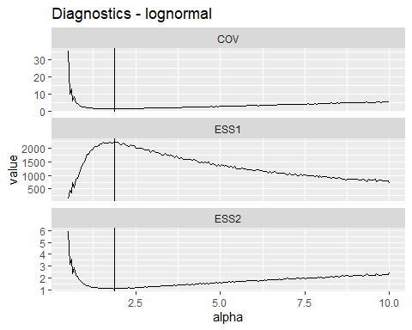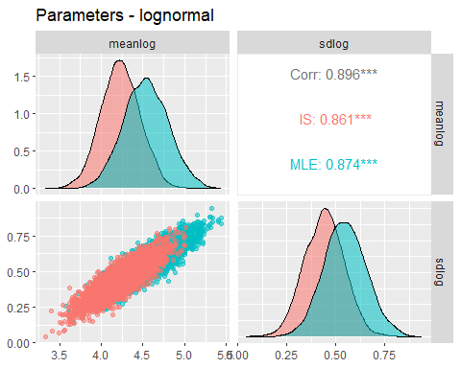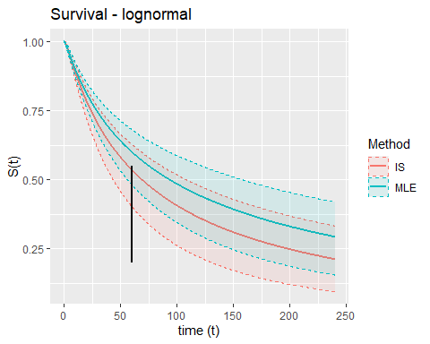

MLE Parameter Estimates

|  | x |
| --- | --- |
| shape | 0.2450539 |
| scale | 4.0866467 |

MLE Covariance Matrix

|  | shape | scale |
| --- | --- | --- |
| shape | 0.0144928 | -0.0213001 |
| scale | -0.0213001 | 0.0434079 |

IS Parameter Estimates

|  | x |
| --- | --- |
| shape | 0.3103417 |
| scale | 3.9558382 |

IS Covariance Matrix

|  | shape | scale |
| --- | --- | --- |
| shape | 0.0111243 | -0.0139385 |
| scale | -0.0139385 | 0.0276608 |

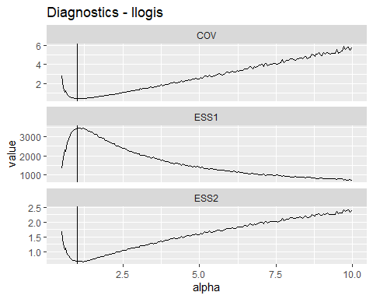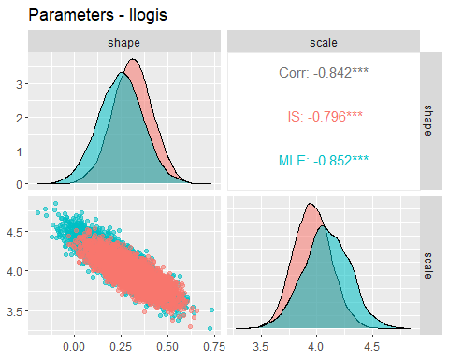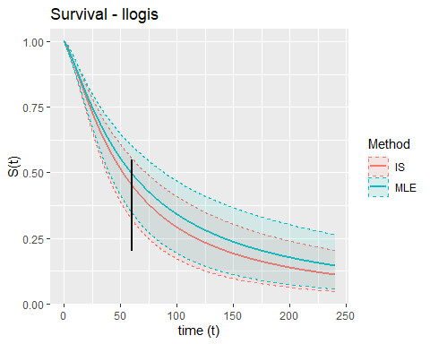

MLE Parameter Estimates

|  | x |
| --- | --- |
| mu | 4.1703317 |
| sigma | -0.3599072 |
| Q | 1.2031485 |

MLE Covariance Matrix

|  | mu | sigma | Q |
| --- | --- | --- | --- |
| mu | 0.1026807 | 0.2899736 | -0.3589428 |
| sigma | 0.2899736 | 1.2303463 | -1.6290913 |
| Q | -0.3589428 | -1.6290913 | 2.1837103 |

IS Parameter Estimates

|  | x |
| --- | --- |
| mu | 4.1857610 |
| sigma | -0.3818327 |
| Q | 1.2508022 |

IS Covariance Matrix

|  | mu | sigma | Q |
| --- | --- | --- | --- |
| mu | 0.0219135 | 0.0031467 | 0.0125013 |
| sigma | 0.0031467 | 0.2238160 | -0.3291366 |
| Q | 0.0125013 | -0.3291366 | 0.5057176 |

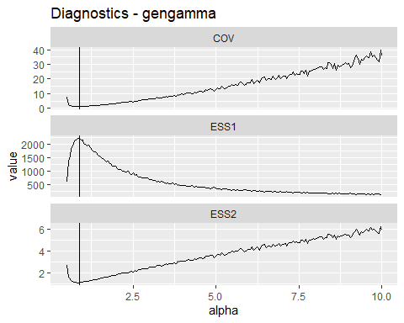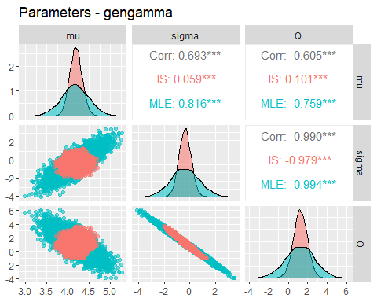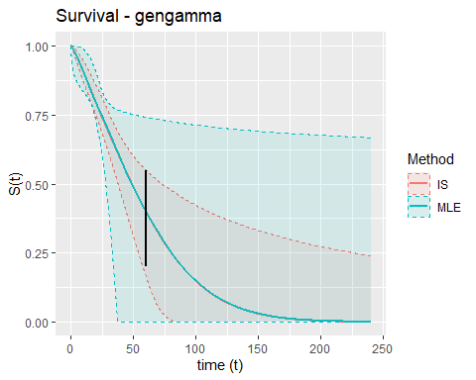

## Parameter variability

Compare ‘Generalised variance,’ i.e., determinants of variance-covariance matrices. This gives the area of the 95% highest density ellipse and can be interpreted as a 1-parameter measure of parameter uncertainty. See <https://stats.stackexchange.com/questions/12762/measure-of-spread-of-a-multivariate-normal-distribution> .

param.uncertainty <- data.frame(Distribution = dists, Distance = rep(NA,  
 6), `MLE Variance` = rep(NA, 6), `IS Variance` = rep(NA,  
 6), Ratio = rep(NA, 6))  
  
for (i in seq_along(dists)) {  
 param.uncertainty[i, 2] <- sqrt(sum((is.models[[dists[i]]][["orig"]]$coefficients -  
 is.models[[dists[i]]]$post_mean)^2))  
 param.uncertainty[i, 3] <- det(as.matrix(is.models[[dists[i]]][["orig"]]$cov))  
 param.uncertainty[i, 4] <- det(as.matrix(is.models[[dists[i]]]$post_cov))  
 param.uncertainty[i, 5] <- param.uncertainty[i, 4]/param.uncertainty[i,  
 3]  
  
}  
  
knitr::kable((param.uncertainty))

| Distribution | Distance | MLE.Variance | IS.Variance | Ratio |
| --- | --- | --- | --- | --- |
| exponential | 0.0957855 | 0.0169491 | 0.0138444 | 0.8168193 |
| weibull | 0.0413796 | 0.0001670 | 0.0000827 | 0.4948566 |
| gompertz | 0.1474564 | 0.0000114 | 0.0000013 | 0.1140791 |
| lognormal | 0.3260830 | 0.0001878 | 0.0001435 | 0.7641277 |
| llogis | 0.1461963 | 0.0001754 | 0.0001134 | 0.6466355 |
| gengamma | 0.0546778 | 0.0003562 | 0.0000405 | 0.1138456 |

# Comparison with expertsurv output

## Plots of survival curves over time

source("comp_expertsurv.R")

## Warning: Removed 5000 rows containing missing values (`geom_line()`).  
## Removed 5000 rows containing missing values (`geom_line()`).

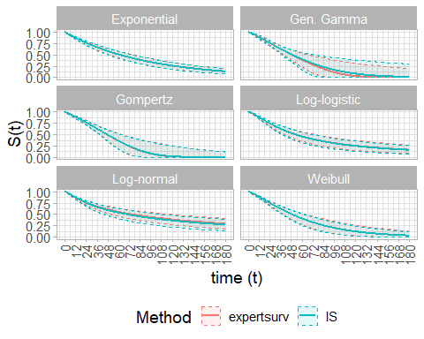

# By curve type  
for (i in 1:6) {  
 g <- ggplot(data = surv.list[[i]], aes(x = time, colour = Method,  
 fill = Method)) + geom_line(aes(y = S_median), lwd = 1) +  
 geom_ribbon(aes(ymin = S_lower, ymax = S_upper), alpha = 0.1,  
 linetype = "dashed") + labs(y = "S(t)", x = "time (t)",  
 title = paste0("Survival - ", distributions[dists[i]]))  
  
 print(g)  
  
}

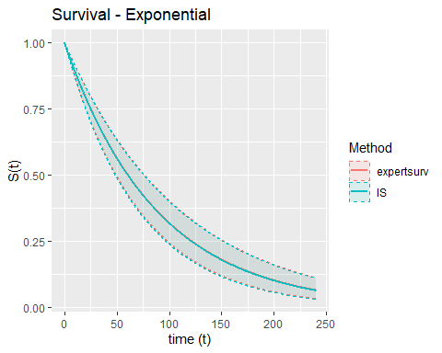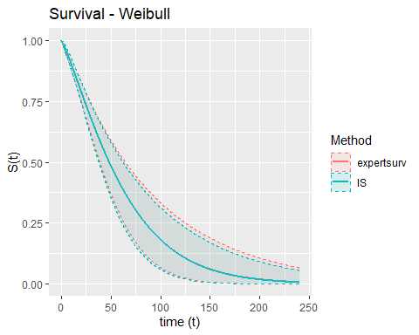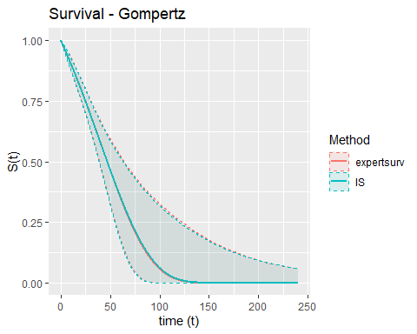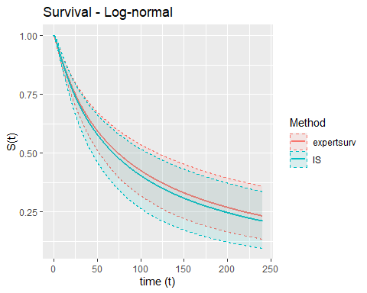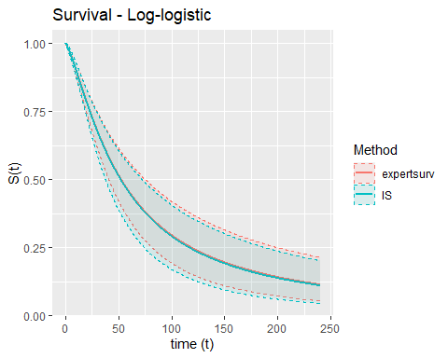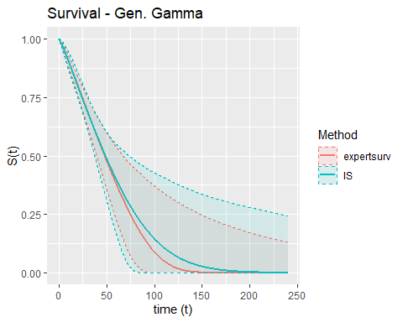

### Comparisons of parameter distributions

library(GGally)  
  
for (i in dists) {  
 # Extract parameter draws from the two types of model  
 # fit and merge  
 df1 <- data.frame(is.sims[[i]][["sims.mvn"]], Method = rep("IS",  
 5000))  
  
 df2 <- data.frame(exs.sims[[i]][["sims.mvn"]], Method = rep("expertsurv",  
 5000))  
  
 names(df2) <- names(df1)  
  
 df <- bind_rows(df1, df2)  
  
 print(ggpairs(df, aes(colour = Method, alpha = 0.4), columns = 1:(ncol(df) -  
 1), title = paste0("Parameters - ", distributions[i])))  
}

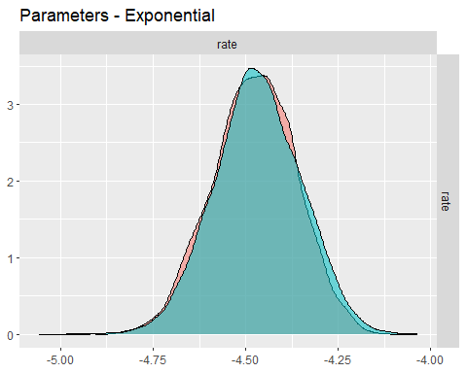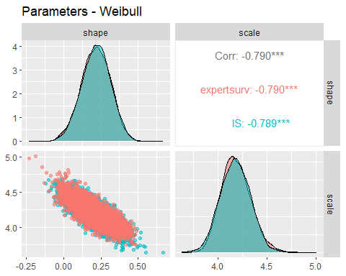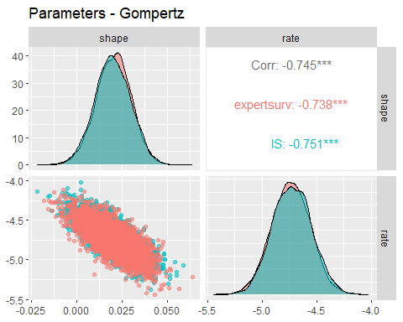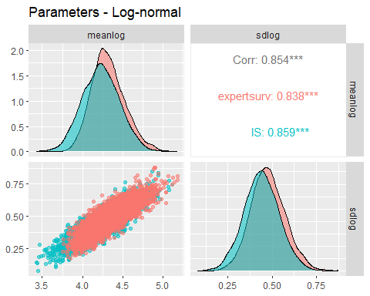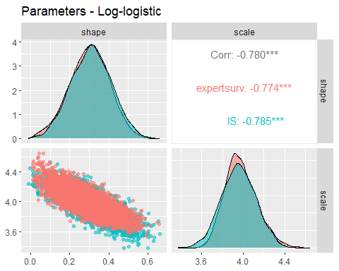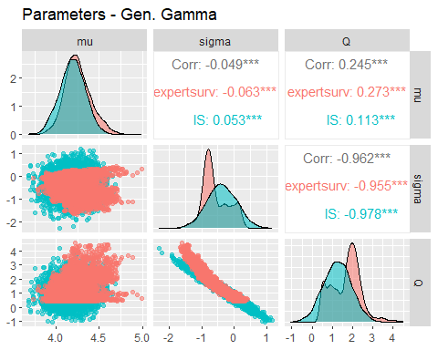

## Comparisons of AUC distributions

# AUC for the models  
  
auc.is <- data.frame(matrix(NA, nrow = 5000, ncol = 6))  
names(auc.is) <- dists  
auc.exs <- auc.is  
  
  
for (dist in dists) {  
 auc.is[dist] <- is.sims[[dist]][["AUC"]]  
 auc.exs[dist] <- exs.sims[[dist]][["AUC"]]  
}  
  
auc.is["Method"] = "IS"  
auc.exs["Method"] = "expertsurv"  
  
auc.df2 <- bind_rows(auc.is, auc.exs) %>%  
 pivot_longer(1:6, names_to = "Distribution", values_to = "AUC")  
  
auc.summary2 <- auc.df2 %>%  
 group_by(Distribution, Method) %>%  
 summarise(mean = mean(AUC), sd = sd(AUC), median = median(AUC),  
 lwr.95 = quantile(AUC, 0.025), upr.95 = quantile(AUC,  
 0.975))

## `summarise()` has grouped output by 'Distribution'. You can override using the  
## `.groups` argument.

# Same for AUC  
  
auc.print2 <- auc.summary2 %>%  
 pivot_wider(names_from = Method, values_from = 3:7) %>%  
 mutate(mean_diff = mean_IS - mean_expertsurv, var.ratio = sd_IS^2/sd_expertsurv^2) %>%  
 mutate(across(where(is.numeric), ~format(round(.x, 2), nsmall = 2))) %>%  
 mutate(expertsurv = paste0(mean_expertsurv, " (", lwr.95_expertsurv,  
 ", ", upr.95_expertsurv, ")"), IS = paste0(mean_IS, " (",  
 lwr.95_IS, ", ", upr.95_IS, ")"), Var.Ratio = var.ratio) %>%  
 ungroup() %>%  
 select(Distribution, expertsurv, IS, Mean.Diff = mean_diff,  
 Var.Ratio)  
  
knitr::kable(auc.print2)

| Distribution | expertsurv | IS | Mean.Diff | Var.Ratio |
| --- | --- | --- | --- | --- |
| exponential | 88.62 (71.03, 110.01) | 87.74 (69.78, 109.28) | -0.88 | 1.02 |
| gengamma | 58.86 (41.15, 117.04) | 71.11 (38.84, 216.27) | 12.26 | 5.81 |
| gompertz | 54.39 (39.58, 87.41) | 53.89 (39.24, 85.24) | -0.49 | 0.67 |
| llogis | 122.76 (77.74, 191.48) | 119.06 (71.11, 181.96) | -3.69 | 0.98 |
| lognormal | 203.91 (123.82, 318.38) | 183.80 (97.93, 295.22) | -20.11 | 1.04 |
| weibull | 62.59 (45.75, 89.91) | 61.93 (44.18, 85.17) | -0.66 | 0.89 |

# AUC density plot No truncation of AUC values but  
# truncation of graph  
library(ggridges)  
  
g.auc <- ggplot(data = auc.df2, aes(x = AUC, y = Distribution,  
 colour = Method, fill = Method)) + geom_density_ridges(alpha = 0.5,  
 scale = 0.95) + scale_fill_manual(values = cbPalette[2:3]) +  
 scale_colour_manual(values = cbPalette[2:3]) + labs(x = "AUC (Mean lifetime OS, Months)",  
 y = "Density") + xlim(0, 360) + theme(legend.position = "bottom")  
  
g.auc

## Picking joint bandwidth of 3.27

## Warning: Removed 85 rows containing non-finite values  
## (`stat_density_ridges()`).

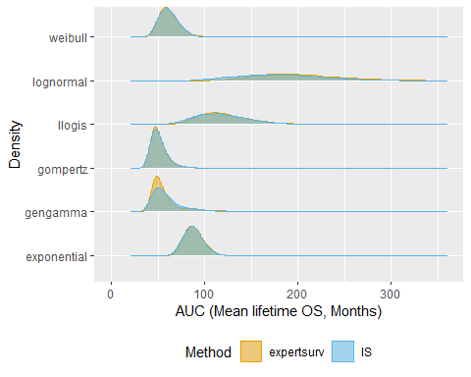

knitr::knit_exit()