

DÜZCE ÜNİVERSİTESİ

MÜHENDİSLİK FAKÜLTESİ

BİLGİSAYAR MÜHENDİSLİĞİ BÖLÜMÜ

NORMAL ÖĞRETİM

VERİTABANI YÖNETİM SİSTEMLERİ PROJE ÖDEVİ

KAMU FİRMASINDA DEMİRBAŞ TAKİBİ VERİTABANI

PROJE DANIŞMANI: Dr. Öğr. Ü. Fatih KAYAALP

HAZIRLAYANLAR

MEHMET CAN ÇETİN 211001039

|  |  |
| --- | --- |
|  |  |

DEMİRBAŞ TAKİBİ VERİTABANI

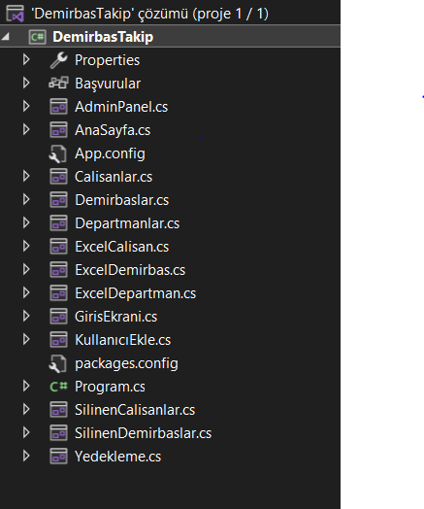

1.GİRİŞ TABLOSU: Çalışanların giriş bilgilerinin tutulduğu tablo.

2.DEMİRBAŞ TABLOSU: Demirbaşların tutulduğu ve kaydedildiği tablo.

3.ÇALIŞANLAR TABLOSU: Çalışanların tutulduğu ve kaydedildiği tablo.

4.DEPARTMANLAR TABLOSU: Departmanların tutulduğu ve kaydedildiği tablo.

5.SİLİNEN ÇALIŞANLAR TABLOSU: Veri tabanında bulunan çalışanların silinince kaydedildiği tablo.

6.SİLİNEN DEMİRBAŞLAR TABLOSU: Veri tabanında bulunan demirbaşların silinince kaydedildiği tablo.

ER DİYAGRAMLARI

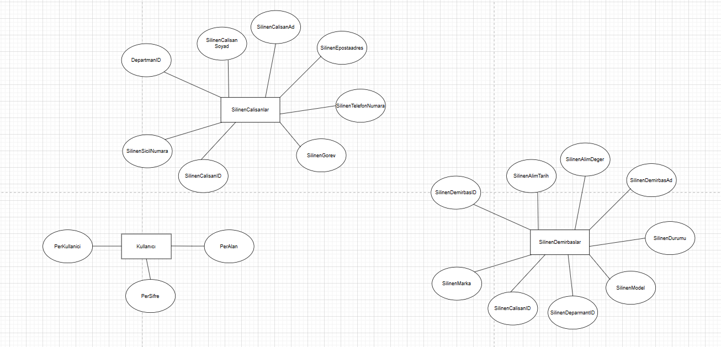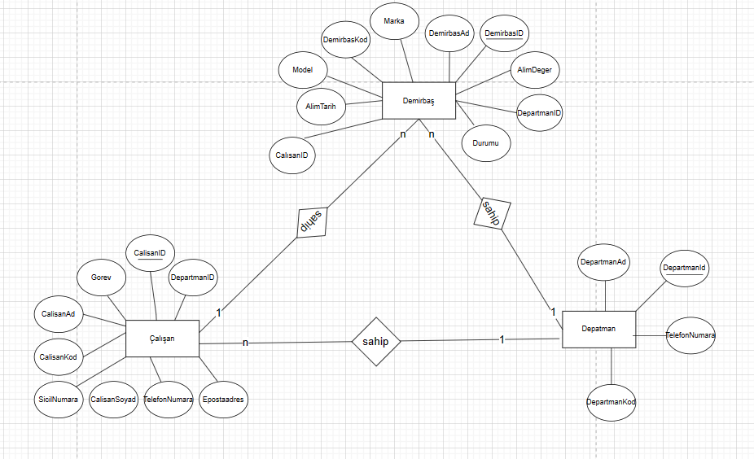

VERİTABANI DİAGRAMI

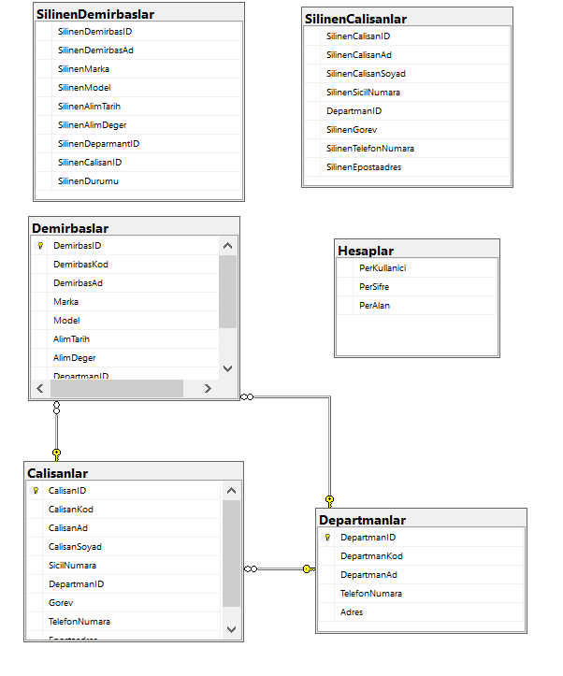

SQL

TRIGGERLAR

Silinen Çalışanların Yeni Tabloya Taşınması

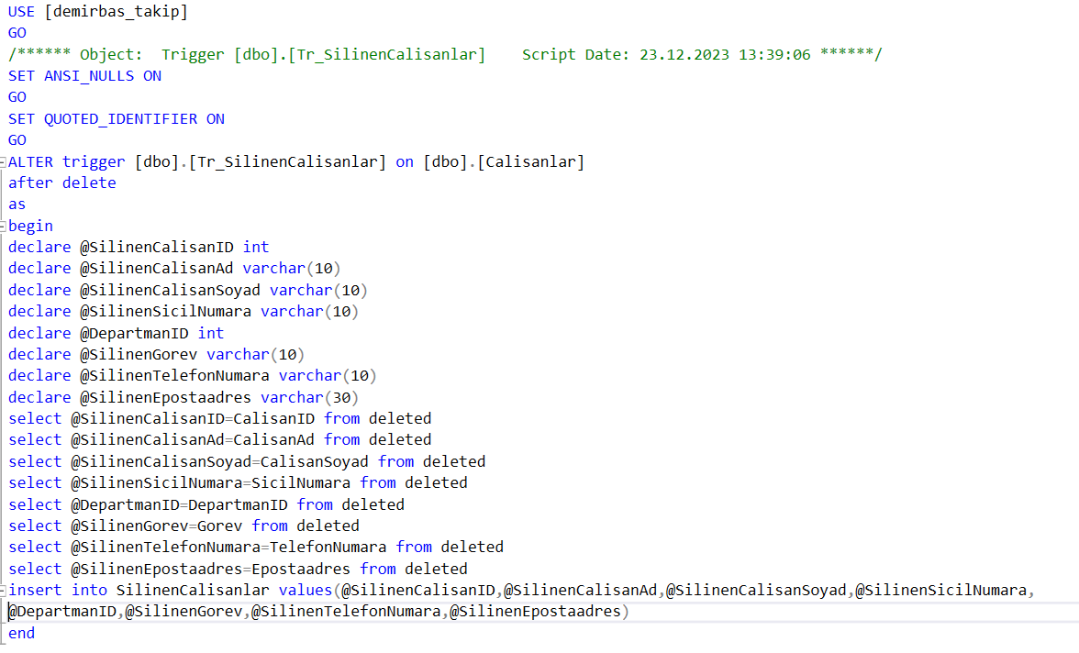

Silinen Demirbaşların Yeni Tabloya Taşınması

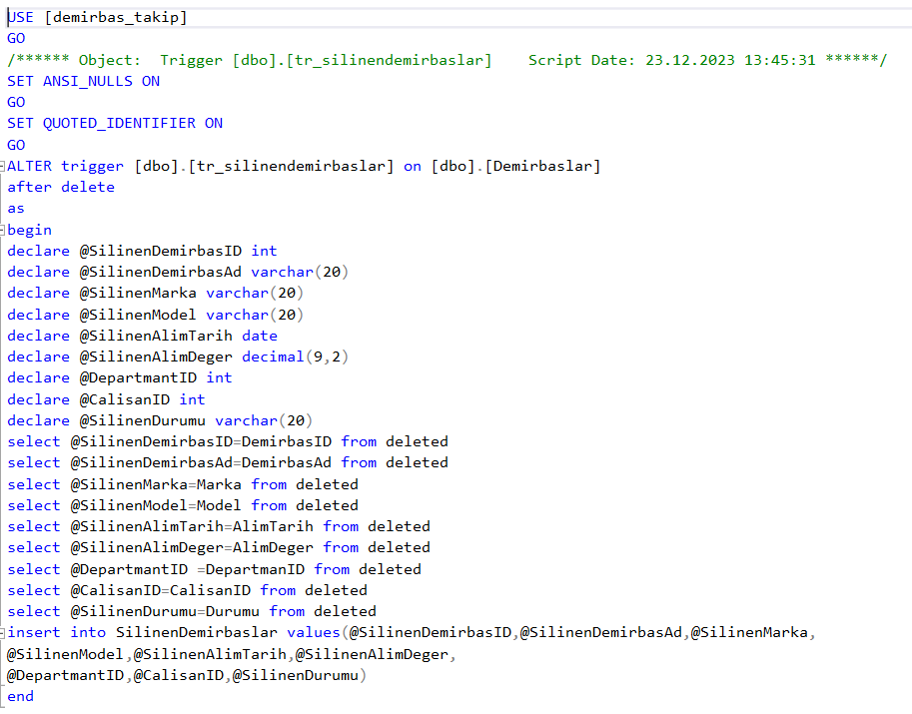

Silinen Demirbaşın Silindikten Sonra Mesaj

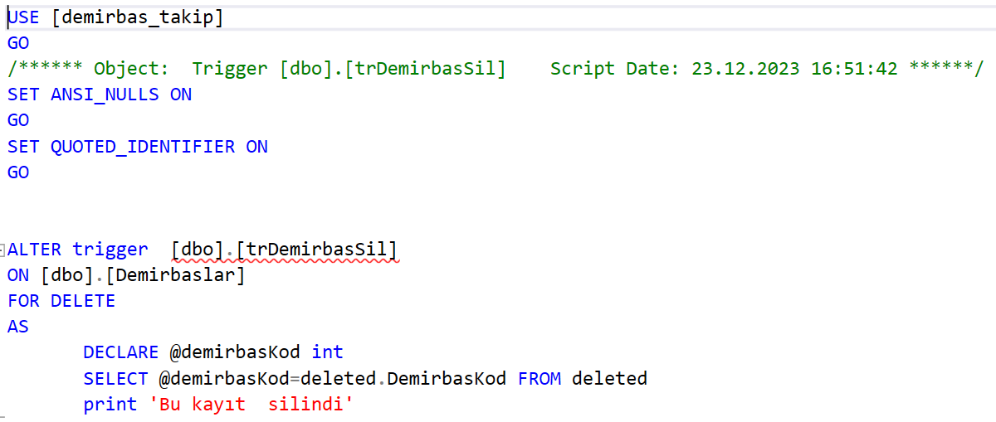

STORED PROCEDURELAR

Ada Göre Arama

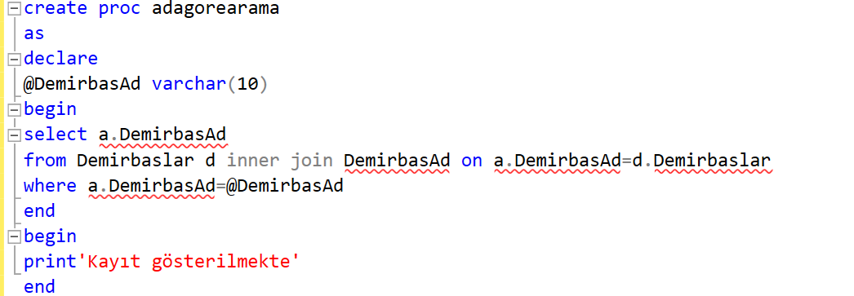

Demirbaş Ekleme, Silme, Gösterme

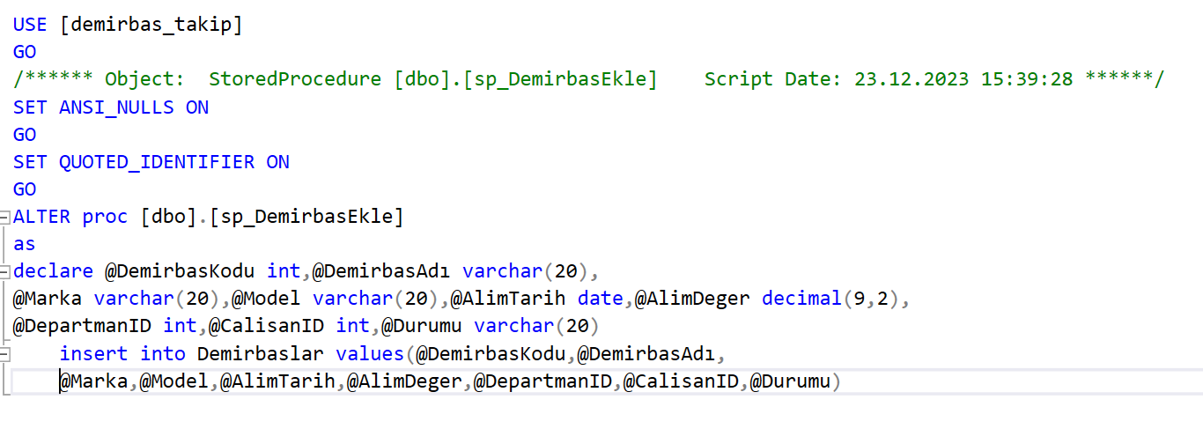

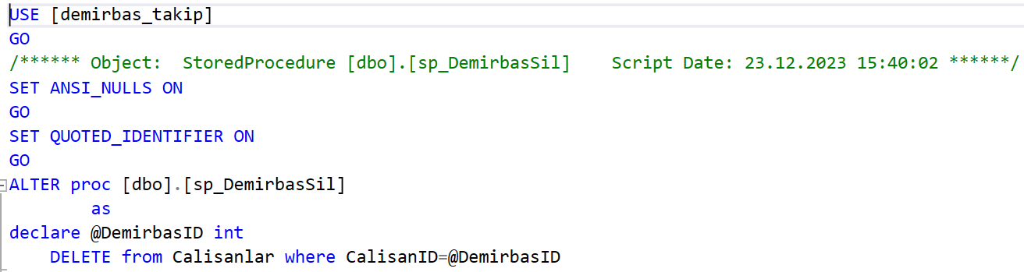

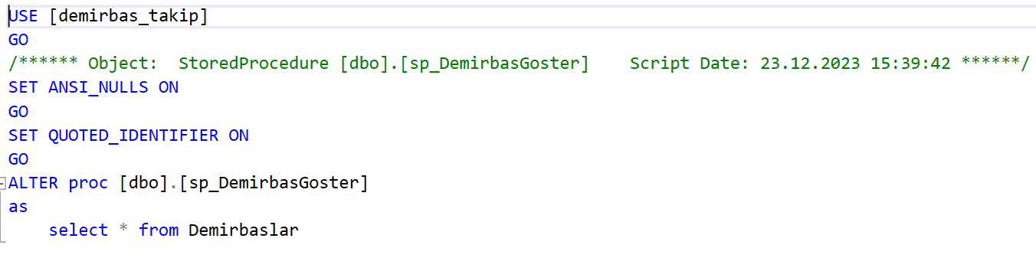

Çalışan Ekleme, Silme, Gösterme

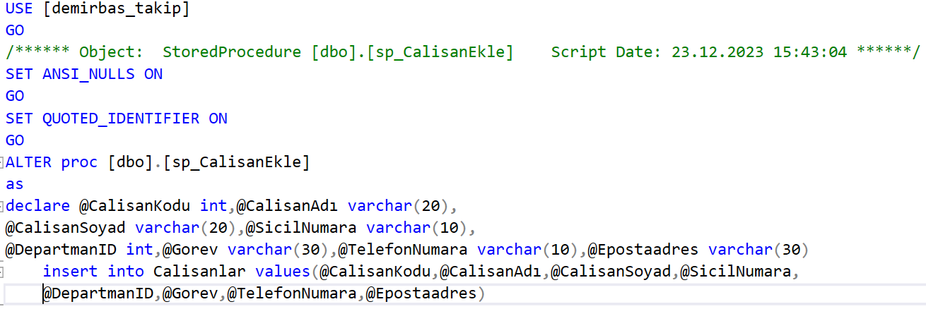

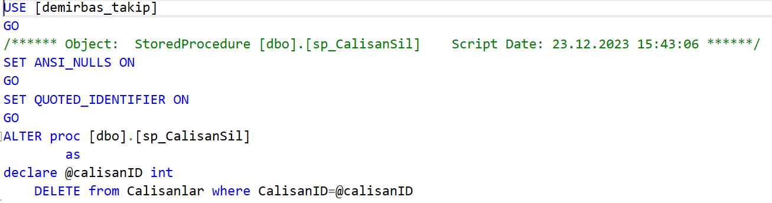

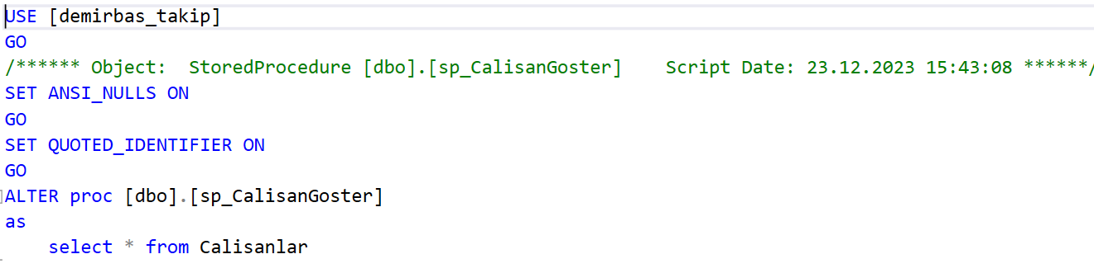

Departman Ekleme, Silme, Gösterme

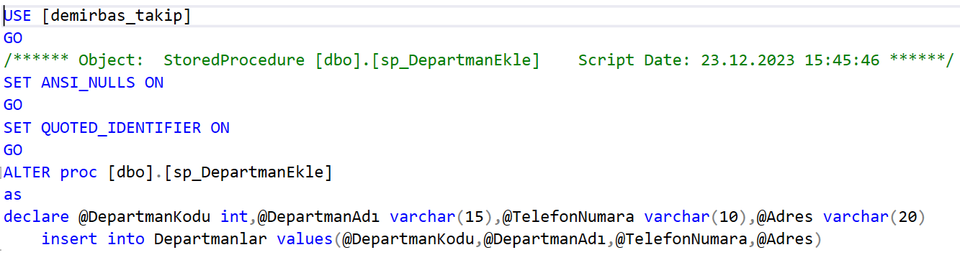

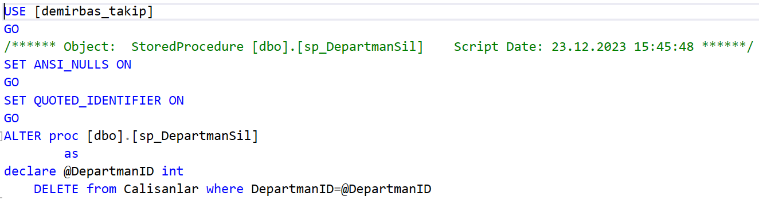

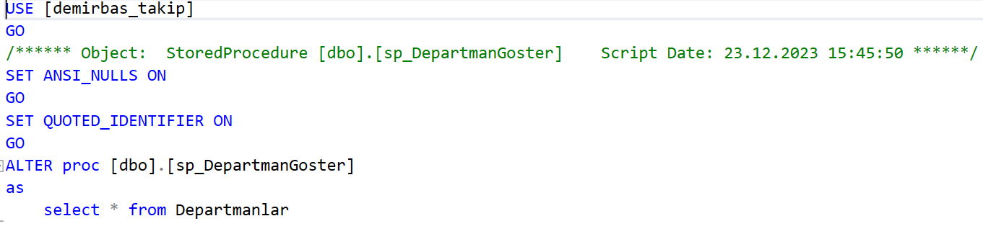

Visual Studio Arayüzü

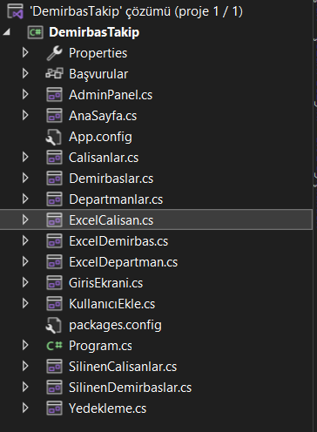

Giriş Ekranı

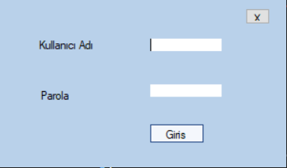

using System;

using System.Collections.Generic;

using System.ComponentModel;

using System.Data;

using System.Data.SqlClient;

using System.Drawing;

using System.Linq;

using System.Text;

using System.Threading.Tasks;

using System.Windows.Forms;

namespace DemirbasTakip

{

public partial class GirisEkrani : Form

{

SqlConnection con = new SqlConnection("server=DESKTOP-202LLLL;initial catalog=demirbas_takip;integrated security=true");

SqlCommand cmd;

SqlDataReader dataReader;

public GirisEkrani()

{

InitializeComponent();

}

private void button1_Click(object sender, EventArgs e)

{

string sorgu = "Select * from Hesaplar where PerKullanici=@KullanıcıAdı and PerSifre=@Parola ";

cmd = new SqlCommand(sorgu, con);

cmd.Parameters.AddWithValue("@kullanıcıAdı", textBox1.Text);

cmd.Parameters.AddWithValue("@Parola", textBox2.Text);

con.Open();

dataReader = cmd.ExecuteReader();

// cmd.ExecuteNonQuery();

if (textBox1.Text == "" || textBox2.Text == "")

{

MessageBox.Show("Eksik Bilgi Girildi");

}

else if(textBox1.Text == "admin" && textBox2.Text == "1234")

{

AdminPanel ap = new AdminPanel();

ap.Show();

this.Hide();

}

else if(dataReader.Read())

{

AnaSayfa ana = new AnaSayfa();

ana.Show();

this.Hide();

}

else

{

MessageBox.Show("Kullanıcı Adı veya Şifre Yanlış!!!");

}

con.Close();

}

private void button2_Click(object sender, EventArgs e)

{

Application.Exit();

}

}

}

Admin Ana Sayfası

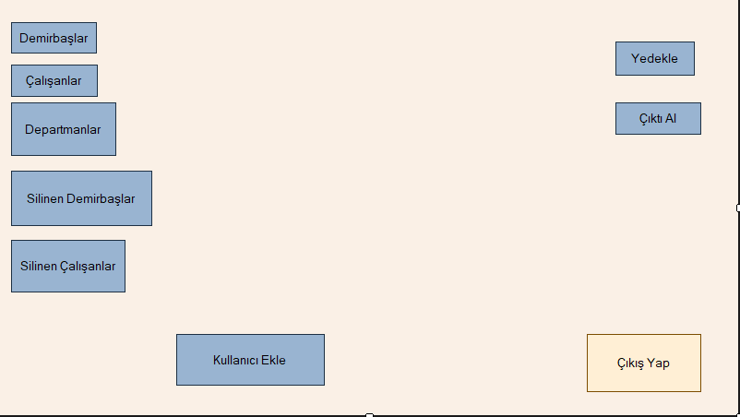

using System;

using System.Collections.Generic;

using System.ComponentModel;

using System.Data;

using System.Data.SqlClient;

using System.Drawing;

using System.Linq;

using System.Text;

using System.Threading.Tasks;

using System.Windows.Forms;

namespace DemirbasTakip

{

public partial class AdminPanel : Form

{

public AdminPanel()

{

InitializeComponent();

}

private void AdminPanel_Load(object sender, EventArgs e)

{

}

private void dmrbas_Click(object sender, EventArgs e)

{

Demirbaslar demirbaslar = new Demirbaslar();

demirbaslar.Show();

this.Hide();

}

private void clsnlar_Click(object sender, EventArgs e)

{

Calisanlar calisanlar = new Calisanlar();

calisanlar.Show();

this.Hide();

}

private void deps_Click(object sender, EventArgs e)

{

Departmanlar departmanlar = new Departmanlar();

departmanlar.Show();

this.Hide();

}

private void slndmr_Click(object sender, EventArgs e)

{

SilinenDemirbaslar silinenDemirbaslar=new SilinenDemirbaslar();

silinenDemirbaslar.Show();

this.Hide();

}

private void slnclsn_Click(object sender, EventArgs e)

{

SilinenCalisanlar silinenCalisanlar=new SilinenCalisanlar();

silinenCalisanlar.Show();

this.Hide();

}

private void cksyap_Click(object sender, EventArgs e)

{

Application.Exit();

}

private void cktal_Click(object sender, EventArgs e)

{

ExcelCalisan excelCalisan = new ExcelCalisan();

excelCalisan.Show();

this.Hide();

//ExcelDepartman excelDepartman= new ExcelDepartman();

//excelDepartman.Show();

//this.Hide();

}

private void ydkle_Click(object sender, EventArgs e)

{

Yedekleme yedeklem=new Yedekleme();

yedeklem.Show();

this.Hide();

}

private void klnEkle_Click(object sender, EventArgs e)

{

KullanıcıEkle kullanıcıEkle=new KullanıcıEkle();

kullanıcıEkle.Show();

this.Hide();

}

}

}

Demirbaş KISMI

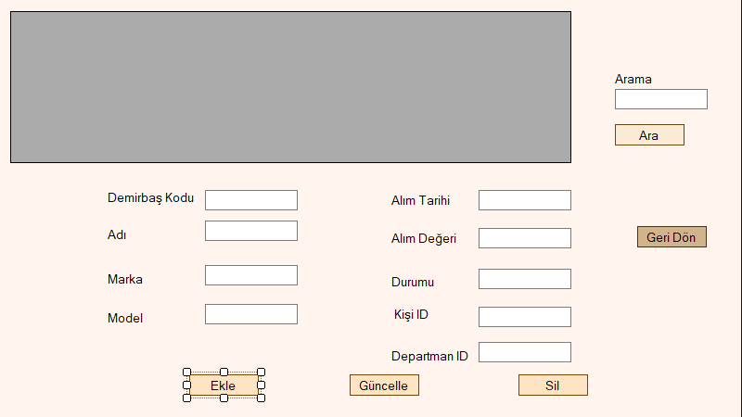

using System;

using System.Collections.Generic;

using System.ComponentModel;

using System.Data;

using System.Data.SqlClient;

using System.Drawing;

using System.Linq;

using System.Text;

using System.Threading.Tasks;

using System.Windows.Forms;

using static System.Windows.Forms.VisualStyles.VisualStyleElement;

namespace DemirbasTakip

{

public partial class Demirbaslar : Form

{

SqlConnection con = new SqlConnection("server=DESKTOP-202LLLL;initial catalog=demirbas_takip;integrated security=true");

SqlCommand cmd;

SqlDataAdapter adapter;

public void Listele()

{

adapter = new SqlDataAdapter("select * from Demirbaslar", con);

DataTable dt = new DataTable();

adapter.Fill(dt);

dataGridView1.DataSource = dt;

}

public void Temizle()

{

textBox1.Text = "";

textBox2.Text = "";

textBox3.Text = "";

textBox4.Text = "";

textBox5.Text = "";

textBox6.Text = "";

textBox7.Text = "";

textBox8.Text = "";

}

public Demirbaslar()

{

InitializeComponent();

}

private void Demirbaslar_Load(object sender, EventArgs e)

{

Listele();

}

private void dataGridView1_CellClick(object sender, DataGridViewCellEventArgs e)

{

textBox1.Text = dataGridView1.CurrentRow.Cells[1].Value.ToString();

textBox2.Text = dataGridView1.CurrentRow.Cells[2].Value.ToString();

textBox3.Text = dataGridView1.CurrentRow.Cells[3].Value.ToString();

textBox4.Text = dataGridView1.CurrentRow.Cells[4].Value.ToString();

textBox5.Text = dataGridView1.CurrentRow.Cells[5].Value.ToString();

textBox6.Text = dataGridView1.CurrentRow.Cells[6].Value.ToString();

textBox7.Text = dataGridView1.CurrentRow.Cells[9].Value.ToString();

textBox8.Text = dataGridView1.CurrentRow.Cells[8].Value.ToString();

textBox9.Text = dataGridView1.CurrentRow.Cells[7].Value.ToString();

}

private void button1_Click(object sender, EventArgs e)

{

//try

//{

// if (textBox1.Text is null)

// {

// MessageBox.Show("Demirbaş kodu boş bırakılamaz");

// }

// else

// {

cmd = new SqlCommand("insert into Demirbaslar (DemirbasKod,DemirbasAd,Marka,Model,AlimTarih,AlimDeger,DepartmanID,CalisanID,Durumu) values(@DemirbasKodu,@Adı,@Marka,@Model,@AlımTarihi,@AlımDeğeri,@DepartmanID,@KisiID,@Durumu)", con);

cmd.Parameters.AddWithValue("@DemirbasKodu", int.Parse(textBox1.Text));

cmd.Parameters.AddWithValue("@Adı", textBox2.Text);

cmd.Parameters.AddWithValue("@Marka", textBox3.Text);

cmd.Parameters.AddWithValue("@Model", textBox4.Text);

cmd.Parameters.AddWithValue("@AlımTarihi", textBox5.Text);

cmd.Parameters.AddWithValue("@AlımDeğeri", float.Parse(textBox6.Text));

cmd.Parameters.AddWithValue("@Durumu", textBox7.Text);

cmd.Parameters.AddWithValue("DepartmanID", int.Parse(textBox9.Text));

cmd.Parameters.AddWithValue("@KisiID", int.Parse(textBox8.Text));

con.Open();

cmd.ExecuteNonQuery();

con.Close();

MessageBox.Show("Kayıt tamam");

Listele();

// }

//}

//catch (Exception ex)

//{

// //MessageBox.Show("Hatalı işlem yaptınız!!");

//}

}

private void button2_Click(object sender, EventArgs e)

{

cmd = new SqlCommand("update Demirbaslar set DemirbasAd=@Adı," +

"Marka=@Marka," +

"Model=@Model," +

"AlimTarih=@AlımTarihi," +

"AlimDeger=@AlımDeğeri," +

"Durumu=@Durum where DemirbasID=@ID", con);

cmd.Parameters.AddWithValue("@ID", dataGridView1.CurrentRow.Cells[0].Value);

cmd.Parameters.AddWithValue("@DemirbaşKodu",int.Parse( textBox1.Text));

cmd.Parameters.AddWithValue("@Adı", textBox2.Text);

cmd.Parameters.AddWithValue("@Marka", textBox3.Text);

cmd.Parameters.AddWithValue("@Model", textBox4.Text);

cmd.Parameters.AddWithValue("@AlımTarihi", textBox5.Text);

cmd.Parameters.AddWithValue("@AlımDeğeri", float.Parse(textBox6.Text));

cmd.Parameters.AddWithValue("@Durum", textBox7.Text);

con.Open();

cmd.ExecuteNonQuery();

con.Close();

MessageBox.Show("Güncelleme tamam");

Listele();

}

private void button3_Click(object sender, EventArgs e)

{

cmd = new SqlCommand("delete from Demirbaslar where DemirbasID=@ID", con);

cmd.Parameters.AddWithValue("@ID",dataGridView1.CurrentRow.Cells[0].Value);

con.Open();

cmd.ExecuteNonQuery();

con.Close();

MessageBox.Show("Silme tamam");

Listele();

}

private void button4_Click(object sender, EventArgs e)

{

AdminPanel ana = new AdminPanel();

ana.Show();

this.Hide();

}

private void button5_Click(object sender, EventArgs e)

{

string co = ("select * from Demirbaslar where DemirbasAd like '%" + textBox10.Text + "%'");

SqlDataAdapter sda = new SqlDataAdapter(co, con);

SqlCommandBuilder builder = new SqlCommandBuilder();

var dataset = new DataSet();

sda.Fill(dataset);

dataGridView1.DataSource = dataset.Tables[0];

con.Close();

}

private void dataGridView1_CellContentClick(object sender, DataGridViewCellEventArgs e)

{

}

}

}

Çalışan KISMI

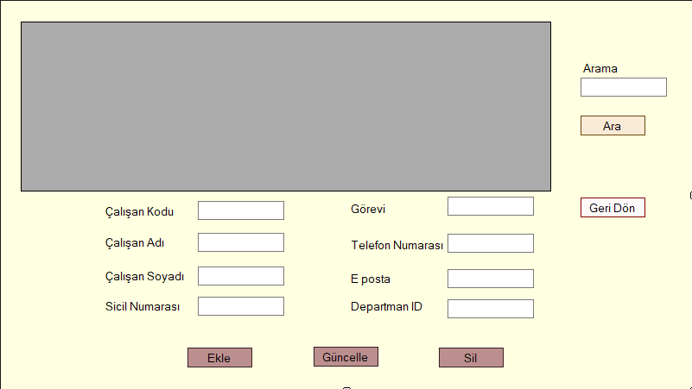

using System;

using System.Collections.Generic;

using System.ComponentModel;

using System.Data;

using System.Data.SqlClient;

using System.Drawing;

using System.Linq;

using System.Text;

using System.Threading.Tasks;

using System.Windows.Forms;

namespace DemirbasTakip

{

public partial class Calisanlar : Form

{

SqlConnection con = new SqlConnection("server=DESKTOP-202LLLL;initial catalog=demirbas_takip;integrated security=true");

SqlCommand cmd = new SqlCommand();

SqlDataAdapter adapter;

public void Listele()

{

adapter = new SqlDataAdapter("select * from Calisanlar", con);

DataTable dt = new DataTable();

adapter.Fill(dt);

dataGridView1.DataSource = dt;

}

public void Temizle()

{

textBox1.Text = "";

textBox2.Text = "";

textBox3.Text = "";

textBox4.Text = "";

textBox5.Text = "";

textBox6.Text = "";

}

public Calisanlar()

{

InitializeComponent();

}

private void Calisanlar_Load(object sender, EventArgs e)

{

Listele();

}

private void dataGridView1_CellClick(object sender, DataGridViewCellEventArgs e)

{

textBox1.Text = dataGridView1.CurrentRow.Cells[1].Value.ToString();

textBox2.Text = dataGridView1.CurrentRow.Cells[2].Value.ToString();

textBox3.Text = dataGridView1.CurrentRow.Cells[3].Value.ToString();

textBox4.Text = dataGridView1.CurrentRow.Cells[4].Value.ToString();

textBox5.Text = dataGridView1.CurrentRow.Cells[6].Value.ToString();

textBox6.Text = dataGridView1.CurrentRow.Cells[7].Value.ToString();

textBox7.Text = dataGridView1.CurrentRow.Cells[8].Value.ToString();

textBox8.Text = dataGridView1.CurrentRow.Cells[5].Value.ToString();

}

private void button1_Click(object sender, EventArgs e)

{

//try

//{

cmd = new SqlCommand("insert into Calisanlar(CalisanKod,CalisanAd,CalisanSoyad,SicilNumara,DepartmanID,Gorev,TelefonNumara,Epostaadres) values(@ÇalışanKodu,@ÇalışanAdı,@ÇalışanSoyadı,@SicilNumarası,@DepartmanID,@Görev,@TelefonNumarası,@Eposta)", con);

cmd.Parameters.AddWithValue("ÇalışanKodu",int.Parse(textBox1.Text));

cmd.Parameters.AddWithValue("@ÇalışanAdı", textBox2.Text);

cmd.Parameters.AddWithValue("@ÇalışanSoyadı", textBox3.Text);

cmd.Parameters.AddWithValue("@SicilNumarası", textBox4.Text);

cmd.Parameters.AddWithValue("@Görev", textBox5.Text);

cmd.Parameters.AddWithValue("@TelefonNumarası", textBox6.Text);

cmd.Parameters.AddWithValue("@Eposta", textBox7.Text);

cmd.Parameters.AddWithValue("DepartmanID",int.Parse(textBox8.Text));

con.Open();

cmd.ExecuteNonQuery();

con.Close();

MessageBox.Show("Kayıt tamam!!");

Listele();

//}

//catch (Exception)

//{

// MessageBox.Show("Hatalı işlem yaptınız!!");

//}

}

private void button2_Click(object sender, EventArgs e)

{

cmd = new SqlCommand("update Calisanlar set CalisanAd=@Adı,CalisanSoyad=@Soyadı,SicilNumara=@SicilNumarası,DepartmanID=@DepartmanID,Gorev=@Görevi,TelefonNumara=@TelefonNumarası,Epostaadres=@Eposta where CalisanID=@ID", con);

cmd.Parameters.AddWithValue("@ID", dataGridView1.CurrentRow.Cells[0].Value);

cmd.Parameters.AddWithValue("@ÇalışanKodu",int.Parse(textBox1.Text));

cmd.Parameters.AddWithValue("@Adı", textBox2.Text);

cmd.Parameters.AddWithValue("@Soyadı", textBox3.Text);

cmd.Parameters.AddWithValue("@SicilNumarası", textBox4.Text);

cmd.Parameters.AddWithValue("@Görevi", textBox5.Text);

cmd.Parameters.AddWithValue("@TelefonNumarası", textBox6.Text);

cmd.Parameters.AddWithValue("@Eposta", textBox7.Text);

cmd.Parameters.AddWithValue("DepartmanID", int.Parse(textBox8.Text));

con.Open();

cmd.ExecuteNonQuery();

con.Close();

MessageBox.Show("Güncelleme tamam!!");

Listele();

}

private void button3_Click(object sender, EventArgs e)

{

cmd = new SqlCommand("Delete from Calisanlar where CalisanID=@ID ", con);

cmd.Parameters.AddWithValue("@ID", dataGridView1.CurrentRow.Cells[0].Value);

con.Open();

cmd.ExecuteNonQuery();

con.Close();

MessageBox.Show("Silme tamam!!");

Listele();

}

private void button4_Click(object sender, EventArgs e)

{

AdminPanel adminPanel = new AdminPanel();

adminPanel.Show();

this.Hide();

}

private void button5_Click(object sender, EventArgs e)

{

string co = ("select * from Calisanlar where CalisanAd like '%" + textBox9.Text + "%'");

SqlDataAdapter sda = new SqlDataAdapter(co, con);

SqlCommandBuilder builder = new SqlCommandBuilder();

var dataset = new DataSet();

sda.Fill(dataset);

dataGridView1.DataSource = dataset.Tables[0];

con.Close();

}

}

}

Departmanlar KISMI

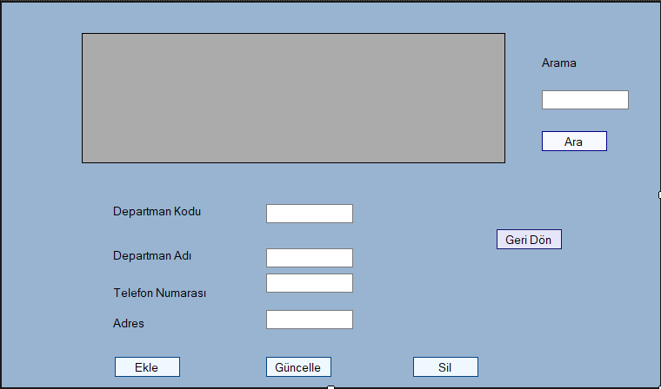

using System;

using System.Collections;

using System.Collections.Generic;

using System.ComponentModel;

using System.Data;

using System.Data.SqlClient;

using System.Drawing;

using System.Linq;

using System.Text;

using System.Threading.Tasks;

using System.Windows.Forms;

namespace DemirbasTakip

{

public partial class Departmanlar : Form

{

SqlConnection con = new SqlConnection("server=DESKTOP-202LLLL;initial catalog=demirbas_takip;integrated security=true");

SqlCommand cmd = new SqlCommand();

SqlDataAdapter adapter;

public void Listele()

{

adapter = new SqlDataAdapter("select * from Departmanlar", con);

DataTable dt = new DataTable();

adapter.Fill(dt);

dataGridView1.DataSource = dt;

}

public void Temizle()

{

textBox1.Text = "";

textBox2.Text = "";

textBox3.Text = "";

textBox4.Text = "";

}

public Departmanlar()

{

InitializeComponent();

}

private void dataGridView1_CellClick(object sender, DataGridViewCellEventArgs e)

{

textBox1.Text = dataGridView1.CurrentRow.Cells[1].Value.ToString();

textBox2.Text = dataGridView1.CurrentRow.Cells[2].Value.ToString();

textBox3.Text = dataGridView1.CurrentRow.Cells[3].Value.ToString();

textBox4.Text = dataGridView1.CurrentRow.Cells[4].Value.ToString();

}

private void button1_Click(object sender, EventArgs e)

{

//try

//{

if (textBox1.Text is null)

{

MessageBox.Show("Departman kodu boş bırakılamaz!!");

}

else

{

cmd = new SqlCommand("insert into Departmanlar(DepartmanKod,DepartmanAd,TelefonNumara,Adres) values(@DepartmanKodu,@DepartmanAdı,@TelefonNumarası,@Adres)", con);

cmd.Parameters.AddWithValue("@DepartmanKodu", int.Parse(textBox1.Text));

cmd.Parameters.AddWithValue("@DepartmanAdı", textBox2.Text);

cmd.Parameters.AddWithValue("@TelefonNumarası", textBox3.Text);

cmd.Parameters.AddWithValue("@Adres", textBox4.Text);

con.Open();

cmd.ExecuteNonQuery();

con.Close();

MessageBox.Show("Kayıt tamam!!");

Listele();

}

//}

//catch (Exception)

//{

// MessageBox.Show("Hatalı işlem yaptınız!!");

//}

}

private void button2_Click(object sender, EventArgs e)

{

cmd = new SqlCommand("update Departmanlar set DepartmanAd=@DepartmanAdı,TelefonNumara=@TelefonNumarası,Adres=@Adres where DepartmanID=@ID", con);

cmd.Parameters.AddWithValue("@ID",dataGridView1.CurrentRow.Cells[0].Value);

cmd.Parameters.AddWithValue("@DepartmanKodu", int.Parse(textBox1.Text));

cmd.Parameters.AddWithValue("@DepartmanAdı", textBox2.Text);

cmd.Parameters.AddWithValue("@TelefonNumarası", textBox3.Text);

cmd.Parameters.AddWithValue("@Adres", textBox4.Text);

con.Open();

cmd.ExecuteNonQuery();

con.Close();

MessageBox.Show("Güncelleme tamam!!");

Listele();

}

private void button3_Click(object sender, EventArgs e)

{

cmd = new SqlCommand("delete from Departmanlar where DepartmanID=@ID", con);

cmd.Parameters.AddWithValue("@ID", dataGridView1.CurrentRow.Cells[0].Value);

con.Open();

cmd.ExecuteNonQuery();

con.Close();

MessageBox.Show("Silme tamam!!");

Listele();

}

private void Departmanlar_Load(object sender, EventArgs e)

{

Listele();

}

private void button4_Click(object sender, EventArgs e)

{

AdminPanel adminPanel = new AdminPanel();

adminPanel.Show();

this.Hide();

}

private void button5_Click(object sender, EventArgs e)

{

string co = ("select * from Departmanlar where DepartmanAd like '%"+textBox5.Text+"%'");

SqlDataAdapter sda = new SqlDataAdapter(co, con);

SqlCommandBuilder builder = new SqlCommandBuilder();

var dataset = new DataSet();

sda.Fill(dataset);

dataGridView1.DataSource = dataset.Tables[0];

con.Close();

}

}

}

Yedekleme ve Yedekten Dönme

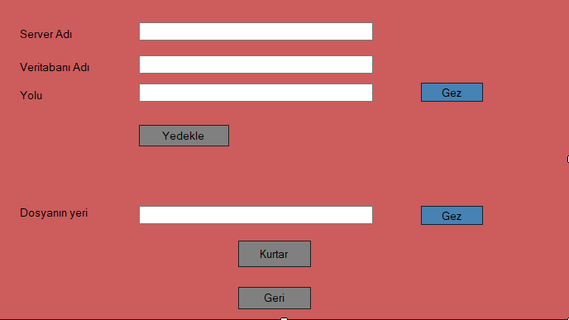

using System;

using System.Collections.Generic;

using System.ComponentModel;

using System.Data;

using System.Data.SqlClient;

using System.Drawing;

using System.IO;

using System.Linq;

using System.Text;

using System.Threading.Tasks;

using System.Windows.Forms;

namespace DemirbasTakip

{

public partial class Yedekleme : Form

{

SqlConnection con = new SqlConnection("server=DESKTOP-202LLLL;initial catalog=demirbas_takip;integrated security=true");

public Yedekleme()

{

InitializeComponent();

}

private void ydk_Click(object sender, EventArgs e)

{

string database = con.Database.ToString();

if (textBox3.Text == string.Empty)

{

MessageBox.Show("Dosyanın Kaydedilcek Yerini Seçin");

}

else

{

string cmd = "BACKUP DATABASE [" + database + "]TO DISK= '" + textBox3.Text + "\\" + "database" + "-" + DateTime.Now.ToString("yyyy-MM-dd--HH-mm-ss") + ".bak'";

con.Open();

SqlCommand command = new SqlCommand(cmd, con);

command.ExecuteNonQuery();

MessageBox.Show("Veritabanı Yedekleme Başarılı");

con.Close();

ydk.Enabled = false;

}

}

private void ydkdon_Click(object sender, EventArgs e)

{

string database = con.Database.ToString();

con.Open();

try

{

string str1 = string.Format("ALTER DATABASE [" + database + "] SET SINGLE_USER WITH ROLLBACK IMMEDIATE");

SqlCommand cmd1 = new SqlCommand(str1, con);

cmd1.ExecuteNonQuery();

string str2 = "USE MASTER RESTORE DATABASE [" + database + "] FROM DISK='" + textBox4.Text + "'WITH REPLACE;";

SqlCommand cmd2 = new SqlCommand(str2, con);

cmd2.ExecuteNonQuery();

string str3 = string.Format("ALTER DATABASE [" + database + "]SET MULTI_USER");

SqlCommand cmd3 = new SqlCommand(str3, con);

cmd3.ExecuteNonQuery();

MessageBox.Show("Kurtarma İşlemi Başarılı", "Bilgi");

con.Close();

}

catch (Exception)

{

MessageBox.Show("ex.Message", "Hata");

}

}

private void button3_Click(object sender, EventArgs e)

{

AdminPanel adminPanel= new AdminPanel();

adminPanel.Show();

this.Hide();

}

private void button1_Click(object sender, EventArgs e)

{

FolderBrowserDialog dlg = new FolderBrowserDialog();

if (dlg.ShowDialog() == DialogResult.OK)

{

textBox3.Text = dlg.SelectedPath;

ydk.Enabled = true;

}

}

private void Yedekleme_Load(object sender, EventArgs e)

{

}

private void button2_Click(object sender, EventArgs e)

{

OpenFileDialog dlg = new OpenFileDialog();

dlg.Filter = "SQL SERVER veritabanı yedek dosyası|*.bak";

dlg.Title = "Database kurtar";

if (dlg.ShowDialog() == DialogResult.OK)

{

textBox4.Text = dlg.FileName;

button2.Enabled = true;

}

}

}

}

EXCEL’E VERİ AKTARIMI VE EXCEL’DEN VERİ OKUMA

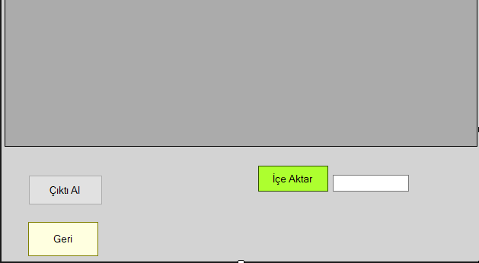

BU KISIM SADECE ÇALIŞANLAR İÇİN UFAK AYARLAMA İLE DİĞER TABLOLAR İÇİN KULLANILABİLİR

using System;

using Excel = Microsoft.Office.Interop.Excel;

using Microsoft.Office.Interop.Excel;

using System.Collections.Generic;

using System.ComponentModel;

using System.Data;

using System.Drawing;

using System.Linq;

using System.Text;

using System.Threading.Tasks;

using System.Windows.Forms;

using System.Data.SqlClient;

using System.Data.OleDb;

using System.Globalization;

using ExcelDataReader;

using System.IO;

namespace DemirbasTakip

{

public partial class ExcelCalisan : Form

{

SqlConnection con = new SqlConnection("server=DESKTOP-202LLLL;initial catalog=demirbas_takip;integrated security=true");

SqlCommand cmd = new SqlCommand();

SqlDataAdapter adapter;

public void Listele()

{

adapter = new SqlDataAdapter("select * from Calisanlar", con);

System.Data.DataTable dataTable = new System.Data.DataTable();

adapter.Fill(dataTable);

dataGridView1.DataSource = dataTable;

}

public ExcelCalisan()

{

InitializeComponent();

}

private void ExcelCalisan_Load(object sender, EventArgs e)

{

Listele();

}

private void aktar_Click(object sender, EventArgs e)

{

OpenFileDialog ac = new OpenFileDialog();

ac.Filter = " Xlsx Dosyaları |*.xlsx| Bütün Dosyalar|*.*";

ac.ShowDialog();

txt_excel.Text = ac.FileName.ToString();

}

private void geri_Click(object sender, EventArgs e)

{

AdminPanel admin = new AdminPanel();

admin.Show();

this.Hide();

}

private void cktAl_Click(object sender, EventArgs e)

{

Microsoft.Office.Interop.Excel.Application excel = new Microsoft.Office.Interop.Excel.Application();

excel.Visible = true;

object missing = Type.Missing;

Workbook workbook = excel.Workbooks.Add(missing);

Worksheet sheet = (Worksheet)workbook.Sheets[1];

int StartCol = 1;

int StartRow = 1;

for (int i = 0; i < dataGridView1.Columns.Count; i++)

{

Range range1 = (Range)sheet.Cells[StartRow, StartCol + i];

range1.Value2 = dataGridView1.Columns[i].HeaderText;

}

StartRow++;

for (int j = 0; j < dataGridView1.Rows.Count; j++)

{

for (int i = 0; i < dataGridView1.Columns.Count; i++)

{

Range range2 = (Range)sheet.Cells[StartRow + j, StartCol + i];

range2.Value2 = dataGridView1[i, j].Value == null ? "" : dataGridView1[i, j].Value;

range2.Select();

}

}

}

private void txt_excel_TextChanged(object sender, EventArgs e)

{

if (txt_excel.Text.Trim().Length > 0)

{

System.Data.DataTable dtexcel = new System.Data.DataTable();

string strConn = "Provider=Microsoft.ACE.OLEDB.12.0;Data Source=" +txt_excel.Text + ";Extended Properties=\"Excel 12.0;HDR=Yes;IMEX=0\"";

OleDbConnection conn = new OleDbConnection(strConn);

conn.Open();

System.Data.DataTable schemaTable = conn.GetOleDbSchemaTable(OleDbSchemaGuid.Tables, new object[] { null, null, null, "TABLE" });

DataRow schemaRow = schemaTable.Rows[0];

string sheet = schemaRow["TABLE_NAME"].ToString();

if (!sheet.EndsWith("_"))

{

string query = "SELECT * FROM [" + sheet + "]";

OleDbDataAdapter daexcel = new OleDbDataAdapter(query, conn);

dtexcel.Locale = CultureInfo.CurrentCulture;

daexcel.Fill(dtexcel);

}

conn.Close();

dataGridView1.DataSource= dtexcel;

}

else

{

MessageBox.Show("Excel seçmediniz.");

}

}

}

}

ÇALIŞANLAR İÇİN ANA SAYFA

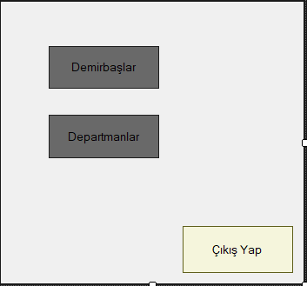

using System;

using System.Collections.Generic;

using System.ComponentModel;

using System.Data;

using System.Drawing;

using System.Linq;

using System.Text;

using System.Threading.Tasks;

using System.Windows.Forms;

namespace DemirbasTakip

{

public partial class AnaSayfa : Form

{

public AnaSayfa()

{

InitializeComponent();

}

private void dmr_Click(object sender, EventArgs e)

{

Demirbaslar demirbaslar = new Demirbaslar();

demirbaslar.Show();

this.Hide();

}

private void dep_Click(object sender, EventArgs e)

{

Departmanlar departmanlar = new Departmanlar();

departmanlar.Show();

this.Hide();

}

private void cks_Click(object sender, EventArgs e)

{

GirisEkrani giris=new GirisEkrani();

giris.Show();

this.Hide();

}

}

}

KULLANICI EKLEME

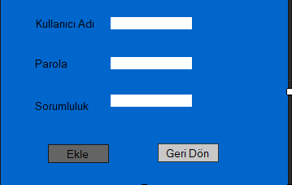

using System;

using System.Collections.Generic;

using System.ComponentModel;

using System.Data;

using System.Data.SqlClient;

using System.Drawing;

using System.Linq;

using System.Text;

using System.Threading.Tasks;

using System.Windows.Forms;

namespace DemirbasTakip

{

public partial class KullanıcıEkle : Form

{

SqlConnection con = new SqlConnection("server=DESKTOP-202LLLL;initial catalog=demirbas_takip;integrated security=true");

SqlCommand cmd;

SqlDataReader dataReader;

public KullanıcıEkle()

{

InitializeComponent();

}

private void Ekle_Click(object sender, EventArgs e)

{

cmd = new SqlCommand("insert into Hesaplar(PerKullanici,PerSifre,PerAlan) values(@KullanıcıAdı,@Parola,@Sorumluluk)", con);

cmd.Parameters.AddWithValue("@KullanıcıAdı", textBox1.Text);

cmd.Parameters.AddWithValue("Parola",textBox2.Text);

cmd.Parameters.AddWithValue("Sorumluluk", textBox3.Text);

con.Open();

cmd.ExecuteNonQuery();

con.Close();

MessageBox.Show("Kullanıcı Eklendi!!");

}

private void geri_Click(object sender, EventArgs e)

{

AdminPanel admin=new AdminPanel();

admin.Show();

this.Hide();

}

}

}