Project Proposal
Date:- 23rd Jan 2026

1. Introduction and Executive Summary
This proposal sets forth a comprehensive solution for the design, pilot, production, and deployment of a Nationwide Connected Fire Alarm System for Ghana intended to enhance public safety, improve emergency response times, and enable centralized operational oversight by the Ghana National Fire Service.
The proposed solution entails the installation of a connected fire alarm device in each residential dwelling, with direct connectivity to a centrally operated Ghana National Fire Service monitoring platform. The system shall enable continuous device health monitoring, automated alarm detection, intelligent routing of incidents, and coordinated dispatch of local fire stations.
The objective of this initiative is to reduce loss of life and property through early detection, reliable communication, and centralized command and control mechanisms.

2. Project Objectives
The objectives of the proposed project are as follows:
- To provide reliable and early fire detection capabilities at the household level nationwide
- To establish a centralized monitoring platform operated by the Ghana National Fire Service
- To enable automated routing of fire alarms to the nearest appropriate fire station
- To improve emergency response times and operational efficiency
- To provide real-time visibility into device status and fire station readiness
- To deploy a scalable, resilient, and future-ready national fire safety infrastructure

3. Scope of the Proposed Solution

3.1 Residential Fire Alarm Device
The Contractor shall supply and install a smart fire alarm device in each residential unit with the following characteristics:
- Integrated smoke and heat sensing capabilities
- Embedded cellular connectivity independent of household internet services
- Automatic reporting of:
  - Device operational status
  - Connectivity health
  - Fire alarm events
- Design suitable for continuous operation in residential environments
Commercial Terms
- Unit cost: USD 1,000 per household
- Installation cost: One-time, included
- Warranty: Two (2) years comprehensive hardware warranty

3.2 National Fire Service Monitoring Platform
The Contractor shall provide a centralized monitoring and control platform to be operated by the National Fire Service, including but not limited to the following capabilities:
- Real-time monitoring of:
  - All deployed fire alarm devices
  - Device health and connectivity status
  - Active and historical fire incidents
  - Fire station availability and operational status
- Automated alarm handling and routing:
  - Upon receipt of an alarm, the system shall automatically identify and notify the nearest appropriate fire station
- Incident lifecycle management, audit logging, and reporting
- Centralized administrative oversight and analytics

4. Alarm Handling and Operational Workflow
The system shall support the following operational flow:
- Detection of fire-related conditions within a residential unit
- Automatic transmission of alarm data to the National Fire Service monitoring platform
- Validation and registration of the incident within the central system
- Automated routing of the incident to the nearest appropriate local fire station
- Local fire station response and incident handling
- Centralized status updates and permanent audit logging
This workflow is intended to minimize manual intervention and optimize emergency response times.

5. Manufacturing and Delivery Model

5.1 Device Manufacturing
- All fire alarm devices shall be manufactured at Ghana.
- Manufacturing processes shall comply with applicable quality, safety, and regulatory standards

5.2 Software Development
- The software platform shall be developed and maintained by a specialized software entity located in India
- This delivery model enables access to specialized expertise while ensuring cost efficiency and delivery scalability

6. Software Support, Maintenance, and Commercial Model
- The Contractor shall provide:
  - Ongoing software updates at no additional cost, including security patches, performance improvements, and functional enhancements
  - Technical support for the operational software platform
- A recurring software maintenance fee shall apply, covering:
  - System hosting and operational support
  - Monitoring and uptime management
  - Technical support services
  - Preventive and corrective maintenance
This model ensures long-term sustainability, reliability, and operational continuity.

7. Project Phasing and Deliverables

Phase 1: Prototype Development and Pilot Testing
The initial phase shall include:
- Development of a prototype fire alarm device
- Development of a minimal server-side software platform
- Core functional validation, including:
  - Sensor detection
  - Connectivity to the central server
  - Alarm transmission and receipt
The objective of this phase is to validate end-to-end system functionality through controlled testing in collaboration with the National Fire Service.

Phase 2: Production and Nationwide Deployment
Subject to successful completion and formal acceptance of Phase 1:
- Commencement of full-scale device manufacturing
- Expansion of software capabilities to full operational scope
- Phased nationwide deployment in coordination with the National Fire Service

8. Anticipated Benefits to the National Fire Service
- Comprehensive nationwide fire detection coverage
- Reduced emergency response times
- Centralized command, control, and situational awareness
- Improved resource allocation and operational planning
- Reduction in false alarms through system intelligence
- Establishment of a long-term, scalable national fire safety infrastructure

9. Conclusion
This proposal outlines a robust and scalable approach to strengthening national fire safety infrastructure through the deployment of connected devices and centralized monitoring systems. The proposed solution is designed to meet the operational needs of the National Fire Service while ensuring long-term sustainability and public value.
The Contractor stands ready to collaborate with the National Fire Service to pilot, validate, and deploy this system in alignment with national safety objectives.
Respectfully submitted

Design of Nationwide Connected Fire Alarm System

1. System Overview
The proposed system is a distributed, GSM-connected fire alarm network integrated with a central cloud-based monitoring and dispatch platform operated by the National Fire Service.
Each residential unit is equipped with a Fire Alarm Device (STM32-based) capable of detecting fire conditions and communicating alarms and device health data over a cellular (GSM) network to a central cloud server. The cloud platform processes incoming events, stores data, and routes alarms to the appropriate local fire stations.

2. High-Level Architecture Description
The system consists of the following major components:
- Residential Fire Alarm Devices (Clients)
- GSM / Cellular Network
- Cloud Server Infrastructure
  - MQTT Broker
  - Application Server
  - Database
The attached diagram illustrates a many-device-to-one-cloud architecture, where multiple fire alarm devices communicate concurrently with a centralized backend.
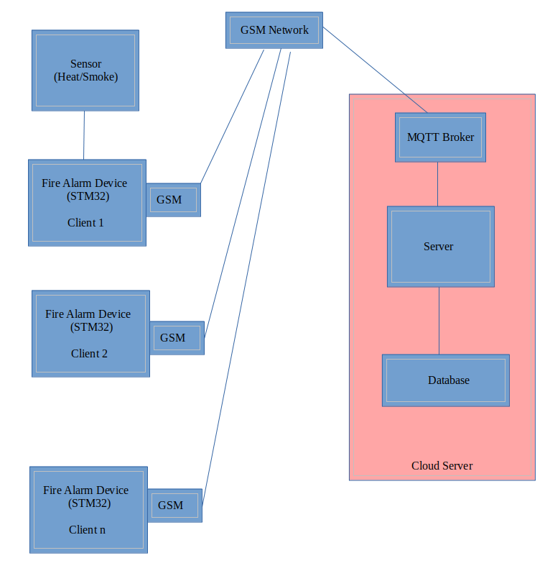

3. Prototype Scope (Initial Deliverable)
The initial prototype will include:
  - Limited number of STM32 fire alarm devices
  - Basic sensor detection functionality
  - GSM communication to cloud
  - MQTT broker and minimal server application
  - Basic data storage and alarm visualization
The prototype will be used to validate:
  - Device reliability
  - End-to-end connectivity
  - Alarm transmission and receipt
  - Overall system feasibility prior to mass production

4. Alarm Data Flow (End-to-End)
The following sequence describes the operational flow illustrated in the diagram:
  - Smoke or heat is detected by the sensor in a residential unit
  - The STM32-based fire alarm device identifies a fire condition
  - The device sends an alarm message via GSM to the MQTT broker
  - The application server consumes the message from the broker
  - The server:
    - Registers the incident
    - Stores relevant data in the database
  - The alarm is made available to National Fire Service operators
  - The incident is routed to the appropriate local fire station for response

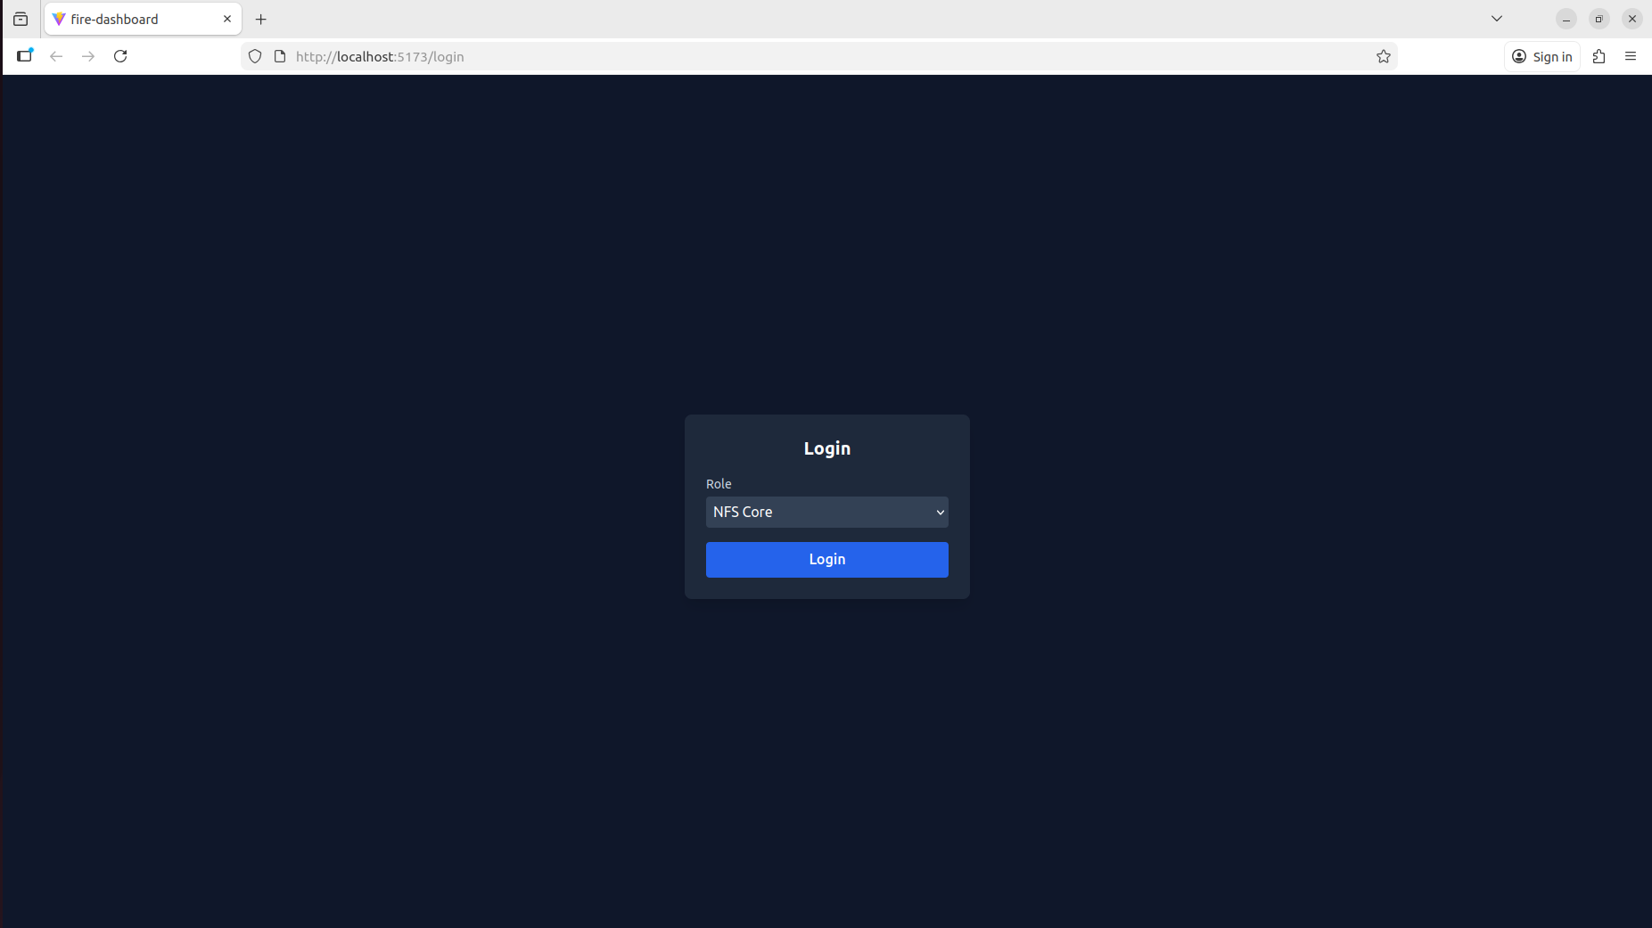
Login Page
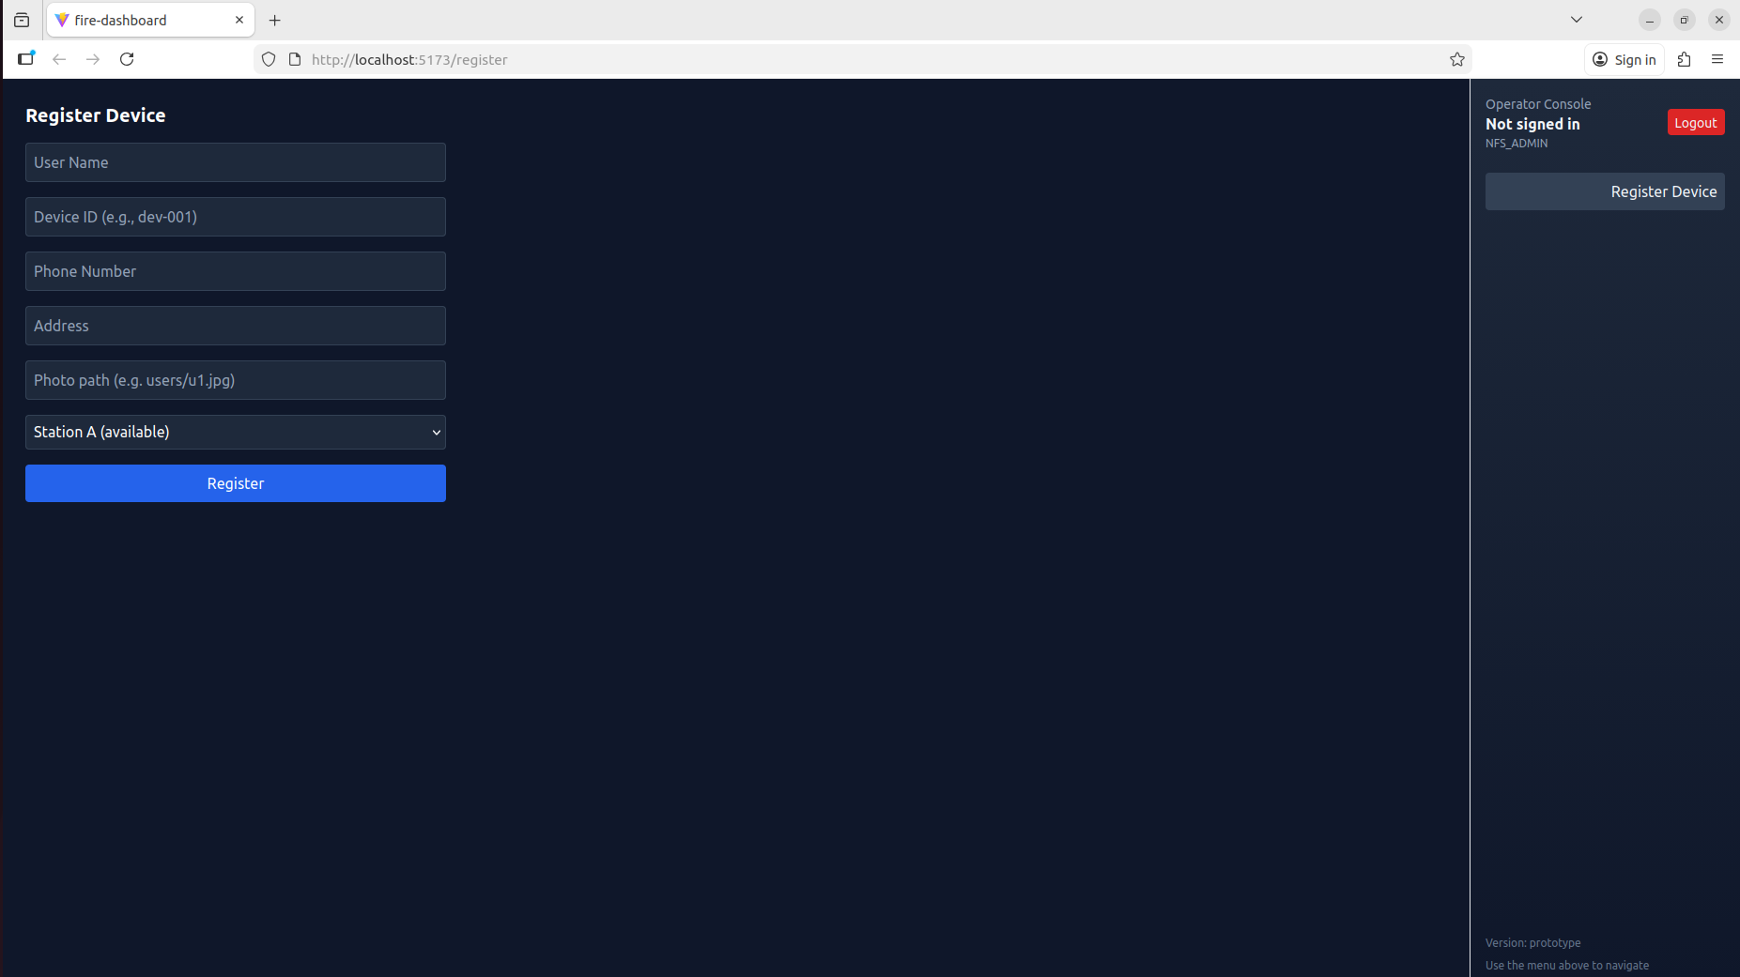
Device Registration
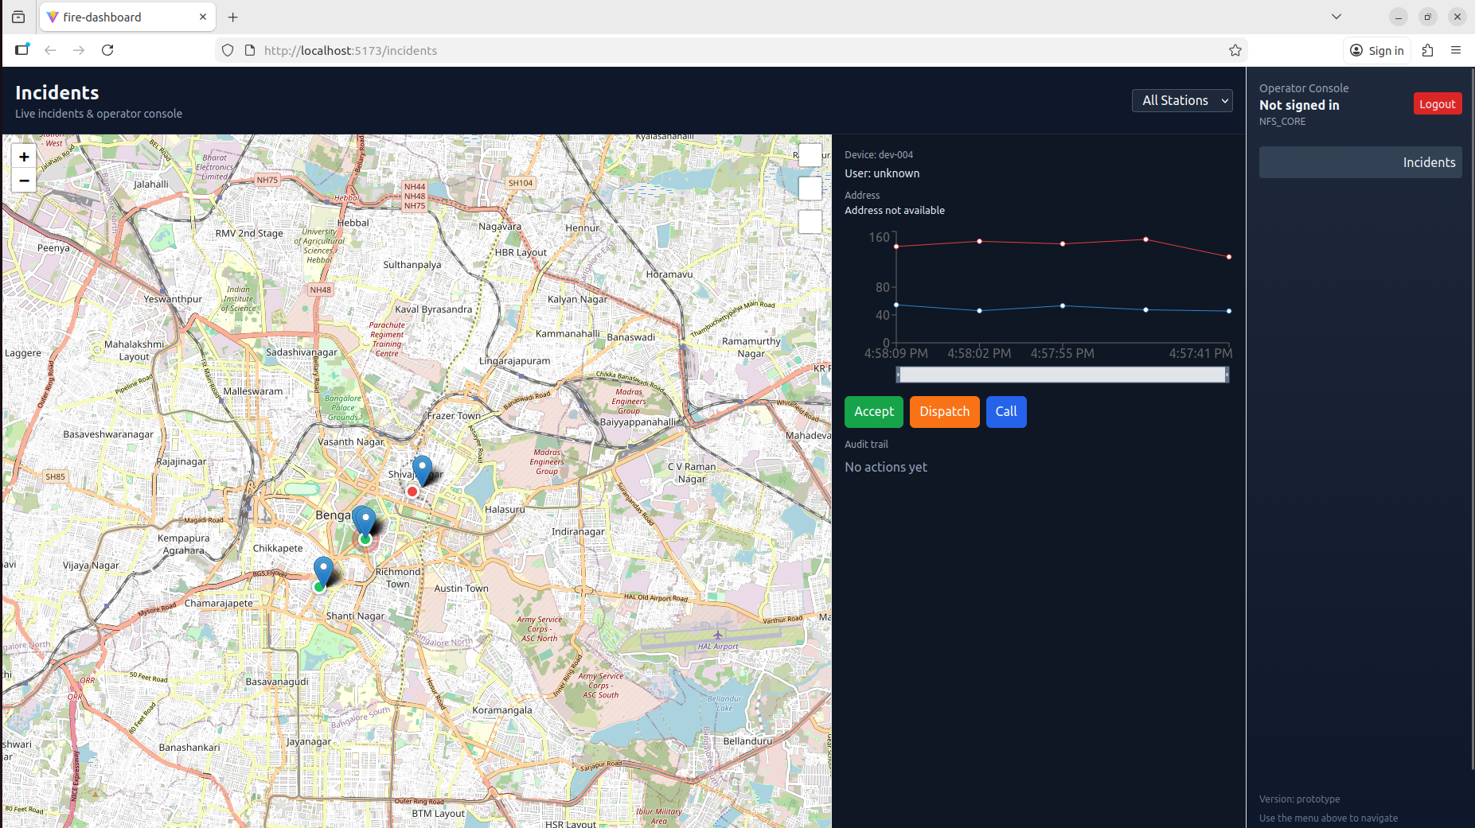
National Fire Service (Central Command/Control)
Project Budget (1 Prototype)

1. Project Plan

Phase | Weeks | Who (FTE) | Key outputs
Spec & architecture + BOM, prototype board design | 1–2 | PM (0.3), HW (0.8), FW (0.3) | Final spec, BOM, PCB design
HW prototype assembly & bring-up | 1–2 (overlapping) | HW (1.0), FW (0.6) | 5–10 assembled dev-boards
Firmware development (drivers, local decision, MQTT client, TLS, storage) | 3–4 | FW (1.0) | Working device sending events
Backend ingestion & storage (MQTT broker + API + Postgres/PostGIS) | 2–3 | Backend (1.0) | Ingest endpoint, device registry, DB
Router / correlation workers & simple heuristics | 2 | Backend (0.8) | Routing + decision engine
Frontend dashboard (map, realtime, incident view, operator actions) | 2–3 | Frontend (0.8) | React + Leaflet dashboard
Notifications + operator integration + audit trail | 1 | Backend (0.4) | Twilio/mock, audit logs
Integration, QA, load tests, bugfixes | 1–2 | QA (0.6), Backend (0.4), FW (0.4) | Integration tests, device simulator
Deploy & demo | 0.5 | DevOps (0.5), PM (0.2) | Live demo, runbook`

2. Effort & labor cost estimate (USD)
Below are two pricing scenarios: Lean contractor rates (lower bound) and Experienced contractor / small product shop (upper bound). You can choose blended staffing to hit your target.
Assumptions:
        - Lean rates: $20/hr for FW/backend, $20/hr frontend, $25/hr QA, $20/hr DevOps/hardware.
        - Workload estimated in hours per role for prototype.

Effort (hours) by role — prototype:
- Embedded FW engineer: 240 hrs (6 weeks full-time)
- Hardware/PCB engineer: 120 hrs (3 weeks)
- Backend engineer: 240 hrs (6 weeks)
- Frontend engineer: 160 hrs (4 weeks)
- DevOps / Infra: 120 hrs (3 weeks)
- PM / Tech lead: 80 hrs (2 weeks part-time)

Low-cost (lean) labor estimate
Cost per hour = 20$
- Embedded: 240h × $20 = $4800
- Hardware: 120h × $20 = $2400
- Backend: 240h × $20 = $4800
- Frontend: 160h × $20 = $3200
- DevOps: 120h × $20 = $2400
- PM/QA: 80h × $40 = $3200
Labor subtotal (lean): ≈ $20800
Add project overhead & contingency 15%: ≈ $3120
Total labor (lean) ≈ $25k
Realistic prototype labor budget is usually in the $25k–$30k range depending on who builds it (small shop vs senior engineers).

