CSC180 Assignment #01 - DRAFT

**1.** Watch the following video tutorials:

1) [Getting Started with Visual Studio 2019](https://www.youtube.com/watch?v=1CgsMtUmVgs&t=50s)

2) [What is C#](https://channel9.msdn.com/Series/CSharp-101/What-is-C) (Microsoft 101 Series)?   
    3)[Creating Your First C# Program](https://channel9.msdn.com/Series/CSharp-Fundamentals-for-Absolute-Beginners/Creating-Your-First-C-Program) (C# Fundamentals for Absolute Beginners)  
    4) [Understanding Your First C# Program](https://channel9.msdn.com/Series/CSharp-Fundamentals-for-Absolute-Beginners/Understanding-Your-First-C-Program) (C# Fundamentals for Absolute Beginners)

**2.** Create a program that will display to the console the following pattern:      
    ^  
  ^^^  
 ^^^^^

Console.WriteLine("^");

Console.WriteLine("^^^");

Console.WriteLine("^^^^^");

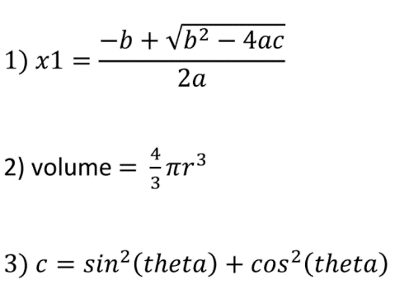**3.** Convert the following three mathematical formula to C# expressions. Use the following four lines of code below to compute and display the result:  
    double x1, volume;  
    double a = 1.0, b=2.83, c=1.2;   
    double r=1.0;  
    double theta=0.523599;

Console.WriteLine(x1=(-b + Math.Sqrt(Math.Pow(b, 2) - 4 * a * c) / 2 * a));

x1 = -1.93432985982562

Console.WriteLine(volume=(4 / 3) * Math.PI * Math.Pow(r, 3));

Volume = 3.14159265358979

Console.WriteLine(c=Math.Pow(Math.Sin(theta), 2) + Math.Pow(Math.Cos(theta), 2));

Angle=1