ELVIS Experiment #2 – Operational Amplifiers (Op Amps)

Introduction:
This experiment demonstrates how Op Amps can be used to amplify an audio signal. Two Op Amps will be used. The first will be set up as a unity-gain amplifier (or “buffer”), and the second will be configured as a variable-gain inverting amplifier. This is illustrated in Figure 1. The experiment will show that using a negative gain amplifier for an audio signal is acceptable. The experiment will also demonstrate some problems that can occur when building Op Amp circuits.
i_1
i_2
Figure 1: Op Amp circuit, including a unity gain “buffer” and a variable-gain inverting amplifier.

Circuit Analysis:
Op Amp circuits are analyzed by using two rules: 1) the voltage at the inverting input terminal is the same as the voltage at the non-inverting input terminal, and 2) the current entering the two input terminals is zero. That is:
To begin with, the output of the buffer amp is the same as its input. Note, however, that the current from the voltage source Vi is zero. The buffer amp effectively isolates the input from the rest of the circuit (which is where it gets its name).
The Inverting amp can also be analyzed by following these two rules. The non-inverting input is grounded, so from rule 1 we know that the voltage at the inverting input is also zero. Using rule 2, we can write KCL at the inverting input as . Using this, we can solve for :

Based on the range of the resistance of the potentiometer, the output voltage will be between –0.1 and (– ∞) times the input voltage. Normally, the variable resistor would be , and the fixed resistor would be , so that the output voltage would vary between 0 and –10 times the input voltage. For this demonstration, we are intentionally reversing the resistors so that we can create a very large gain and force the op amp outside of its linear range.

Implementation:
Op Amps are commonly purchased as integrated circuits. A few Op Amp integrated circuits are shown in Figure 2, below.
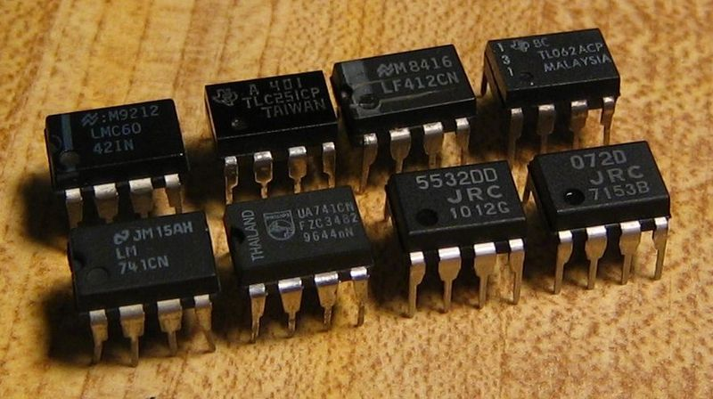
Figure 2: Some common Op Amps
The 741 is probably the most common Op Amp, and has become so popular that several competing types have adopted the same configuration of input and output pins, or “pin-out.” The 741’s pin-out is shown below. For this experiment we will use pins 2, 3, 4, 6, and 7 on each of the Op Amp chips.
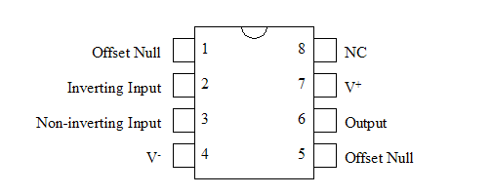
Figure 3: 741 pin-out
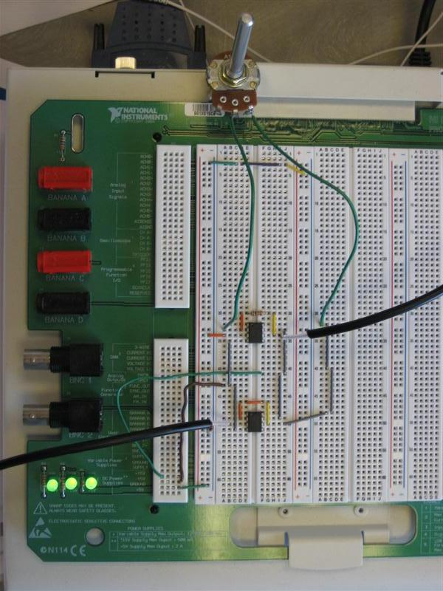
Audio input
Audio output
Variable resistor
(R1)
Figure 4: Overview of the complete circuit.
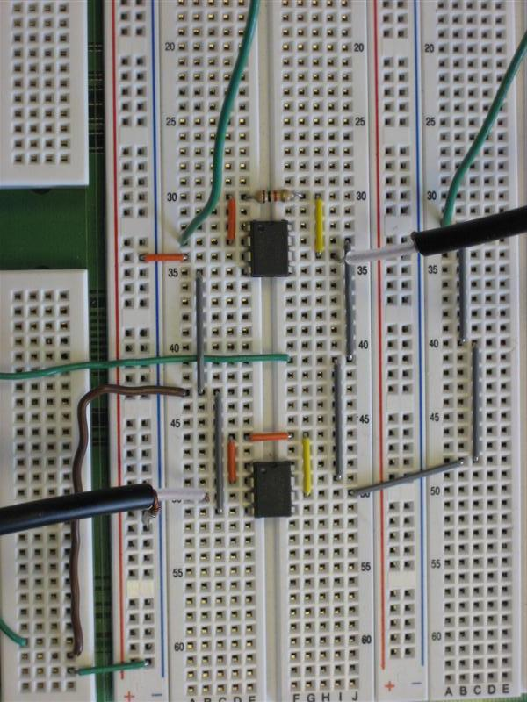
Inverting amplifier
Unity-gain amplifier
(Buffer)
Figure 5: Close-up view of the two Op Amps

