ELVIS Experiment #3 – Summer

Introduction:
This experiment will build on experiment 2 by adding a second voltage input. The modification to the circuit is relatively simple. All that is required is the addition of second variable resistor. This allows two input voltages to be summed together.

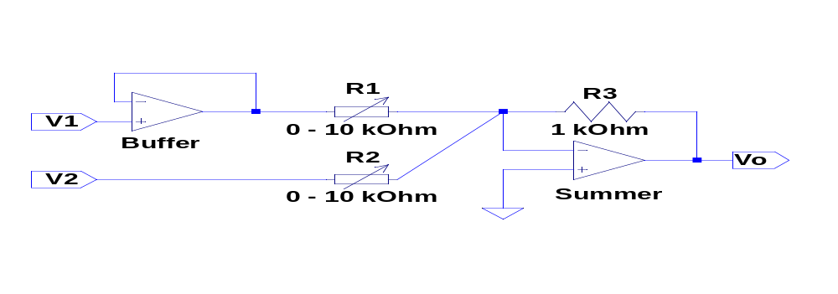
Figure 1: Op Amp Summer circuit.

Circuit Analysis:
The circuit can be analyzed using the two rules presented in the previous experiment; however, here the circuit will be analyzed by identification of basic Op Amp modules in the circuit. The circuit consists of a Buffer (a.k.a. voltage follower), which has a gain of one, and a summer. The summer multiplies the first input voltage, V1, by –R3/R1; the second input voltage, V2, is multiplied by –R3/R2. The two voltages are then added together.
As in the previous circuit, each gain is variable and ranges from –0.1 to (– ∞).

Implementation:
An audio source is used as V1, and a function generator producing a sine wave is used as V2. The function generator is part of Elvis and it has built in circuit protection. Because of this, the voltage from the function generator can be fed directly into the summer, without first putting it through a Buffer. The signal from the function generator can be heard as a steady tone on top of the music being played. The volume of the music and the tone can be changed independently by turning the two variable resistors.
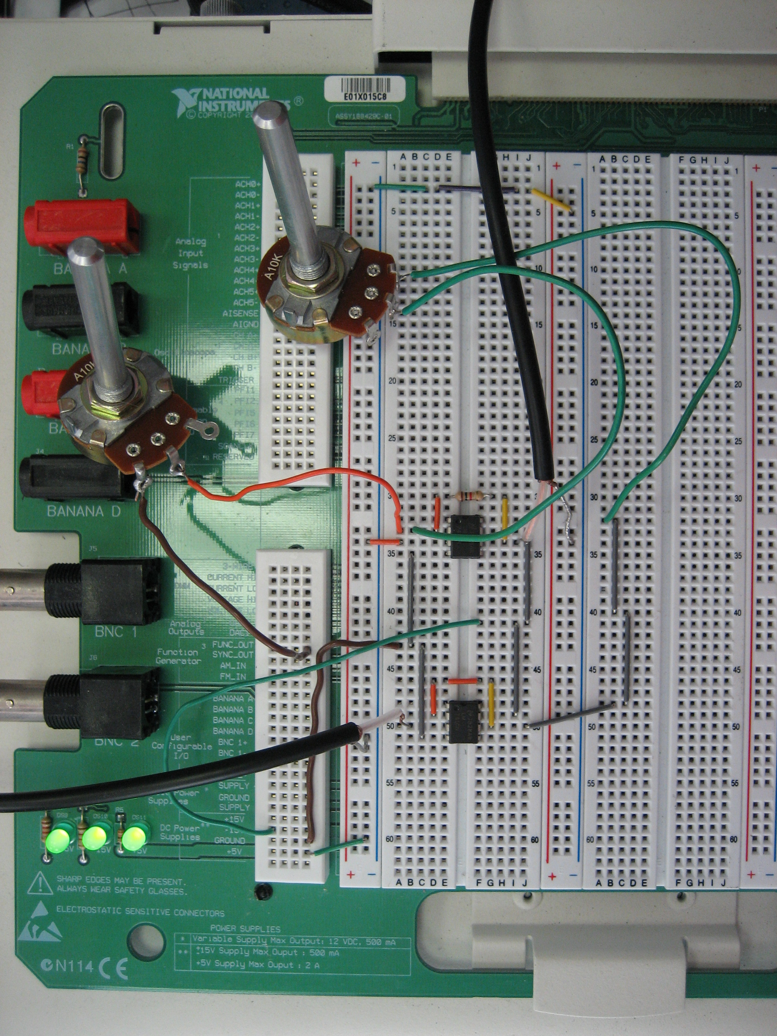
Variable resistor
(R1)
Audio input (V1)
Audio output (Vo)
Variable resistor
(R2)
Function generator input (V2)
Figure 2: Summer circuit.
Unity-gain amplifier
(Buffer)

