ELVIS Experiment #4 – Filtering

Introduction:
This experiment demonstrates how circuits involving resistors and capacitors (RC circuits) can be used to filter time-varying signals. In the first part of the experiment, a sine wave is used as an input to the circuit shown in Figure 1.

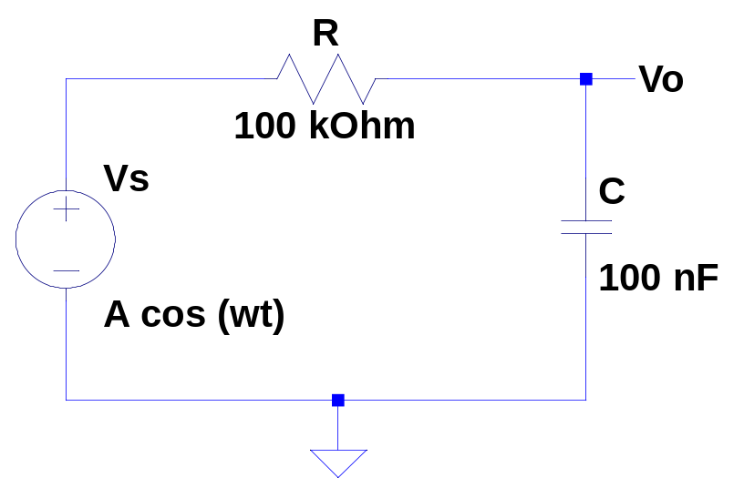
Figure 1: RC low-pass filter.
In the second part of the experiment, an RC filter involving two capacitors and an Op Amp is added to the summer circuit from experiment 3. This filters out high frequencies from the music being played as well as the noise added by the function generator. This is demonstrated by increasing the frequency of the added noise, and noticing that as the frequency increases, the volume of the noise decreases.

Circuit Analysis:
The circuit in Figure 1 can be analyzed using Laplace domain circuit analysis. The impedance of the resistor is  and the impedance of the capacitor is 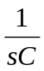. The circuit can then be treated as a voltage divider, so that
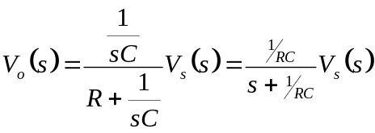.
The input-output relationship 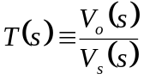 is called the transfer function of the circuit. The transfer function describes how the circuit acts when the input is a sine or cosine wave with a frequency of rad/sec. Because the circuit is linear, the output will be a sine or cosine wave of the same frequency as the input, but the amplitude of the output may be different from that of the input, and the two waves may not reach their peaks at the same time. Stated mathematically, if the input is
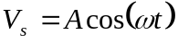,
then the output will be of the form
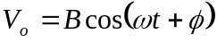.

The ratio of to  and the value of the angle change with frequency. We can determine these two values by using the transfer function and setting
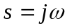.
This will give a complex function of . The ratio of to is called the gain, and is the length of the complex function. The angle is called the phase, and is the angle that the complex function makes with the positive real axis in the complex plane. The gain and phase of the RC circuit are calculated below.
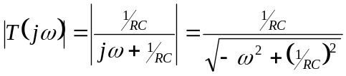

The plots of the gain and phase are together called the frequency response, or Bode plot of the circuit. The Bode plot of the circuit is shown below. (Note that the vertical scale of the gain plot is in units of decibels, which is a logarithmic unit. The horizontal scales of both plots are also logarithmically spaced.)
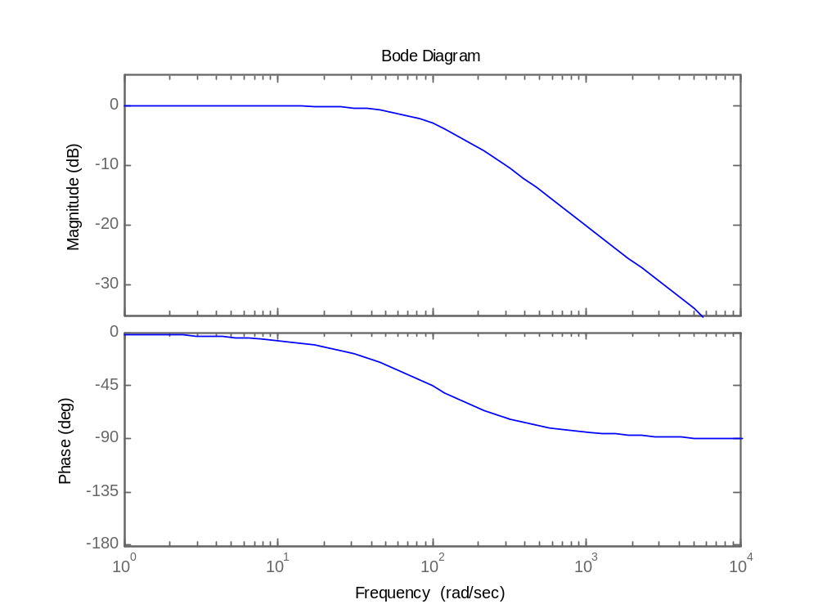
Figure 2: Bode plot of RC low-pass filter.

Figure 2 shows that at low frequencies, the magnitude and phase of the output will be almost exactly the same as the magnitude and phase of the input. Above around 100 rad/sec, the amplitude of the output will start to be significantly smaller than the input. The output will also start to become out of phase with the input. This is the frequency 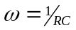, which is called the cutoff frequency.
The circuit used in the second part of the experiment is a second order Chebyshev filter, with a cutoff frequency of around 5000 Hz. The Bode plot of the filter is shown in Figure 3, below.
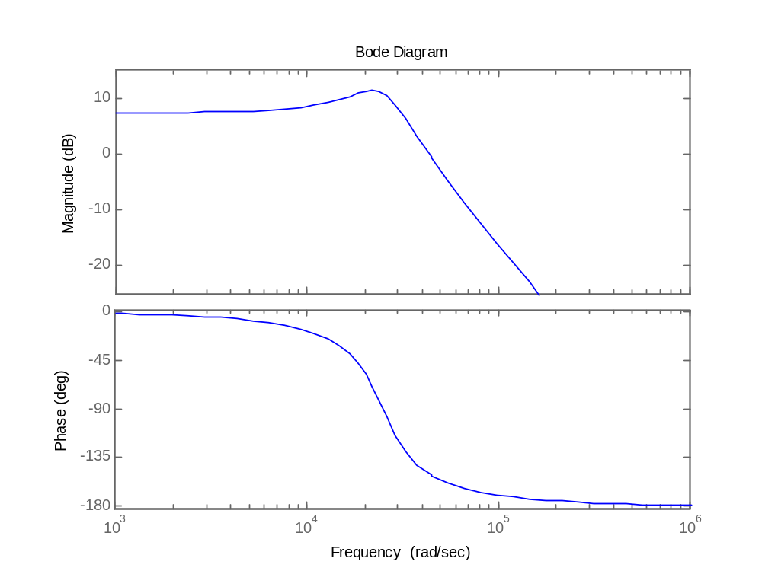
Figure 3: Bode plot of a second order Chebyshev Type I filter.

Implementation:
The first order RC low-pass filter is easy to implement, only requiring a resistor, a capacitor and a few wires. It can be built on a small section of the prototyping board, leaving room for the second part of the experiment. A close-up view of the RC low-pass filter is shown in Figure 4. Figure 5 shows the input and output of the RC low pass filter, using an input frequency of 34 Hz (around twice the cut-off frequency).
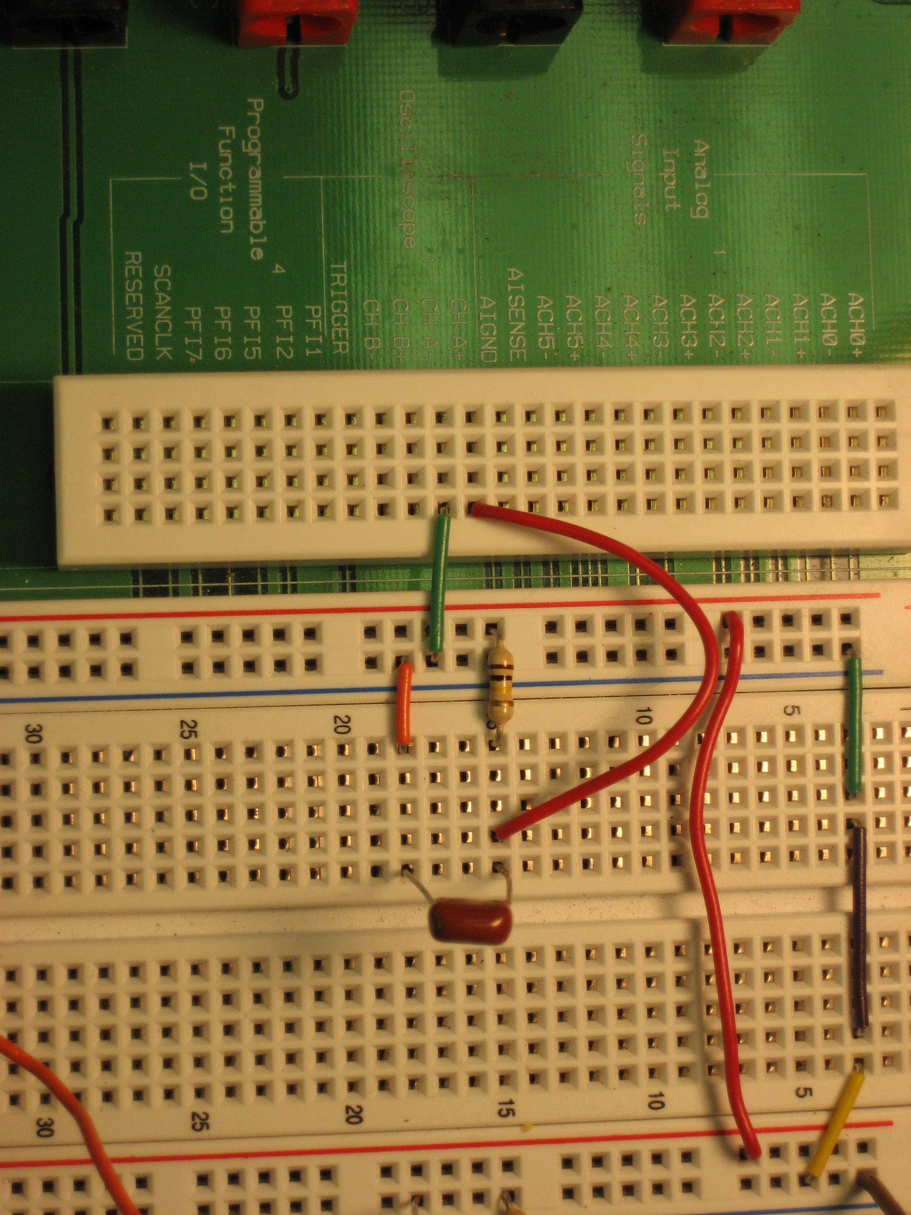
RC filter
Capacitor
Figure 4: Implementation of RC low-pass filter.

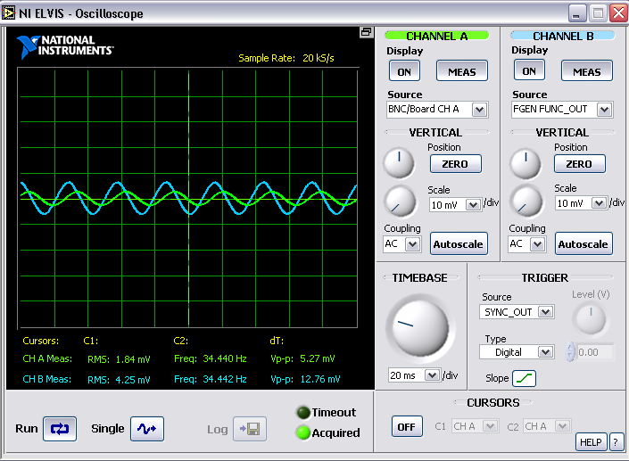
Input
Output
Figure 5: Input to the RC low-pass filter (Channel B) and output from the filter (Channel A) at approximately twice the cut-off frequency.
To implement the second part of the experiment, an Op-Amp implementation of a second order Chebyshev filter is added to the summer from experiment 3, allowing noise above around 5,000 Hz to be eliminated. The complete summer with added filter is shown in Figure 6.

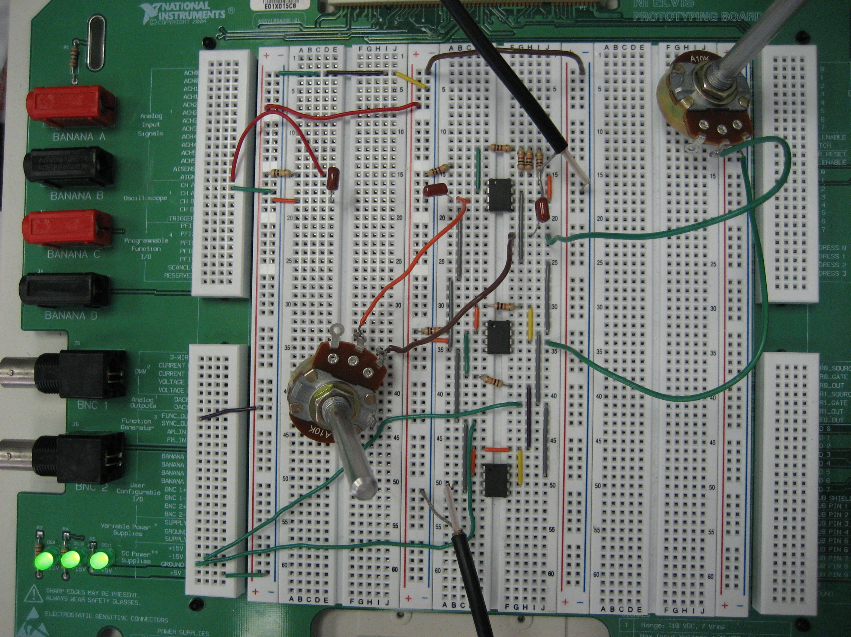
Chebyshev filter
RC filter
Summer from experiment 3
Figure 6: Implementation of Chebyshev filter.

