Creep test for RCV polymer.

In this report I perform my data of the creep test measurements made for RCV polymer samples during May of 2019. Experimental data is performed in a table below, for 3 different types of samples:

|  |  |  |  |  |
| --- | --- | --- | --- | --- |
| Length,  mm | Width,  mm | Thickness, mm | Young Modulus, Kpa | Average YM, Kpa |
| 15,74 | 8,96 | 0,21 | 1157,61 | 879,32 ± 50 |
| 15,72 | 9,52 | 0,21 | 869,82 |
| 15,89 | 8,99 | 0,18 | 890,514 |
| 15,77 | 8,93 | 0,22 | 650,03 |
| 15,53 | 8,75 | 0,23 | 925,11 |
| 15,42 | 9,83 | 0,21 | 899,89 |
| 15,53 | 9,33 | 0,18 | 835,84 |
| 15,42 | 9,77 | 0,19 | 805,77 |

Table 1. Experimental data for the sample annealed at 120 °C, speed of tension = 5 μm/s

|  |  |  |  |  |
| --- | --- | --- | --- | --- |
| Length,  mm | Width,  mm | Thickness, mm | Young Modulus, Kpa | Average YM, Kpa |
| 15,43 | 10,36 | 0,18 | 800,53 | 932,06 ± 59,33 |
| 15,33 | 8,3 | 0,2 | 1020,87 |
| 15,46 | 8,83 | 0,18 | 1043,24 |
| 15,42 | 9,35 | 0,18 | 863,611 |

Table 2. Experimental data for the sample annealed at 170 °C, speed of tension = 5 μm/s

|  |  |  |  |  |
| --- | --- | --- | --- | --- |
| Length,  mm | Width,  mm | Thickness, mm | Young Modulus, Kpa | Average YM, Kpa |
| 15,37 | 9,34 | 0,21 | 432,04 | 443,89 ± 14,20 |
| 15,4 | 8 | 0,17 | 469,63 |
| 15,44 | 9,53 | 0,2 | 439,27 |
| 15,42 | 9,2 | 0,2 | 467,13 |
| 15,37 | 8,75 | 0,2 | 411,4 |

Table 3. Experimental data for the sample annealed at 150 °C, speed of tension = 5 μm/s

To calculate values of Young Modulus for each experiment, I used the part of data corresponding to the linear proportionality region. Typical graphs are performed on the next page.

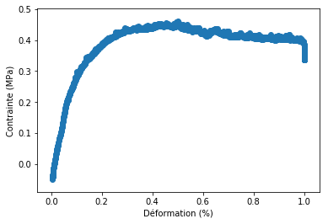

Figure 1. Sample annealed at 150 °C, experimental data

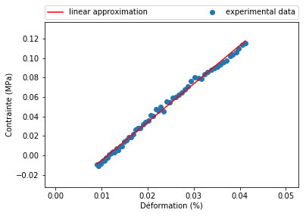

Figure 2. Sample annealed at 150 °C, linear approximation

The performed results were made with same elongation speed. An experimental data for different speeds is performed below, but these results are very chaotic and demand to be qualified.

|  |  |  |  |  |  |
| --- | --- | --- | --- | --- | --- |
| Length,  mm | Width,  mm | Thickness, mm | Speed,  μm/s | Young Modulus, Kpa | Temp. of annealing, °C |
| 15,86 | 8,61 | 0,19 | 1 | 577,95 | 150 |
| 15,83 | 8,02 | 0,18 | 1 | 338,06 |
| 15,77 | 8 | 0,18 | 2 | 682,41 |
| 17,31 | 10,35 | 0,19 | 10 | 271,4 | 170 |
| 15,84 | 10,38 | 0,17 | 1 | 338,11 |
| 17,91 | 8,73 | 0,21 | 2 | 248,2 |
| 17,69 | 9,21 | 0,21 | 2 | 467,52 |
| 16,74 | 7,72 | 0,18 | 2 | 460,84 | 120 |