Technical university „Gheorghe Asachi” Iasi

Faculty of Automatic Control and Computer Engineering

Distributed systems and web technologies

Histogram equalization

Students:

Mircea Dobreanu

Chelaru Ștefan

Used images:

Image 1 Image 2

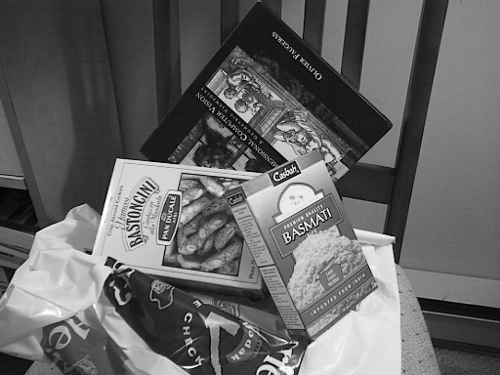 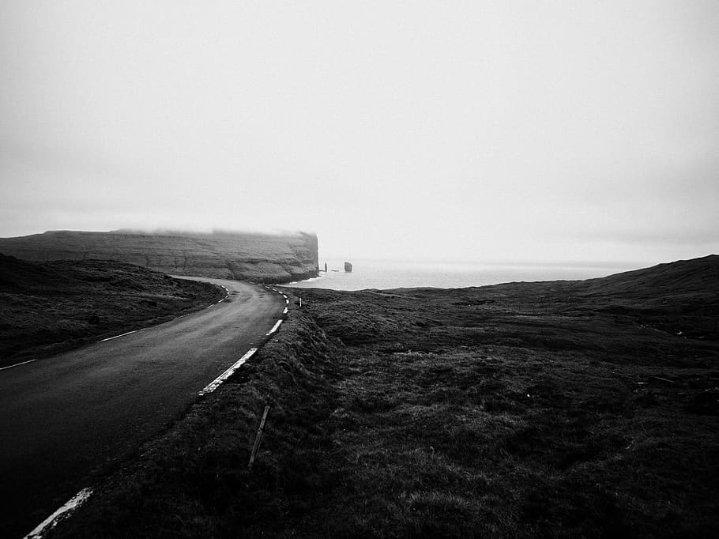

512x384 910x682

Image 3 Image 4

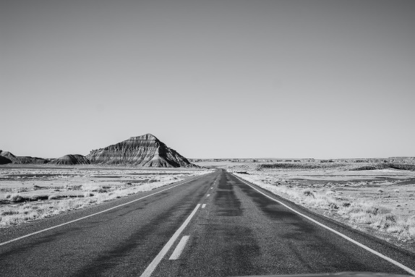 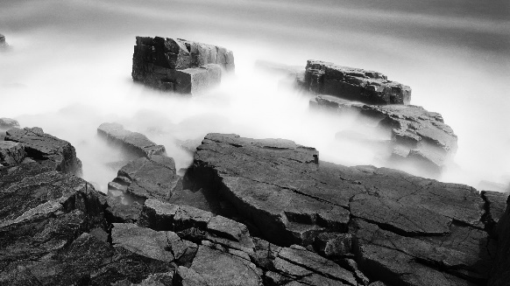

1000x667 1920x1080

Image 5

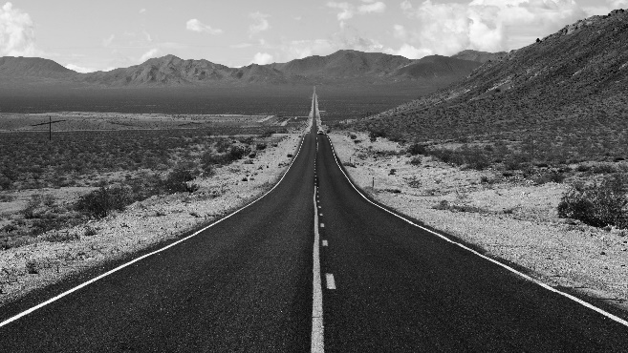

5120x2880

|  |  |  |  |  |  |
| --- | --- | --- | --- | --- | --- |
| Image number | CPU total time (μs) | Time to transfer image from CPU to GPU (μs) | The time to equalize the histogram on the GPU for the input image (μs) | The time to transfer the equalized image back to CPU (μs) | GPU total time (μs) |
| 1 | 932 | 112 | 563 | 96 | 771 |
| 2 | 7946 | 223 | 996 | 303 | 1522 |
| 3 | 8985 | 216 | 1011 | 208 | 1436 |
| 4 | 5487 | 563 | 2196 | 476 | 3236 |
| 5 | 13612 | 3299 | 11958 | 3349 | 18607 |

**\*Time is measured in microseconds**

**Device specifications:**

**CPU: i7-9750H CPU @ 2.60GHz 2.59 GHz**

**16Gb RAM**

**GPU: nvidia GTX 1650**