CHURCH FENTON VILLAGE HALL MANAGEMENT COMMITTEE

RULES AND REGULATIONS FOR THE HIRING THE VILLAGE HALL

- General Conditions

All bookings require full payment at the time of booking the hire unless the hirer has an agreement for multi booking payments in advance with the Village Hall Committee.

Fire regulations require that all exits must be kept clear of any obstructions whenever the Hall is in use. NO SMOKING is allowed within the building. Failure to observe this requirement may lead to legal action being taken against individuals.

The Entertainment Licence is only valid until Midnight. All events and parties must finish before this time and the hall vacated by Midnight. The Hirer shall be responsible for obtaining any licences as required for the consumption of alcohol.

The Booking Manager will allow the hirer to return on a Sunday morning after a party booking on a Saturday night to clear up, this must be booked in advance and completed before 10am, a flat £40 fee will be charged. Any other hours required after 10am will be charged at £10 per hour.

The premises shall not be used for any purpose other than that for which permission has been granted.

The Hirer is deemed to be personally responsible for the behaviour of anyone attending their event; they must not sub-let or transfer the booking to any other person.

The Management Committee reserves the right to cancel the event IF the Hall is required for use in an emergency, elections, or any such other business, in which case the Hirer shall be entitled to a refund.

The Management Committee’s decision regarding the interpretation and application of these Rules & Regulations shall be final and conclusive.

- Cancellation Policy

  - A 48-hour cancellation period is in place for all bookings. If a cancellation is made in this time period, the full payment will be due.

- Payment Terms for Birthday Parties and One-off Bookings

  - All birthday parties or one-off bookings must pay within 7 days of receiving the invoice. If the payment is not received within this period, the reserved slot will be cancelled.

- During the Period of Hire

Tea towels, dish cloths and washing up liquid are to be provided by the hirer.

  - Church Fenton Village Hall is run by Church Fenton people for the benefit of Church Fenton people; so, the committee places importance on being a good neighbour to local residents. Hirers are asked to ensure that they are considerate to the neighbours when they use the hall.

  - The Booking Manager may allow the Hirer to return on a Sunday morning to clear up after parties.

- After the Period of Hire

  - At the end of any period of hire, the Hirer shall:

    - remove all their own equipment from the Hall
    - wash and put away any Hall crockery and cutlery used
    - ensure all the kitchen appliances and work surfaces are left clean
    - wipe down any tables before being returning them to their original places
    - stack Chairs in the racks provided
    - sweep and mop as necessary the floors leaving them clean and tidy
    - ensure all toilets are left clean with bins emptied and spillages cleared
    - ensure all rubbish and waste is taken
    - away and disposed of

Cleaning products will be left in the kitchen under the sink for these purposes. Note there is a child lock on the cupboard to avoid children gaining access to the cleaning products. Directions for how to operate the lock are detailed in the picture below:

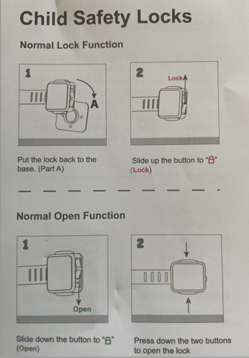

  - Any damage to equipment in the Hall must be reported to the Booking Manager as soon as possible after the incident – costs to repair/replace items damaged may be requested.

  - The Management Committee accepts no responsibility for personal belongings including coats and clothing left in any part of the building. Any items left behind will be kept by the Booking Manager for 1 month, after which they will be recycled.

  - Before leaving the premises, the Hirer must:
    - ensure that all the internal lights have been turned off and the heating is turned off at the thermostat by the kitchen door. Please do not switch off the heating at the Boiler main switch.
    - If the urn has been used please empty and switch off
    - all external fire doors are securely shut and locked,
    - and finally, that the front door keys have been replaced in the external key box and the code has been scrambled.

I agree to abide by the above rules and regulations and will pay for any broken or missing items.

Organisation _____________________________________
(If applicable)

Date of Function __________________________________

Signed __________________________________________

Print Name ______________________________________ Date _____________

Contact Telephone No _____________________________

Rules for Hire of Church Fenton Village Hall – March 2025

