*PathFinder -*​ Design Document

Date: 05/13/2019 Author: Mark McDonald

Table of Contents

Introduction 2

Overview 3

Requirements 4

Description of Technology 4

Description of Hardware 4

Description of Data 5

Frame Files 5

Modifications to Mask Data 6

Directory Structure 6

Installation, Configuration and Setup 6

A – Download Source Data 6

B – Download Application 7

C – Run Master Notebook 8

Demonstration 9

STEP 1 - Set Backend For GPU Support 9

STEP 2 - Check that you are in the correct current directory 10

STEP 3 - Set Variables 10

STEP 4 - Extract Data From Downloaded Files 12

SIDEBAR: Understanding the data set 13

STEP 5 - Create a superimposed video file based on original data 16

STEP 6 - Change the mask data to Binary Values 17

STEP 7 – Model Training 19

Independent Test of External Video 27

Summary/Next Steps 28

YouTube Video Links 29

References 29

Documentation 29

Appendix: Support Code 30

data_preprocess.py 30

models.py 35

video_support_processes.py 39

# Introduction

In recent years, autonomous vehicle navigation has been focused on road-based vehicles. This popularity is warranted by the enormous demand for safe and reliable travel and will continue to progress. Advances in robotics have extended beyond being able to assist humans with road-based travel needs. Modern robots have the ability to maneuver over complex natural landscapes like humans and animals can do. This brings the benefits of automated machinery to a much broader scope of applications such as farming, military, security, search and rescue, etc.

The PathFinder project aims to teach off-road autonomous vehicles how to determine navigable paths. PathFinder is a deep learning-based application that will develop a heatmap from an image of a landscape that highlights navigable areas.

**Problem Statement:**

*“Provide ground-based autonomous vehicles and robots support with understanding their surroundings in order to select an adequate navigable path using a model of Autoencoders and Convolutional Neural Networks trained using Keras with a sample videos from a variety of landscapes and lighting conditions.”*

# Overview

The project is divided into 3 distinct efforts;

1. data handling
2. model development and training,
3. using the model to display the heat maps

The training data for the model will originate from <http://www.mikeprocopio.com/labeledlagrdata.html>. The initial research project was focused on enhancing robotic navigation using stereoscopic visual which is beyond the scope of this project. The PathFinder project will be limited to identifying a path of travel with a single-plane image.

The source data is packed into various series of MAT files which include various pieces of data for each frame in a video sequence. After downloading the data, some of this data is extracted and used for training and testing our PathFinder application. The training data includes an image and a mask that highlights navigable areas. The testing data includes images without any mask.

Each MAT file represents a single frame of video. The image files need to be extracted and stitched together in order to create a video. The video is a sequence showing the navigation of a path. The PathFinder program will create videos with mask overlays that show the navigable elements of the scene. For testing data, the mask will be generated by our model and overlaid on the training video.

The amount of data images available is limited, so training will rely on augmentation.

After several trial and errors, the final model chosen to train the network is an AutoEncoder using CNN layers, image augmentation, no regularization and is trained on color images.

Once training is complete, the trained model will be used to produce a heatmap that highlights navigable areas of a test video sequence.

# Requirements

1. Develop the ability to extract image data from data set, create heatmaps and superimpose them over the images.
2. Provide the ability to combine a sequence of images into a video.
3. Build a model optimized for the problem domain that highlights traversable areas of an image.
4. Use the provided data as training data setting a portion aside for training validation.
5. Use augmentation to extend the training data
6. Demonstrate the model with the test data provided
7. Demonstrate the data with an independent video source of a path
8. Provide instructions on how to use the project scripts to replicate the data preparation, training and final visualization
9. Create a 2-minute video explaining the effort and its results
10. Create a 1-page summary report that is aligned with the video summary
11. Create a 15-minute video with detailed explanation of the effort and its results
12. Create a detailed report exampling the project and its results.

# Description of Technology

Pathfinder is based on Python using py scripts to support a Jupyter notebook that will execute the whole project.

Keras is used to develop and train models. CNN layers are stacked to create an encoded layer that is expanded back to the original size except the expanded image represents a mask that highlights navigable areas.

Image augmentation is used which drives the use of data generators.

OpenCV is used to produce videos.

# Description of Hardware

Computer: iMac (Retina 5k, 2017)

Processor: 4.2 GHz Intel Core i7, 24GB

GPU: Razer Core X Case with AMD Radeon RX Vega 64 External GPU Card

Using a GPU is imperative to process the data in this project. When attempting to execute some of the steps using CPU’s, the kernel would fail.

Since macOS Mojave, macOS only supports AMD GPU cards. TensorFlow only works on Nvidia cards so in order to use Tensorflow with a GPU, macOS HighSierra or earlier is needed. In order to use an eGPU with macOS Mojave, the PlaidML backend with Keras is necessary. As a result, the master notebook includes a line that will enable the PlaidML backend for Keras. This can be commented out as needed but can be left as-is without problems. If running the project where an Nvidia eGPU is used, this line should be commented out.

# Description of Data

A ‘toy_data’ directory provided with the project includes an extremely limited number of stripped down training images. For best results, it is recommended to download the entire data set. The examples below are form the original dataset. Output will vary when using the toy data.

Each of the 6 training videos has a sequence of 100 frames for a total of 600 training images. Each frame of the test sequences has a corresponding labeled overlay which will be referred to as a mask. Each pixel of each mask is marked as either ‘ground plane’ = 0, ‘obstacle’ = 1 or ‘unidentified’ = 2.

Each of the test scenes has a total of 500 frames each with no overlay information.

## Frame Files

Each directory contains several files where each file represents a frame of video. The file format of each frame is “*.mat” which includes several pieces of extractable information related to the frame. The data in each MAT file is a dictionary with the following keys:

__header__

__version__

__globals__

im_disparity

im_rgb

stereo_diff_disparity

stereo_disparity_valid

stereo_max_disparity

stereo_min_disparity

frame_number_a

frame_number_b

frame_number_c

image_timestamp

extract_timestamp

extract_author

extract_version

stereo_mask_precalc

feature_image_precalc

manual_human_labeling_mask

For the scope of this project, we will focus on the data in ‘im_rgb’ and ‘manual_human_labeling_task’ where the ‘im_rgb’ data is the source image and the ‘manual_human_labeling_task’ data is the respective mask.

The ‘im_rgb’ data frames have a resolution of 640x480 with 3 color layers (RGB Tensorflow ordering).

The ‘manual_human_labeling_task’ frames have a resolution of 640x480 with 1 layer.

Each frame will be treated as a unique image for training purposes and not as a sequential video. For this series of images (which can be combined to make a video), the outcome of any frame is not dependent on the previous one so no sequential analysis effort is necessary. Each frame can be considered a unique image and training does not need to be sequential.

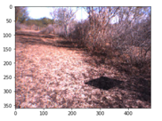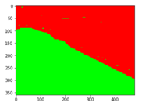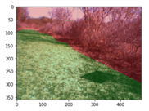

+

=

Figure : Mask Overlay

## Modifications to Mask Data

Masks from the original data set include a label for each pixel of 0,1 or 2 (‘ground plane’ = 0, ‘obstacle’ = 1 or ‘unidentified’ = 2). We are really just interested in things that are ground plane or not. If something is unidentified, we will assume that it is not navigable. Since we are looking for a path, we don’t want it to be labeled with 0, but rather with a 1. In order to achieve this, we will need to change our masks so that they are composed of 0’s or 1’s only and so that the 1 represents the path.

This makes the masks binary and reduces the amount of data that needs to be processed.

## Directory Structure

The instructions below will explain how to setup an initial directory structure for the program data. Then, the user will extract the program. The data directory and the program files do not need to be in the same directory structure. Upon executing the program, a series of support directories will be created in the data directory. the downloaded data will be used to create training and validation data sets of images and masks. The setup process will also create a series of videos for each of the training sequences. A ‘results’ directory will be created to store training results.

# Installation, Configuration and Setup

## A – Download Source Data

Data for the training comes from <http://www.mikeprocopio.com/labeledlagrdata.html> where research was done on robotic navigation over natural terrain using stereoscopic vision.

Train and test data is extensive at over 7GB. Data must be stored locally for training. Access over a network or the Internet will be too slow.

Downloaded data will be in 9 directories. The directories with “SupplimentalFrames” are test data. The video frames in these directories are sequential to the training data so that when they are stitched together, they create a seamless sequence. The training data is in the remaining 6 directories ending with 4 characters, e.g: “DS1A”. “DS” represents “data sequence” and the “1” represents the scene number and the “A” represents the lighting condition. The test directories also contain a corresponding tag that indicates which training sequence it is aligned with.

**Move Downloaded Data into the Following Local Data Structure**

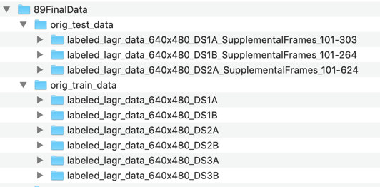

Figure : Each directory includes a series of video frames. Each directory includes a tag that represents the scene and lighting conditions. E.g. “DS1A” – Data Sequence 1 Scene A

After downloading data, directories for “train” and “test” must be manually created and the respective downloaded directories respectively moved. In the screenshot above, the directories “89FinalData”, “orig_test_data” and “orig_train_data” were manually created.

Any reasonable name can be chosen for these directories. The names of these directories can be specifically referenced in a later process. Whichever names are chosen, note them as they will be set as variables when we execute our program.

## B – Download Application

The application is in a zip file that can be extracted to any reasonable location.

AutonomousNavigation_MarkMcDonald_FinalCodeAndData.zip

Once unzipped, the application includes the following directories and files:

* code
  + master_pathfinder_notebook.ipynb
  + create_superimposed_video_from_MP4.ipynb
  + create_video_from_pickle_file.ipynb
  + data_preprocess.py
  + models.py
  + video_support_processes.py
* documentation
  + AutonomousNavigation_OnePageSummary_MarkMcDonald.docx
  + AutonomousNavigation_FullReport_MarkMcDonald.docx (this document)
  + AutonomousNavigation_Slides_MarkMcDonald.docx

The file ‘master_pathfinder_notebook.ipynb’ is a Jupyter notebook that is used to drive the entire process including data setup, training and testing. The other two ipynb notebook files are used to create videos based on trained models. ‘create_superimposed_video_from_MP4’ is designed to create a superimposed video based on an existing MP4 file, and ‘create_video_from_pickle_file’ is designed to create a superimposed video based on a series of unmasked jpeg files which represent frames of a video.

Supporting scripts are referenced by the master notebook to keep the notebook as concise as reasonable.

‘data_preprocess.py’ will handle data preparation steps.

‘models.py’ will define data generators and the model that is used to train the network.

‘video_support_processes.py’ will create videos based on training and test data.

## C – Run Master Notebook

Once the data set is downloaded, moved to training and test directories and the application is downloaded and unzipped, you can execute the program.

Start Jupyter notebook named ‘master_pathfinder_notebook.ipynb‘ from the ‘code’ directory.

From terminal:

cd ‘<full path to unzipped application directory>/code’

jupyter notebook

Each of the following steps are shown in detail in the **demonstration** section.

#### STEP 1 - Set Backend For GPU Support

The initial project was developed using PlaidML as a backend for Keras instead of TensorFlow. PlaidML is the only Keras backend that supports using and AMD GPU. Since macOS Mojave doesn’t support Nvidia GPU’s, this was a necessary step for development. If you have an Nvidia GPU, you have skip this step.

#### STEP 2 - Check that you are in the correct current directory

It is imperative that you are in the current directory before starting.

#### STEP 3 - Set Variables

Where your downloaded data is saved must be identified. Additionally, a location to save modified data will also be necessary.

#### STEP 4 - Extract Data From Downloaded Files

One of the support scripts will extract image and mask data from the downloaded dataset.

#### STEP 5 - Create a superimposed video file based on original data

In order to visualize the training and validation data, a video of superimposed masks is displayed.

#### STEP 6 - Change the mask data to Binary Values

The initial masks from the data set contain more data than is needed. To simplify training, we will create masks with only 0’s and 1’s.

#### STEP 7 – Model Training

We will train our model and create a video with a superimposed mask calculated by the model. One video will be created for each test scene. This will serve as a visual test to see how well the model is working. The script will train the model, save the model and lastly use the model to create a video that can be opened by navigating to it in your local file system.

# Demonstration

### STEP 1 - Set Backend For GPU Support

# Check that the current directory is '.../code'

import os

# fix libiomp5.dylib error for mac

os.environ['KMP_DUPLICATE_LIB_OK'] = 'True'

The following line is optional based on your local GPU capabilities. Here we import basic libraries and set the Keras backend to PlaidML. If you are using an Nvidia GPU, the line used to set the backend can be commented out. Using PlaidML is necessary to use an AMD external GPU on masOS Mojave.

# OPTIONAL SETTING

# Here we override the keras backend env variable to use plaidml

# plaidml can make use of AMD GPUs

# This assignment needs to be added before loading keras libraries

os.environ["KERAS_BACKEND"] = "plaidml.keras.backend"

# to install plaidML, activate appropriate environment and then:

# pip install -U plaidml-keras

# plaidml-setup

import matplotlib.pyplot as plt

import numpy as np

import keras

keras.__version__

### STEP 2 - Check that you are in the correct current directory

Here we must ensure we are in the correct directory.

If in the correct directory, support scripts are imported.

pwd = !pwd

if pwd[0][-4:] != "code":

print("ERROR: You're currently not in the project's code directory.")

print(pwd[0])

else:

print("SUCCESS: You are in the 'code' directory")

print(pwd[0])

import data_preprocess as pf_preprocess

import models as pf_model

import video_support_processes as pf_video



### STEP 3 - Set Variables

Here we set local directories for our downloaded data. The highlighted directories were created after downloading data in **STEP A** above. The validation split can be changed , if desired.

# This is where data downloaded from http://www.mikeprocopio.com/labeledlagrdata.html should exist

original_train_dir = '/Users/markmcdonald/Desktop/89FinalData/orig_train_data'

original_test_dir = '/Users/markmcdonald/Desktop/89FinalData/orig_test_data'

# This is where directories containing data extracted from original data will be placed.

base_dir = '/Users/markmcdonald/Desktop/89FinalData'

# This is the percentage of validation data

val_split = .20

The entries are checked to ensure these directories exist:

# Test that supplied source data directory exists

if not os.path.exists(original_train_dir):

print("ERROR: Please supply a valid local directory that hold downloaded source train data.")

print("Source data can be downloaded from http://www.mikeprocopio.com/labeledlagrdata.html.")

else:

print("SUCCESS: Found original train data directory: {}".format(original_train_dir))

# Test that supplied test data directory exists

if not os.path.exists(original_test_dir):

print("ERROR: Please supply a valid local directory that hold downloaded source test data.")

print("Source data can be downloaded from http://www.mikeprocopio.com/labeledlagrdata.html.")

else:

print("SUCCESS: Found original test data directory: {}".format(original_test_dir))

# Test that supplied base data directory exists

if not os.path.exists(base_dir):

print("ERROR: Please create a directory that will be used to store extracted source data.")

print("ERROR: Doesn't Exist: ", base_dir)

else:

print("SUCCESS: Found base directory: {}".format(base_dir))



Now, we can set the supporting directory structure in our application. The ‘True’ argument is used to delete and recreate directories that already exist. During development, ‘False’ avoids recreating data when we only need to set variable names for the directories:

# Here we establish the supporting directories for our training and validation data

# The True parameter will erase any pre-existing data in the directries

# Setting this parameter to False will only set the variables

train_dir, train_video_dir, val_dir = pf_preprocess.set_directories(base_dir, True)

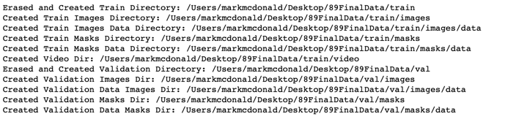

**The Data Directory Structure After Step 3**

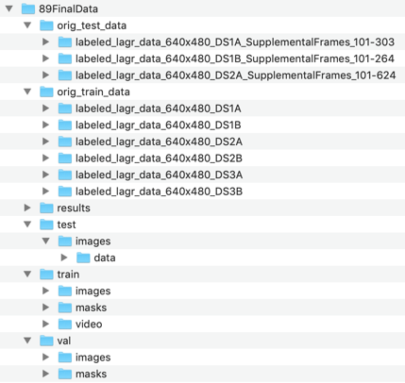

Figure : Data Directory Structure

### STEP 4 - Extract Data From Downloaded Files

Now that directories are setup for our training, we will extract images and masks from the downloaded *.mat files. We run an extraction method on the training set and the test set.

# Here we extract the image and mask data from our original data stored in MAT files

pf_preprocess.create_img_and_mask_data(original_train_dir, train_dir)

# For the test directories, masks won't be created

pf_preprocess.create_img_and_mask_data(original_test_dir, test_dir)

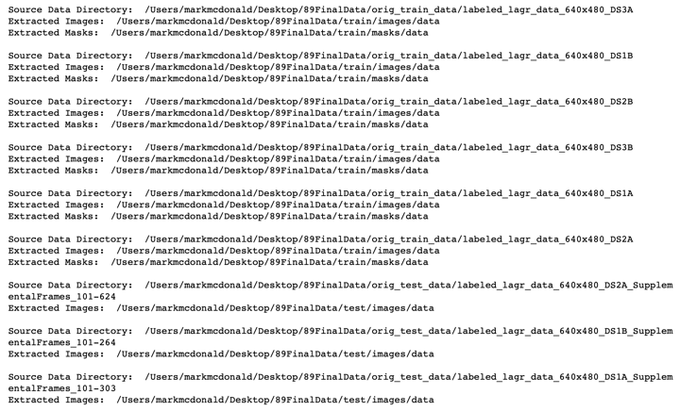

This process extracted an image and a mask from each of the files from the original data set. Each image and mask pair is saved into a respective directory where it will be accessed for training and validation. Additionally, the test video sequence images are extracted and saved.

Now, we can move some of the extracted images into a validation set of directories:

# Validation images and masks are pulled out of the training set and put into validation directories

pf_preprocess.create_val_set(train_dir, val_dir, val_split)



### SIDEBAR: Understanding the data set

Let’s take a moment to understand the data that we are working with.

#### MAT File Structure

The downloaded data is a series of MAT files. These are simple data files with a dictionary of data elements. We can view the dictionary keys:

# Review the original data

import scipy.io

mat_file_path = os.path.join(original_train_dir, 'labeled_lagr_data_640x480_DS1A/frame001.mat')

mat_file = scipy.io.loadmat(mat_file_path)

# Dictionary entries in the MAT file

for k in mat_file.keys():

print(k)

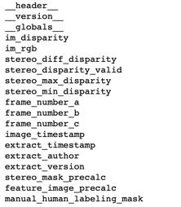

We observe several pieces of data, but for our project, we will only need the ‘im_rgb’ and ‘manual_human_labeling_mask’ items. The ‘im_rbg’ item is an array that represents the base image and the ‘manual_human_labeling_mask’ is the respective mask.

We have one MAT file for every frame of video:

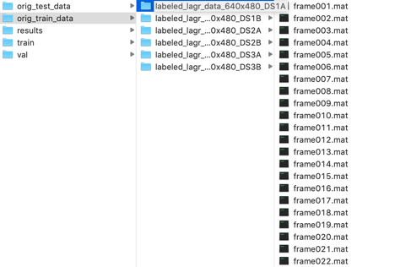

The frames are separated into directories where each directory is a different scene. We observe 6 scenes in our training set. The 6 scenes are in 3 settings with 2 different lighting conditions for each.

After running the data extraction script, we have images and masks in supporting directories from each of the frames:

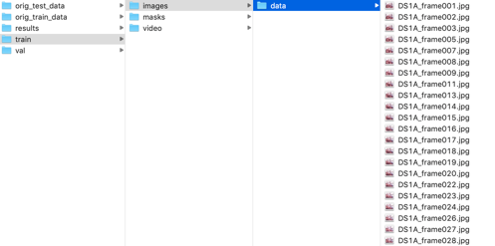

The ‘data’ directory is necessary for the data generators that we will use to generate batches during training.

Each jpg file is prepended with the scene name.

Each jpg has a corresponding mask file with the same name:

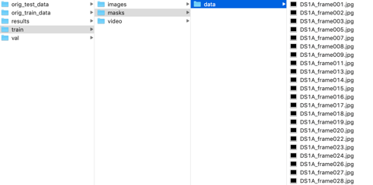

The masks don’t preview because they only have 1-channel.

We can observe the data stored im the ‘im_rgb’ dictionary element:

# Original images are 640 x 480 (note that this is a vertical format)

orig_image = mat_file['im_rgb']

print("Image Shape: ", orig_image.shape)



As well as the mask:

# Masks are the same size as the images but only one channel.

orig_mask = mat_file['manual_human_labeling_mask']

print("Mask Shape: ",orig_mask.shape)



The original data is 640 x 480. We will make this smaller to train. Note that these are in vertical format. We will rotate them when they are extracted.

The mask data ranges from 0 to 2.

# The values in the mask range from 0 to 2 as expected

import numpy as np

print(np.amin(orig_mask))

print(np.amax(orig_mask))

We change this to 0 and 1 for our training.

We also have a testing set; however, the test set does not have mask data:

# Test file does not have the same data elements

mat_test_file_path = os.path.join(original_test_dir, 'labeled_lagr_data_640x480_DS1A_SupplementalFrames_101-303/frame101.mat')

mat_test_file = scipy.io.loadmat(mat_test_file_path)

# Dictionary entries in the MAT file

for k in mat_test_file.keys():

print(k)

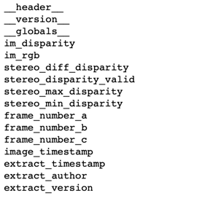

Note that the ‘manual_human_labeling_mask’ is missing. This is test data so there is no mask. We will get mask data from our model to create superimposed videos after training is complete.

### STEP 5 - Create a superimposed video file based on original data

In order to visualize the training and validation data, a video of superimposed masks is displayed.

Before making any changes to our data, we will create a video for each scene that superimposes the mask over the image. The superimposed data represents areas for safe navigation:

pf_video.create_superimposed_video_from_MATFiles(original_train_dir, train_video_dir)

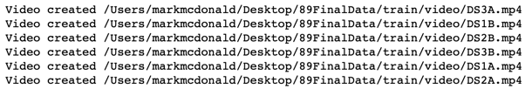

A screen shot of one of the videos is displayed below:

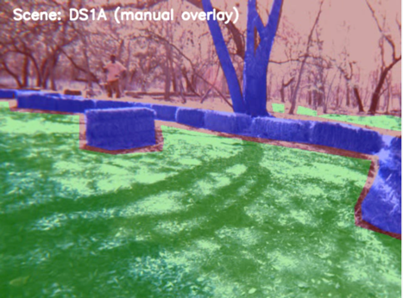

Figure : Frame from video of superimposed mask from training set

This is a perfect mask created by a person. Our model will attempt to recreate the green area of the mask.

### STEP 6 - Change the mask data to Binary Values

The initial masks from the data set contain more data than is needed. To simplify training, we will create masks with only 0’s and 1’s.

We make these changes in-place, so our original mask data is destroyed. After creating the superimposed videos, we no longer need this data. We use a support script to do this for us. The new masks have a 1 place for every navigable place in the image. The rest is filled with zero’s.

# In-place conversion of original masks to binary masks for training purposes

# This will destory the original masks and repalce them with binary masks

pf_preprocess.convert_jpg_mask_to_binary_mask(os.path.join(train_dir, 'masks'))

pf_preprocess.convert_jpg_mask_to_binary_mask(os.path.join(val_dir, 'masks'))

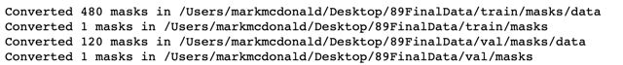

We can create a superimposed single image to see that our conversion works properly. Since we will do this again later, we will create a support function to help:

# Displays and image with a mask overlay

from keras.preprocessing import image as kimage

def display_overlay(image, mask, ispath=True):

if ispath:

image = kimage.load_img(image)

mask = kimage.load_img(mask)

image = np.uint8(image)

mask = np.asarray(mask)

noneType = type(None)

if type(mask) != noneType:

# make red layer for mask

mask = np.moveaxis(mask, 2, 0)

new_mask = np.zeros((3, mask.shape[1], mask.shape[2]))

new_mask[0] = np.array(mask[0]==0)*180

new_mask[1] = np.array(mask[0]==1)*180

new_mask = np.moveaxis(new_mask, 0, 2)

image = np.uint8(new_mask*.3 + image*.7)

if image.shape[2] != 3:

image = np.uint8((np.zeros(shape=(360,480,3))) + image)

plt.imshow(np.uint8(image))

Let’s pull an image and a mask and display them:

imagefiles = sorted(os.listdir(os.path.join(train_dir, 'images', 'data')))

maskfiles = sorted(os.listdir(os.path.join(train_dir, 'masks', 'data')))

test_image = os.path.join(train_dir, 'images', 'data', imagefiles[0])

test_mask = os.path.join(train_dir, 'masks', 'data', maskfiles[0])

display_overlay(test_image, test_mask, ispath=True)

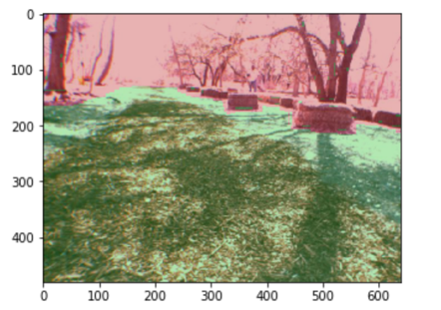

Figure : Example of masked image after making masks binary

Our result is reasonable.

Now, our data is ready to be trained.

### STEP 7 – Model Training

Training will rely on data generators for both the training and validation images. We will using augmentation because of our small data set. This poses a challenge because augmented images will also require augmented masks to go with them. Out support script called models.py includes data generators for both the training images and the validation images.

#### Train Steps in Script

We are first going to test our generators so that we can see what they are doing. Since training data includes an augmented image, we need to make sure that masks are augmented exactly the same way.

We start by getting a model from our models.py support script:

from keras import models

from keras import layers

# get a model tuple to test the generators with

model_tuples = []

model_tuples.append(pf_model.get_autoenc_model(epochs=40,

rot=45,

zoom=[.6,1.1],

hflip=True,

vflip=False,

notes="test model"))

The call to get_autoenc_model() can optionally include a setting for any of the items in the dictionary. The get_autoenc_model() function is designed to return a model as well as a description dictionary that includes the settings the model should be trained with. The dictionary settings are set with the arguments sent to the get_autoenc_model() function. Here, we can see the structure of our tuple.

The value of using the get_autoenc_model() process with a ‘description’ dictionary is so that we can be sure that a generator is created which matches the parameters of the model. Later, we create a generator using the description dictionary. An additionally benefit for the dictionary is that we can use this dictionary to create a video with the correct parameters as well as meaningful overlay and filename.

model_tuples[0]

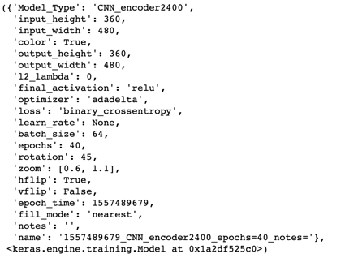

This was useful during development allowing several model variations to be trained unattended simultaneously.

Let’s retrieve a train generator using the ‘description’ dictionary. Elements of the dictionary are used to setup the generator so that it matches our model.

description = model_tuples[0][0]

color = description['color']

rot = description['rotation']

zoom = description['zoom']

hflip = description['hflip']

vflip = description['vflip']

train_generator = pf_model.get_img_mask_generator(os.path.join(train_dir, 'images'),

os.path.join(train_dir, 'masks'),

description)

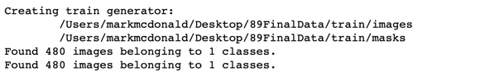

We can test our generator by getting a batch of images and masks and displaying a superimposed impage of the two:

import cv2

image, mask = next(train_generator)

image1 = np.uint8(np.asarray(image[0]*255)) # genereated image is scaled to 1/255

mask1 = np.uint8(mask[0]) # mask wasn't rescaled because values are 0 or 1

display_overlay(image1,mask1, ispath=False)

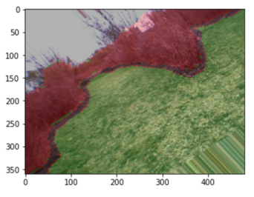

The example shows an image that is rotated to the left. The mask is correspondingly rotated.

We can do the same test on our validation generator. Note that we add a False value to the optional ‘augment’, argument. The get_img_mask_generator() function will augment images by default. To avoid augmentation, we must set this argument to False.

val_generator = pf_model.get_img_mask_generator(os.path.join(val_dir, 'images'),

os.path.join(val_dir, 'masks'),

description,

augment=False)

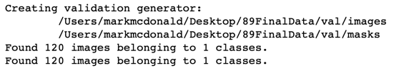

import cv2

image, mask = next(val_generator)

image = np.uint8(np.asarray(image[0]*255)) # genereated image is scaled to 1/255

mask = np.uint8(mask[0]) # mask wasn't rescaled because values are 0 or 1

display_overlay(image,None, ispath=False)

Here we show the image without a mask:

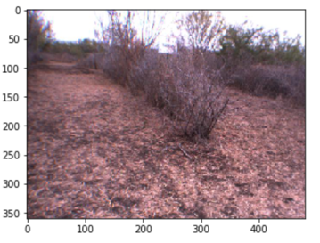

And now, we show the image with the mask:

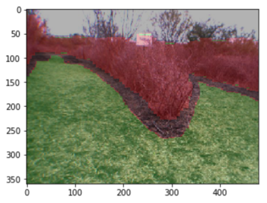

For validation, we don’t want any augmentation and we don’t see any.

We will also use a generator to generate images from our test directory. These images will be used to create masks from our model later. This generator is created as a simplified way to generate test images in the same way that our model was trained with:

test_generator = pf_video.get_test_img_generator(os.path.join(test_dir, 'images'), description)

import cv2

image = next(test_generator)

display_overlay(image[0], None, ispath=False)

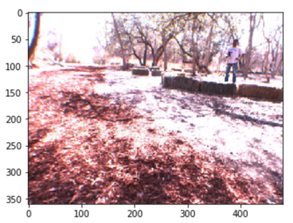

After we are done training, we will save the description object and the trained model weights in a pickle file:

# After training, we will save the description and the trained model weights in a pickle variable

import pickle

# Use pickle to save history for later use

def pickle_save(variable, save_path):

save_file = save_path + '/data.pickle'

if os.path.isdir(save_path) == 0:

os.mkdir(save_path)

with open(save_file, 'wb') as f:

pickle.dump(variable, f)

# Loading a prevously saved pickle file

def pickle_load(pickel_filepath):

with open(pickel_filepath, 'rb') as f:

data = pickle.load(f)

return data

Now, we can get the model that we will train using our function that provides both a description object and a model.

# Get models for training

model_tuples = []

# The following model parameters were determined to provide the best overal results

model_tuples.append(pf_model.get_autoenc_model(epochs=40,

rot=30,

zoom=[.6,1.0],

hflip=True,

vflip=True,

dropout=.4,

notes="rot30-.6-1.0zoom_dropout=.4BEST"))

Next, we start the training process. Several things are happening here. First, we train in a loop so that if we have multiple models in our model_tuples object, they can train unattended.

We compile the model using the optimizer and loss functions stored in our description dictionary.

We setup a Tensorboard directory for this model so that it can be viewed separately from other trained models.

We retrieve generators for training and validation making sure that our validation generator does not use augmentation.

We use the Keras fit_generator() method to train taking advantage of our generators.

We extend our dictionary to include the training results and history.

We create a text that will be overlaid on our video.

We create a directory for this training and save the description and model objects in a single pickle file in that directory.

Finally, we generate an overlaid video using the trained model and store the video in the model’s directory.

from tensorflow.keras.callbacks import TensorBoard

import math

import shutil

num_models = len(model_tuples)

# a model_tupled object can contain multiple models

# us pf_model.get_autoencoder_model() method to create tuples

for i, model_tuple in enumerate(model_tuples):

description = model_tuple[0]

model = model_tuple[1]

# Compile model

optimizer = description['optimizer']

loss = description['loss']

model.compile(optimizer=optimizer, loss=loss)

# Add Tensorboard capability

name = description["name"]

tensorboard = TensorBoard(log_dir="logs/{}".format(name))

# remove the logging directory for the model if it exists

if ( os.path.isdir("logs/{}".format(name)) ):

shutil.rmtree("logs/{}".format(name))

# get number of images to train and validate

num_timages = len(os.listdir(os.path.join(train_dir, 'images', 'data')))

num_vimages = len(os.listdir(os.path.join(val_dir, 'images', 'data')))

# create generators based on the model description variables

train_gen = pf_model.get_img_mask_generator(os.path.join(train_dir, 'images'),

os.path.join(train_dir, 'masks'),

description,

augment=True)

val_gen = pf_model.get_img_mask_generator(os.path.join(val_dir, 'images'),

os.path.join(val_dir, 'masks'),

description,

augment=False)

epochs = description["epochs"]

batch_size = description["batch_size"]

print(model.summary())

# step_per_epcoch and val_steps is numbner of images / batchsize

history = model.fit_generator(train_gen,

steps_per_epoch=math.ceil(num_timages/batch_size),

epochs=epochs, verbose=1,

callbacks=[tensorboard],

validation_data=val_gen,

validation_steps=math.ceil(num_vimages/batch_size),

use_multiprocessing=True,

shuffle=True)

results = model.evaluate_generator(val_gen, steps=math.ceil(num_vimages/batch_size))

description.update({"history": history})

description.update({"results": results})

acc = str(np.round(results, decimals=4))

print("Final Accuracy: ", acc)

# Create overlay text and prepare a directory to save video and pickle file

overlay_text = name + "_loss=" + acc

source_dir = test_dir

target_dir = os.path.join(results_dir, overlay_text)

os.mkdir(target_dir)

# Save description and model in a pickle file

pickle_save((description, model), target_dir)

print(description)

# Create video with mask overlay generated from model

pf_video.create_video_with_test_data(source_dir, model, description, target_dir)

After training of each model is complete, a summary statement will show where the video was saved.

#### View Training Data Charts in Tensorboard

We can review the training progress in Tensorboard. Here, only the epoch_val_loss is shown as it is most indicative of the training progress:

* + From terminal:

cd <directory to project>/code

tensorboard --logdir=‘./logs’

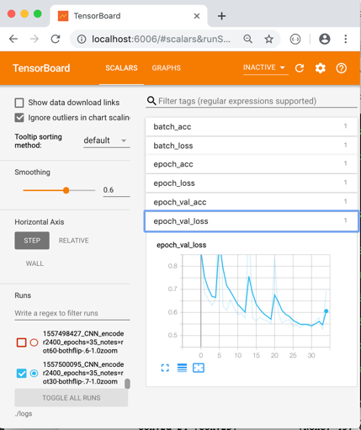

#### View Video

We can navigate on our local computer to the results directory that was created in our data directory. In that directory, we find a sub-directory for each model that was trained. In that directory, we find 2 files; 1) data.pickle and 2) an mp4 video file.

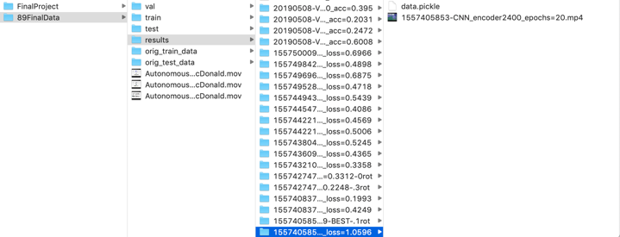

The pickle file includes a tuple of the description and trained model weights. The mp4 video file is a video of all test data sequences with an overlay generated by our model. Below is a screen shot of a sample video:

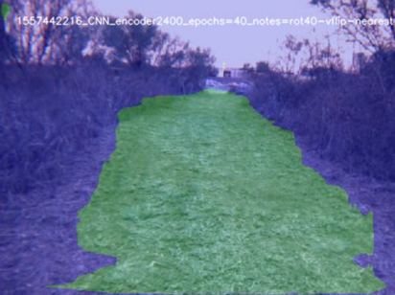

### Independent Test of External Video

The superimposed video output is based on test data from the original dataset. I wanted to see how this would work on a video that was not part of the dataset. The script ‘create_superimposed_video_from_MP4.ipynb’ will take any MP4 video and extract the frames into image files that can be used with the model. The output was impressive, below is a screenshot:

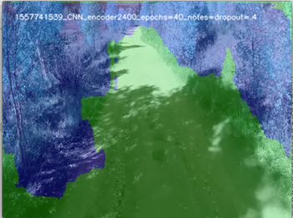

# Summary/Next Steps

The initial model that was used was based on the Reuters multi-class classification example. The idea was that the mask represents a series of 0’s and 1’s where each classification represents a mask pixel. I tried this using a small 30x40 mask, but had limited success. It worked, but was not acceptable.

I moved to an autoencoder model with the idea to encode an image and decode it as a mask. Using CNN layers in the encoder, I attempted to capture features of the image that could be encoded and then when decoding, certain features would turn on mask pixels or not. This proved more effective.

The final model still has limitations. I suspect that by adding layers to the model, I could see better results. Since the chosen model design worked, I chose to focus on changing the parameters to make the model work better. I made several observations that brought me to the final combination of parameters:

* Color was better than black and white
  + I suspect that the color of objects helped to identify obstacles
* Final activation of ‘relu’ was much better than ‘sigmoid’
  + The complexity of the landscape makes some areas more likely to be paths or obstacles. Using ‘relu’ takes this probability into account.
* More epochs were not better
  + I continually tried to extend training by hundreds of epochs running overnight. This never created a better model. I found the optimal number of training epochs to be around 30-40.
* Skewed and shifted augmentations did not work well
  + When skewing images, some areas are filled in. Although the masks match this skewing, the filled in areas never looked like paths not obstacles and only limited the mask space that was displayed. Instead, zoom, rotation, and flipping were used.
* Regularization did not work
  + No matter how small or large the l2 lambda value used, results became speckled.
* A single Dropout layer proved best
  + Adding multiple dropout layers was not helpful. A single layer at the top of the model was the best option.

The next steps to improve this are to experiment with different model designs. This could include additional layers as well as changing the type of model. For the scope of this effort, additional model designs were not explored.

Another area to explore would be to specifically identify hazards like trees, rocks, lakes, cliffs and kittens so that the model could explicitly make those areas of the image non-navigable.

# YouTube Video Links

**2-Minute Video Link**: <https://www.youtube.com/watch?v=YpPW69S8C2M>

**Detailed video link**: <https://www.youtube.com/watch?v=1XsFCXq8SQA>

# 

# References

Data set:

Michael J. Procopio, Hand-Labeled DARPA LAGR Datasets, <http://www.mikeprocopio.com/labeledlagrdata.html>, 2007

# Documentation

One-Page Summary:

**Filename**: AutonomousNavigation_OnePageSummary_MarkMcDonald

PowerPoint Presentation:

**Filename**: AutonomousNavigation_Slides_MarkMcDonald

Full Report (this file):

**Filename**: AutonomousNavigation_FullReport_MarkMcDonald

Code and Data:

**Filename**: AutonomousNavigation_MarkMcDonald_FinalCodeAndData.zip

(Should be under 10MB and should not exceed 20MB.)

# Appendix: Support Code

This appendix includes the code in the support files used by the master notbook.

## data_preprocess.py

# Pathfinder - Support Script - data_preprocesses.py  
# Author - Mark McDonald (2019)  
  
# This module contains various support methods to create  
# files and directories needed to execute the pathfinder  
# project.  
  
import os  
import scipy.io  
import imageio  
import numpy as np  
import random  
import shutil  
from keras.preprocessing import image as kimage  
import cv2  
  
  
# Sets a series of directories for training and validation data  
# Arguments:  
# base_directory: directory under which supporting directories are created  
# remove_existing_structure_bool: If True, removes previously created  
# project directories. (except 'results' directory)  
# Return Value: train_data_dir, train_data_video_dir, val_data_dir, test_data_dir, results_dir  
# Summary:  
# Project requires specific directories for train, validation, results and test data.  
# These will be created with this method.  
# Note that image and mask directories have 'data' subdirectory which is  
# necessary for data generators.  
# Requires a full path to the base directory under which  
# supporting directories will be created.  
def set_directories(base_directory, remove_existing_structure_bool):  
  
 if not os.path.isdir(base_directory):  
 print("ERROR: You must first create a base directory.")  
 print("ERROR: Create directory and try again: ", base_directory)  
 print("No directories were removed or created.")  
 exit(0)  
  
 # Define directory paths  
 train_data_dir = os.path.join(base_directory, 'train')  
 train_data_images_dir = os.path.join(train_data_dir, 'images')  
 train_data_labels_dir = os.path.join(train_data_dir, 'masks')  
 train_data_video_dir = os.path.join(train_data_dir, 'video')  
  
 val_data_dir = os.path.join(base_directory, 'val')  
 val_data_images_dir = os.path.join(val_data_dir, 'images')  
 val_data_labels_dir = os.path.join(val_data_dir, 'masks')  
  
 test_data_dir = os.path.join(base_directory, 'test')  
 test_data_images_dir = os.path.join(test_data_dir, 'images')  
  
 results_dir = os.path.join(base_directory, 'results')  
  
 # Create Train Directories  
 # Note: data directory is needed for use of data generators  
 try:  
 os.mkdir(train_data_dir)  
 print("Created Train Directory: {}".format(train_data_dir))  
 except:  
 if remove_existing_structure_bool:  
 shutil.rmtree(train_data_dir)  
 os.mkdir(train_data_dir)  
 print("Erased and Created Train Directory: {}".format(train_data_dir))  
 else:  
 print("Train Directory already existed and was retained: {}".format(train_data_dir))  
  
 try:  
 os.mkdir(train_data_images_dir)  
 print("Created Train Images Directory: {}".format(train_data_images_dir))  
 except:  
 print("Train Images directory already exists: {}".format(train_data_images_dir))  
  
 try:  
 os.mkdir(os.path.join(train_data_images_dir, 'data'))  
 print("Created Train Images Data Directory: {}".format(os.path.join(train_data_images_dir, 'data')))  
 except:  
 print("Train Images data directory already exists: {}".format(os.path.join(train_data_images_dir, 'data')))  
  
 try:  
 os.mkdir(train_data_labels_dir)  
 print("Created Train Masks Directory: {}".format(train_data_labels_dir))  
 except:  
 print("Train Masks directory already exists: {}".format(train_data_labels_dir))  
  
 try:  
 os.mkdir(os.path.join(train_data_labels_dir, 'data'))  
 print("Created Train Masks Data Directory: {}".format(os.path.join(train_data_labels_dir, 'data')))  
 except:  
 print("Train Masks data directory already exists: {}".format(os.path.join(train_data_labels_dir, 'data')))  
  
 try:  
 os.mkdir(train_data_video_dir)  
 print("Created Video Dir: {}".format(train_data_video_dir))  
 except:  
 print("Video Dir already exists: {}".format(train_data_video_dir))  
  
 # Create Validation Directories  
 try:  
 os.mkdir(val_data_dir)  
 print("Created Validation Directory: {}".format(val_data_dir))  
 except:  
 if remove_existing_structure_bool:  
 shutil.rmtree(val_data_dir)  
 os.mkdir(val_data_dir)  
 print("Erased and Created Validation Directory: {}".format(val_data_dir))  
 else:  
 print("Validation Directory already existed and was retained: {}".format(val_data_dir))  
  
 try:  
 os.mkdir(val_data_images_dir)  
 print("Created Validation Images Dir: {}".format(val_data_images_dir))  
 except:  
 print("Validation Images Dir already exists: {}".format(val_data_images_dir))  
  
 try:  
 os.mkdir(os.path.join(val_data_images_dir, 'data'))  
 print("Created Validation Data Images Dir: {}".format(os.path.join(val_data_images_dir, 'data')))  
 except:  
 print("Validation Data Images Dir already exists: {}".format(os.path.join(val_data_images_dir, 'data')))  
  
 try:  
 os.mkdir(val_data_labels_dir)  
 print("Created Validation Masks Dir: {}".format(val_data_labels_dir))  
 except:  
 print("Validation Masks Dir already exists: {}".format(val_data_labels_dir))  
  
 try:  
 os.mkdir(os.path.join(val_data_labels_dir, 'data'))  
 print("Created Validation Data Masks Dir: {}".format(os.path.join(val_data_labels_dir, 'data')))  
 except:  
 print("Validation Data Masks Dir already exists: {}".format(os.path.join(val_data_labels_dir, 'data')))  
  
 # Create Test Directories  
 try:  
 os.mkdir(test_data_dir)  
 print("Created Test Directory: {}".format(test_data_dir))  
 except:  
 if remove_existing_structure_bool:  
 shutil.rmtree(test_data_dir)  
 os.mkdir(test_data_dir)  
 print("Erased and Created Validation Directory: {}".format(test_data_dir))  
 else:  
 print("Validation Directory already existed and was retained: {}".format(test_data_dir))  
  
 try:  
 os.mkdir(test_data_images_dir)  
 print("Created Test Images Dir: {}".format(test_data_images_dir))  
 except:  
 print("Test Images Dir already exists: {}".format(test_data_images_dir))  
  
 try:  
 os.mkdir(os.path.join(test_data_images_dir, 'data'))  
 print("Created Test Data Images Dir: {}".format(os.path.join(test_data_images_dir, 'data')))  
 except:  
 print("Test Data Images Dir already exists: {}".format(os.path.join(test_data_images_dir, 'data')))  
  
 # Create Results Directory  
 # If exists, 'results' directory is not recreated  
 try:  
 os.mkdir(val_data_dir)  
 print("Created Results Directory: {}".format(results_dir))  
 except:  
 print("Results Directory already existed and was retained: {}".format(results_dir))  
  
 return train_data_dir, train_data_video_dir, val_data_dir, test_data_dir, results_dir  
  
  
# will extract data from a single mat file and save the image and mask data  
# if a mask does not exist, no mask actions will be taken  
# Arguments:  
# mat_file_path: full path the the mat file  
# img_dir: full path to the directory where the image should be saved  
# mask_dir: full path to the directory where the mask will be saved  
# save_to_name: a name that will be used for both the image and mask file  
def extract_matfile_data(mat_file_path, img_dir, mask_dir, save_to_name):  
 # get the mat file data  
 try:  
 mat_file = scipy.io.loadmat(mat_file_path)  
 except:  
 print("Can't load mat file: ", mat_file_path)  
  
 # retrieve the frame's array data  
 try:  
 frame = mat_file['im_rgb']  
 img_exists = True  
 except:  
 img_exists = False  
  
 # retrieve the labeled mask array data  
 try:  
 mask = mat_file['manual_human_labeling_mask']  
 mask_exists = True  
 except:  
 mask_exists = False  
  
 # rotate images so they are horizontal  
 frame = np.moveaxis(frame, 0, 1)  
  
 if mask_exists:  
 mask = np.moveaxis(mask, 0, 1)  
  
 # need to add this dimension to mask so when using data generator, it sees it as gray scale  
 mask = np.expand_dims(mask, axis=2)  
  
 # convert mask to JPEG image and save to disk  
 imageio.imwrite(os.path.join(mask_dir, str(save_to_name) + ".jpg"), mask, format='JPEG-PIL')  
  
 # convert image to JPEG image and save to disk  
 imageio.imwrite(os.path.join(img_dir, str(save_to_name) + ".jpg"), frame, format='JPEG-PIL')  
  
 return img_exists, mask_exists  
  
  
# After supporting directories are created, this method will extract  
# image and mask data from mat files and place them in respective  
# project directories.  
# Arguments:  
# orig_data_path: a path that includes subdirectories that contain  
# *.mat files. The subdirectories under orig_data_path  
# should represent a scene and the mat files under each scene  
# directory represent the frames in the video sequence.  
# target_dir: An existing directory where 'images/data' and 'masks/data'  
# subdirectories already exist. Extracted image and mask data will be saved  
# in these subdirectories. The frames from all scenes will be extracted  
# to the same directory.  
# Return Value: train_data_dir, train_data_video_dir, val_data_dir, test_data_dir, results_dir  
# Note:  
# MAT files without a mask will ignore mask actions.  
def create_img_and_mask_data(orig_data_path, target_dir):  
 if not os.path.isdir(orig_data_path):  
 print("Provided path must be a directory.")  
 return  
  
 target_img_dir = os.path.join(target_dir, 'images', 'data')  
 target_mask_dir = os.path.join(target_dir, 'masks', 'data')  
  
 mask_exists = False  
 img_exists = False  
  
 # Get the scene name from the directory  
 # Scene names start with DS and are 4 characters long  
 path_split = orig_data_path.split('_')  
 for item in path_split:  
 if item[0:2] == "DS" and len(item)==4:  
 scene_name = item  
 break  
  
 # First get all MAT files and then extract data into training directories  
 for item in os.listdir(orig_data_path):  
 if item[0] == '.': continue  
 new_path = os.path.join(orig_data_path, item)  
  
 # if the item is a directory, recurse  
 if os.path.isdir(new_path):  
 create_img_and_mask_data(new_path, target_dir)  
 continue  
  
 # only process mat files  
 elif item[-4:] != ".mat":  
 continue  
  
 # if the item is a file extract_and_save_train_data  
 else:  
 filename = scene_name + '_' + item[0:len(item) - 4]  
 img_exists, mask_exists = extract_matfile_data(new_path, target_img_dir, target_mask_dir, str(filename))  
  
 if len(orig_data_path) > 0:  
 if img_exists or mask_exists:  
 print("\nSource Data Directory: ", orig_data_path)  
 if img_exists:  
 print("Extracted Images: ", target_img_dir)  
 if mask_exists:  
 print("Extracted Masks: ", target_mask_dir)  
  
  
# Move the validation set to validation directories from training set  
# After supporting directories are created, this method will extract  
# image and mask data from mat files and place them in respective  
# project directories.  
# Arguments:  
# source_dir: a path that includes image and mask subdirectories from  
# which, a portion of image files and respective mask files  
# will be moved to a validation directory.  
# target_dir: An existing directory where selected images and masks will  
# be moved to.  
# val_split: A percentage of items from teh source_dir that will be moved to the  
# target_dir.  
# Return Value: none  
def create_val_set(source_dir, target_dir, val_split):  
 source_img_dir = os.path.join(source_dir, 'images', 'data')  
 source_mask_dir = os.path.join(source_dir, 'masks', 'data')  
 target_img_dir = os.path.join(target_dir, 'images', 'data')  
 target_mask_dir = os.path.join(target_dir, 'masks', 'data')  
  
 # This will hold a random series of indicies that will be moved to the target  
 move_indices = []  
 files_list = [x for x in sorted(os.listdir(source_img_dir)) if not x.startswith(".")]  
 masks_list = [x for x in sorted(os.listdir(source_mask_dir)) if not x.startswith(".")]  
 all_indicies = list(range(0, len(files_list) - 1))  
 num_images_to_move = int(len(files_list) * val_split)  
  
 move_indices = random.sample(all_indicies, num_images_to_move)  
  
 # move the images and masks with indicies in the test_indicies list to the train directory  
 move_indices = sorted(move_indices, reverse=True)  
 for i in move_indices:  
 shutil.move(os.path.join(source_img_dir, files_list[i]), os.path.join(target_img_dir, files_list[i]))  
 shutil.move(os.path.join(source_mask_dir, masks_list[i]), os.path.join(target_mask_dir, masks_list[i]))  
  
 print("\nMoved {} validation images to {}".format(num_images_to_move, target_img_dir))  
 print("Moved {} validation images to {}".format(num_images_to_move, target_mask_dir))  
  
  
# Recursively iterates over subdirectories to find original masks and convert to  
# binary masks.  
# Arguments:  
# jpeg_mask_filepath: a directory or file that contains or is a mask  
# Return Value: 1 if file converted  
# Note:  
# Only masks that have a min value of 0 and max value of 2 will be converted.  
def convert_jpg_mask_to_binary_mask(jpeg_mask_filepath):  
 # If filepath is a directory iterate and process all files  
 converted = 0  
 if os.path.isdir(jpeg_mask_filepath):  
 for item in os.listdir(jpeg_mask_filepath):  
 if item[0] == '.': continue  
 item = os.path.join(jpeg_mask_filepath, item)  
 converted += convert_jpg_mask_to_binary_mask(item) # recurse  
  
 # if the filepath is a file, do the conversion  
 else:  
 # load current mask  
 try:  
 mask = kimage.load_img(jpeg_mask_filepath)  
 except:  
 print("Could not load filepath: " + jpeg_mask_filepath)  
 return  
  
 # Test that we are converting an original mask  
 # Check that elements of mask are between 0 and 2  
 if np.amin(mask) == 0 and np.amax(mask) == 2:  
 print("Not an original mask. Didn't convert: {}".format(jpeg_mask_filepath))  
 return  
  
 # convert image to an array  
 mask = np.array(mask)  
  
 # move the channels to the first dimension  
 mask = np.moveaxis(mask, 2, 0)  
  
 # change the 0's to 1's and everything else 0  
 binary_mask = np.array(mask[0] == 0)  
 binary_mask = np.array(binary_mask, dtype='uint8')  
  
 # Write over the original mask with the new binary mask  
 # imageio.imwrite(jpeg_mask_filepath, binary_mask, format='JPEG-PIL')  
 return cv2.imwrite(jpeg_mask_filepath, binary_mask)  
  
 print("Converted {} masks in {}".format(converted, jpeg_mask_filepath))  
 return 0

## models.py

# Pathfinder - Support Script - models.py  
# Author - Mark McDonald (2019)  
  
# This script contains the base project model and supporting  
# data generators.  
  
import os  
import random  
import time  
import numpy as np  
from keras import regularizers  
from keras.preprocessing import image  
from keras.preprocessing.image import ImageDataGenerator  
from keras.layers import Input, Conv2D, MaxPooling2D, UpSampling2D, Dropout  
from keras.models import Model  
  
# Returns a tuple that includes a model description dictionary  
# and a Keras untrained model.  
# Arguments:  
# input_height: the model's input height  
# input_width: the model's input width  
# op_height: the model's output height  
# op_width: the model output width  
# l2_lambda: if a value exists, regularization will be used with this value  
# epochs: The number of epochs the model is trained with  
# final_activation: the final activation function  
# color: Boolean value that indicates if model trains color or b&w  
# rot: The augmentation rotation value  
# zoom: The augmentation zoom value  
# hflip: The augmentation horizontal flip value (T/F)  
# vflip: The augmentation vertical flip value (T/F)  
# fill_mode: fill mode used for augmentation (nearest or reflect are most reasonable)  
# dropout: If 0, no dropout layers will be used.  
# Else, a dropout layer is added with the provided value.  
# notes: Notes that can be added to the description dictionary  
  
# Return Value: List of path for each video created.  
# Summary:  
# Image and mask data is extracted from each *.mat file.  
# Each mask is overlayed on its respective image.  
# Each overlayed image is added to a video sequence and saved  
def get_autoenc_model(input_height=360,  
 input_width=480,  
 op_height=360,  
 op_width=480,  
 l2_lambda=0,  
 epochs=20,  
 final_activation='relu',  
 color=True,  
 rot=0,  
 zoom=0,  
 hflip=True,  
 vflip=False,  
 fill_mode=None,  
 dropout=0,  
 notes="no notes"):  
  
 if fill_mode is None: fill_mode = 'nearest'  
  
 # use epoch time to label the results directory and file  
 epoch_time = int(time.time())  
  
 description = dict( Model_Type="CNN_encoder2400",  
 input_height=input_height,  
 input_width=input_width,  
 color=color,  
 output_height=op_height,  
 output_width=op_width,  
 l2_lambda=l2_lambda,  
 final_activation=final_activation,  
 optimizer='adadelta',  
 loss='binary_crossentropy',  
 learn_rate=None,  
 batch_size=64,  
 epochs=epochs,  
 rotation=rot,  
 zoom=zoom,  
 hflip=hflip,  
 vflip=vflip,  
 dropout=dropout,  
 epoch_time=epoch_time,  
 fill_mode=fill_mode)  
  
 description.update(notes=notes)  
  
 name = str(description["epoch_time"])  
 name = name + "_" + description["Model_Type"]  
 name = name + "_epochs=" + str(description["epochs"])  
 name = name + "_notes=" + description["notes"]  
 description.update(name=name)  
  
 # Support for black and white images  
 channels = 3  
 if not color:  
 channels = 1  
  
 # MODEL DESIGN  
 # Note that some layers are optionally added based on arguments provided  
 input_img = Input(shape=(input_height, input_width, channels))  
  
 # -- ENCODER --  
 if l2_lambda == 0:  
 x = Conv2D(16, (3, 3), activation='relu', padding='same')(input_img)  
 else:  
 x = Conv2D(16, (3, 3), activation='relu', padding='same',  
 activity_regularizer=regularizers.l2(l2_lambda))(input_img)  
 x = MaxPooling2D((2, 2), padding='same')(x)  
  
 if dropout != 0:  
 x = Dropout(dropout)(x) # a single dropout works well with no regularization  
  
 if l2_lambda == 0:  
 x = Conv2D(8, (3, 3), activation='relu', padding='same')(x)  
 else:  
 x = Conv2D(8, (3, 3), activation='relu', padding='same',  
 activity_regularizer=regularizers.l2(l2_lambda))(x)  
  
 x = MaxPooling2D((2, 2), padding='same')(x)  
  
 # if dropout != 0:  
 # x = Dropout(dropout)(x) # trying additional dropouts  
  
 if l2_lambda == 0:  
 x = Conv2D(8, (3, 3), activation='relu', padding='same')(x)  
 else:  
 x = Conv2D(8, (3, 3), activation='relu', padding='same',  
 activity_regularizer=regularizers.l2(l2_lambda))(x)  
  
 x = MaxPooling2D((2, 2), padding='same')(x)  
  
 # if dropout != 0:  
 # x = Dropout(dropout)(x) # trying additional dropouts  
  
 if l2_lambda == 0:  
 x = Conv2D(8, (3, 3), activation='relu', padding='same')(x)  
 else:  
 x = Conv2D(8, (3, 3), activation='relu', padding='same',  
 activity_regularizer=regularizers.l2(l2_lambda))(x)  
  
 encoded = MaxPooling2D((3, 3), padding='same')(x)  
 encoder = Model(input_img, encoded)  
  
 # at this point the representation is (15, 20, 8) i.e. 2400-dimensional  
  
 # -- DECODER --  
 x = Conv2D(8, (3, 3), activation='relu', padding='same')(encoded)  
 x = UpSampling2D((3, 3))(x)  
 x = Conv2D(8, (3, 3), activation='relu', padding='same')(x)  
 x = UpSampling2D((2, 2))(x)  
 x = Conv2D(8, (3, 3), activation='relu', padding='same')(x)  
 x = UpSampling2D((2, 2))(x)  
 x = Conv2D(16, (3, 3), activation='relu', padding='same')(x)  
 x = UpSampling2D((2, 2))(x)  
 decoded = Conv2D(1, (3, 3), activation=final_activation, padding='same')(x)  
  
 autoencoder = Model(input_img, decoded)  
  
 return description, autoencoder  
  
  
# Data Generators  
  
# Returns a generator used for training data.  
# This generator will augment images.  
# If arguments are not supplied, values from description dictionary are used.  
# Arguments:  
# train_img_dir: the model's input height  
# train_mask_dir: the model's input width  
# description: the model's output height  
# color: Boolean value that indicates if model trains color or b&w  
# rot: The augmentation rotation value  
# zoom: The augmentation zoom value  
# hflip: The augmentation horizontal flip value (T/F)  
# vflip: The augmentation vertical flip value (T/F)  
# fill_mode: Fill mode to be used for augmentation (nearest and reflect are most reasonable)  
# augment: Boolean that indicates if images are augmented or not  
# Validation generators should not be augmented  
# Return Value: Returns a generator that will provide an augmented image and  
# identically augmented mask.  
# Summary:  
# Masks and images are augmented with the same values by fitting a  
# test image and mask. Same 'seed' value must be used for both generators.  
def get_img_mask_generator(train_img_dir,  
 train_mask_dir,  
 description,  
 color=True,  
 rot=0,  
 wsr=0,  
 hsr=0,  
 zoom=0,  
 hflip=None,  
 vflip=None,  
 fill_mode=None,  
 augment=True):  
 print("Creating generator:")  
 print("\t"+train_img_dir)  
 print("\t"+train_mask_dir)  
 print("\tAugemntation: ", augment)  
 batch_size = description["batch_size"]  
 input_height = description["input_height"]  
 input_width = description["input_width"]  
 output_height = description["output_height"]  
 output_width = description["output_width"]  
  
 # Determine if argument values or description values are used  
 if rot == 0: rot = description["rotation"]  
 if zoom == 0: zoom = description["zoom"]  
 if fill_mode is None: fill_mode = description["fill_mode"]  
  
 color_mode = 'rgb'  
 if color is None:  
 color = description["color"]  
 if not color: color_mode = 'grayscale'  
  
 if hflip is None: hflip = description["hflip"]  
 else: hflip = True  
  
 if vflip is None: vflip = description["vflip"]  
 else: vflip = True  
  
 # Create ImageDataGenerator object with augmentation  
 if augment:  
 # Create dictionary for data generator arguments  
 data_gen_args = dict(rotation_range=rot,  
 width_shift_range=wsr,  
 zoom_range=zoom,  
 height_shift_range=hsr,  
 horizontal_flip=hflip,  
 vertical_flip=vflip,  
 fill_mode=fill_mode)  
  
 # the mask data is only 0's and 1's so does not need to be rescaled  
 # The other augmentations must be the same as the image datagenerator above  
 mask_datagen = ImageDataGenerator(**data_gen_args)  
  
 # Add rescaling factor to the image generator  
 data_gen_args.update(rescale=1. / 255)  
 image_datagen = ImageDataGenerator(**data_gen_args)  
  
 # Create ImageDataGenerator object without augmentation  
 else:  
 image_datagen = ImageDataGenerator(rescale=1. / 255)  
 mask_datagen = ImageDataGenerator()  
  
 # We are going to augment the image and mask in the same exact way.  
 # To do this, we will create two identical data generators.  
 # Since the augmentation is random, we need to make sure the random  
 # change is applied the same to both. We can do this be fitting the  
 # data generators with the same seed. The fit method only requires a  
 # single sample image and mask, but it requires a 4th dimension as the  
 # first element.  
  
 # Get samples  
 sample_img_path = os.path.join(train_img_dir, 'data')  
 sample_img_path = os.path.join(sample_img_path, os.listdir(sample_img_path)[0])  
 img = image.load_img(sample_img_path)  
 img_array = image.img_to_array(img)  
 img_array = np.expand_dims(img_array, axis=0)  
  
 sample_mask_path = os.path.join(train_mask_dir, 'data')  
 sample_mask_path = os.path.join(sample_mask_path, os.listdir(sample_mask_path)[0])  
 mask = image.load_img(sample_mask_path)  
 mask_array = image.img_to_array(mask)  
 mask_array = np.expand_dims(mask_array, axis=0)  
  
 # Provide the same seed and keyword arguments to the fit and flow methods  
 seed = random.randint(1, 100)  
 image_datagen.fit(img_array, augment=False, seed=seed)  
 mask_datagen.fit(mask_array, augment=False, seed=seed)  
  
 image_generator = image_datagen.flow_from_directory(  
 train_img_dir,  
 target_size=(input_height, input_width),  
 color_mode=color_mode,  
 class_mode=None,  
 batch_size=batch_size,  
 shuffle=True,  
 seed=seed)  
  
 mask_generator = mask_datagen.flow_from_directory(  
 train_mask_dir,  
 target_size=(output_height, output_width),  
 color_mode='grayscale',  
 class_mode=None,  
 batch_size=batch_size,  
 shuffle=True,  
 seed=seed)  
  
 # combine generators into one which yields image and masks  
 generator = zip(image_generator, mask_generator)  
  
 return generator

## video_support_processes.py

# Pathfinder - Support Script - video_support_processes.py  
# Author - Mark McDonald (2019)  
  
# This module contains various support methods to create  
# video files from frames.  
  
import os  
import scipy.io  
import numpy as np  
import cv2  
import math  
from keras.preprocessing.image import ImageDataGenerator  
  
  
# Creates an MP4 video file with mask overlay  
# Arguments:  
# source_dir: directory containing *.mat files  
# target_dir: directory where the video will be saved  
# Return Value: List of path for each video created.  
# Summary:  
# Image and mask data is extracted from each *.mat file.  
# Each mask is overlayed on its respective image.  
# Each overlayed image is added to a video sequence and saved  
def create_superimposed_video_from_MATFiles(source_dir, target_dir):  
  
 video_paths = []  
 for item in os.listdir(source_dir):  
 if item[0] == '.': continue  
 if os.path.isdir(os.path.join(source_dir, item)):  
 scene_name = item[-4:]  
 scene_dir = os.path.join(source_dir, item)  
  
 # Loop MAT files in supplied directory and extract images and masks  
 images = []  
 masks = []  
  
 image_paths = sorted(os.listdir(scene_dir))  
  
 for item in image_paths:  
  
 # skip hidden and non-mat files  
 if item[0] == '.' or item[-3:] != 'mat': continue  
  
 # get the mat file data  
 try:  
 mat_file = scipy.io.loadmat(os.path.join(scene_dir, item))  
 except:  
 print("Can't load mat file:", os.path.join(scene_dir, item))  
  
 try:  
 image = mat_file['im_rgb']  
 except:  
 print("Missing 'im_rbg' element: ", os.path.join(scene_dir, item))  
  
 try:  
 mask = mat_file['manual_human_labeling_mask']  
 except:  
 print("Missing 'manual_human_labeling_mask' element: ",  
 os.path.join(scene_dir, item))  
  
 # rotate images so they are horizontal  
 image = np.moveaxis(image, 0, 1)  
 mask = np.moveaxis(mask, 0, 1)  
  
 images.append(image)  
 masks.append(mask)  
  
 # iterate through all the images and create superimposed images with mask  
 superimposed_images = []  
 for i, image in enumerate(images):  
  
 # make a displayable mask  
 mask = np.zeros((3, 480, 640))  
 mask[0] = np.array(masks[i] == 1) * 255  
 mask[1] = np.array(masks[i] == 0) * 200  
 mask[2] = np.array(masks[i] == 2) * 127  
 mask = np.moveaxis(mask, 0, -1)  
  
 # superimpose mask on image  
 superimposed_image = np.uint8(image * .6 + mask * .4)  
  
 # Create text overlay for the frame  
 # 'putText' function requires item to be saved as file  
 overlay_text = "Scene: " + scene_name + " (manual overlay)"  
 # need to create jpg file first  
 cv2.imwrite("tempfile.jpg", superimposed_image)  
 tempfile = cv2.imread("tempfile.jpg") # read newly created file  
  
 # put overlay  
 cv2.putText(tempfile,  
 overlay_text,  
 (20, 30),  
 cv2.FONT_HERSHEY_SIMPLEX,  
 .75,  
 (255, 255, 255),  
 2,  
 lineType=cv2.LINE_AA)  
  
 superimposed_images.append(tempfile)  
  
 try:  
 os.remove("tempfile.jpg")  
 except:  
 print("Could not remove tempfile.jpg")  
  
 # Create video of superimposed images  
 video_paths.append(create_video_file(superimposed_images,  
 target_dir,  
 scene_name))  
  
 else:  
 print("Directory supplied is expected to contain subdirectories of scenes.")  
 print("Skipped: ".format(source_dir + "/" + item))  
  
 # Outermost for loop is complete. Return paths to videos created.  
 return video_paths  
  
# Creates an MP4 video file based on list of arrays  
# Arguments:  
# image_list: list of 3-channel np.array images that make up video  
# target_dir: directory where the video will be saved  
# file_name: name of video file to be saved  
# Return Value: Path to video created.  
# Summary:  
# Uses cv2 to stitch images together into video file  
def create_video_file(image_list, target_dir, file_name):  
  
 # Make sure file is appended with filetype  
 if file_name[-4:] != ".mp4": file_name = file_name + ".mp4"  
  
 video_path = os.path.join(target_dir, file_name)  
  
 # Determine the width and height from the first image  
 height, width, channels = image_list[0].shape  
  
 # Define the codec and create VideoWriter object  
 fourcc = cv2.VideoWriter_fourcc(*'mp4v')  
 out = cv2.VideoWriter(video_path, fourcc, 20.0, (width, height))  
  
 for image in image_list:  
 out.write(image) # Write out frame to video  
  
 # Release everything if job is finished  
 out.release()  
 cv2.destroyAllWindows()  
 video_path = os.path.join(target_dir, file_name)  
  
 print("Video created {}".format(video_path))  
  
 return video_path  
  
  
# Creates an MP4 overlay video file on mask created from model  
# Arguments:  
# source_dir: directory containing a 'data' directory that contains base images  
# model: Keras trained model that will generate mask based on images  
# description: dictionary containing entries describing model  
# target_dir: directory where video will be saved  
# batch_size: Number of images to convert at a time. If none, all files in dir will be converted at once  
# overlay_text: text that will be overlayed on video  
# color(boolean): whether or not the test data will be color  
# bias(float): value between -10 and +10. More(+) of less(-) aggressive with masked areas.  
# Return Value: Path to video created  
# The video will be saved with a name containing relevant model parameters.  
# Requires method which returns a configured generator for test images.  
# Summary:  
# Retrieves test images from generator.  
# Creates a mask for each image and creates overlay image  
# Calls function to create video based on list of np.array images.  
def create_video_with_test_data(source_dir,  
 model,  
 description,  
 target_dir,  
 filename=None,  
 batch_size=None,  
 overlay_text=None,  
 color=None,  
 bias=0,  
 fps=20.0,  
 invert=False):  
  
 output_height = description["output_height"]  
 output_width = description["output_width"]  
  
 if overlay_text is None:  
 overlay_text = description["name"]  
  
 if filename is None:  
 filename = overlay_text  
  
 # if color argument is not supplied, use color from description dictionary  
 # defaults to 'rgb', color=True  
 if color is None:  
 color = description["color"]  
  
 # count the number of valid images in source directory  
 num_images = 0  
 for img_file in os.listdir(os.path.join(source_dir, 'images', 'data')):  
 if img_file[0] != '.' and img_file[-3:] == "jpg":  
 num_images += 1  
 if num_images == 0:  
 print("No images to process in dir: ", source_dir)  
 return  
  
 if batch_size is None:  
 batch_size = num_images  
  
 # Retrieve generator for test images and get batch of all images  
 generator = get_test_img_generator(os.path.join(source_dir, 'images'),  
 description,  
 batch_size=batch_size,  
 color=color)  
  
 # steps is the number of times a batch needs to be called to get all images  
 steps = math.ceil(num_images/batch_size)  
  
 print("Processing {} images in {} batches.".format(num_images, steps))  
  
  
 # TEST - MAKING LOOP  
  
 # Make sure file is appended with filetype  
 if filename[-4:] != ".mp4": filename = filename + ".mp4"  
  
 video_path = os.path.join(target_dir, filename)  
 print("Creating video name: ", video_path)  
 print("FPS: ", fps)  
  
 # Define the codec and open VideoWriter stream  
 fourcc = cv2.VideoWriter_fourcc(*'mp4v')  
 out = cv2.VideoWriter(video_path, fourcc, fps, (output_width, output_height))  
  
 superimposed_images = []  
 zero_length = False  
 # for each batch, create superimposed images and write to video file  
 for step in range(steps):  
  
  
 images = next(generator)  
  
 # skip iteration if no images  
 # if you skipped a batch with no images already, break  
 if len(images) == 0:  
 if zero_length is True: break  
 zero_length = True  
 continue  
  
 # generate masks from images using model model  
 masks = model.predict(np.asarray(images))  
  
 avg = np.average(masks)  
 print("Processing batch: {}/{}".format(step + 1, steps), end=" | ")  
 print("Max/Min/Avg mask value: {}/{}/{}".format(np.round(np.amax(masks), decimals=2),  
 np.round(np.amin(masks), decimals=2),  
 np.round(avg, decimals=2)))  
  
 # A bias will move the average to show more or less highlighted areas  
 if bias < 0:  
 bias = (1 - avg) * (bias / 10)  
 avg += bias  
 if bias > 0:  
 bias = avg * (bias / 10)  
 avg -= bias  
  
 follow_layer = 1  
 avoid_layer = 0  
 if invert:  
 follow_layer = 0  
 avoid_layer = 1  
  
 # generate superimposed images  
 for i, mask in enumerate(masks):  
  
 # mask is created by highlighting pixels that exceed the average  
 mask = cv2.resize(mask, (output_width, output_height))  
 new_mask = np.zeros((3, mask.shape[0], mask.shape[1]))  
 new_mask[avoid_layer] = np.array(mask <= avg) * 200 # Red Layer  
 new_mask[follow_layer] = np.array(mask >= avg) * 200 # Green Layer  
 new_mask = np.moveaxis(new_mask, 0, 2)  
 new_mask = np.uint8(new_mask)  
  
 superimposed_image = np.uint8(images[i]*.7 + new_mask*.3)  
  
 # Create text overlay for the frame  
 # need to create jpg file first  
 cv2.imwrite("tempfile.jpg", superimposed_image)  
 tempfile = cv2.imread("tempfile.jpg") # read newly created file  
 cv2.putText(tempfile,  
 overlay_text,  
 (20, 30),  
 cv2.FONT_HERSHEY_SIMPLEX,  
 .40,  
 (255, 255, 255),  
 1,  
 lineType=cv2.LINE_AA)  
  
 superimposed_images.append(tempfile)  
  
 ### TEST MAKING PART OF A FILE AT A TIME  
 for image in superimposed_images:  
 out.write(image) # Write out frame to video  
  
 # Release everything if job is finished  
 out.release()  
 cv2.destroyAllWindows()  
  
  
 # print("Video created {}".format(video_path))  
  
 ### END TEST  
  
 try:  
 os.remove("tempfile.jpg")  
 except:  
 print("Could not remove tempfile.jpg")  
  
 print("Video created {}".format(video_path))  
 # return create_video_file(superimposed_images, target_dir, overlay_text)  
  
  
# Define a test image generator for all files in a directory as a single batch  
# Arguments:  
# source_dir: directory containing a 'data' directory that contains base images  
# description: dictionary containing entries describing model that will use generator  
# color(boolean): Whether or not yielded images are color or black and white.  
# None (missing color argument) will force use of color  
# variable from description dictionary.  
# Return Value: Configured ImageGenerator that can be called with next(<generator_name>)  
# The video will be saved with a name containing relevant model parameters.  
# Requires method which returns a configured generator for test images.  
# Summary:  
# Retrieves test images from generator.  
# Creates a mask for each image and creates overlay image  
# Calls function to create video based on list of np.array images.  
def get_test_img_generator(source_dir, description, batch_size=None, color=None):  
  
 print("Creating test image generator:")  
 print("\t"+source_dir)  
 input_height = description["input_height"]  
 input_width = description["input_width"]  
  
 # if color argument is not supplied, use color from description dictionary  
 # defaults to 'rgb', color=True  
 color_mode = 'rgb'  
 if color is None:  
 color = description["color"]  
 if not color:  
 color_mode = 'grayscale'  
  
 if batch_size is None:  
 batch_size = description["batch_size"]  
  
 # Configure image generator  
 image_datagen = ImageDataGenerator()  
 image_generator = image_datagen.flow_from_directory(  
 source_dir,  
 target_size=(input_height, input_width),  
 color_mode=color_mode,  
 batch_size=batch_size,  
 class_mode=None,  
 shuffle=False)  
  
 return image_generator