Notes

Layer elevations

* Raster DTM_smooth = Top L1
* Raster Bott_L1_fix = Bottom L1
* Raster Bott_L2_fix = Bottom L2
* Bottom L3 = Bottom L2 – 60 m (constant thickness)

BC

* GHB L1 North = from 103.5 to 104.2
* GHB L1 South = from 99.6 to 96.3
* 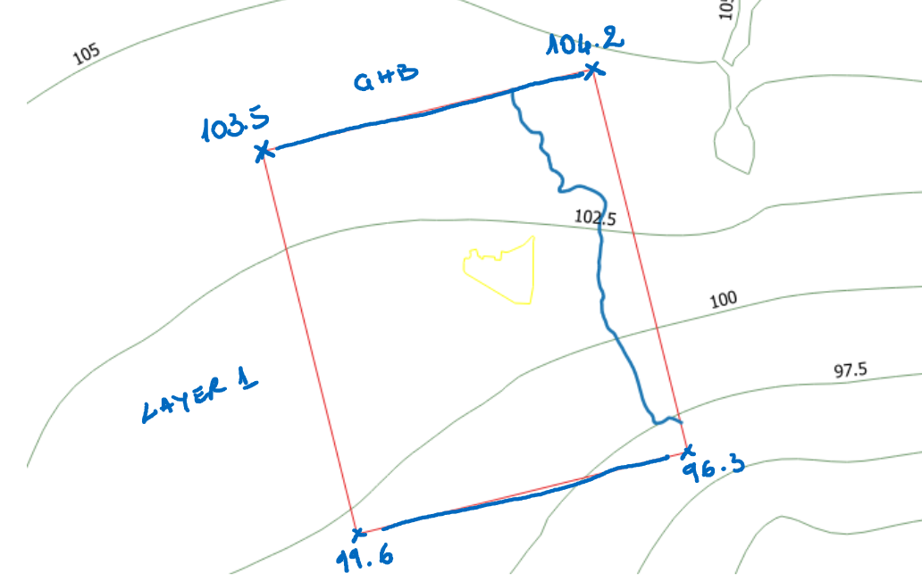
* GHB L3 North = 102.5 (constant along the row)
* GHB L3 South = 92.5 (constant along the row)
* RIVER = River_stages.shp – elevations taken from raster DTM_domain (this raster is not smoothed as the one used for the layer 1 top).
* WEL = wells.shp
* RECHARGE = recharge4.shp, reports values in mm/y