Statistical Inference - Course Project Part 1

Michael Celeste

Saturday, October 25, 2014

No more than 3 page report with 3 pages of supporting appendix material if needed (code, figures, etc)

1. Show the center of the distribution and compare it to the theoretical center (1/lambda)
2. Show variable it is and compare it to the theoretical variance of the distribution (1/lambda^2)
3. Show that the distribution is approximately normal

## Create exponential distribution of averages simulate - 1000  
edist <- replicate(1000, mean(rexp(40,0.2)))  
## Create a dataframe for ggplot use  
df <- data.frame(x=edist)  
## Calculate theoretical mean (1/lambda) where lambda = 0.2  
mu <- 1/0.2  
1/mu^2## ggplot creation

## [1] 0.04

##gp <- ggplot(df, aes(x=x))  
##gp <- gp + geom_histogram(binwidth=0.1, aes(y=..density..), fill="salmon", colour="black")+geom_density()  
##gp <- gp + geom_vline(xintercept = mu1, colour="red", size=1)  
##gp <- gp + geom_vline(xintercept = mu, colour="green", size=1)  
  
## Standard deviation  
sqrt((sum(edist^2) - mean(edist^2))/1000)

## [1] 5.082

Theoretical center of the exponential distribut is equal to 1/lambda which is equal to 5 where lambda is equal to 0.2.

The Theoretical variance is 1/lambda^2

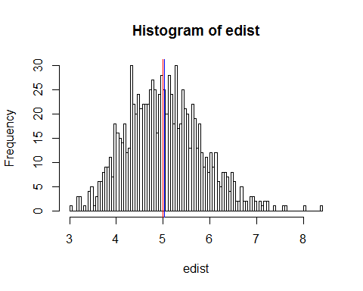

Note that the echo = FALSE parameter was added to the code chunk to prevent printing of the R code that generated the plot.

Use a line graph with colored areas to compare distributions

distribution of sample variances?