Organelle Model Notes
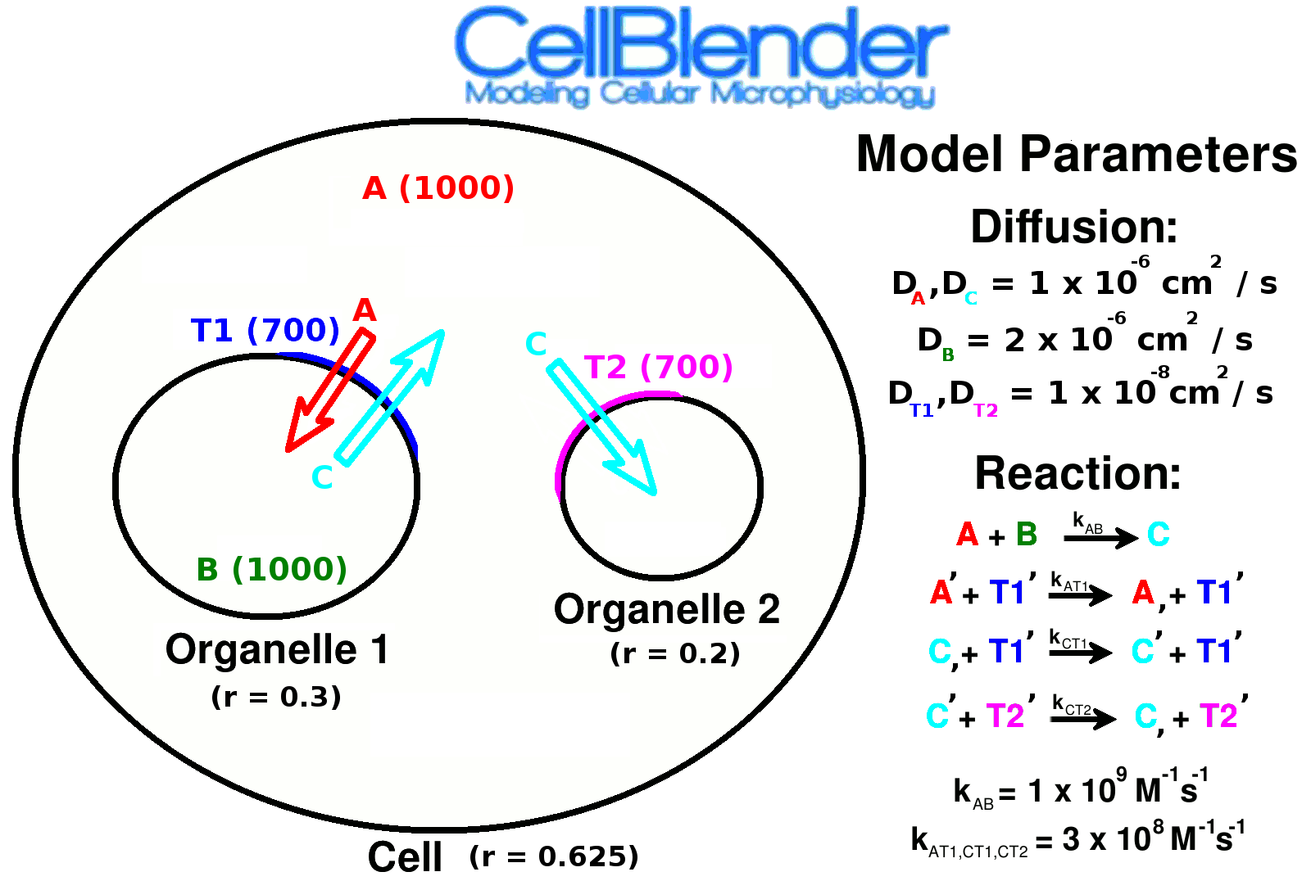

--- START ---

Molecules: +, A, 1e-6
Molecule Placement: +, A, 1000

--- CP1 ---

Run, Reload, Orthographic View, Zoom, Play Simulation, Drag in Timeline

Molecule: B 2e-6
Molecule Placement: B at x location = 0.2, 1000

--- CP1 ---

Run, Reload, Play Simulation

Molecule: C 1e-6
Reaction: A+B → C [1e9]

--- CP3 ---

Run, Reload, Play Simulation
Change Visualization Options: A → A, B → B, C → C, Change C color to Cyan

--- CP4 ---

Plotting setup: + A, + B, + C, One Page One Plot with Legend

--- CP5 ---

Model Objects: Add Icosphere, 3 subdivs, size=0.625, name=cell, + (to add to model)
Model Object / Display Options: Add Material, Transparent (object and material), alpha=0.2

--- CP6 ---

Run, Reload, Play Simulation, Plot Results

Molecule Placement: Release site 1, Change to Object/Region, cell
Molecule Placement: Release site 2, Change to Object/Region, cell

--- CP7 ---

Run, Reload, Play Simulation

Model Objects: Add Icosphere, 3 subdivs, radius 0.3, y=-0.25, name: organelle_1, + (to add to model)
Model Object / Display Options: Add Material, Transparent (object and material), alpha=0.2

Model Objects: Add Icosphere, 3 subdivs, radius 0.2, y=0.3, name: organelle_2, + (to add to model)
Model Object / Display Options: Add Material, Transparent (object and material), alpha=0.2

Molecule Placement: B in Object/Region organelle_1
Molecule Placement: A in cell[ALL] – organelle_1[ALL] – organelle_2[ALL]

--- CP8 ---

Molecules: +, name=t1, type=Surface, dc=1e-8, glyph=Receptor, color: dark blue
Reactions: +, A' + t1' → A, + t1' 3e8
Molecule Placement: t1, Object/Region, organelle_1, 700

--- CP9 ---

Reactions: C, + t1' → C' + t1', 3e8

--- CP10 ---

Run, Reload, Play Simulation

Plotting setup: + C in organelle_1

--- CP11 ---

Run Panel: Iterations=5000
Partitions: Auto Partitioning

--- CP12 ---

Molecules: +, name=t2, type=Surface, diffusion constant=1e-8
Reactions: C' + t2' → C, + t2', 3e8
Molecule Placement: t2, Object/Region, organelle_1, 700

Plotting Setup: Count C in organelle_2

Run: 10,000 interations (use show/hide text while running)

--- CP13 ---

Additional: Add patches to restrict initial release of t1 and t2

