Judo Saskatchewan OCTOBER 2015 Update

Judo Saskatchewan updates are here to keep you informed of upcoming and past events. They are here to help you to know what is going on in our sport. Please feel free to pass these updates on to anyone you feel can benefit from these updates.

For more information on Judo Saskatchewan and our programs please visit our website: www.judosask.ca

If you would like to unsubscribe yourself from the Judo Saskatchewan Update please email: judocotton@yahoo.ca

Judo Saskatchewan Facebook Page:
https://www.facebook.com/groups/158916920950217/
Judo Saskatchewan would like to have Judo Saskatchewan members post photos from their judo clubs, competition, training camps and events on the Judo Saskatchewan Facebook page. Find updates on Judo Saskatchewan on the Judo Saskatchewan Facebook page today!

UpComing Events
☑ U OF A COMPETITION OCT 17 2015
☑ KATA CLINIC SASKATOON OCT 24 201
☑ OMNIUM QUEBEC MONTREAL OCT. 31 NOV 1 2015

☐ CAMP MONTREAL NOV 2 TO 6 2015

☐ Ontario Open Nov 7/8 2015

Results
☐ WE HAD NO COMPETITIONS THIS MONTH WITH THE START OF THE NEW YEAR. BUT WE HAD OUR FIRST TRAINING CAMP IN MOOSE JAW ON SEPT 2526/27.
WAS GREAT SEEING SO MANY COME OUT AND PARTICIPATE!!
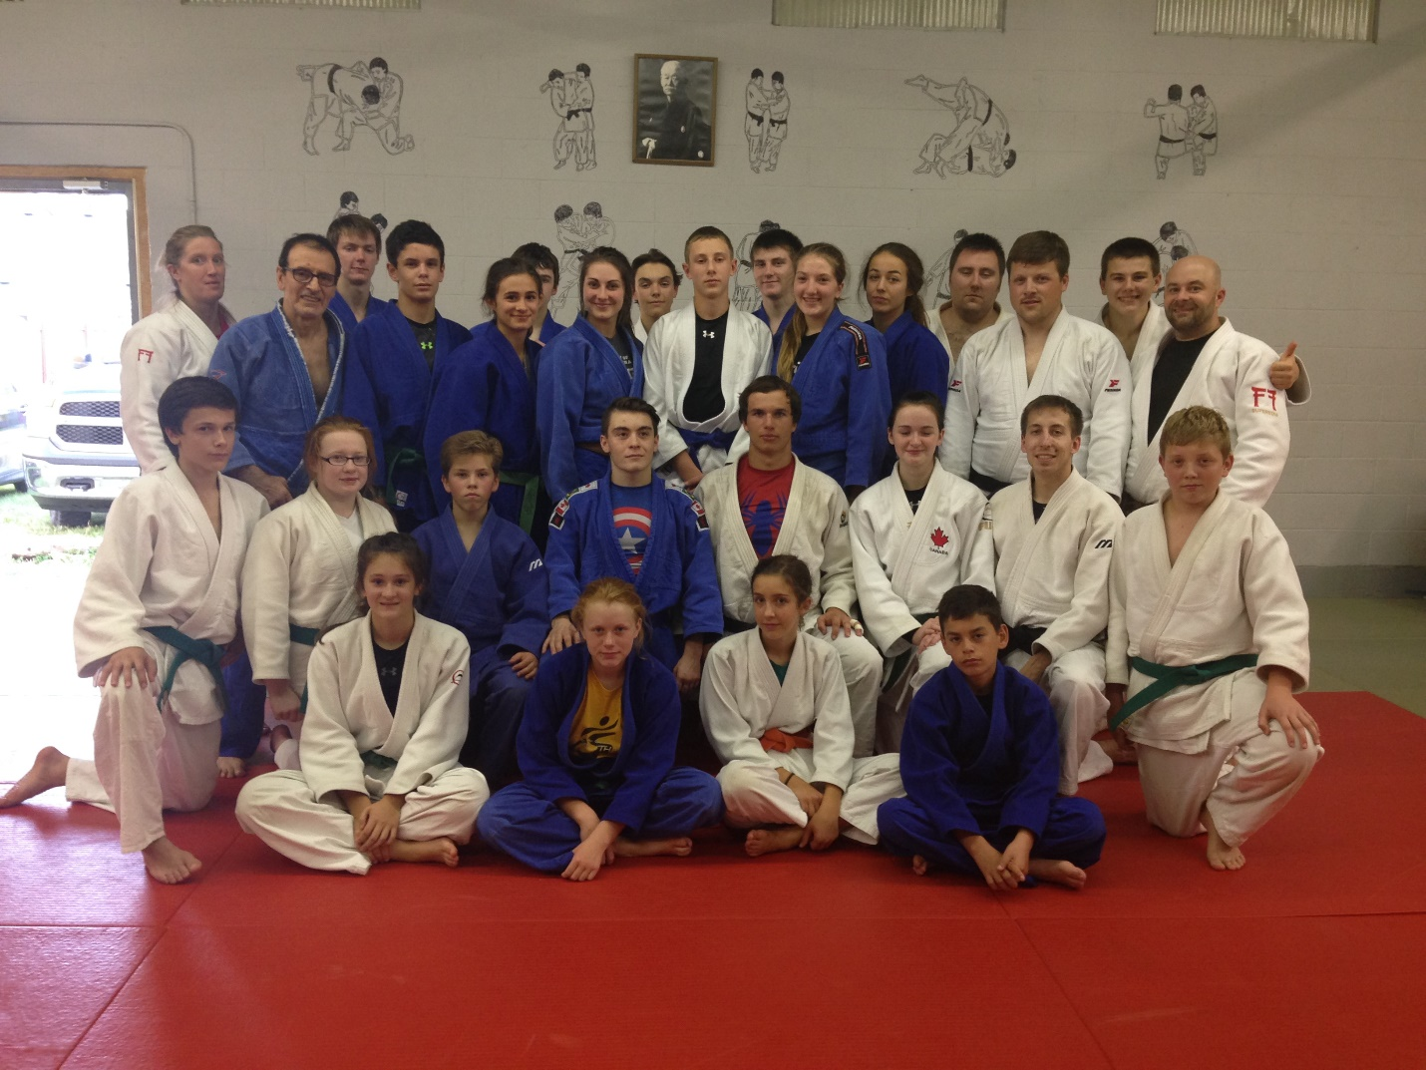

imPORTANT
Doping Control Website: http://www.globaldro.com/ca-en/
To find the status of any medication or other substance, consult the Global DRO.

.

Fights to watch

Misato Nakamura vs Erika Miranda World Judo Championships 2015 - Astana
Look at the choke Miranda does in the first minute, doesn’t work but but she is right on top.
Look at intensity throughout the fight, going non-stop and won at the very last second.
ANYBODY CAN WIN ON ANY DAY!!!
https://www.youtube.com/watch?v=tKPZlQ3Bfsw

Ericka Miranda Look at intensity of the choke how fast she is. How she places her body to get the choke.
https://www.youtube.com/watch?v=E92WGlQrXvA

