Good Will Training Camp
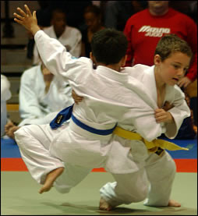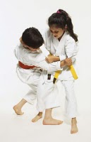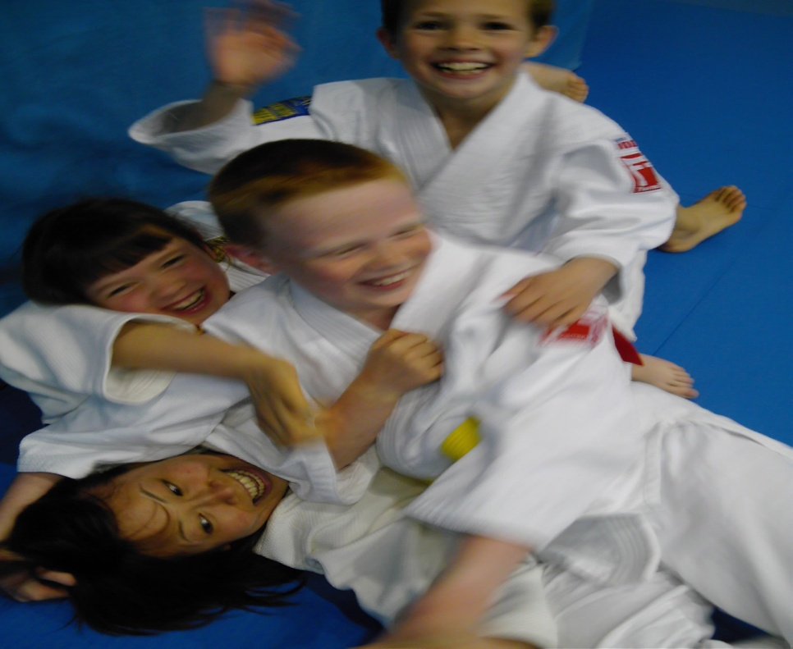
March 23- 24 2019

SPECIAL GUEST COACH Michael Horley

Location: Moose Jaw Koseikan Judo Club
801 Hochelaga Street East, Moose Jaw.

Athletes will be sleeping in the judo club on the judo mats and will be chaperoned by adults and coaches.

Each Judo Club is eligible to send 4 judoka: 1 Judoka has be female;
The 3 remaining judoka male or female (orange to White Belts)
2007 up to and including 2011

CONFIRMATION DATE: March14, 2019

Please confirm with Justin Filteau which athletes will be participating
Justin.filteau@icloud.com

Judo Sask Good Will Training Camp
Date: March 23 to 24, 2019
Location: Moose Jaw Judo Club, Moose Jaw, Saskatchewan

Saturday March 23, 2019
Time | Training | Location
9:00 AM | Registration (Sign In/Kid Drop Off) | Moose Jaw Judo Club
10:00AM to 11:30AM | Judo Session | Moose Jaw Judo Club
11:45PM | Lunch | Moose Jaw Judo Club
2:00PM to 3:30PM | Judo Session | Moose Jaw Judo Club
5:00PM | Supper | Moose Jaw Judo Club
7:00PM-8:30PM | Swimming | Kinsmen Sportsplex
9:00PM | Movie | Moose Jaw Judo Club
11:00PM | Lights Out | Moose Jaw Judo Club

Sunday March 24, 2019
Time | Training | Location
7:30AM | Wake-Up | Moose Jaw Judo Club
8:15 AM | Breakfast | Moose Jaw Judo Club
09:15AM | Judo Games | Moose Jaw Judo Club
10:15AM to 11:45AM | Judo Session | Moose Jaw Judo Club
12:00AM | Snack | Moose Jaw Judo Club
12:15AM | Clean-Up | Moose Jaw Judo Club
12:30PM | Departure | Moose Jaw Judo Club
Location: Moose Jaw Koseikan Judo Club, 801 Hochelaga Street East, Moose Jaw. Athletes will be sleeping in the judo club on the judo mats and will be chaperoned by adults and coaches.
Selection: Each Judo Club is eligible to send 4 judoka born 2007 up to and including 2011. One judoka has to be female. (orange to White Belts)

CONFIRMATION DATE: March 14th 2019

Things To Bring:

_____ Judogis

_____ Sleeping Bag

_____ Pillow

_____ Water Bottle

_____ Flashlight

_____ Swim Suit/Towel

_____ Toiletries

_____ Gym Clothes

_____ Jogging Shoes

_____ Night Clothing

_____ Spending Money
Arrival Time:
March 23, 2019, – 9:00AM

Departure Time:
March 24, 2019 – 12:30PM

JUDO SASKATCHEWAN GOOD WILL TRAINING CAMP FORM
Please confirm with Justin Filteau which athletes will be participating
Justin.filteau@icloud.com

Mail to: Judo Saskatchewan
c/o Justin Filteau 2706 Broadway ave, S7J 0Z9, Saskatoon

Name: ______________________________ Age: __________ Male/Female (circle one)
Date Of Birth: - Year __________Month _________Day_______
Address:_________________________________________________________
City: __________________________________ Province: __________
Postal Code: ____________________
Telephone #: ___________________________ Medical #: _________________
Allergies: _____________________________ Recent Injuries: ______________
IN CASE OF EMERGENCY: CONTACT NAME: _________________________
EMERGENCY TELEPHONE #: ___________________________
GENERAL WAIVER: We reserve the right to refuse enrollment or dismiss a judoka if it is in the best interest of the judoka and/or the camp. In the event of a dismissal, there will be no refund on any part of the Camp fee. We also regret we cannot be responsible for any losses and or damage to a judoka’s belongings. Permission is hereby given to use the photo image, written testimonial or voice of the campers, which may appear in the camp brochure/report or future advertising.

I desire my child to participate in the full camp program and all activities, unless I advise you otherwise in writing (in advance). I agree that having taken such precaution as in your discretion is deemed advisable, you shall not be held responsible for any sickness or accident to my child. Parents are therefore reminded to see that their son/daughter is covered under one of their own sickness and/or accident insurance plans available at a minimum cost throughout the year. If for any reason my child requires medical attention beyond that furnished by the camp, I agree to be responsible for any expenses incurred. I hereby volunteer release, forever discharge and agree to indemnify and hold harmless Judo Saskatchewan (including their agents, officers, volunteers, employees and all other persons acting in the capacity on their behalf) from any, and all claims, demands, or cause of action, which are in any way connected with the registered individual’s participation in this activity.

Signature of Parent/ Guardian _______________________________ Date _________________

Signature of Athlete _______________________________________ Date _________________

Medication (Current medication if any)

Medical History

