**Long Arms**

(working title)

# References

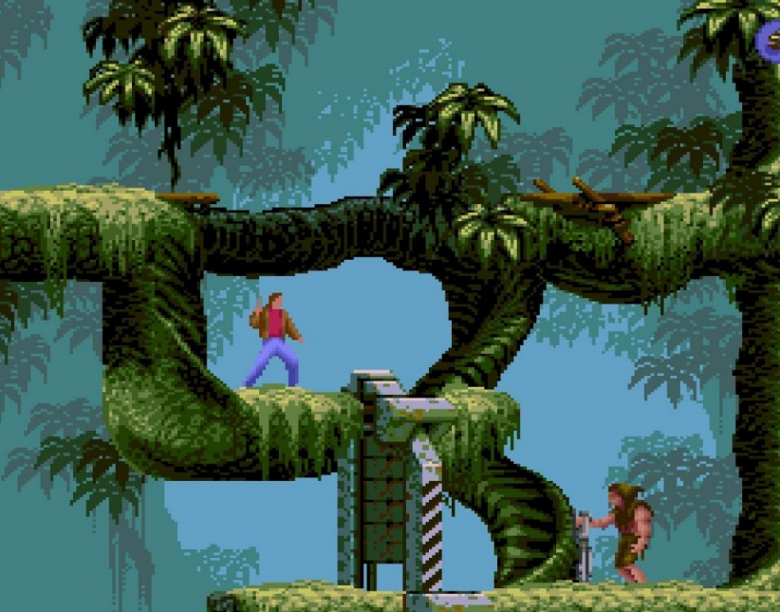

Flashback (SNES)

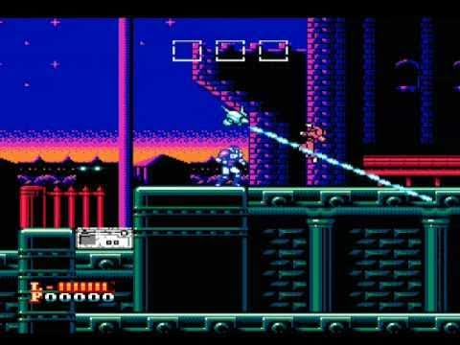

*Solbrain (famicom)*

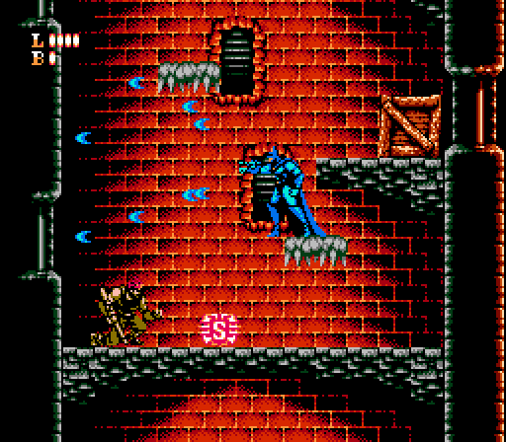

*Batman: Return of the Joker (nes)*

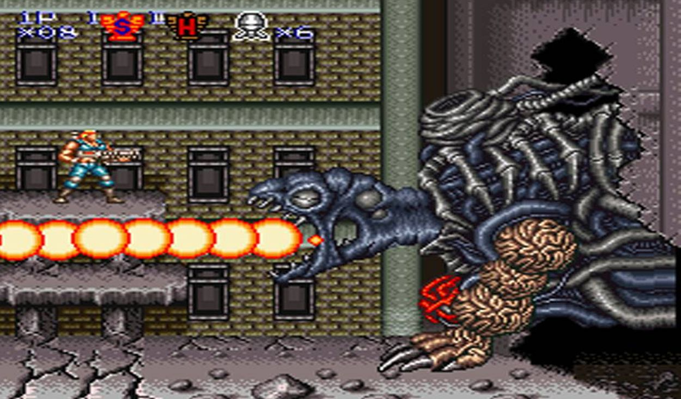

*Contra III (snes)*

# Elevator Pitch

A 2D action platformer game where you have the ability of stretching your arms so you can attack or do grappling hook fashion actions.

# History

You and your homeless friend are staring at the stars at night, talking about life and other stuff, in the middle of a futuristic city.  
Sudenly, some kind of ship appears and both of the mens are abducted by this ship. Next scene the two mans are laying on beds, tied up and placed in a place that looks like a laboratory. A voice is heard telling a little about what is happening: you were chosen for an experiment because you are homeless people and nobody would care. Next, the experiment starts, something goes wrong and your friend gets gruesome killed. Then is your turn and this is your origin story and motive: your arms gets the ability of stretch and now you are looking for revenge.

# Core mechanics

Your character is controlled using arrows on gamepad and 3 buttons/actions:

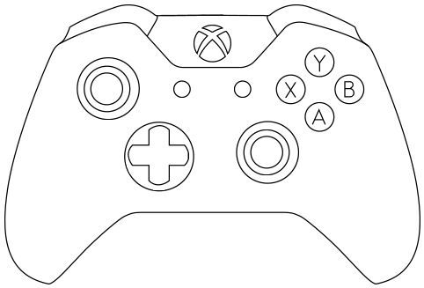

*Xbox controller for illustrative porpouses*

A: Jump  
B: Attack  
X: Grappling hook

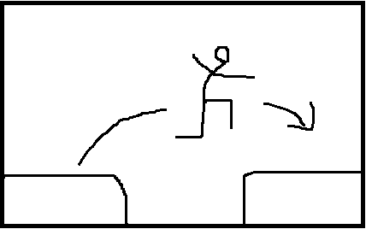

*Jump (A)*

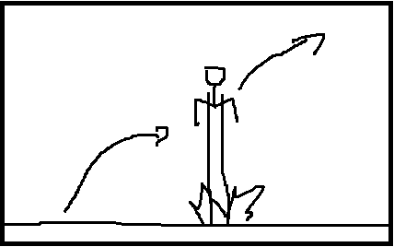

*Double jump (A + A in mid air) (achieved streching the arms and hitting the ground, so you need ground below you)*

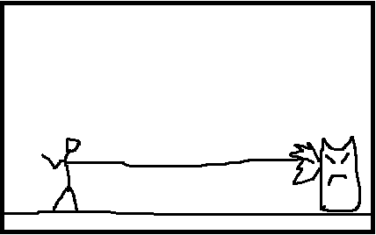

*Attack (B)*

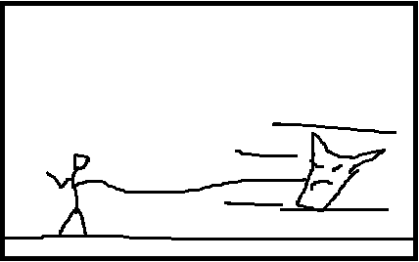

*Hook enemy (X) and…*

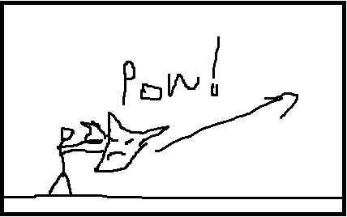

*Attack (B) (is similar to a parry, you need to time this attack, the enemy flies away and can damage others enemies)*

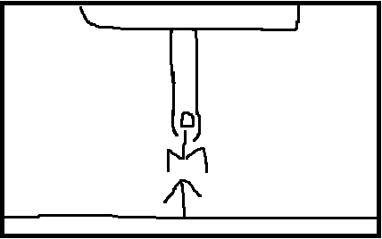

*Up Grappling Hook (X + UP)*

# 

# *Left or right grappling hook (X + LEFT or RIGHT)*

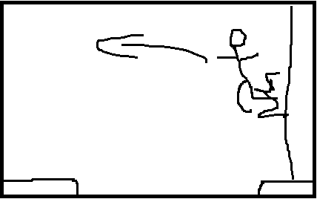

# *This automatically triggers a Wall jump in the opposite direction, giving the chance of combo with other Wall grapple or enemy attacks, etc.*

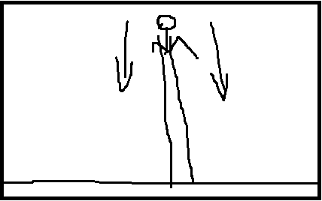

# *Down grappling hook (X + DOWN) this makes you go down quick, and does an area attack*

# Theme / Setting

Futuristic Robocop/dystopia, cyberpunk maybe.

