curl -sLO <https://github.com/eksctl-io/eksctl/releases/latest/download/eksctl_$PLATFORM.tar.gz>

# for ARM systems, set ARCH to: `arm64`, `armv6` or `armv7`

ARCH=amd64

PLATFORM=$(uname -s)_$ARCH

curl -sLO "https://github.com/eksctl-io/eksctl/releases/latest/download/eksctl_$PLATFORM.tar.gz"

# (Optional) Verify checksum

curl -sL "https://github.com/eksctl-io/eksctl/releases/latest/download/eksctl_checksums.txt" | grep $PLATFORM | sha256sum --check

tar -xzf eksctl_$PLATFORM.tar.gz -C /tmp && rm eksctl_$PLATFORM.tar.gz

sudo mv /tmp/eksctl /usr/local/bin

Asociamos IAM a Provider

eksctl utils associate-iam-oidc-provider \

--region us-east-1 \

--cluster cluster-desarrollo \

--approve

Politica

curl -o iam_policy_v2.7.json <https://raw.githubusercontent.com/kubernetes-sigs/aws-load-balancer-controller/release-2.7/docs/install/iam_policy.json>

Crear el Rol para la política

aws iam create-policy \

--policy-name AWSLoadBalancerControllerIAMPolicy \

--policy-document <file://iam_policy_v2.7.json>

arn:aws:iam::692859923457:policy/AWSLoadBalancerControllerIAMPolicy

crear ingress minikube

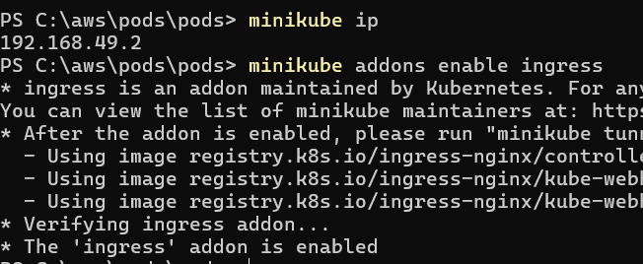

eksctl create iamserviceaccount \

--cluster cluster-desarrollo\

--namespace=kube-system \

--name=aws-load-balancer-controller \

--attach-policy-arn=arn:aws:iam::692859923457:policy/AWSLoadBalancerControllerIAMPolicy \

--override-existing-serviceaccounts \

--approve

Instalamos HELM manejador de paquetes de Kubernetes

curl https://raw.githubusercontent.com/helm/helm/master/scripts/get-helm-3 > get_helm.sh

chmod 700 get_helm.sh

./get_helm.sh

Helm versión

Windows:

<https://github.com/microsoft/winget-cli/releases/tag/v1.9.2151-preview>

Instalar istioctl

[Release Istio 1.21.6 · istio/istio (github.com)](https://github.com/istio/istio/releases/tag/1.21.6)

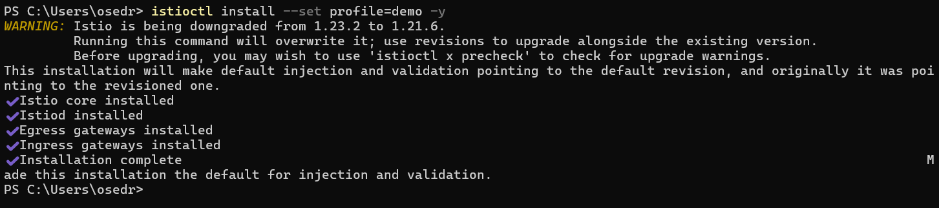

helm install aws-load-balancer-controller eks/aws-load-balancer-controller \ -n kube-system \

--set clusterName=cluster-desarrollo \

--set serviceAccount.create=false \

--set serviceAccount.name=aws-load-balancer-controller \

--set region= us-east-1 \

--set vpcId=vpc-06b808fbaac7104cb

////

helm install aws-load-balancer-controller eks/aws-load-balancer-controller \ -n kube-system \ --set clusterName=cluster-desarrollo \ --set serviceAccount.create=false \ --set serviceAccount.name=aws-load-balancer-controller \ --set region= us-east-1 \ --set vpcId=vpc-06b808fbaac7104cb

///

kubectl get pods -n kube-system

kubectl get pods -o wide -n kube-system