CSCE 144 – Introduction to Computer Science

Spring 2004

Lab # 3

Point of Sale Program
Goals for this lab:
- Practice using the String instance methods
- Do basic computations in Java using int and double types.
- Solve a mathematical problem using Java.
- Use the JOptionPane class for input and output.

Specifications: The goal is to write a simple point-of-sale program that will allow the user to purchase something with a debit card with cash back, and the program will provide a receipt and count change.

Details: Your program will ask the user for 3 things: his/her debit card number, the purchase price in cents, and the debit card amount. You will use JOptionPane.showInputDialog methods to get this input. For example:
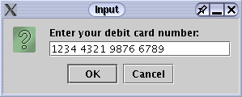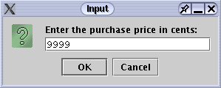

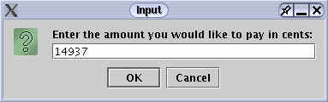

Once you have all the input, your program will compute the change that is owed, and determine how many dollar bills, how many quarters, dimes, nickels, and pennies to give to the customer. Then the program will display a receipt like the one shown below.

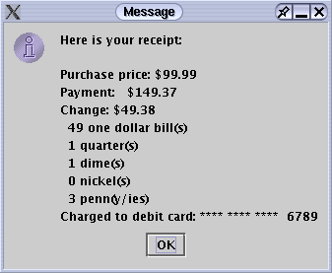

The credit card line above shows only the last 4 characters of the credit card number. The rest are displayed as asterisks (*).
Hints: You will read in the data as a String, and will need to convert some of the input to integers. To do so recall the Integer.parseInt method. When displaying the receipt, you will need to display the monetary values as real numbers so you will divide by 100.0, in the process converting them to double values. In order to display double values nicely on the screen, you can use the DecimalFormat class. For example:

int priceInCents = 4250;
double priceInDollars = priceInCents / 100.0;

DecimalFormat formatter = new DecimalFormat(“0.00”);
JOptionPane.showMessageDialog(null, “The price is $” +
formatter.format(priceInDollars) );

The format method in the DecimalFormat class converts a double to a String, in the process formatting it appropriately.

Prelab: Write on a piece of paper (not on the computer) the steps that you will need to execute to compute the change. You may use basic Java commands, but don’t write the whole program, just the statements required to compute the number of one dollar bills, quarters, dimes, nickels, and pennies. Make sure you have your lab instructor check your work upon your arrival. You should wait to incorporate the java code for this segment into your program until you have developed the basic input/out windows.

In-Lab
- Create a Lab3 folder on your X-drive.
- Create your program. Name your class PointOfSale and your file PointOfSale.java
- Don’t do the whole thing at once. Do parts of the problem, and test as you go. You may want first to develop one of the input windows and the output window. Then keep adding code.
- You may do Post-Lab tasks as time permits.
- Be sure to log out and sign out appropriately.

BE SURE THAT YOU GET THE INSTRUCTOR OR ASSISTANT TO SIGN YOUR COVER SHEET before you leave the lab.

Post-Lab
- Add something creative to your program. Some suggestions include:
  - Include a tip that is a percentage ( say 15 %) in the total charge. Show it separately on the receipt. This will, of course, affect the change. (up to 10 pts.)
  - Add sales tax (say 8.9%) to the purchase price before you compute the change. Show it on the receipt. (up to 10 pts)
  - Allow the use of $20, $10, and $5 bills as change. (up to 10 pts.)
  - Surprise us. If desired you can discuss your creativity with the instructor who will determine its point value.

(To receive “creativity” points you should make some creative additions to you program. You may make several if you like. In this lab, you can earn up to 10 creativity-points. Be sure to specify the creativity on your source-code-information-sheet. NOTE: Creativity points are only awarded after all required parts are working correctly. Also, credit will only be given for documented creativity.)

- Prepare your program for submission—electronically and hard-copy. Be sure they are the same version. Don’t forget to include appropriate documentation comments in your code.

- Submit your program in both forms before the due date.

Name Class Section:
Lab Section:
Important: The pre-lab and in-lab sections of this cover sheet must be filled in and initialed by the instructor/lab assistant during your lab session. Turn in your cover sheet ( and prelab worksheet, when there is one) with your assignment.
CSCE 144 – Introduction to Computer Science, Fall 2003
Lab # 3 Cover Sheet
Prelab – Must be completed when lab starts!

/10 Arrived on time and completed the prelab satisfactorily: analyzed the “problem” and wrote out how to solve it.

/10 Prelab total (0 points if not completed when lab begins) lab assistant initials: ______
In-lab
/10 The basic in-lab java program was completed and tested or student attended entire lab session

/10 In-lab total lab assistant initials: ______

Hand-in

student fills this line: name(s) of Java file(s) submitted electronically: _____________________________.java

Basic Assignment:

/10 Source code information sheet contains all correct information and format.
grader comments:

________/40 Program compiles and runs correctly under all reasonable choices of input data, except as noted in the “Known Bugs” statement.
grader comments:

/10 Java code uses good programming form, appropriate identifiers names, indenting, etc.
grader comments:

/10 Appropriate header & comment information & format in program code listing
grader comments:

/10 Creativity: Something extra that requires some creativity or individual study. This should be clearly documented on the source code information sheet
grader comments:

/80 Hand-in total

/100 Lab Grade

