CSCE 144 – Introduction to Computer Science

Spring 2004

Lab # 7

Grade Histogram
Goals for this lab:
- Practice using the Graphics instance methods
- Using if-else statements to control program execution
- Use the JOptionPane class for input and output

Specifications: Write a simple program to draw a histogram bar chart of the grades for a class. Your program will also calculate whether students did well or poorly overall and will display an additional label indicating that.

Details: Your program will ask the user for two things: a label for the chart, and a list of five numbers for the number of students getting A, B, C, D, or E on the assignment. You will use JOptionPane.showInputDialog methods to get this input. For example:

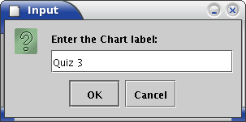

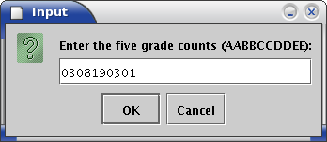

The first input dialog shows the input of the label “Quiz 3” and the second shows the input of counts of 3 A's, 8 B's, 19 C's, a3 D's, and 1 E. You should assume that each of the counts is exactly two digits; the post-lab creativity will give you an opportunity to change that.

Once you have the input, your program will compute the height and positions of the histogram's bars. It will then draw the bars, the coordinate axes, the chart label, and the axes' labels. Here is what it could look like:

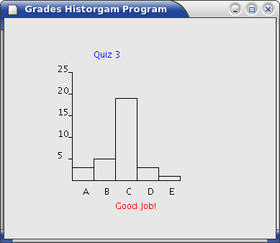

You should write this program in two phases. The first phase will be completed in lab on Thursday. The second phase will be completed for the post lab.

Prelab:
Review section 5.6 of the text on the Graphics class methods for drawing simple things like rectangles, ovals, lines, and strings. You will use these methods to draw your chart. You may also want to look at the online documentation for the Graphics class.

For the prelab write the following on a separate piece of paper:
- A list of all the constants your program will use (e.g. the bar width, the vertical scale, etc.). Use as many constants as you can to make your program as flexible and useful as possible. If any value depends on other values then write an expression to calculate that value. In that way changing the height or width of the window will automatically reposition the chart in the window.
- A list of the variables your program will use (e.g. chart label, number of A's, etc.)
- Draw on a piece of graph paper a diagram of your chart with the locations of everything clearly shown. Do this for the example chart shown above.
- Write the formulas used to calculate the locations of each of the items in your chart. Note that there are over 20 items needed ( 5 bars, 5 horizontal axis labels, chart label, etc.) .

In-Lab
- Create a Lab7 folder on your X-drive.
- Download the outline of the program, Histogram.java, from the class web site.
- Add declaration statements to the class for all of the constants your program will have. The class will also be where you declare the count variables for the numbers of each of the grades; it will also have your chart label. Initialize the variables to the example values for the in lab part of the program. You will change the program later to allow the user to input the values when the program starts. For now only work on getting the calculations and drawing to work correctly.
- Add declaration statements for the variables needed in the paint method for the variables needed to draw the chart.
- Add statements to the paint method to do the calculations you developed in the prelab.
- Add the Graphics statements to draw the chart. Do this in careful steps:
1. Draw the coordinate axes.
2. Draw the first rectangle.
3. Draw the rest of the rectangles.
4. Draw one axis' labels.
5. Draw the other axis' labels.
6. And so on.
- You may do Post-Lab tasks as time permits.
- Be sure to log out and sign out appropriately.

BE SURE THAT YOU GET THE INSTRUCTOR OR ASSISTANT TO SIGN YOUR COVER SHEET before you leave the lab.

Post-Lab
- Add the input dialogs shown above. This dialog should be shown only once when the program is first started and so it should be done in the constructor of the class before the setVisible(true) statement.
- Add statements to check that the counts entered are valid (not negative for example). Display a message if there is an error and only draw the chart if the numbers are all non-negative.
- Add statements to put an additional label on the graph depending on how the class did. If the number of A's and B's is at greater than the number of D's and E's then the class did well. Otherwise the class did poorly and the assignment should be redone.
- Add something creative to your program. Some suggestions include:

  - Draw the actual counts at the top of each bar.
  - Use some color.
  - Surprise us. If desired you can discuss your creativity with the instructor who will determine its point value.

(To receive “creativity” points you should make some creative additions to you program. You may make several if you like. In this lab, you can earn up to 10 creativity-points. Be sure to specify the creativity on your source-code-information-sheet. NOTE: Creativity points are only awarded after all required parts are working correctly. Also, credit will only be given for documented creativity.)

- Prepare your program for submission—electronically and hard-copy. Be sure they are the same version. Don’t forget to include appropriate documentation comments in your code.

- Submit your program in both forms before the due date.

Name Class Section:
Lab Section:

Important: The pre-lab and in-lab sections of this cover sheet must be filled in and initialed by the instructor/lab assistant during your lab session. Turn in your cover sheet ( and prelab worksheet, when there is one) with your assignment.
CSCE 144 – Introduction to Computer Science, Spring 2004
Lab # 7 Cover Sheet
Prelab – Must be completed when lab starts!

/20 Listed constants, variables needed. Drew the diagram for the example chart. Wrote the formulas to calculate the positions of the chart elements.

/20 Prelab total (0 points if not completed when lab begins) lab assistant initials: ______
In-lab
/10 The basic in-lab java program was completed and tested or student attended entire lab session

/10 In-lab total lab assistant initials: ______

Hand-in

student fills this line: name(s) of Java file(s) submitted electronically: _____________________________.java

Basic Assignment:

________/40 Program compiles and runs correctly under all reasonable choices of input data, except as noted in the “Known Bugs” statement.
grader comments:

/10 Java code uses good programming form, appropriate identifiers names, indenting, etc.
grader comments:

/10 Appropriate header & comment information & format in program code listing
grader comments:

/10 Creativity: Something extra that requires some creativity or individual study. This should be clearly documented on the source code information sheet
grader comments:

/70 Hand-in total

/100 Lab Grade

