CSCE 144 – Introduction to Computer Science

Spring 2004

Lab # 10

HiLo Game GUI
Goals for this lab:
- Extending JFrame to make a GUI program
- Implementing ActionListener for event handling

Overview: Write a simple JFrame based GUI program to play the HiLo game from the last lab. Here is what your program should look like at the start before the user has made a first guess:

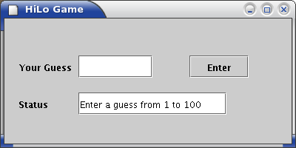
Here is what it should look like after a few guesses:

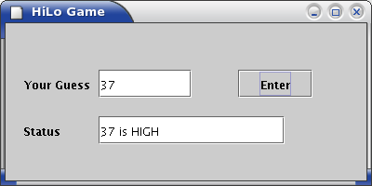

Details:
When the program is started it will generate a secret number and show the interface above with labels, text fields, and one button. On the first line are components for the user's guess: a label, text field and a button. When the “Enter” button is pushed the program reads the number in the text field and compares it to the secret number. The result of the comparison is then put into the text field on the second line. Only the result of the last guess is shown in the text field.
At the beginning the status text field tells the user to enter a number. After that the status text field will show the status of the last guess or that the user has won or lost.

The program is only designed to play one game initially. In the post lab you will add the capability to play several games by adding a “New Game” button like this:

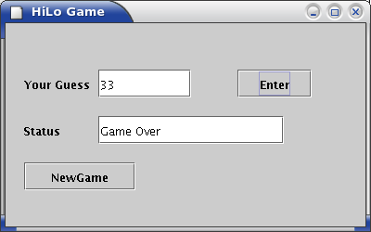
When the “New Game” button is pushed the program should go back to the state it was in at the beginning. There should be a new secret number, the number of guesses is set to zero, the guess text field is empty, and the status text field tells the user to enter a number from 1 to 100.

Pre-lab:
Review Chapter 7 sections 1-4 on GUI building by extending JFrame and implementing ActionListener. These sections also cover the use of JLabel, JTextField, and JButton.

For the pre-lab write the following on a separate piece of paper:
- A list of the methods you will have in your game class. You will need at least main, a constructor, and actionPerformed. We recommend that you write and use an initGame method which initializes the game variables for the start of a new game. You should also be sure to use the genSecretNumber method from the last lab. Using more methods generally makes writing programs easier.
- For each method give a statement of exactly what the method does. The description should include the use of the parameters (if there are any) and what the return value is (if there is one).
- Show which methods use which others. For example, the main method will use the constructor to create an instance of the game class.
- Draw the layout of your game and carefully label the location and size of each GUI component as in Figure 7.7 in the text.

In-Lab
We will carefully create this program in a series of steps. Each step will add a capability to the program such as a GUI component or an event handling. After each addition we will test the program by compiling and running it.
- Create a Lab10 folder on your X-drive.
- Create a HiLo game class that extends JFrame and implements ActionListener. This initial class should only have a constructor, main, and actionPerformed methods. Only the main method should be complete; the others should only be stubs. Save, compile, and run it to see that you have a simple JFrame showing.
- Add the GUI components one at a time. Save, compile, and run after each addition to see that the layout is as you want it.
- Add the game variables and initialization code.
- Add the event handling code: add an ActionListener to the guess button, add code to the actionPerformed method to handle the event of the button being pushed. For now simply display the user's number in the status text field.
- Add code to handle the user's guesses to play the game as it was done in the last lab.
- You may do Post-Lab tasks as time permits.

BE SURE THAT YOU GET THE INSTRUCTOR OR ASSISTANT TO SIGN YOUR COVER SHEET before you leave the lab.

Post-Lab
- Add statements to check that the guess is valid. Display a message if there is an error (in the status text field). If the guess is not valid the game state should not change. In particular, an invalid guess does not count as a guess for playing the game.
- Add a “New Game” button. When the button is pushed the program should be ready for the user to start guessing a new number.
- Add something creative to your program. Some suggestions include:

  - Use a JTextArea to show the history of the user's guesses.
  - Use some color in the GUI.
  - Surprise us. If desired you can discuss your creativity with the instructor who will determine its point value.

(To receive “creativity” points you should make some creative additions to you program. You may make several if you like. In this lab, you can earn up to 10 creativity-points. Be sure to specify the creativity on your source-code-information-sheet. NOTE: Creativity points are only awarded after all required parts are working correctly. Also, credit will only be given for documented creativity.)

- Prepare your program for submission—electronically and hard-copy. Be sure they are the same version. Don’t forget to include appropriate documentation comments in your code.

- Submit your program in both forms before the due date.

Name Class Section:
Lab Section:

Important: The pre-lab and in-lab sections of this cover sheet must be filled in and initialed by the instructor/lab assistant during your lab session. Turn in your cover sheet ( and prelab worksheet, when there is one) with your assignment.
CSCE 144 – Introduction to Computer Science, Spring 2004
Lab # 10 Cover Sheet
Prelab – Must be completed when lab starts!

/20 Listed methods needed with description and usage of each. Drew the diagram for the layout of the GUI.

/20 Prelab total (0 points if not completed when lab begins) lab assistant initials: ______
In-lab
/10 The basic in-lab Java program was completed and tested or student attended entire lab session

/10 In-lab total lab assistant initials: ______

Hand-in

Student fills this line: name(s) of Java file(s) submitted electronically: _____________________________.java

Basic Assignment:

________/40 Program compiles and runs correctly under all reasonable choices of input data, except as noted in the “Known Bugs” statement.
grader comments:

/10 Java code uses good programming form, appropriate identifiers names, indenting, etc.
grader comments:

/10 Appropriate header & comment information & format in program code listing
grader comments:

/10 Creativity: Something extra that requires some creativity or individual study. This should be clearly documented on the source code information sheet
grader comments:

/70 Hand-in total

/100 Lab Grade

