CSCE 144 – Introduction to Computer Science-Spring 2004

Lab # 11 – 1-D Arrays and GUI
Gradebook
(IMPORTANT NOTE: Lab begins at the time scheduled and prelabs are “due” at that time. If you arrive late to lab you should expect to receive a 0 on your prelab.)
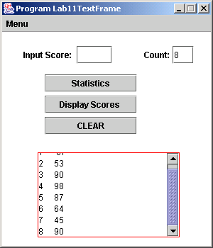
Goals for this lab:
- Learn to create and manipulate a one-dimensional array.
- Improve skills in creating and using GUI objects.

The Problem: You goal is to do statistics on a set of student scores. The scores will be input by the user. The program will compute the mean (average) and standard deviation for all the scores.

You will carry this out using a GUI. There will be a labeled text field for entering the score (user pushing ENTER puts this score into the array and blank the text field). There will be another labeled text field which will show the current number of scores that have been entered. There will also be a text area (with a scroll bar) for showing various output.

The program will make provisions for (when requested by user): (1) displaying in the text area the statistics for the mean and standard deviation of the current set of scores, (2) displaying in the text area the set of scores entered so far (numbered 1 thru n), (3) clearing text area.

To the right you see what the pane might look like after inputting 8 records and pushing the Display Scores button.

These user requests may be implemented either with some additional buttons or by having a menu with three item in it. (both are shown—but you decide which your program will use; menus are discussed in section 7.5 in the text, see especially page 413.)

BACKGROUND:
Given a set of n numbers 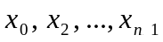 the mean (average) is defined by mean = 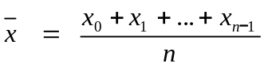

The standard deviation is defined by Standard Deviation = 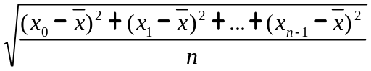

Prelab:
Read the problem carefully together with the suggested order of development.
Answer the following questions on a sheet of paper and give it to your instructor when you come into lab. (essentially create a skeleton for your program.)
- Draw the layout of your pane with locations and sizes of the GUI items clearly labeled.
- Write the header for your GradeBook class.
- List the instance variables you will need for the GradeBook class.
- Write headers for the methods you will need for your GradeBook class. At a minimum you will need main, a constructor and actionPerformed. You should also write a method to compute the mean and one to compute the standard deviation. Write a short description of what each does including the use of parameters, and return value if there is one. ( javadoc comments??)
- Show which methods use which others.
- Write a description or pseudo-code for the part of the event handler (actionPerformed) which adds a new score.

In-Lab Suggested order of development:

- Begin to build the basic window and declare variables for for creating the array of scores and for keeping track of how many of them there currently are. (Don’t put in the menu or extra buttons yet!). Get code that compiles and runs as soon as possible!
- Begin constructing the menu or other buttons by implementing the display-scores choice.
- Implement computing and displaying the mean.
- Implement computing and displaying the standard deviation.
- Finish implementing the rest.

InLab:
Finish solving the stated problem or stay for the whole lab period.

Post-Lab:
1. Finish the basic lab.
2. Add something creative to your program. Some suggestions:
- Max and min of the scores is computed and displayed. (5)
- Mean and standard deviation have their own display spot on the pane and will be automatically updated after each new record is added. (5)
- Menu/button choice: delete. Brings up a Dialog box for user to input the record number to be deleted. (5)
- Program checks before addition of new record to see if the array is full. If it is, the program create a larger array (say 1.5 times original size) and copy the old records into this new array and then use this new array for storage, etc. (10)
- Do something creative to this program of your own invention. Check with your instructor to determine its appropriateness. (up to 10 points)

NOTE: Creativity points are only awarded after all required parts are working correctly. Also, credit will only be given for documented creativity.

NOTE: To receive creativity points, you must add something creative to your program. You can add several if you like. For this lab, you can earn up to 10 creativity points. Be sure to describe your creativity on your source code information sheet.

3. Prepare your program for submission electronically and hard-copy. Be sure they are the same version. Be sure that your user instructions (on the source code info sheet) describe any special input restrictions.

4. Submit your program in both forms before the due date.
Name Class Section:
Lab Section:
Important: The pre-lab and in-lab sections of this cover sheet must be filled in and initialed by the instructor/lab assistant during your lab session. Turn in your cover sheet ( and prelab worksheet, when there is one) with your assignment.
CSCE 144 – Introduction to Computer Science, Spring 2004
Lab # 11 Cover Sheet
Prelab – Must be completed when lab starts!
Prelab completed as specified in Prelab description

/20 Prelab total (0 points if not completed when lab begins) lab assistant initials: ______
In-lab 1 The inlab assignment was completed, tested and running correctly, or student attended entire lab session

/10 In-lab total lab assistant initials: ______

Hand-in
Basic Assignment:

/5 Source code information sheet contains all appropriate information with appropriate formatting. It should describe an shortcoming and limitations of the program and give the user instructions, if appropriate.
grader comments:

/30 Correct code as specified which compiles and runs to produce specified results including correct GUI interaction. classes defined correctly with constructors, etc., when appropriate. (Note: There should not be input/output to the console or JOptionPanes in the submitted version of this program.)
grader comments:

/10 GUI is well designed and has nice appearance. User-friendly input and output, as appropriate.
grader comments:

/5 Correct header information: classes and methods described using Javadoc syntax.
grader comments:

/10 Code is well-structured, well-written, non-redundant, using (classes and) methods appropriately. Code has good documentation and self-documentation (descriptive identifiers used, appropriate code block & in-line comments and appropriate and consistent indenting used, etc.)
grader comments:

/10 Creativity: Something extra that requires some creativity or individual study. This should be clearly documented on the source code information sheet
grader comments:

/70 Hand-in total

/100 Lab Grade

