CSCE 144 – Introduction to Computer Science
Lab #12
The Game of Life
Spring 2004
In three words I can sum up everything I've learned about life. It goes on. ~Robert Frost
Goals for this lab:
- To use two dimensional arrays
- More practice with nested loops
- Stepwise refinement

Overview:

The Game of Life was invented by John H. Conway to simulate the birth and death of cells in a society. The following rules govern the birth and/or death of these cells from one generation to the next:

A live cell
remains alive if it has two or three live neighbors
dies from overcrowding if it has more than three live neighbors
dies from isolation if it has less than two live neighbors
A dead cell
becomes alive if it has exactly three live neighbors
remains dead otherwise

A cell’s neighbors consist of the eight cells around it:


The following patters would occur for times ranging from 0 to 4, if the first society was that shown for T = 0. Black represents a live cell; white indicates a dead cell:

T = 0 | T = 1 | T = 2 | T = 3 | T = 4
 | 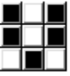 |  | 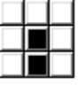 | 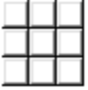

//Society dies off at T = 4

//Society stabilizes, pattern repeats
T = 0 | T = 1 | T = 2 | T = 3 | T = 4
 | 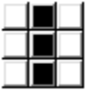

For this lab you will implement a JFrame that allows the user to enter a starting configuration for a society and displays the next generation each time the user clicks a button. It should also allow the user to clear the current configuration; here is what one generation would look like:

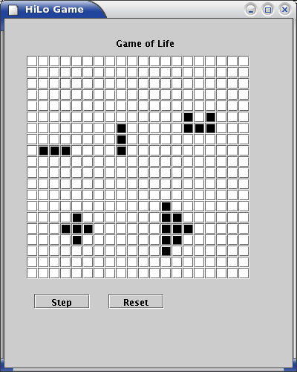

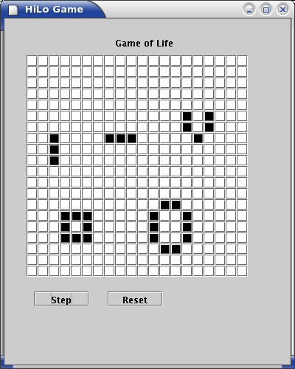

To simplify user input, implement your cells as an array of JButton objects, where a JButton’s background color indicates if that cell is living or dead. Note: The number of living neighbors of a cell is counted once before the state of any of its neighbors changes. This means you must save the state of the current cell society by copying it into a temporary two dimensional array before computing the cell states for the next generation.

Pre-lab Assignment:

Your JFrame could use the following methods:

- void GameOfLife()
Puts the label, cell buttons and control buttons into the frame.
- void actionPerformed( ActionEvent e)
This just calls the appropriate method based on which button the user clicks.
- public void clearCells()
This method will set all the cells to dead.
4. public Color nextCellState(int r, int c)
This method should determine the next state (ALIVE or DEAD) for a cell in position [r][c] of the current generation of cells. Don’t forget, cells on the edges will have fewer than eight neighbors. (Hint: you can avoid going out of bounds of your array by adding an outer “border” where no cell may be placed.)
5. public void getNextGeneration()
This method should save the status of the current society of cells and determine the new status for the next generation of cells using nextCellState(). It will first copy the cells’ background colors into an array of Color. It will then use nextCellState() on each of these to compute the next color for the button backgrounds.

Pre-Lab:
- Specify the names and types of the instance variables your program will use (size of the grid, etc.)
- Write the algorithms for the nextCellState and getNextGeneration methods.

In Lab:
      - Have your instructor or lab assistant check your Pre-lab worksheet.
      - Begin coding and testing your methods.
Post-lab:
      - Finish coding and testing your methods.
      - Add something creative to your applet. Remember that creative additions should add usefully to the program and that creativity points are given only if the assigned part of the program works correctly. Here are some suggestions:
- Add a button to your program that allows the user to display the “rules” for the Game of Life.
- Implement simple animation using a loop and the Thread.sleep() method. Your program should continue to display the next generation of cells until the society becomes stable (the next and current generations are the same) or after 40 generations have been displayed.
- Implement animation using the Timer class.
- Surprise us with something.
      - You may get up to 10 extra credit points for more complex additions, such as:
- Create your cells by drawing rectangles in paint() and use mouse input to alter a cell’s state.
- Animate your program so the user may choose to view the evolution of a society by clicking a button only once and may interrupt the animation by clicking the animation button, or one of the other applet buttons.

What to turn in:
Before class time on Wednesday, you should use the online submission system to submit your Java file.

Hand in the following, stapled together, at the beginning of class on Wednesday:
- Your lab #12 cover sheet.
- Your Pre-lab worksheet.
- A printout of your Java source file.

CSCE 144 Lab 12 Pre-lab worksheet

      - Your program will need several constants and instance variables. Some of these are defined below; what additional ones will you need?

private Color DEAD = Color.white ; // used to color a cell that is dead
private Color ALIVE = Color.black ; // used to color a cell that is alive
private Jbutton cells[][] ; // array of buttons showing the current generation
private Color current[][] ; // used to hold a copy of the current generation
// to compute the next generation

- Algorithm for nextCellState

- Algorithm for getNextGeneration

Name Class Section:
Lab Section:

Important: The pre-lab and in-lab sections of this cover sheet must be filled in and initialed by the instructor/lab assistant during your lab session. Turn in your cover sheet ( and prelab worksheet, when there is one) with your assignment.
CSCE 144 – Introduction to Computer Science, Spring 2004
Lab # 12 Cover Sheet
Prelab – Must be completed when lab starts!

/20 Pre-lab worksheet completed well.

/20 Prelab total (0 points if not completed when lab begins) lab assistant initials: ______
In-lab
/10 The basic in-lab Java program was completed and tested or student attended entire lab session

/10 In-lab total lab assistant initials: ______

Hand-in

Student fills this line: name(s) of Java file(s) submitted electronically: _____________________________.java

Basic Assignment:

________/40 Program compiles and runs correctly under all reasonable choices of input data, except as noted in the “Known Bugs” statement.
grader comments:

/10 Java code uses good programming form, appropriate identifiers names, indenting, etc.
grader comments:

/10 Appropriate header & comment information & format in program code listing
grader comments:

/10 Creativity: Something extra that requires some creativity or individual study. This should be clearly documented on the source code information sheet
grader comments:

/70 Hand-in total

/100 Lab Grade

