|  |  |
| --- | --- |
| Course Name | ITD 2313 – Script Programming |
| Instructor | Mark L. Pranger |
| Student Name | Derrick McFall |
| Due date | 19-Apr-18 |
| Grade | <grade earned here> |
| Grading Comments | <instructor comments here> |

Lab Final

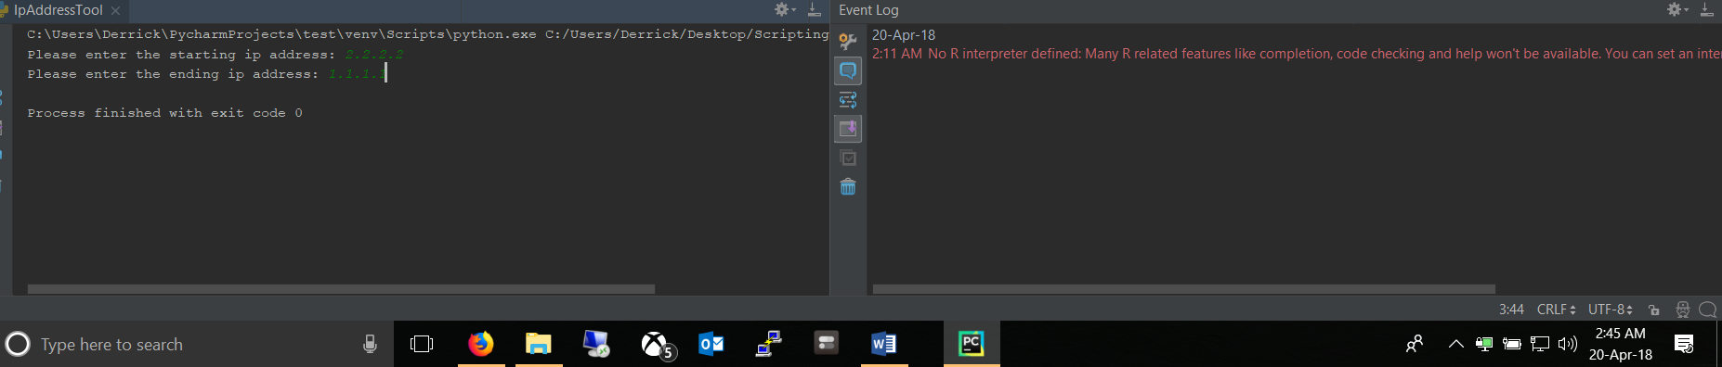

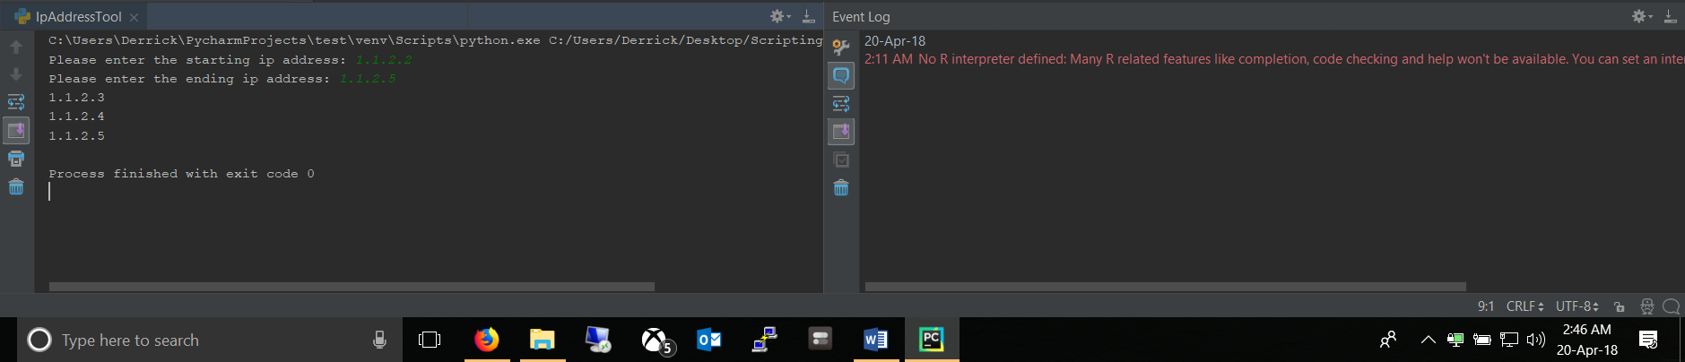

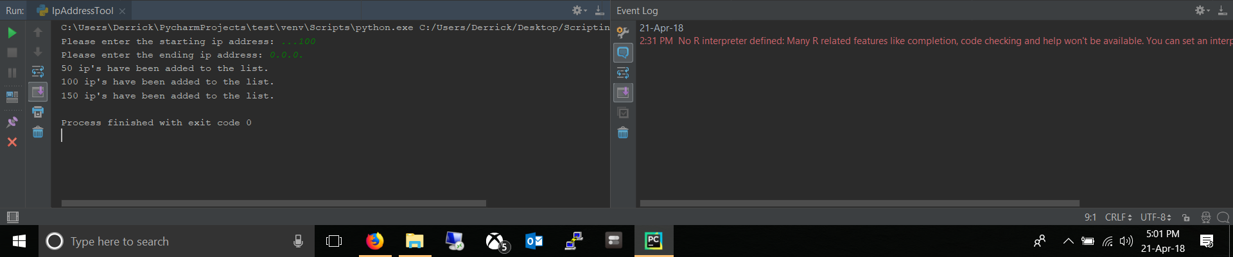

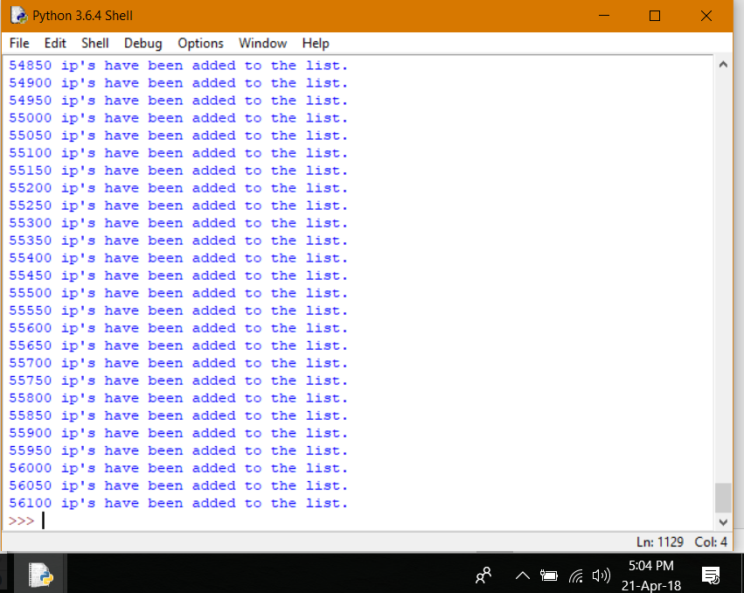

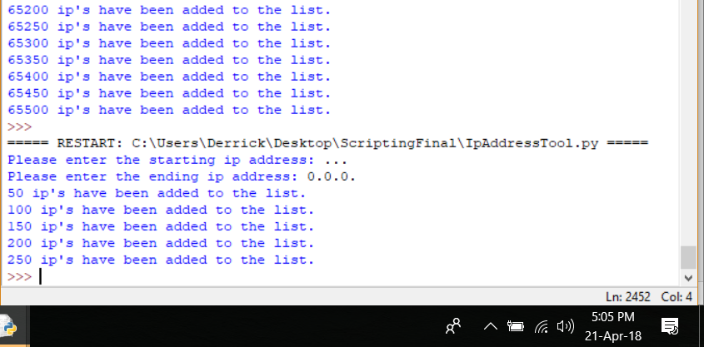

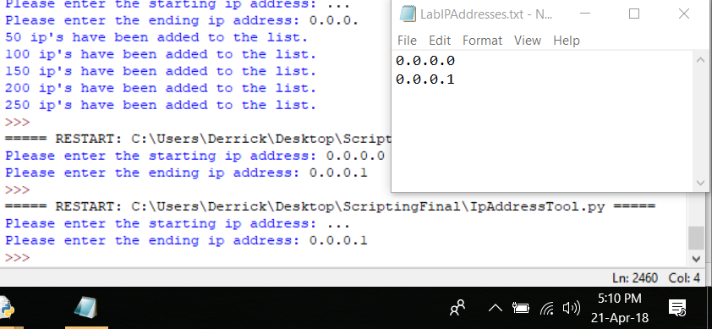

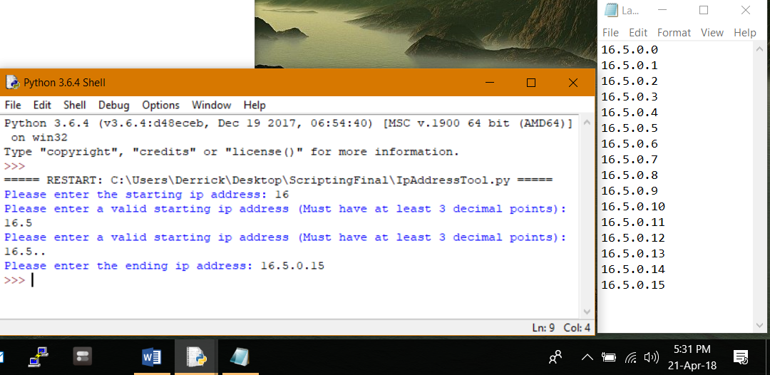

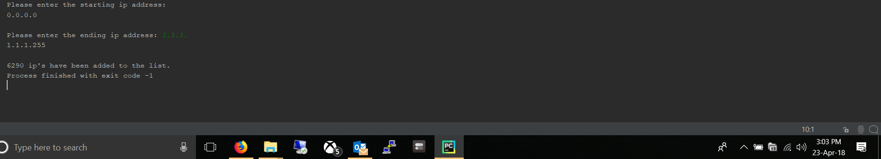

Working with out entering a starting ip or finishing the ending ip