ITD 3663 Mobile Programming Grade **__75__**

Instructor: J. Strother

Student Name: Derrick McFall

Due Date: October 28, 2018

Gradebook Comments: good start, project not complete.

## Module Eight Sailing Adventures

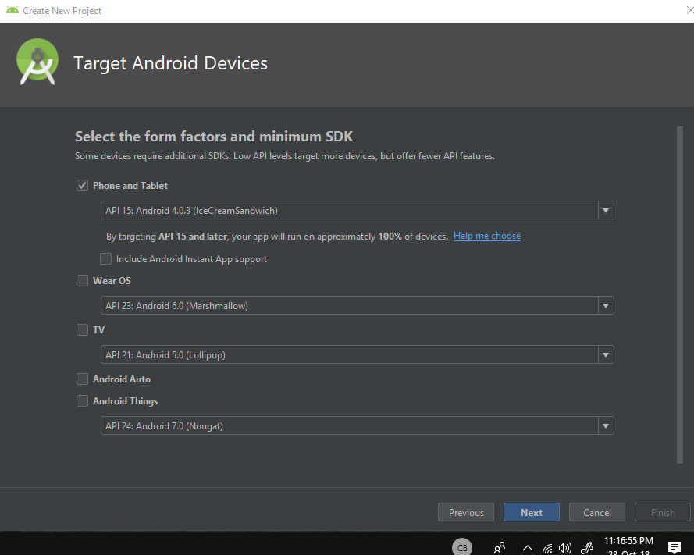

No option for honey comb exists here. I will continue without it and hope it doesn’t bite me later.

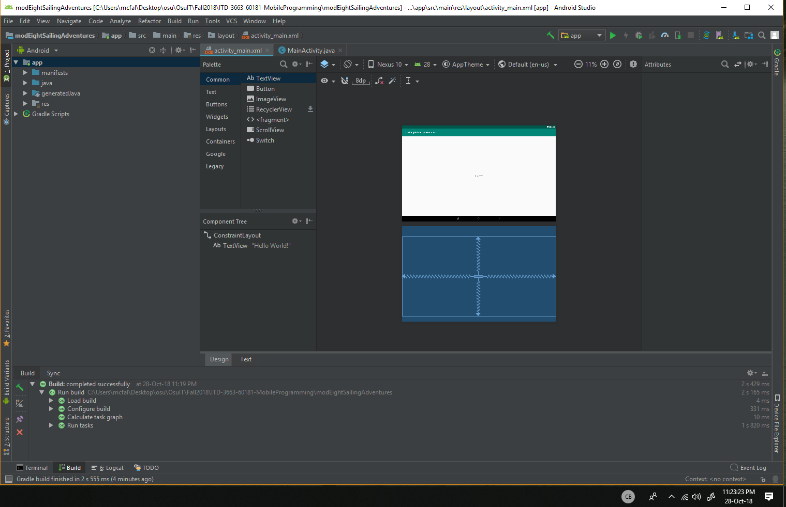

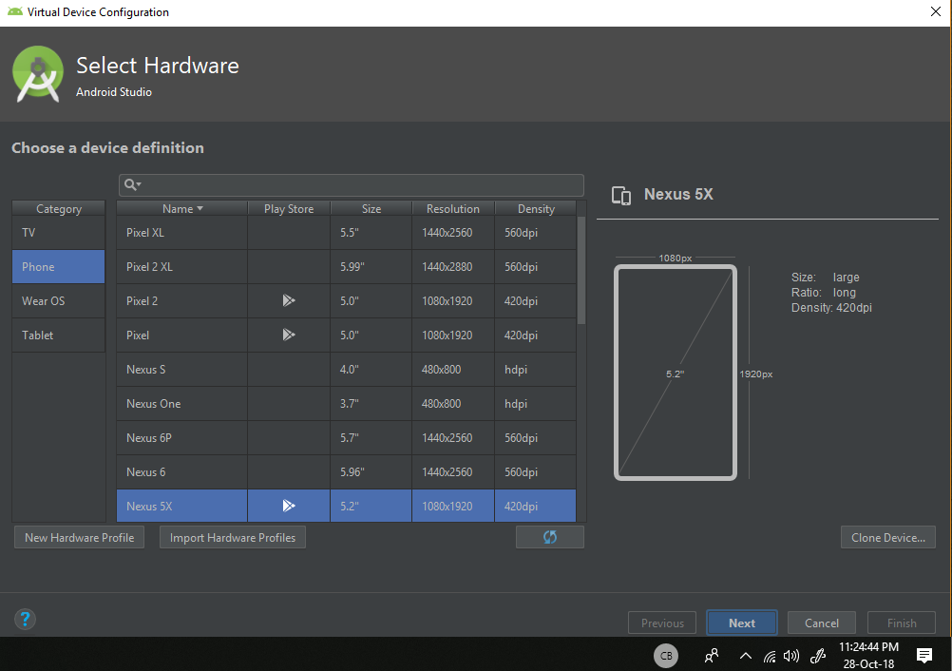

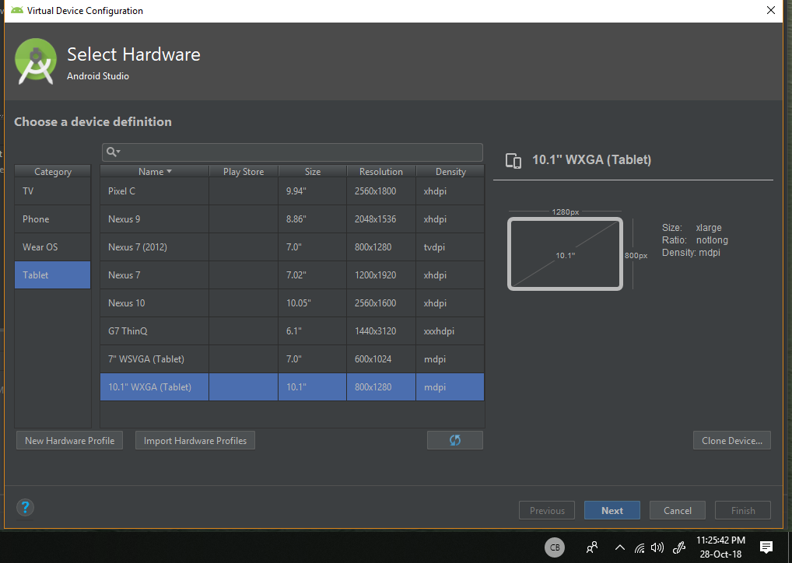

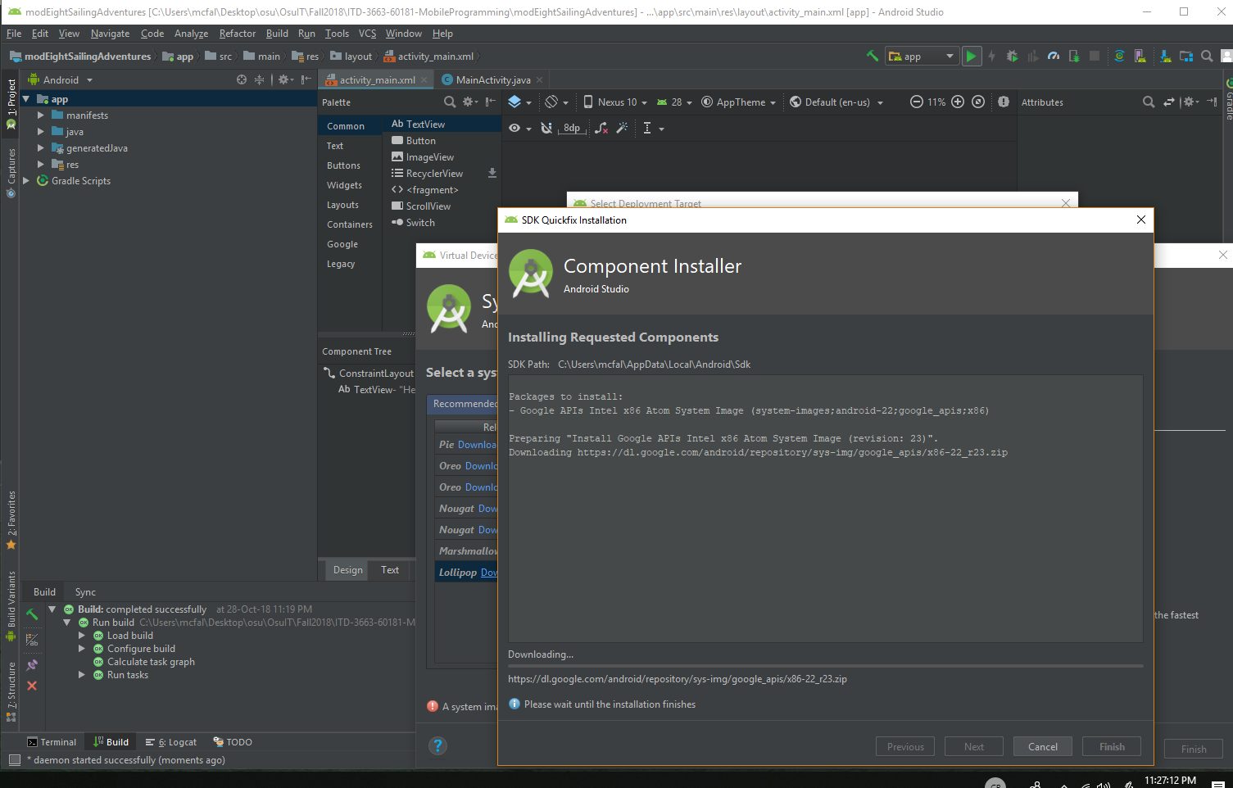

Couldn’t get any new images so I couldn’t select lollipop.

