ITD 3663 Mobile Programming Grade **__100__**

Instructor: J. Strother

Student Name: Derrick McFall

Due Date: November 18, 2018

Gradebook Comments: looks good

## Module Eleven Electric Car

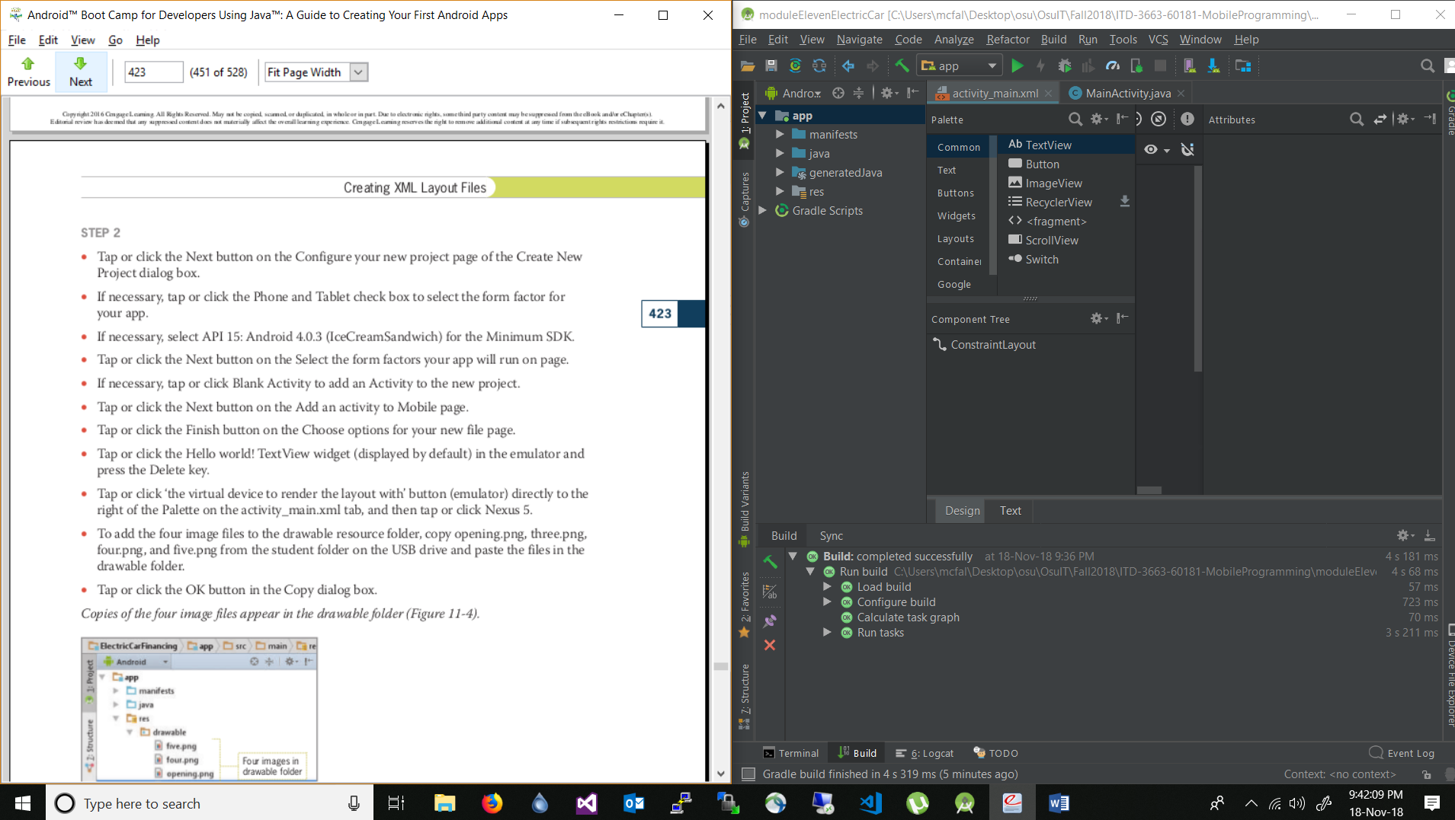

Very beginning of the app. Deleted the hello world text view.

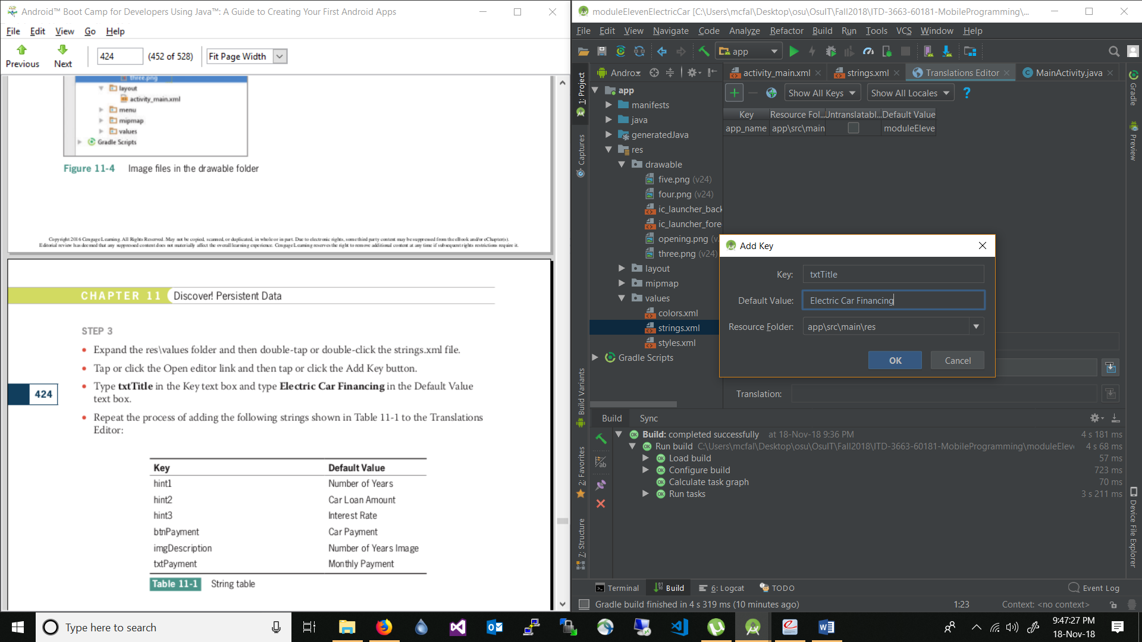

Adding the strings to the strings.xml file.

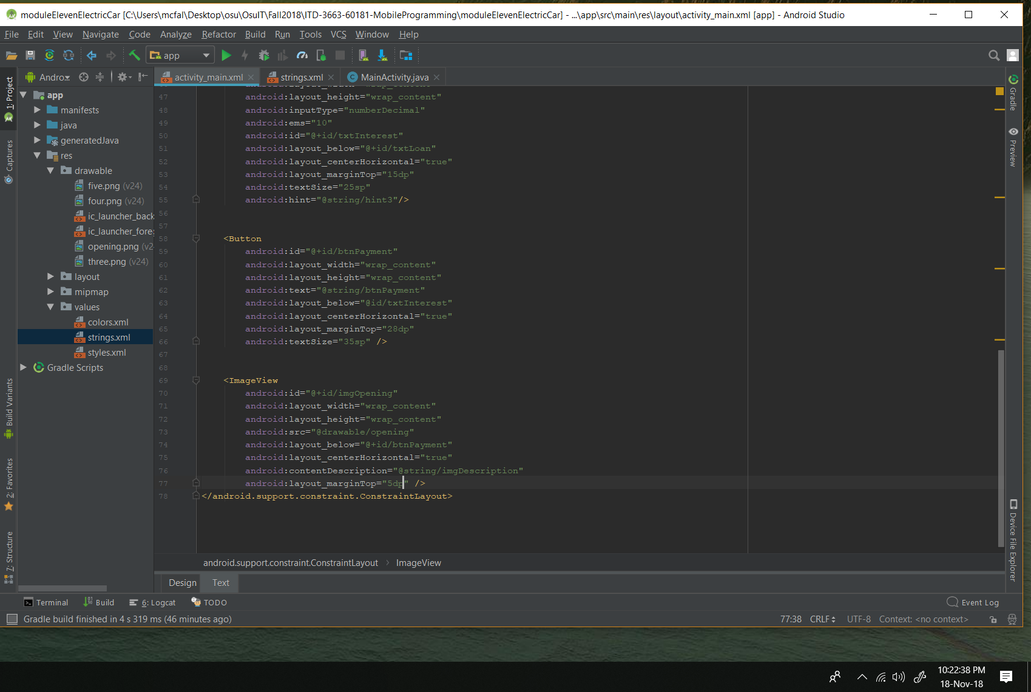From page 426: added the customized code for the app.

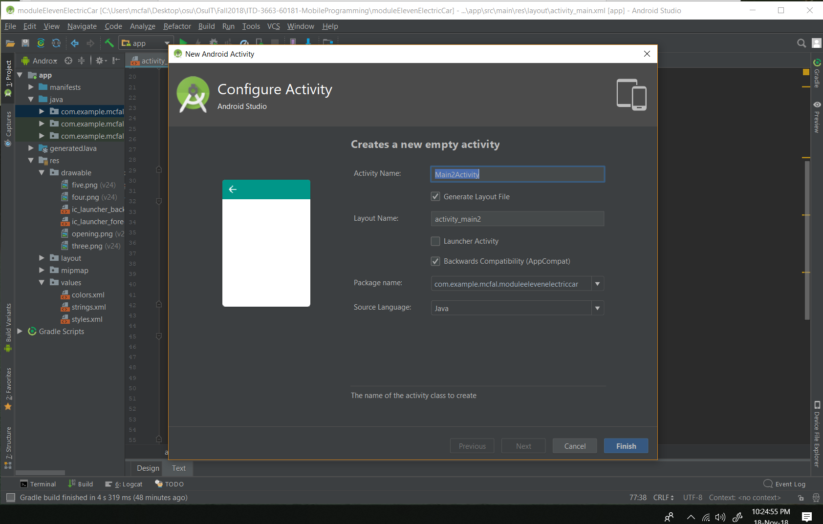Adding the new activity  
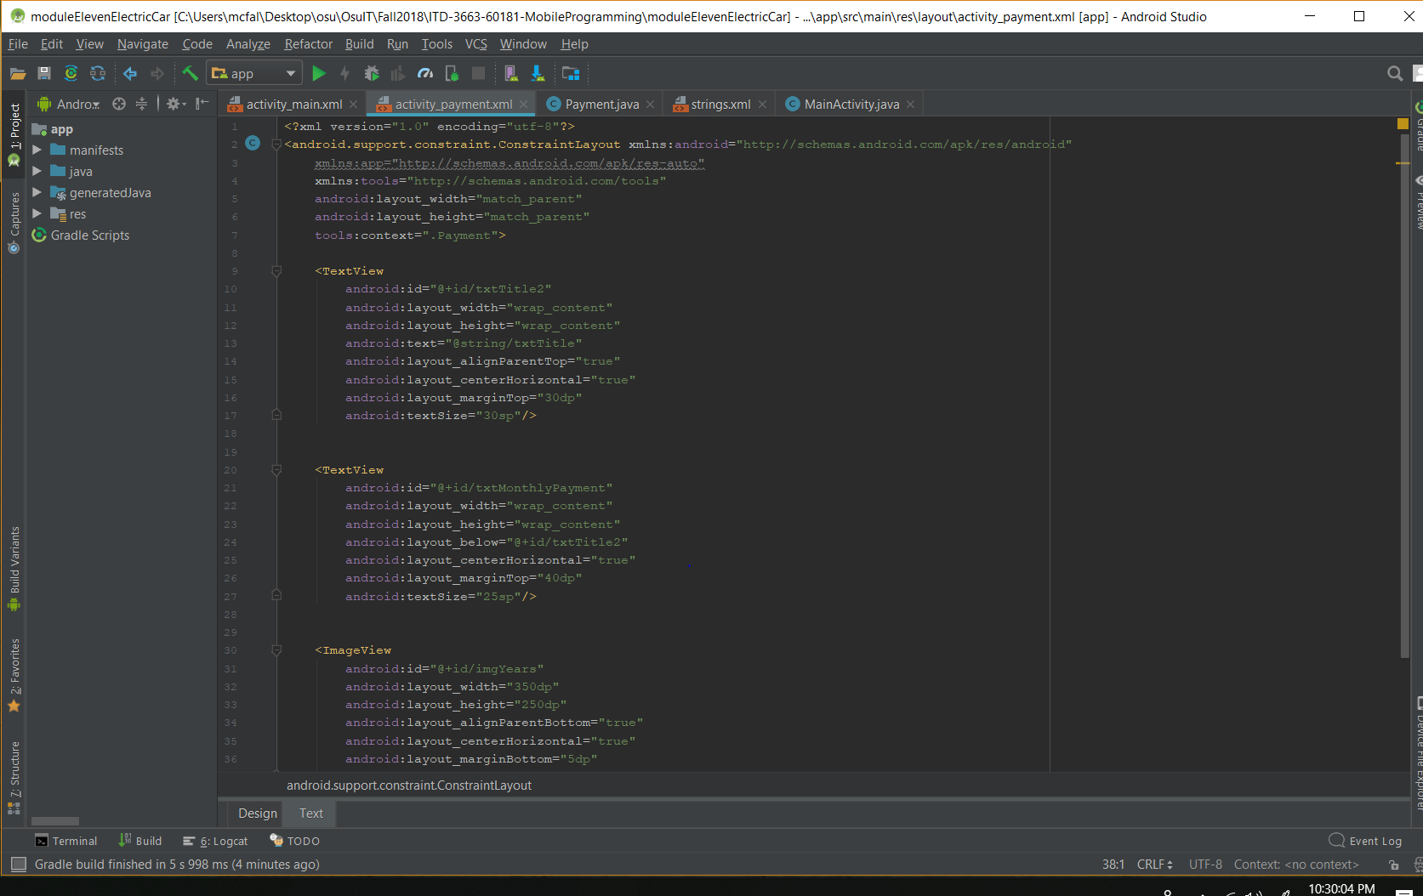Pg. 429: added the code for the customized payment

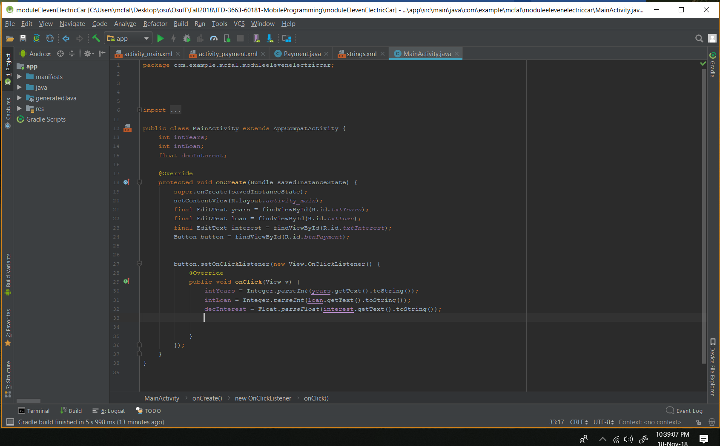Pg. 433: added the code to get the info from the text boxes and store into variables.

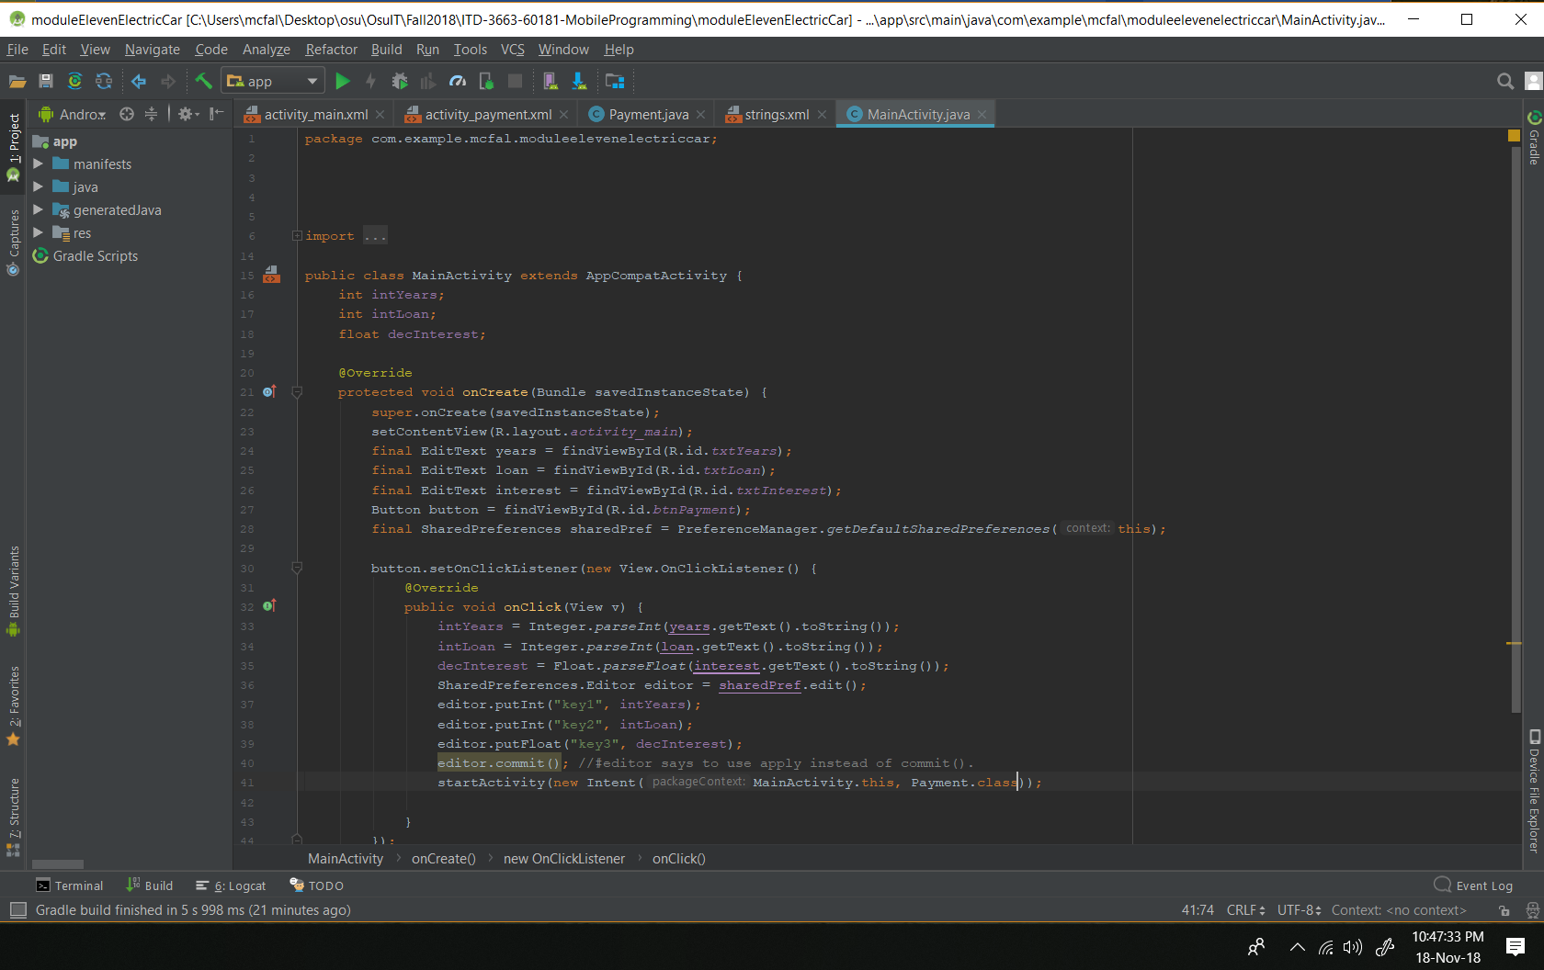Pg. 435-436

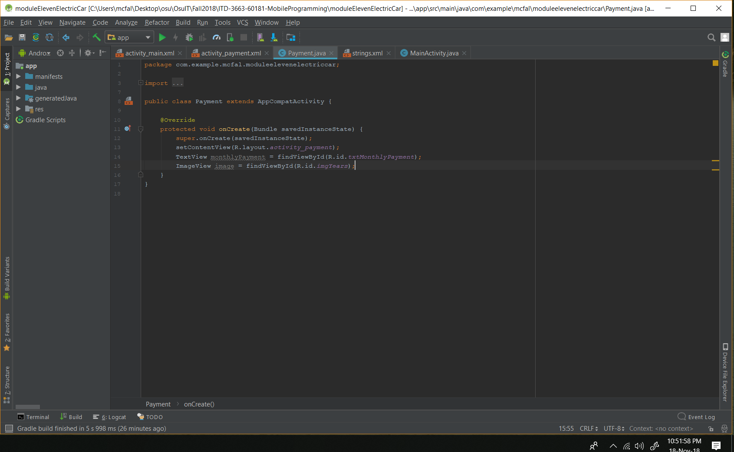Pg. 437-438 instantiating the views in the payment activity.

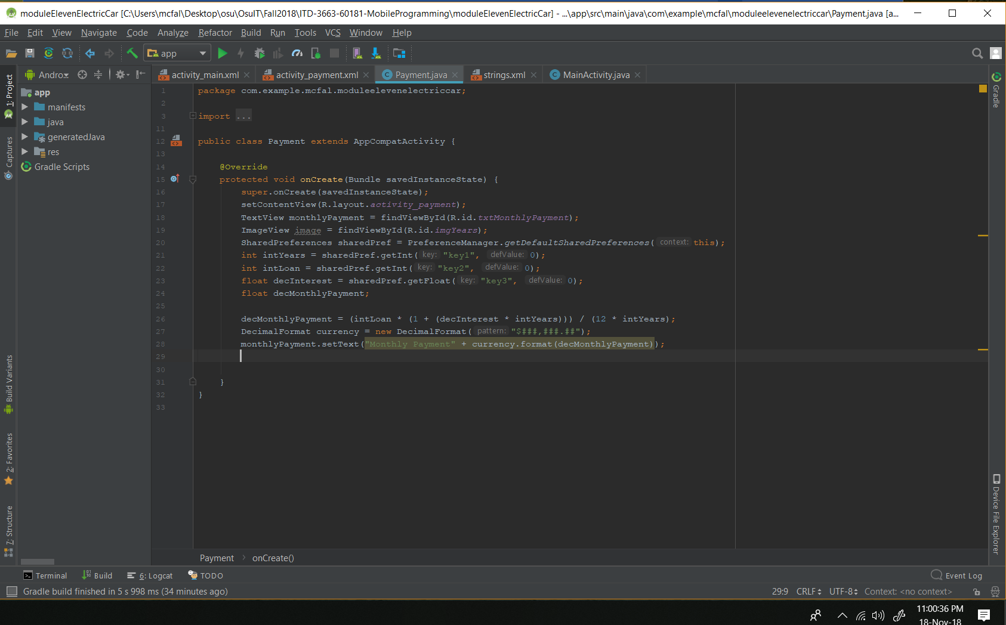Pg. 439-441: The calculation to get the monthly payment and also display it.

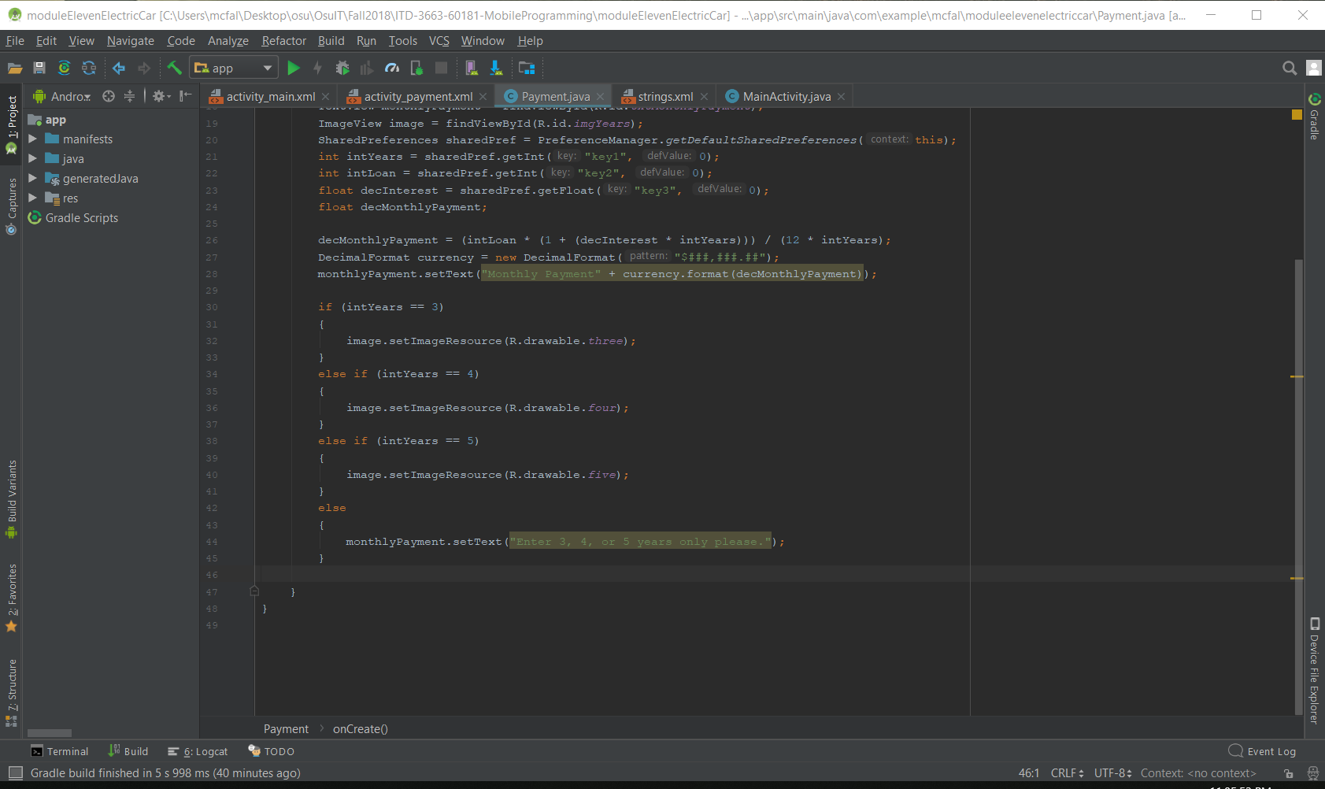

Pg. 442-444

Testing the app:

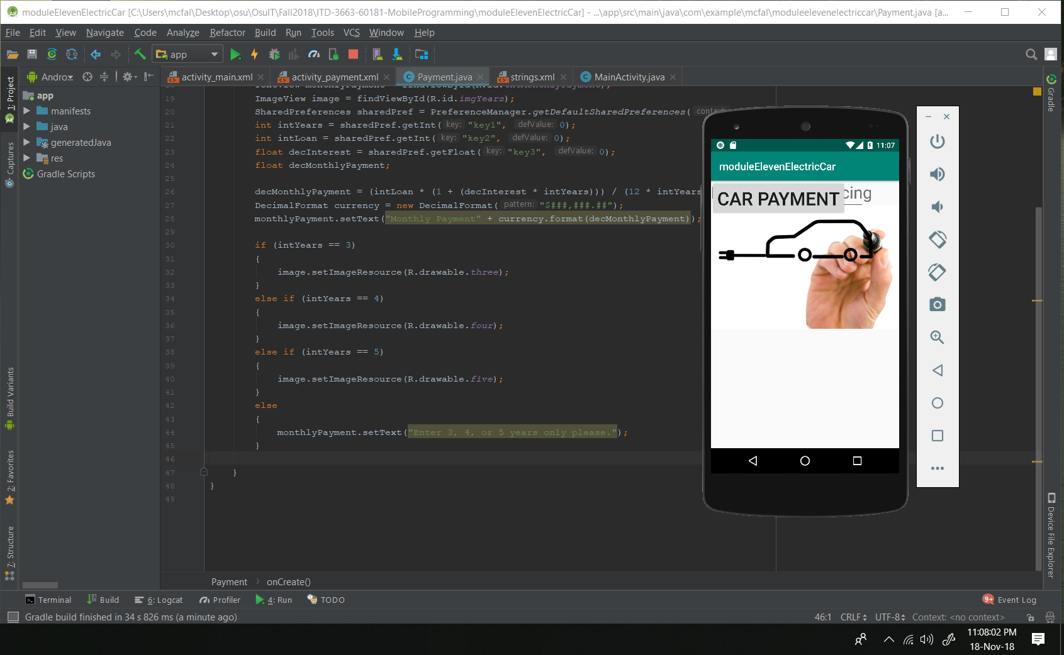

The initial test shows that I need to go in and constrain each of the objects so they don’t over lap like they are in the photo.

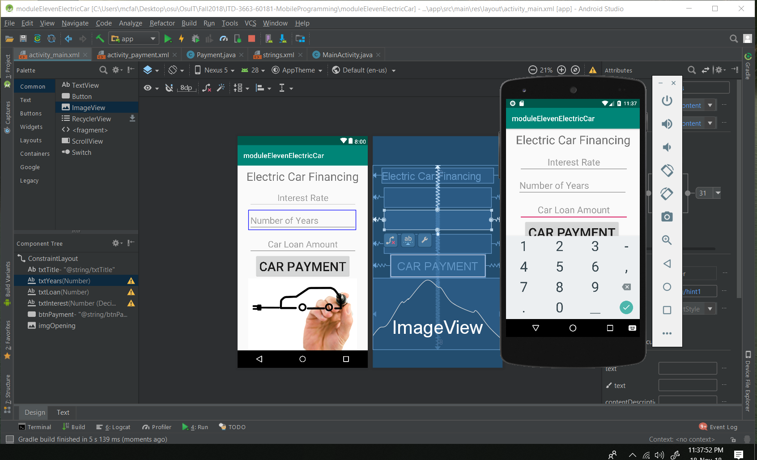I found that by adding this code:

app:layout_constraintLeft_toLeftOf="parent"

app:layout_constraintRight_toRightOf="parent"

app:layout_constraintTop_toTopOf="parent"

app:layout_constraintBottom_toBottomOf="parent"

The elements were much easier to work with as far as setting them where I wanted them to be. Otherwise they jumped around and looked really stupid in the app.

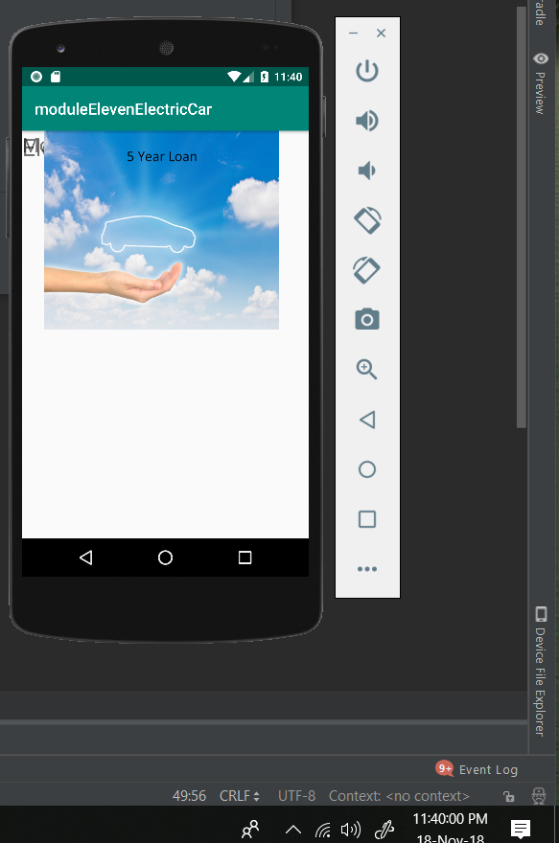

This is what the payment activity looked like before adding the code. ^

After adding the code I was able to easily move the elements around and it looks like this now:

