ITD 3663 Mobile Programming Grade **__100__**

Instructor: J. Strother

Student Name: Derrick McFall

Due Date: September 30, 2018

Gradebook Comments: this looks good, show more of your work.

## Module 4 Medical Calculator

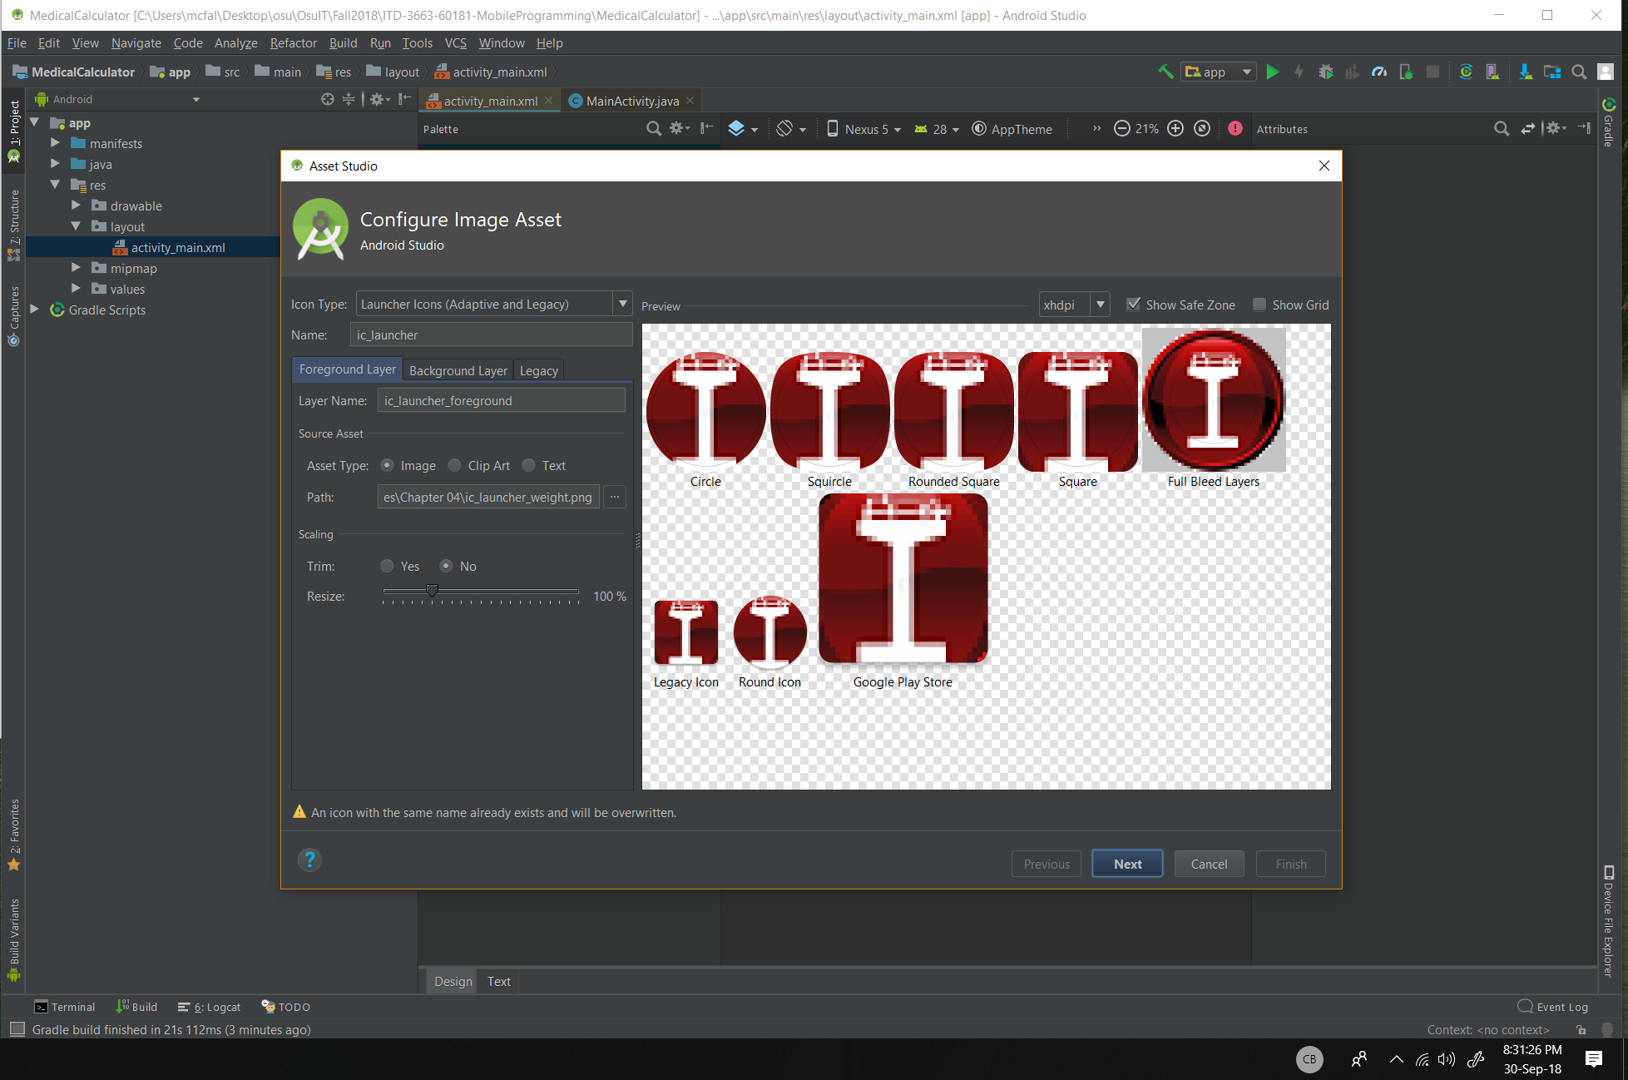

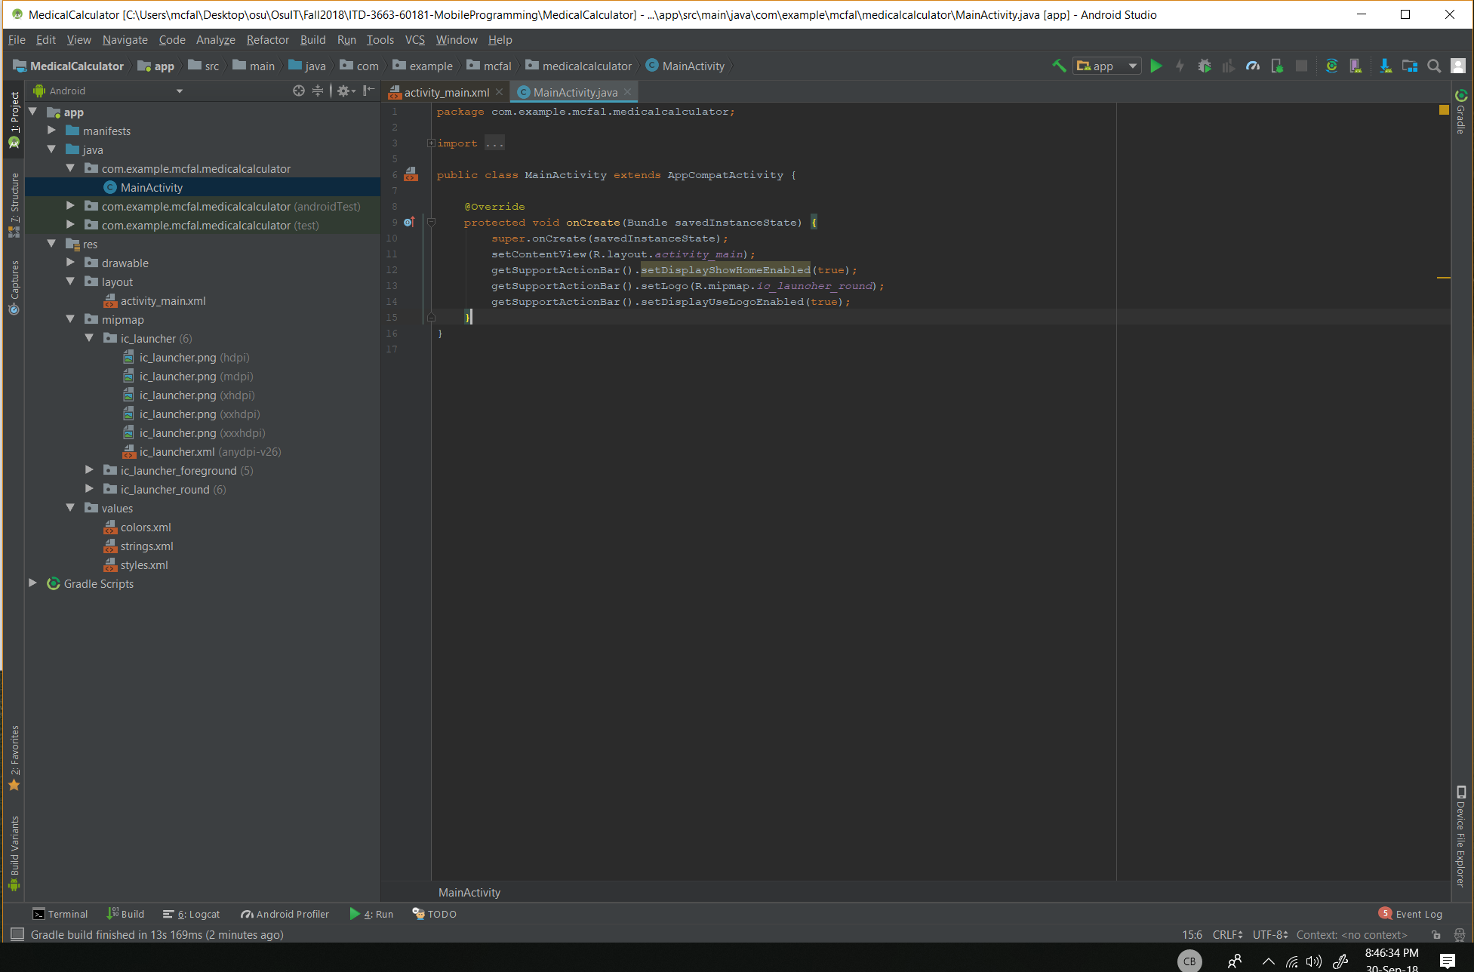

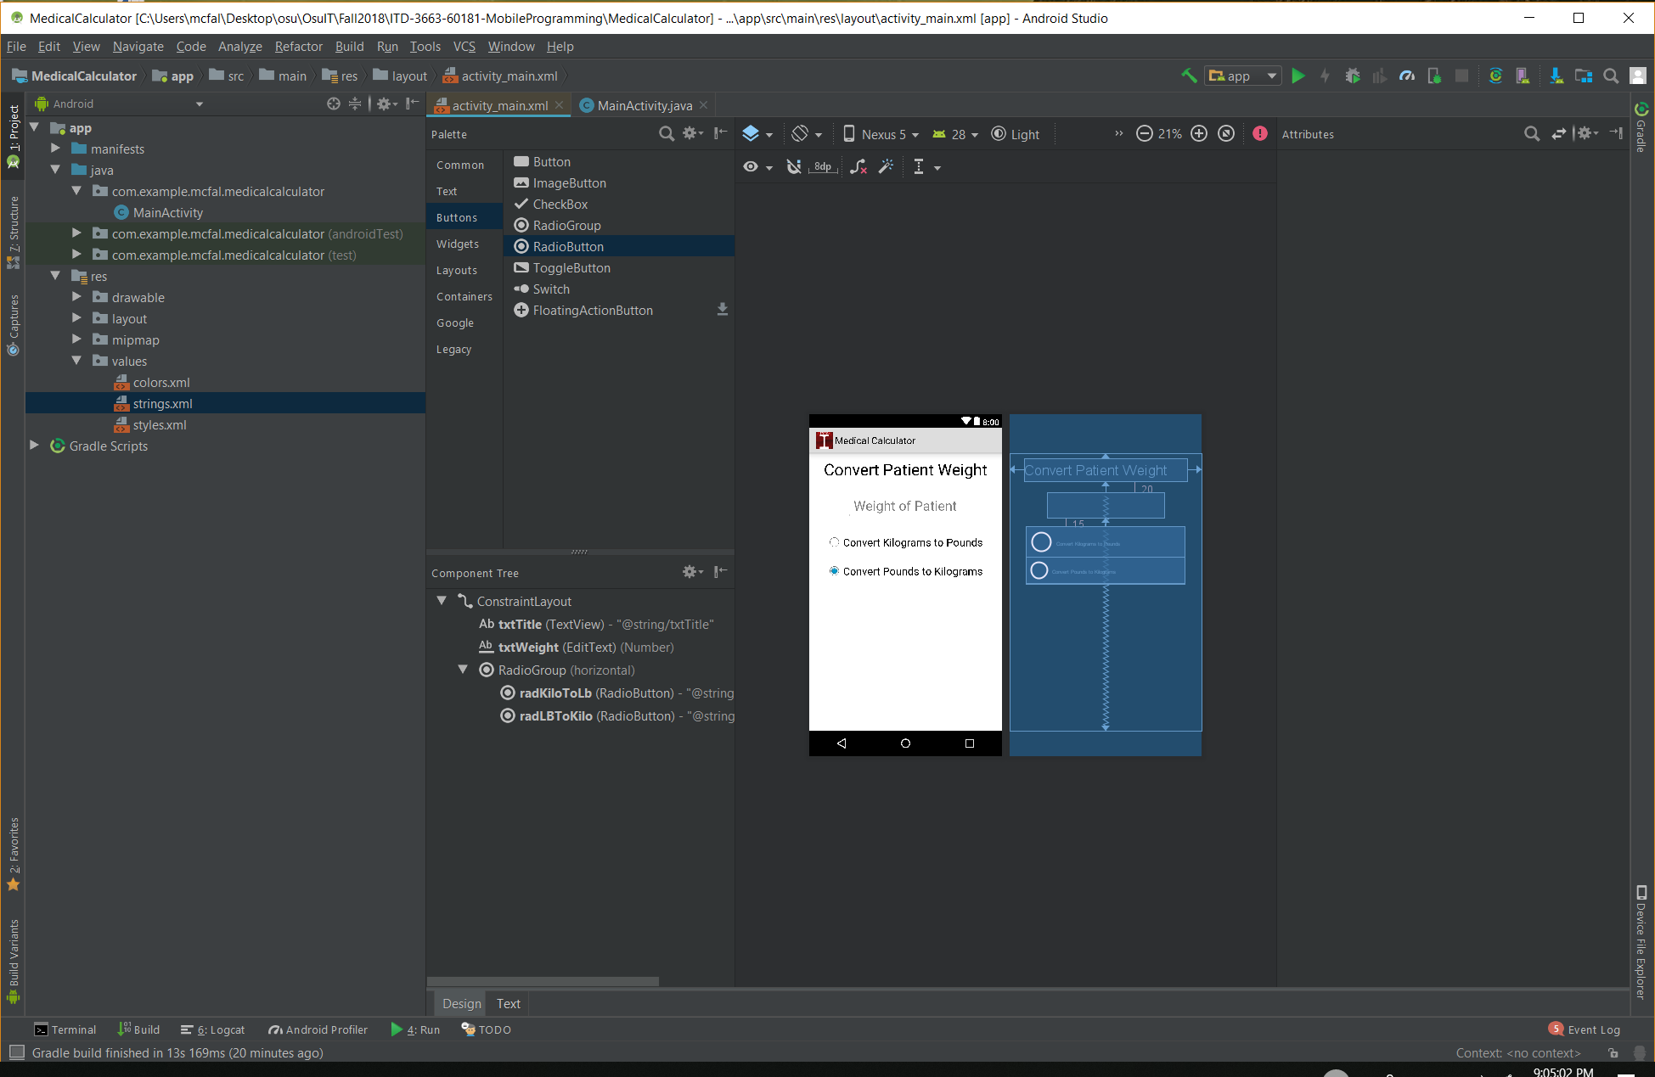

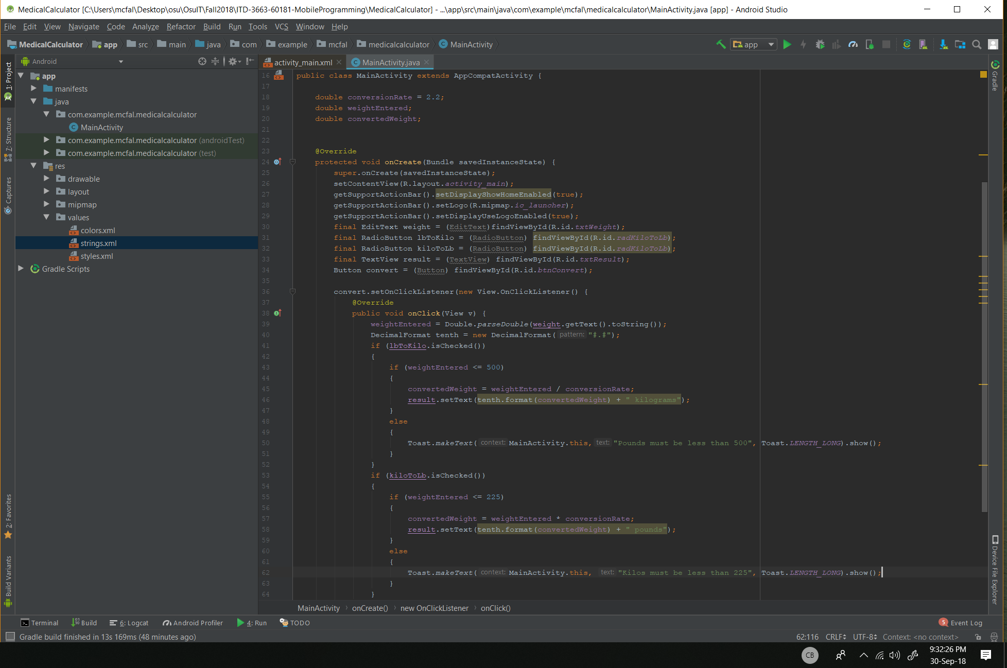

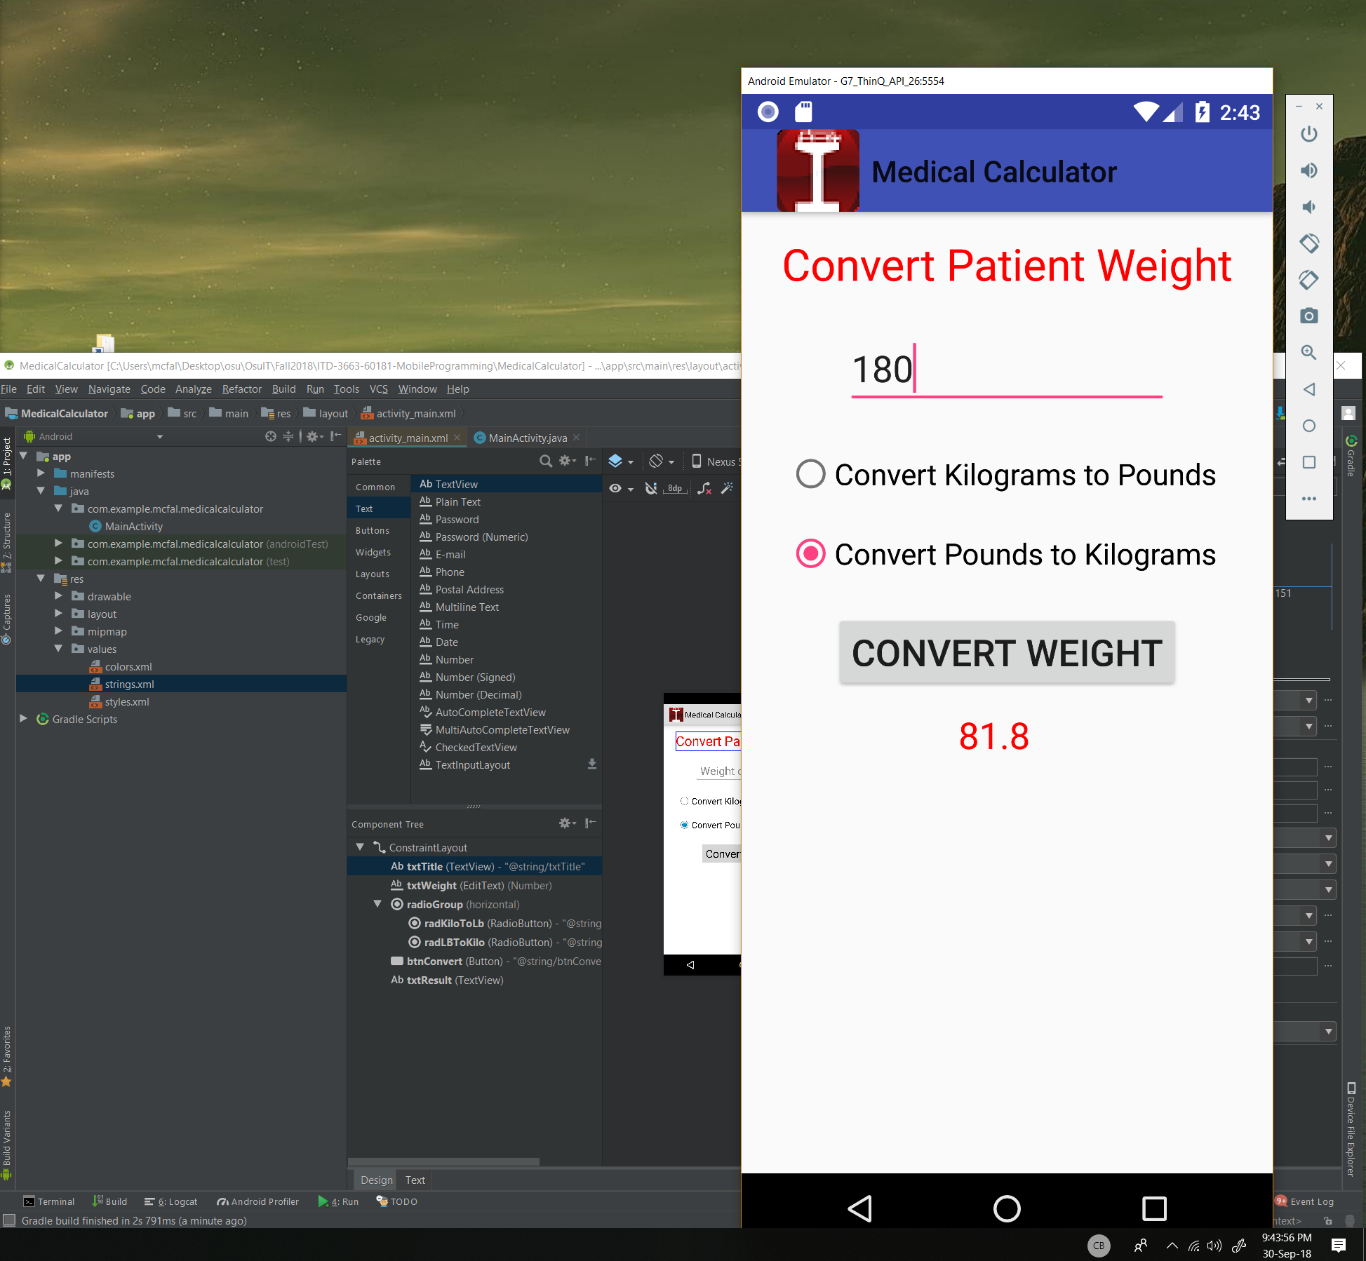

Couldn’t make the icon Circle.