ITD 3663 Mobile Programming Grade **__100__**

Instructor: J. Strother

Student Name: Derrick McFall

Due Date: September 9, 2018

Gradebook Comments: looks good, take more screenshots documenting your work/progress.

## Module One Hello World

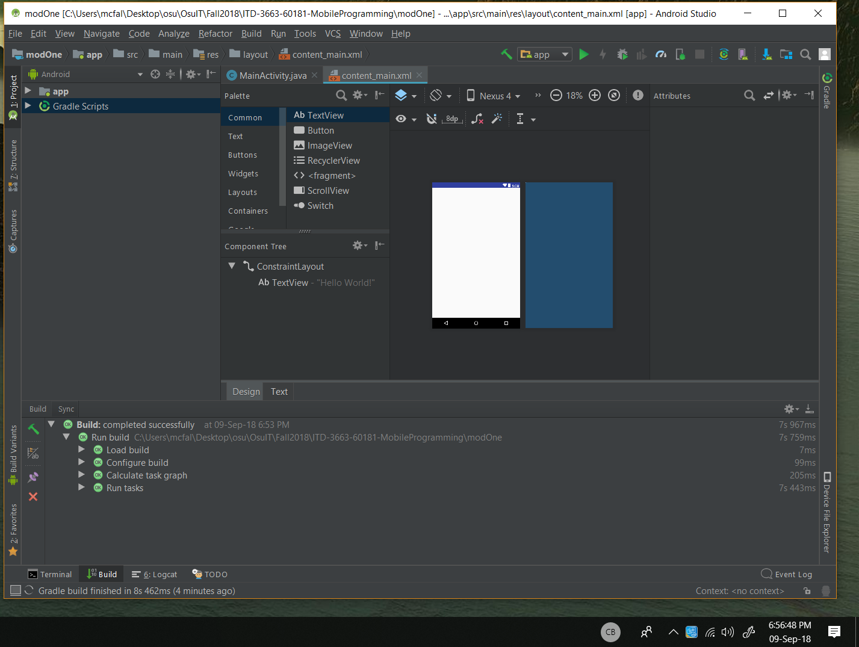

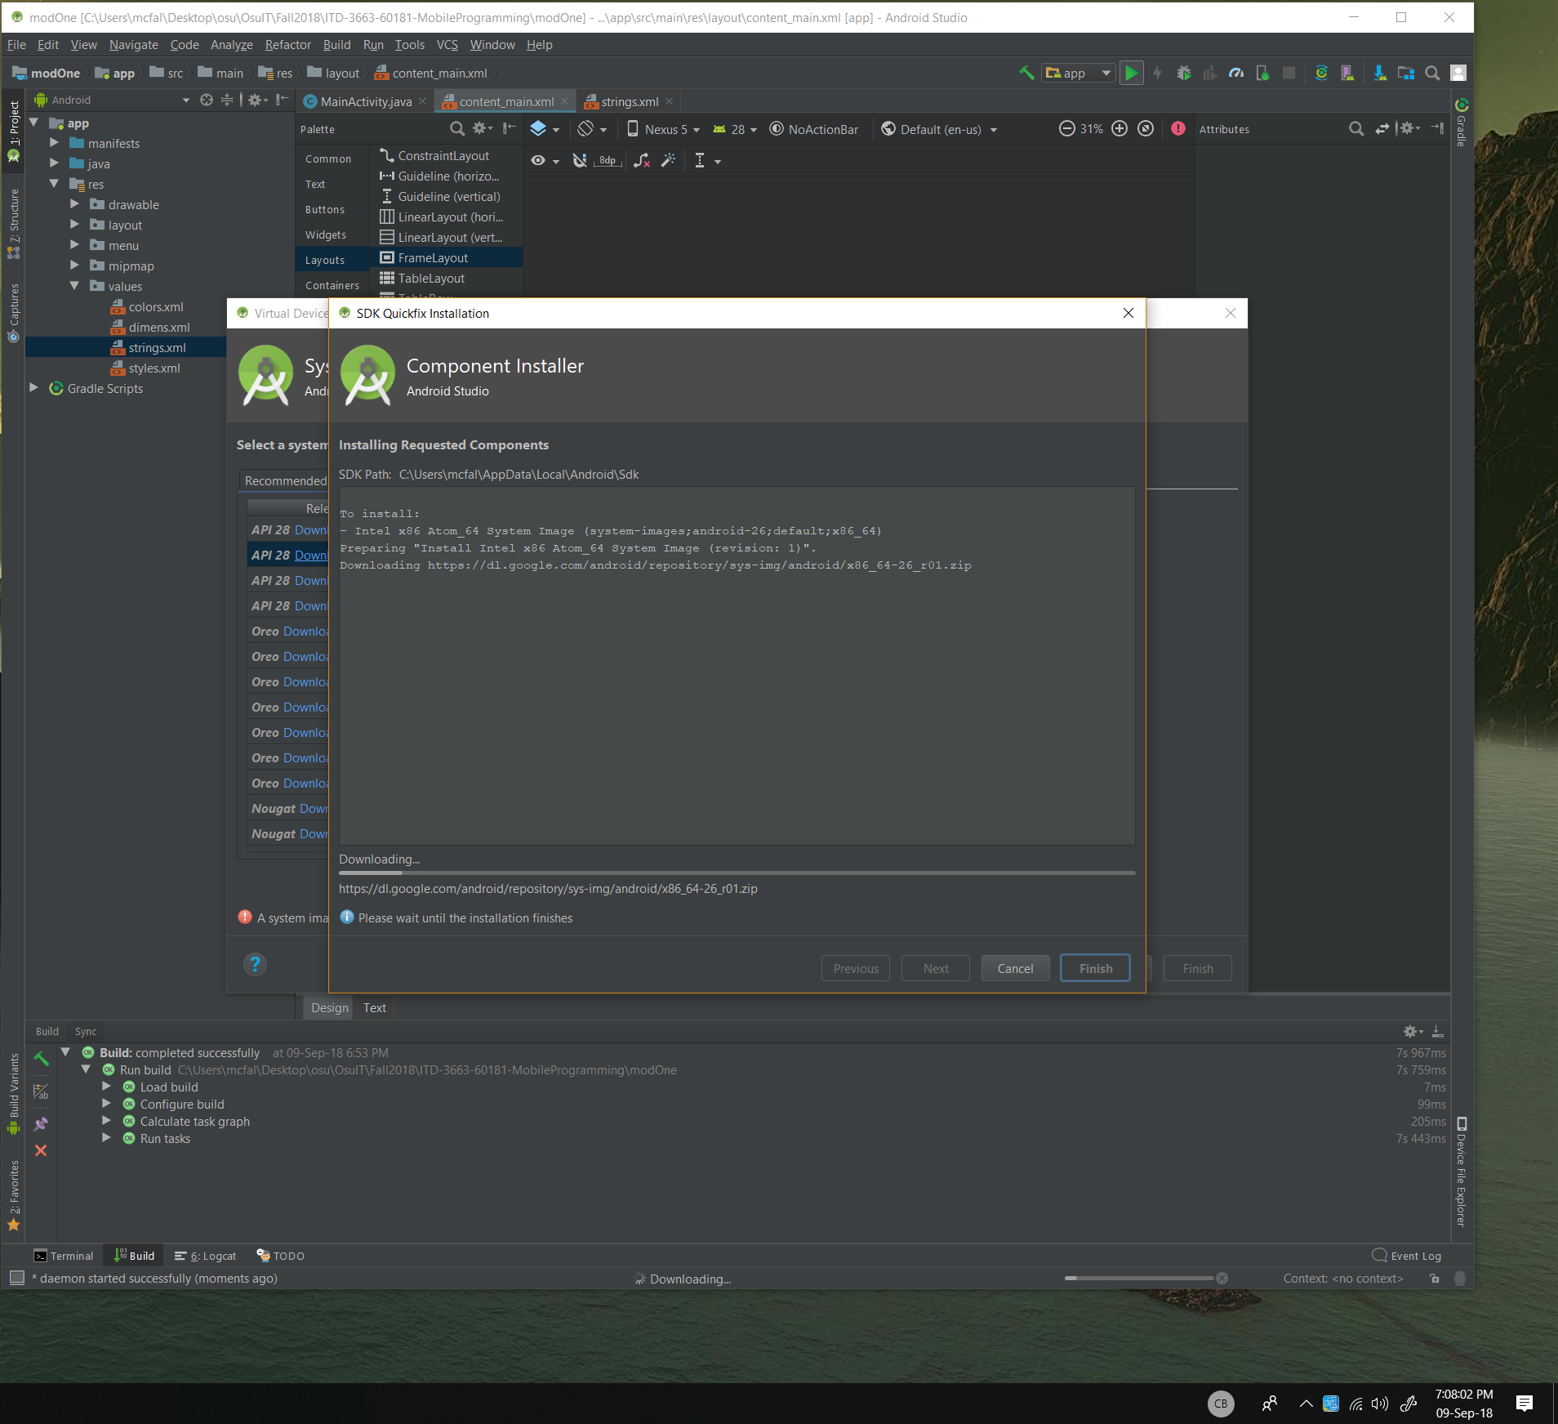

I am installing a virtual device the nexus 5

Then I get this:

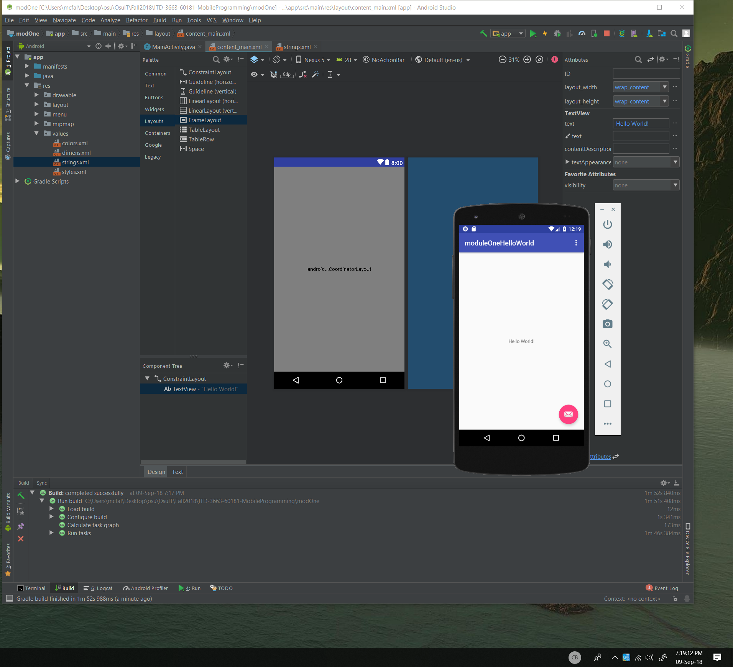

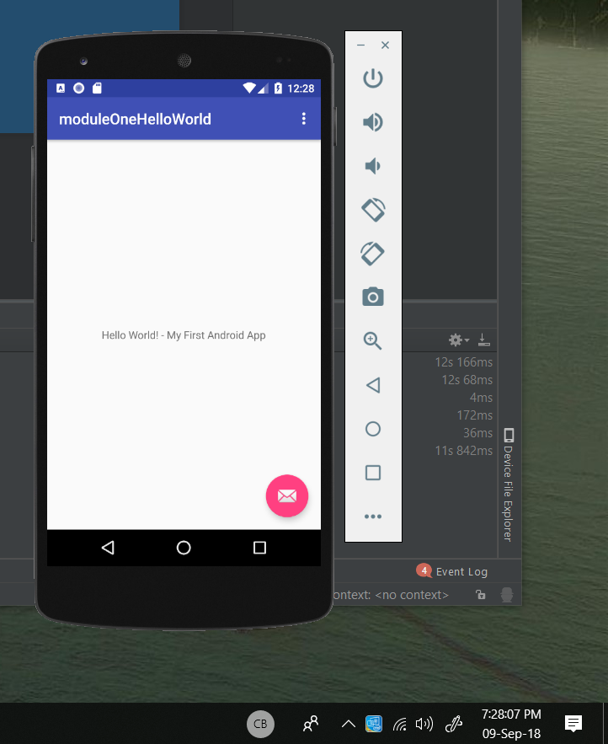

A little tough getting used to a new IDE but I will get the hang of it. So far so good.