ITD 3663 Mobile Programming Grade **__100__**

Instructor: J. Strother

Student Name: Derrick McFall

Due Date: October 21, 2018

Gradebook Comments: looks good

## Module Seven Endangered Species

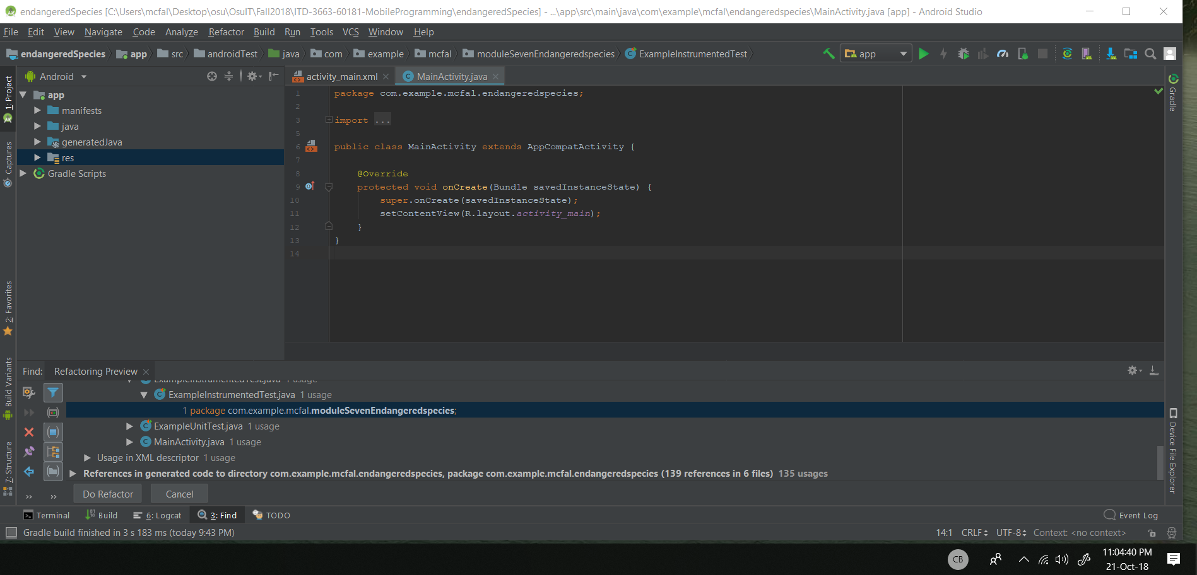

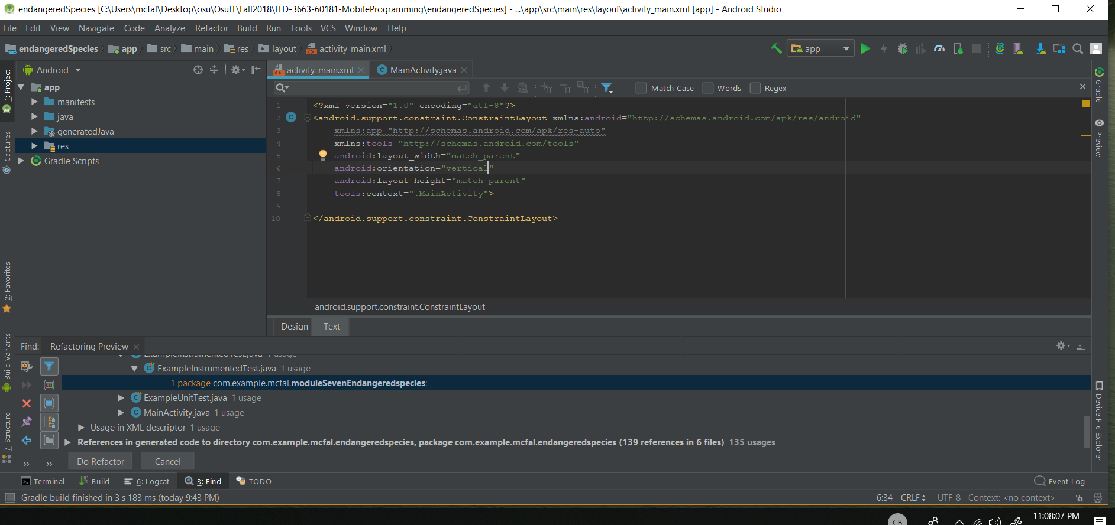

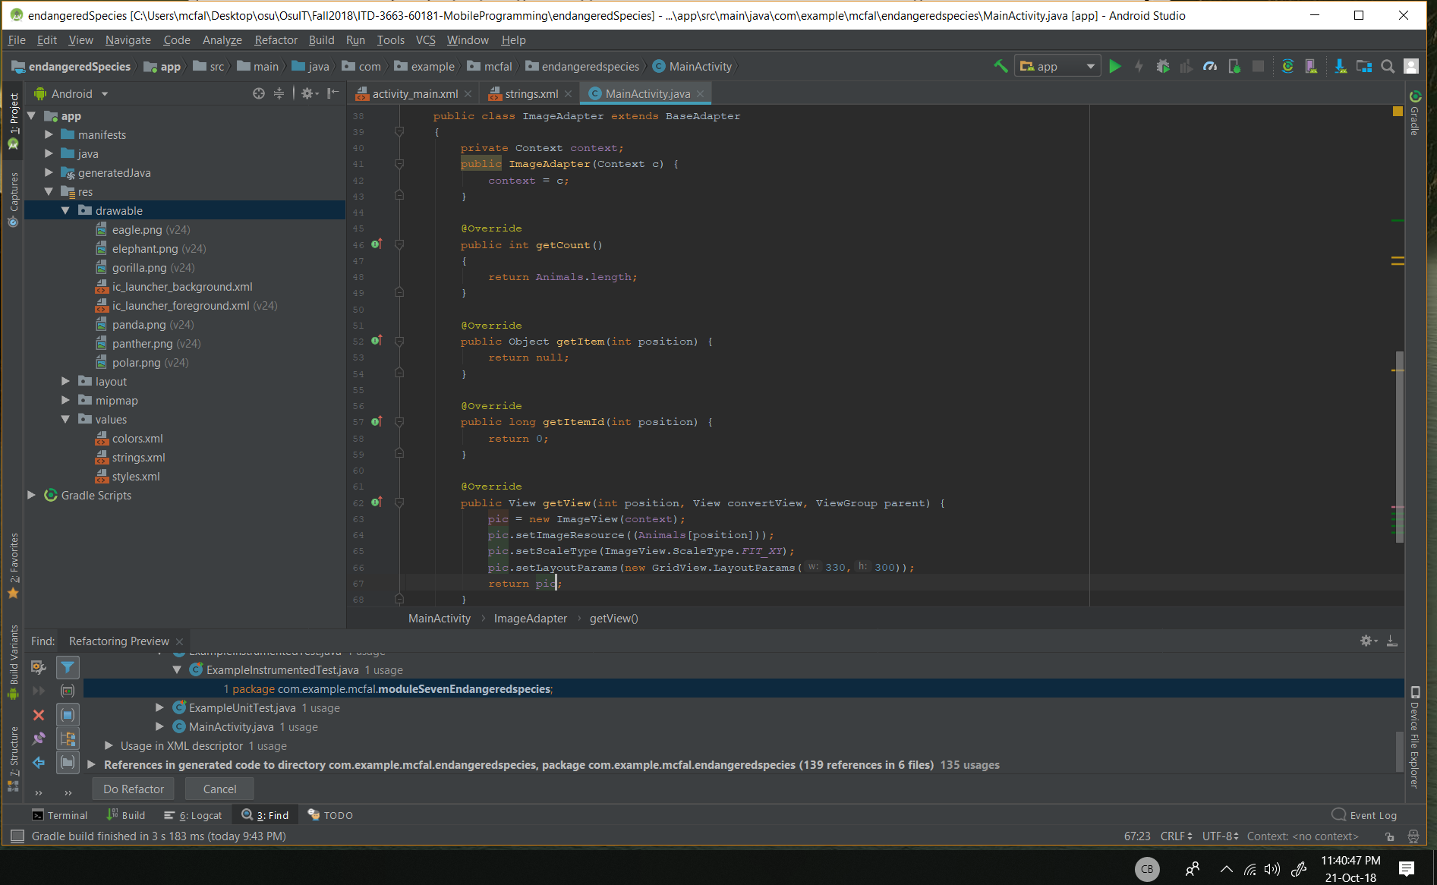

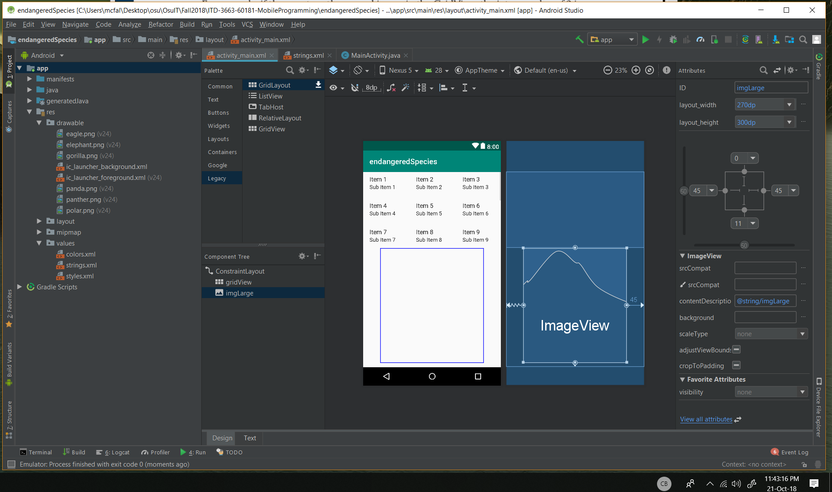

After the code is entered, I just have to go the views and add margins so that they don’t overlap each other.

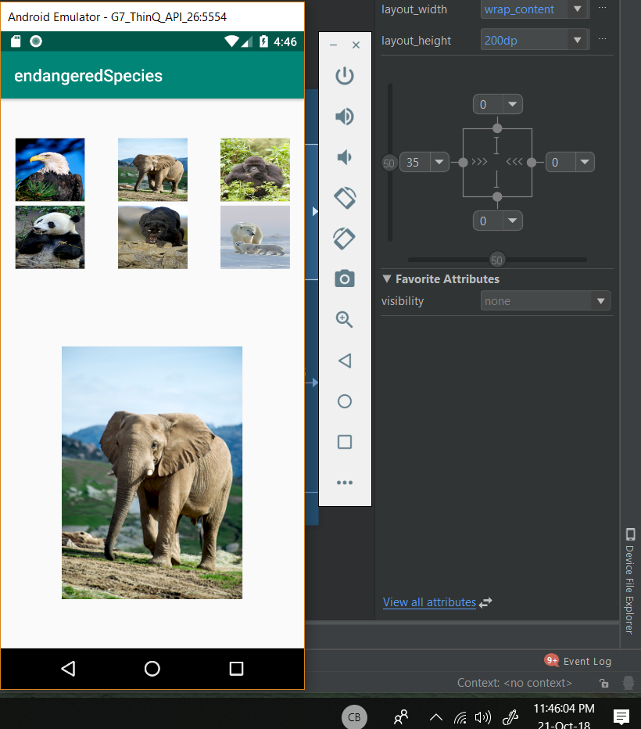

The app works as expected, but I did have to add a left margin padding to the gridView in order for it to be centered.

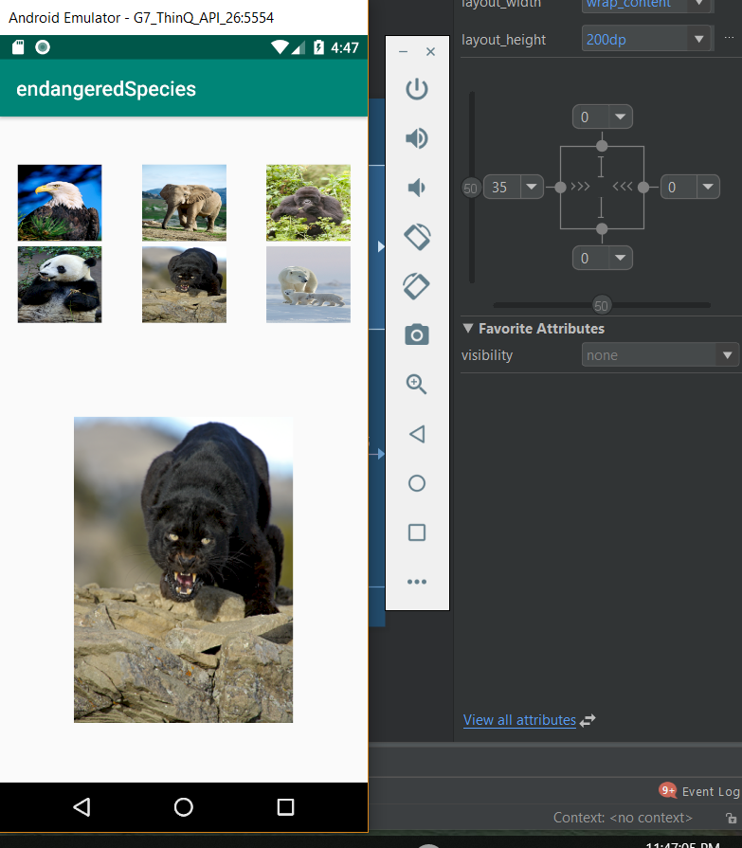

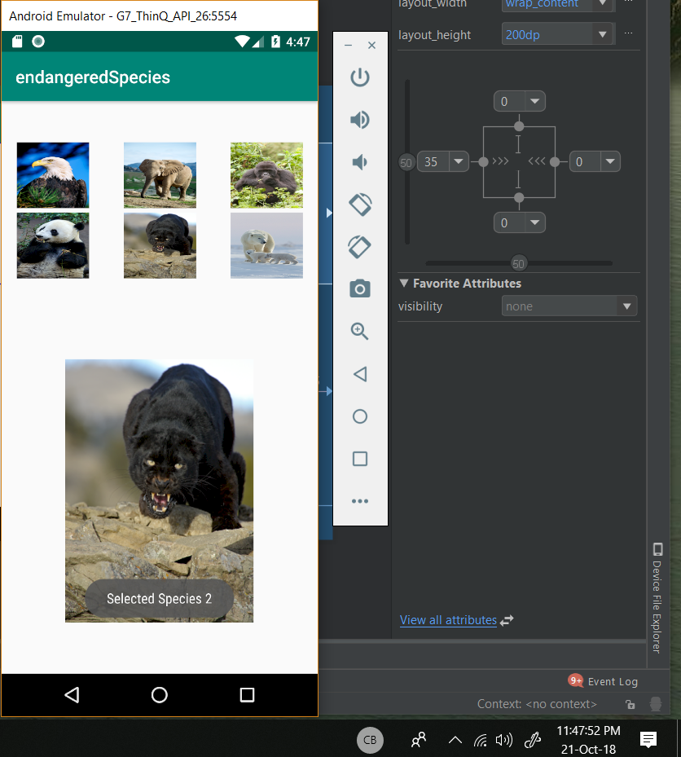

This one shows the Toast message working as expected as well as the photo change.