ITD 3663 Mobile Programming Grade **__90__**

Instructor: J. Strother

Student Name: Derrick McFall

Due Date: December 2, 2018

Gradebook Comments: overall good, needed to show your screen with the data entry.

## Module Thirteen Limerick

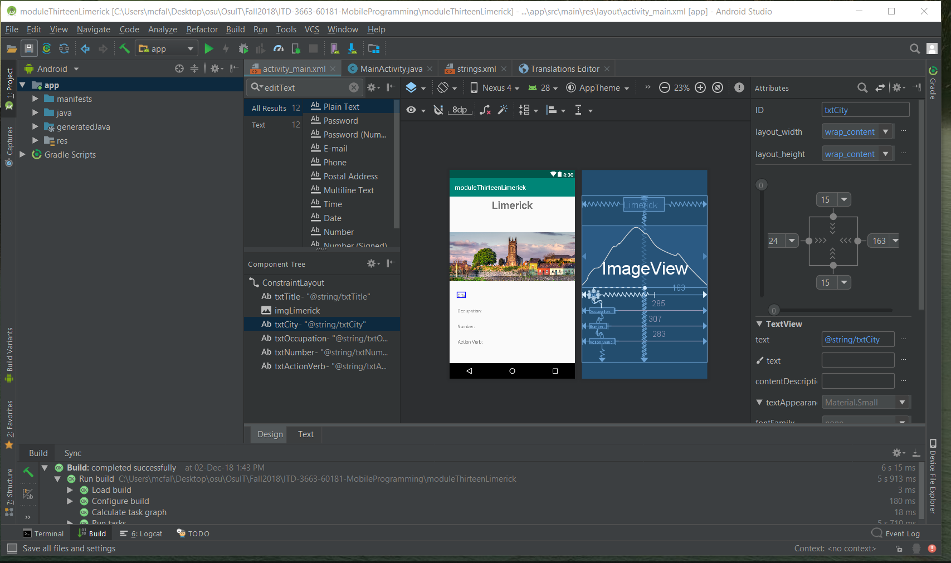

Created the project and am adding in the text fields as specified by page 454 in the book.

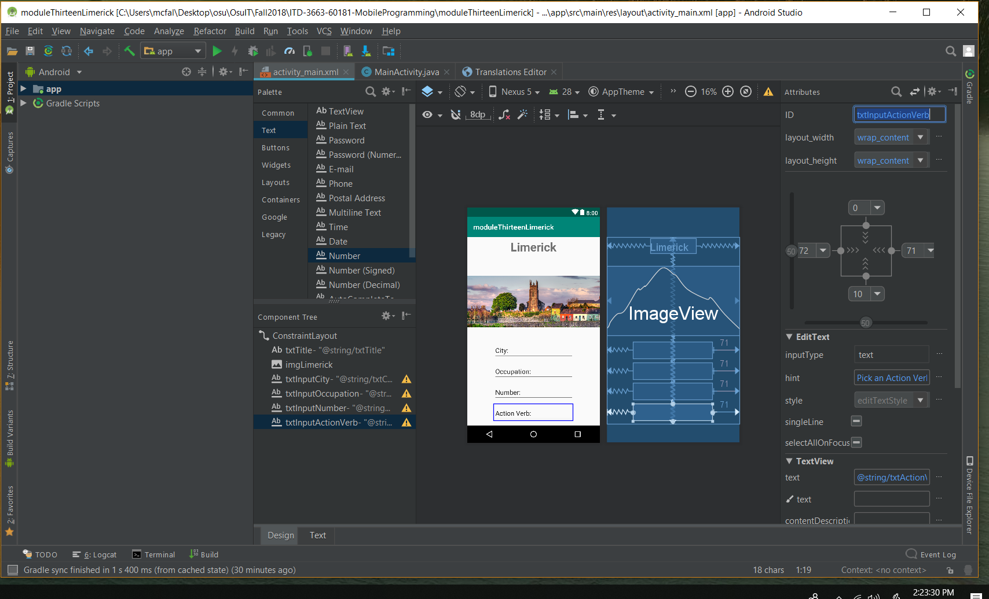

Seemed easier to use the same text for input and description.

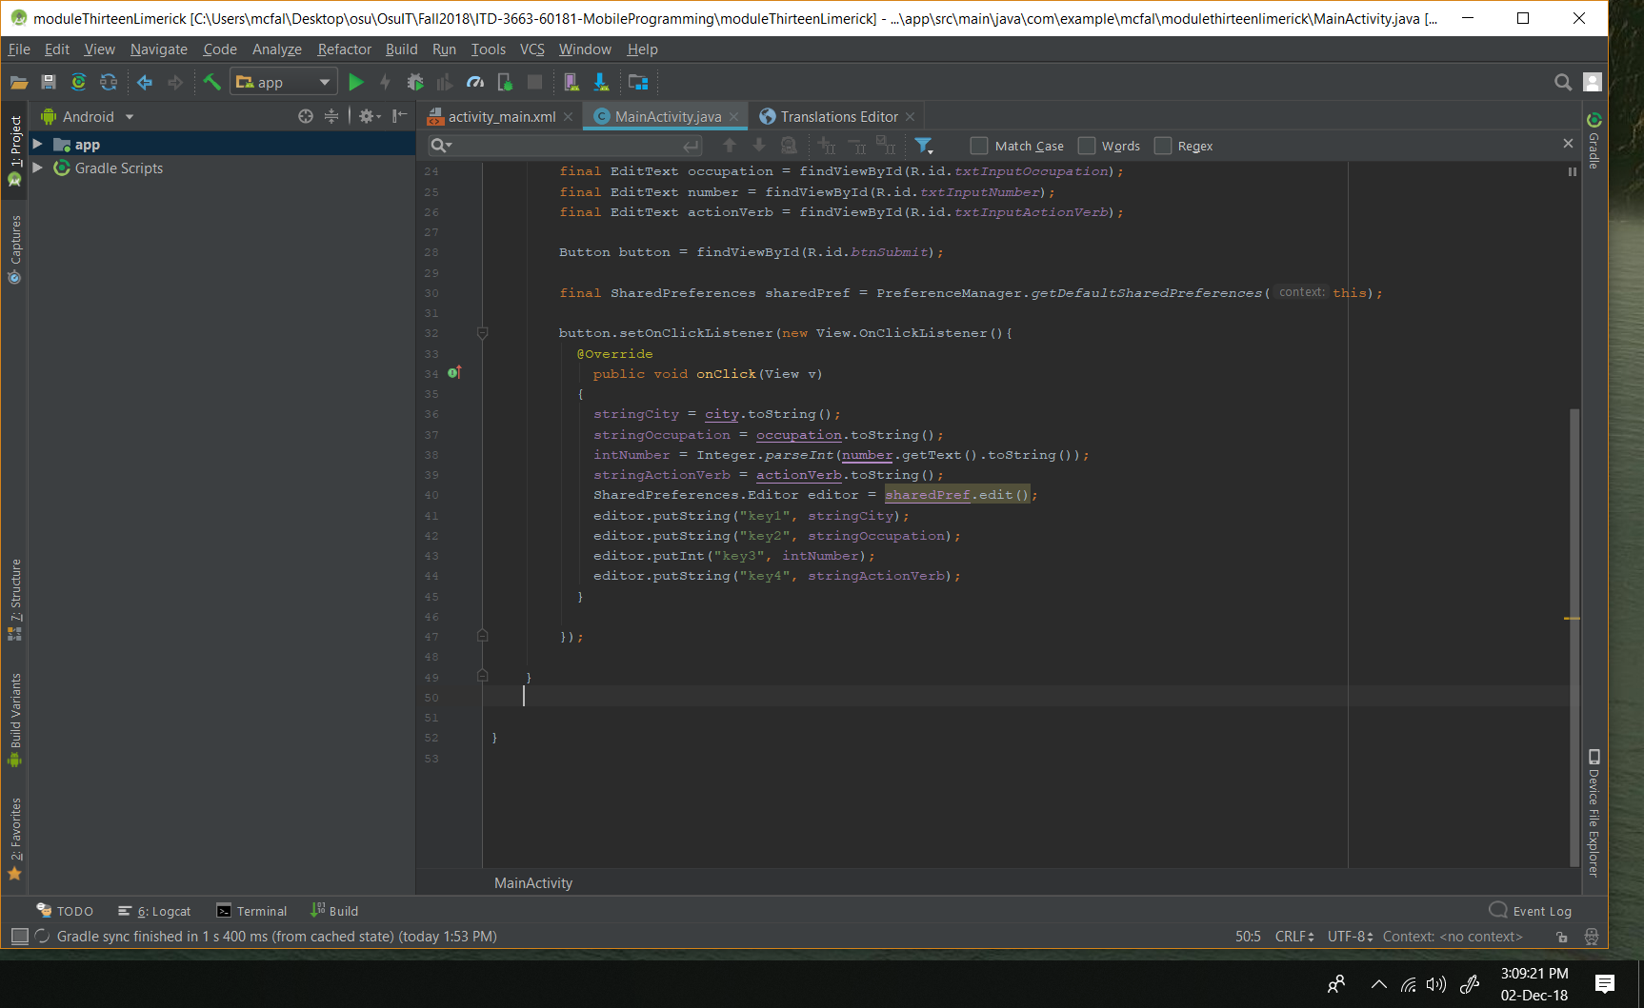

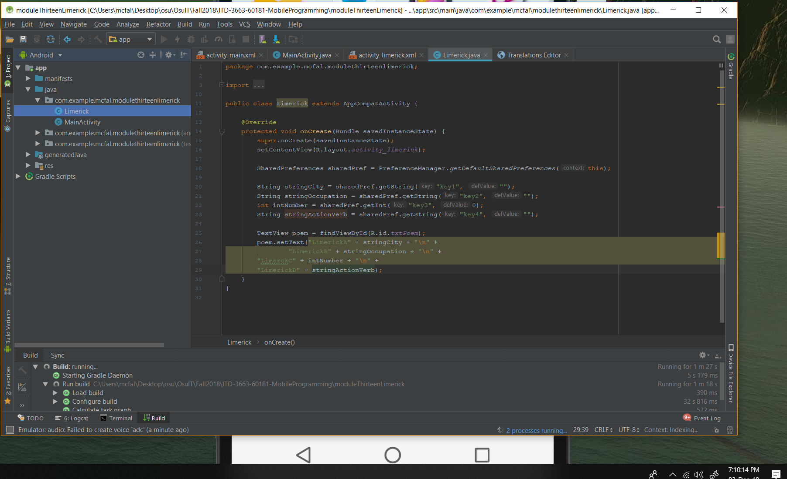Testing to make sure the text view can just be set to whatever text I want.

When I am in ____ I need to pee.

If I were a _____ I would flee.

Since I am ____ everything is okay.

I insist it is what I must say.

On bad days I ____ with a tree.

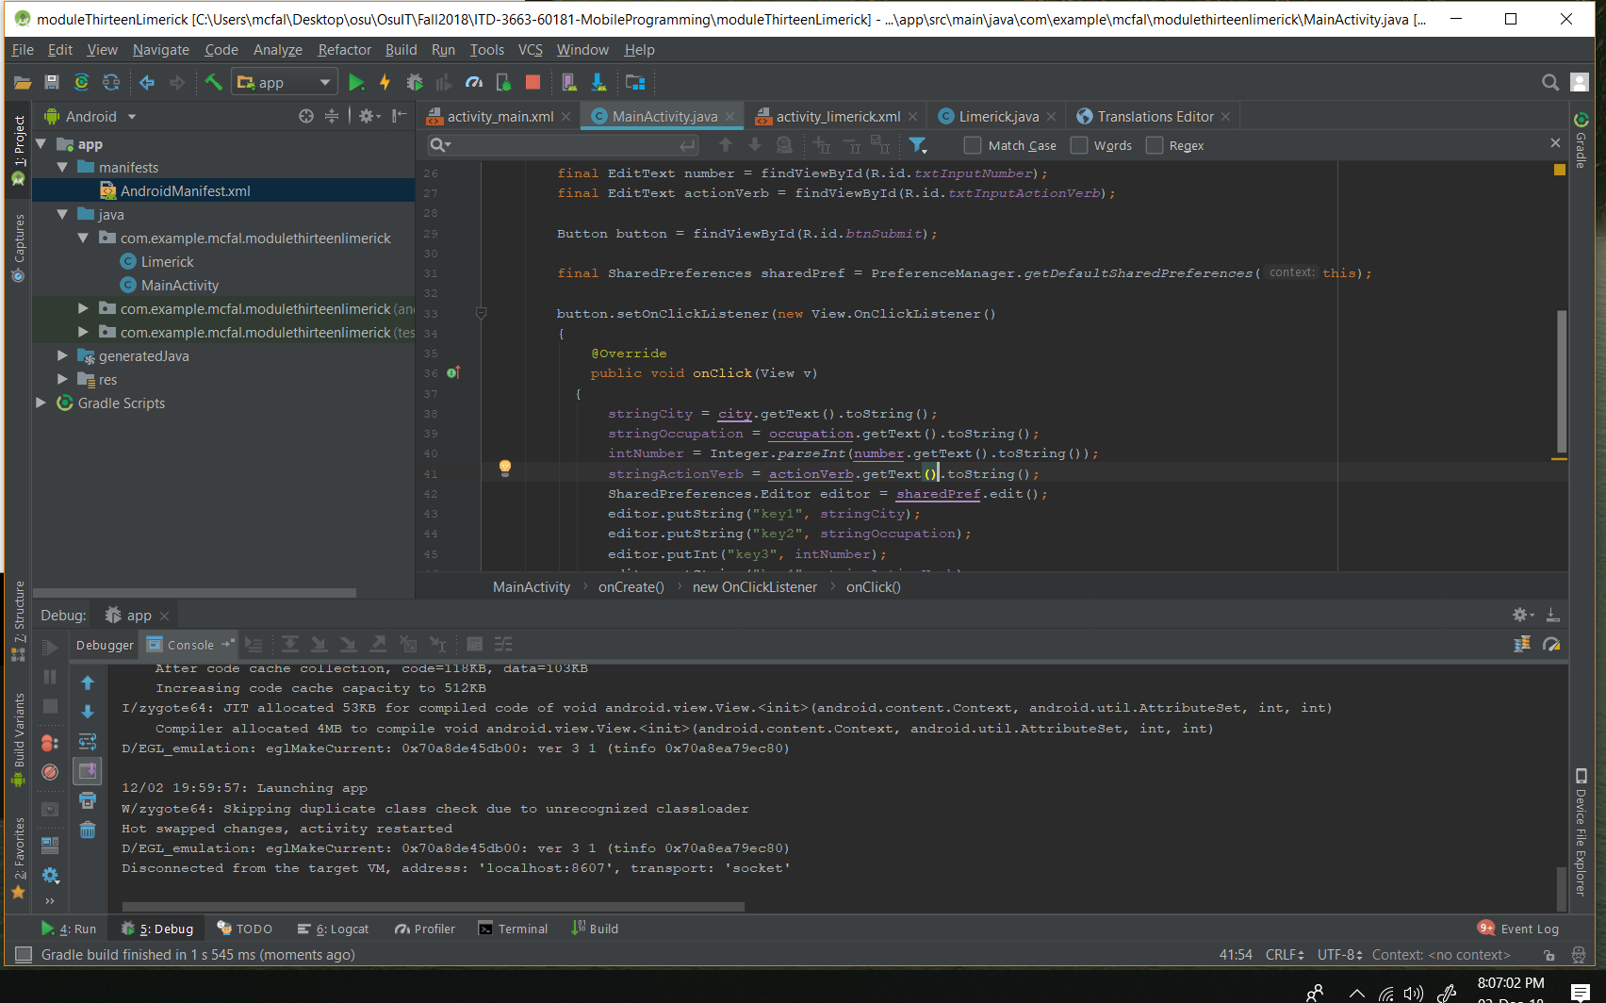

I was having a problem with garbage showing up as my text that the user puts in. I did not have getText().toString() instead I just had toString() initially which caused many problems. Now it seems to be working okay.

