ITD 3663 Mobile Programming Grade **__100__**

Instructor: J. Strother

Student Name: Derrick McFall

Due Date: September 23, 2018

Gradebook Comments: app looks great, I will be wanting more screenshots showing your progress on future projects.

## Module 3 Concert Tickets

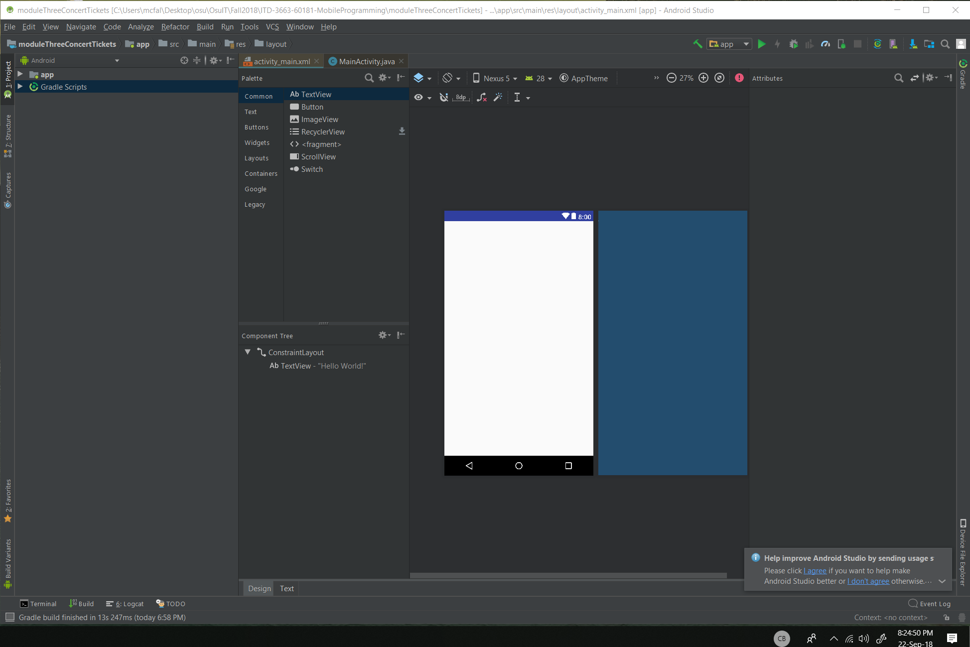

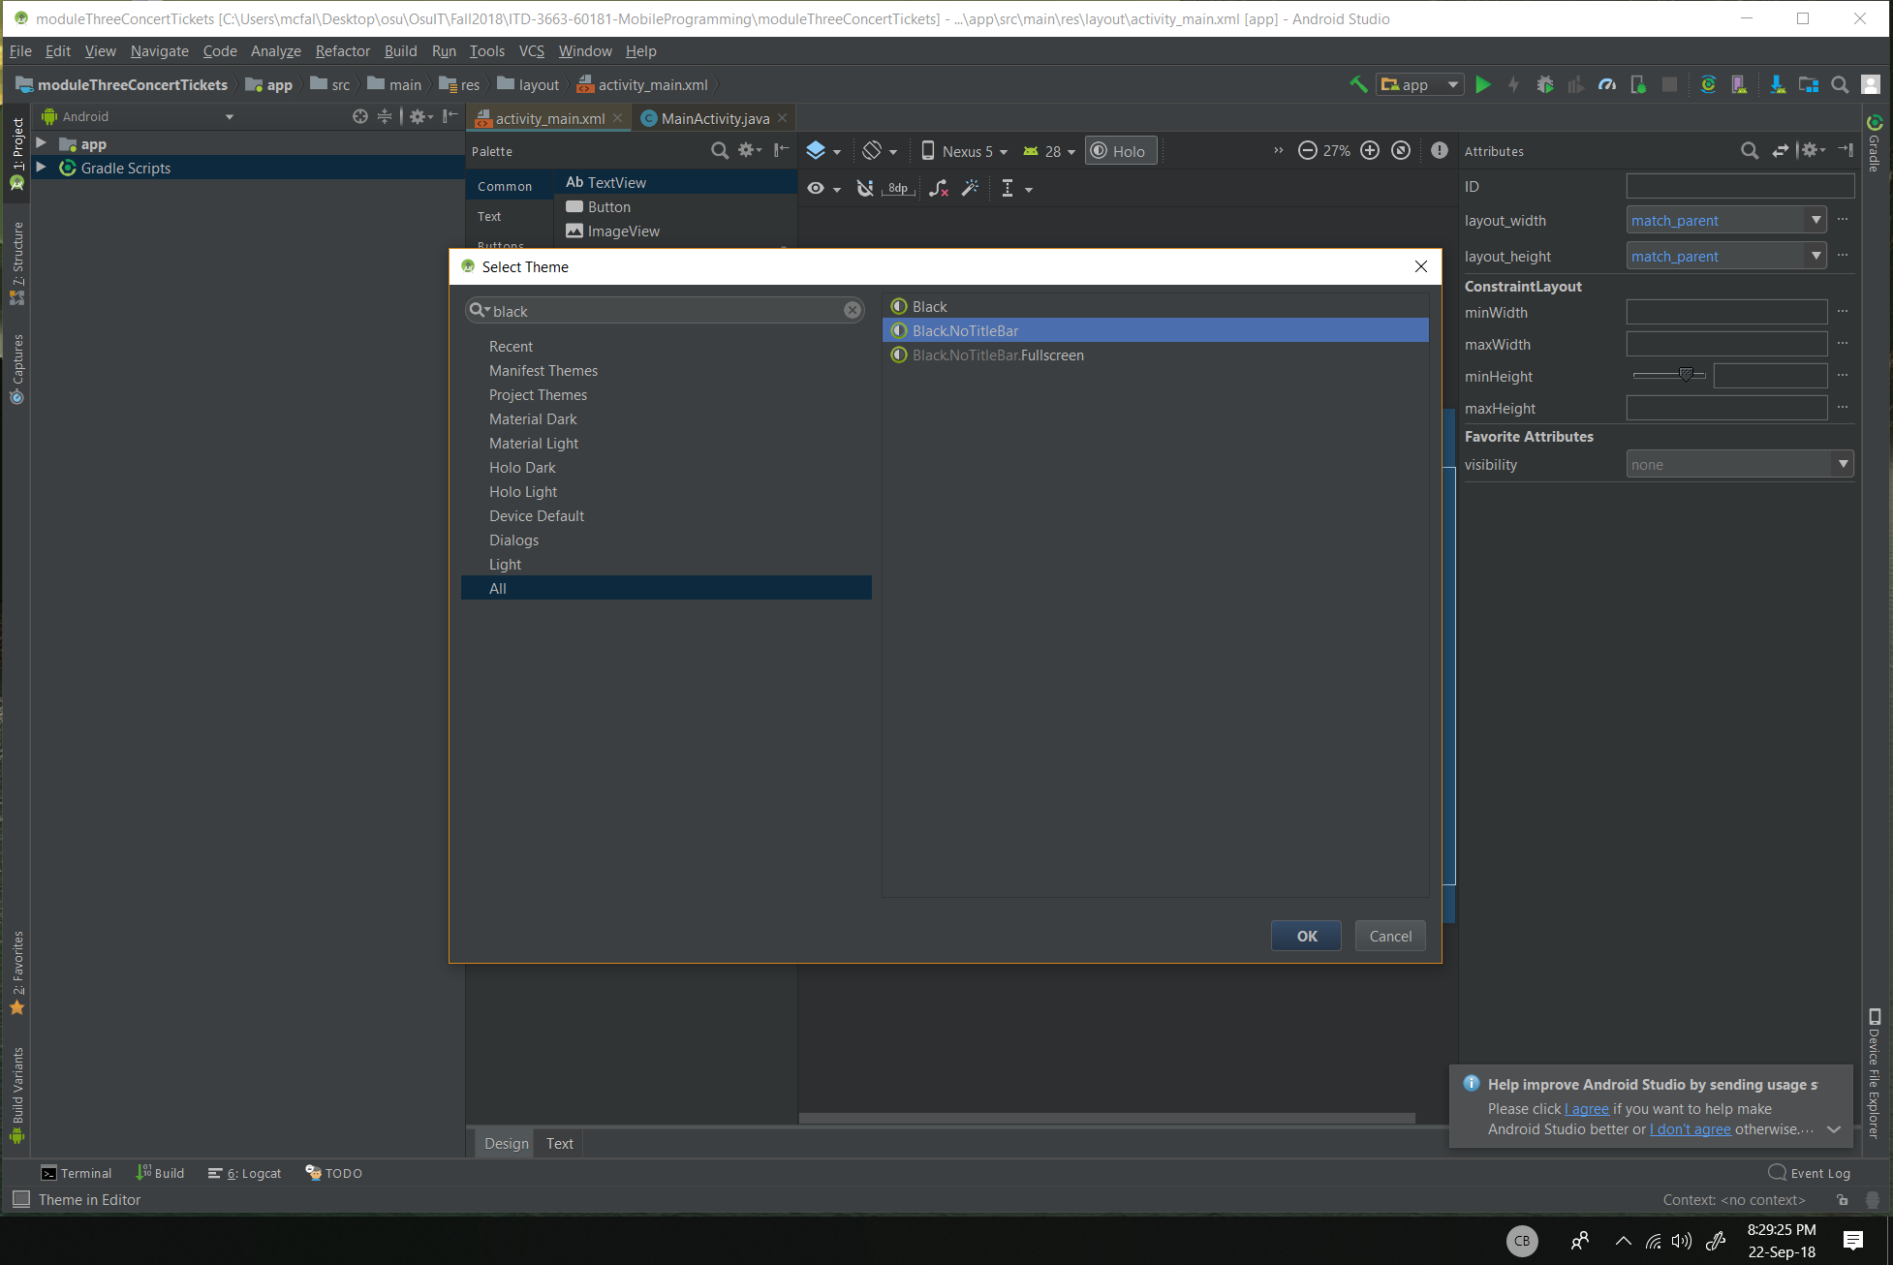

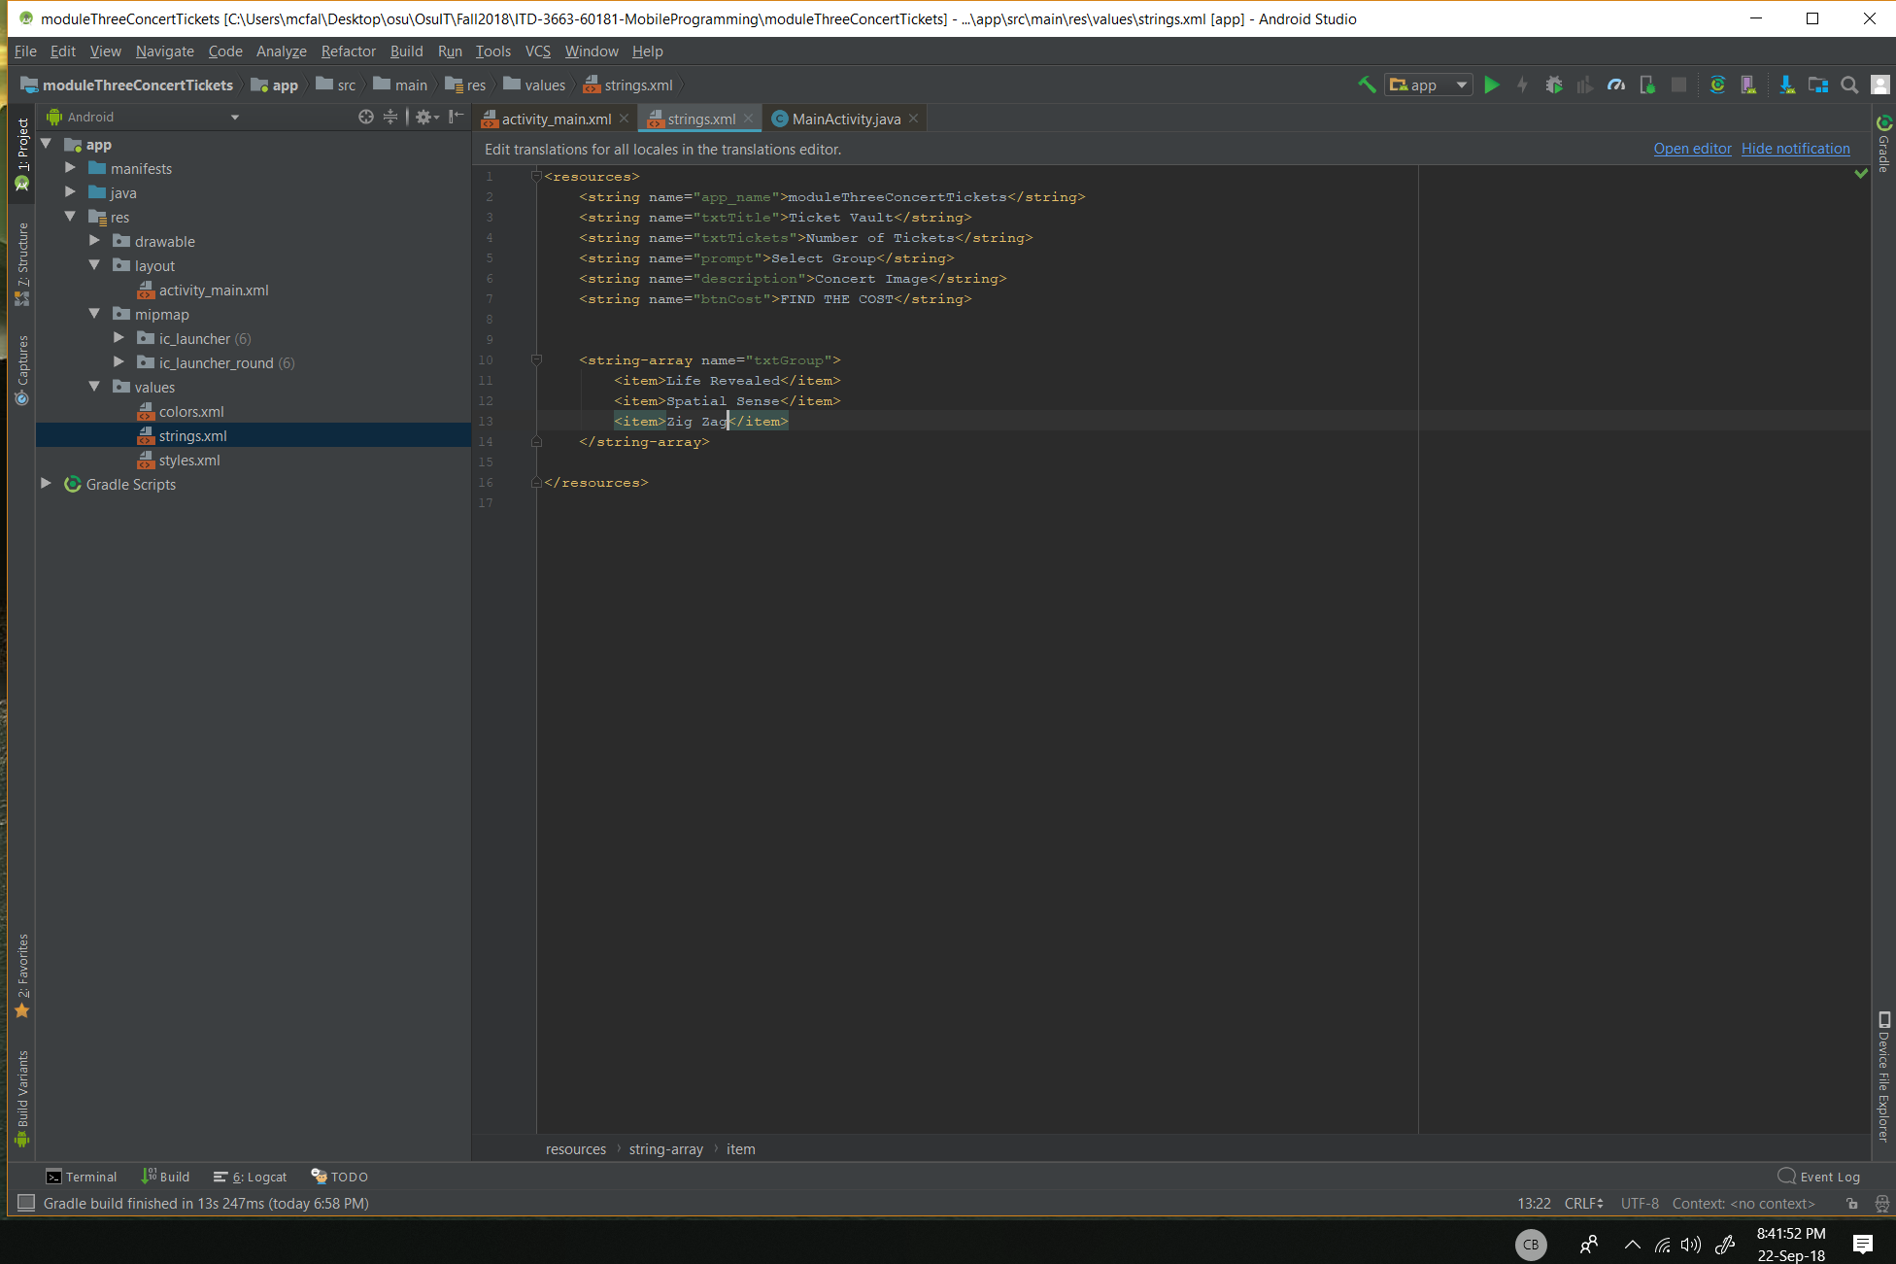

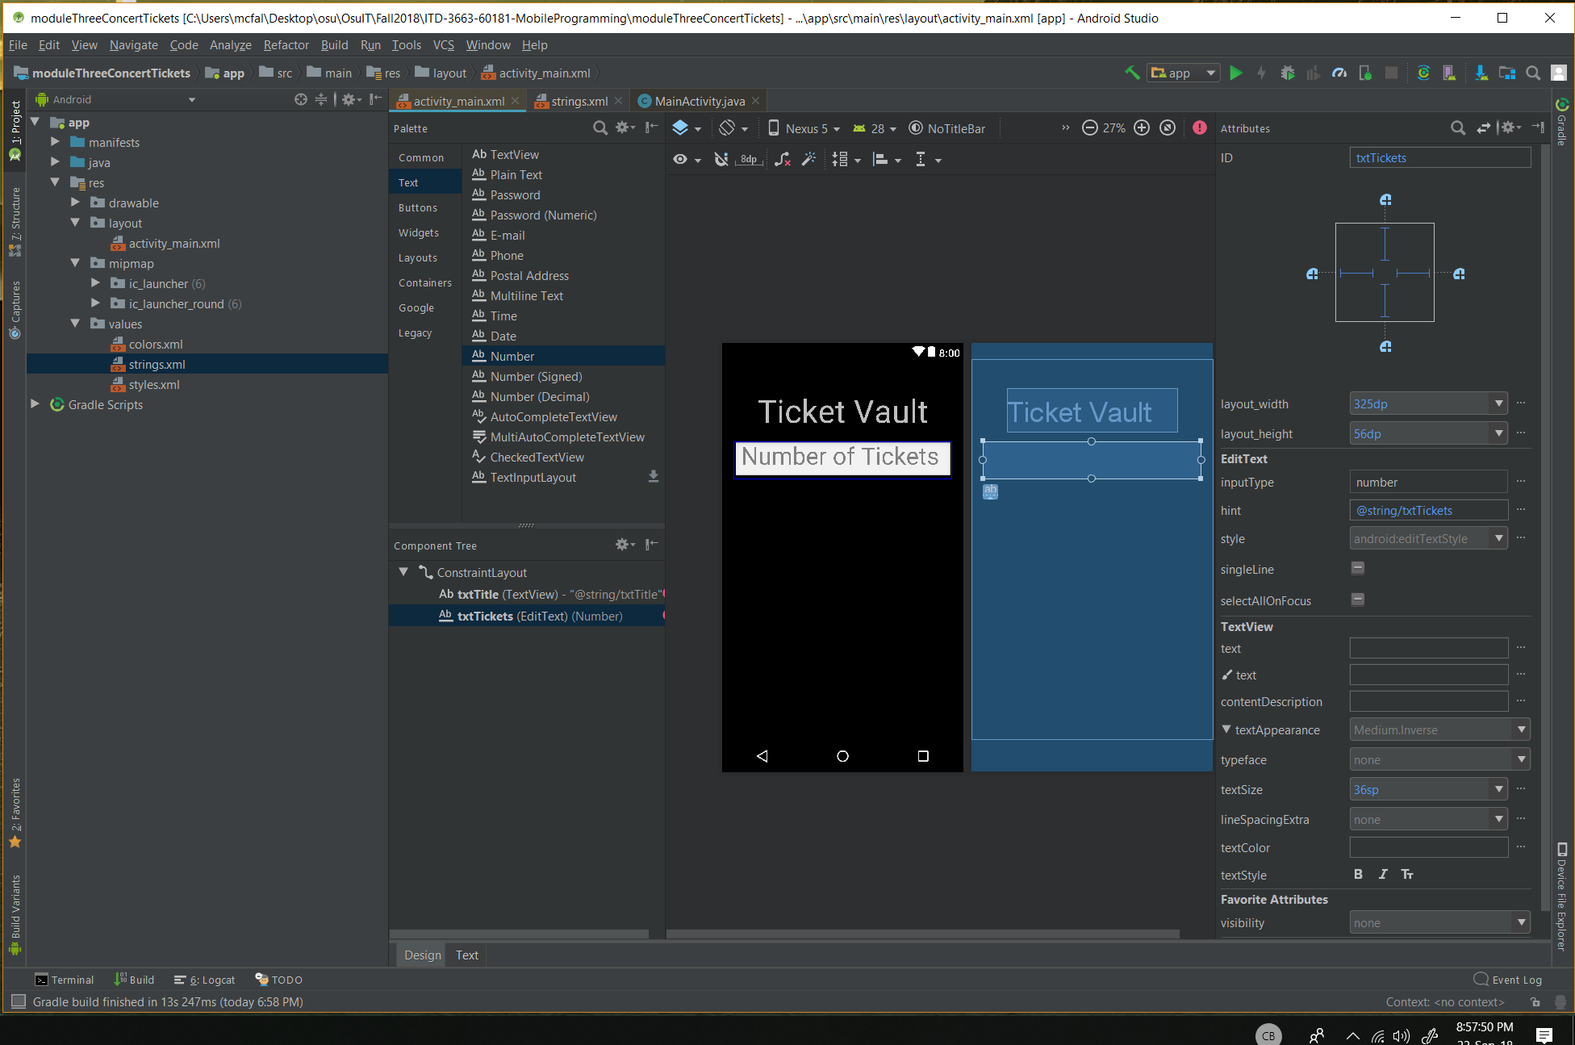

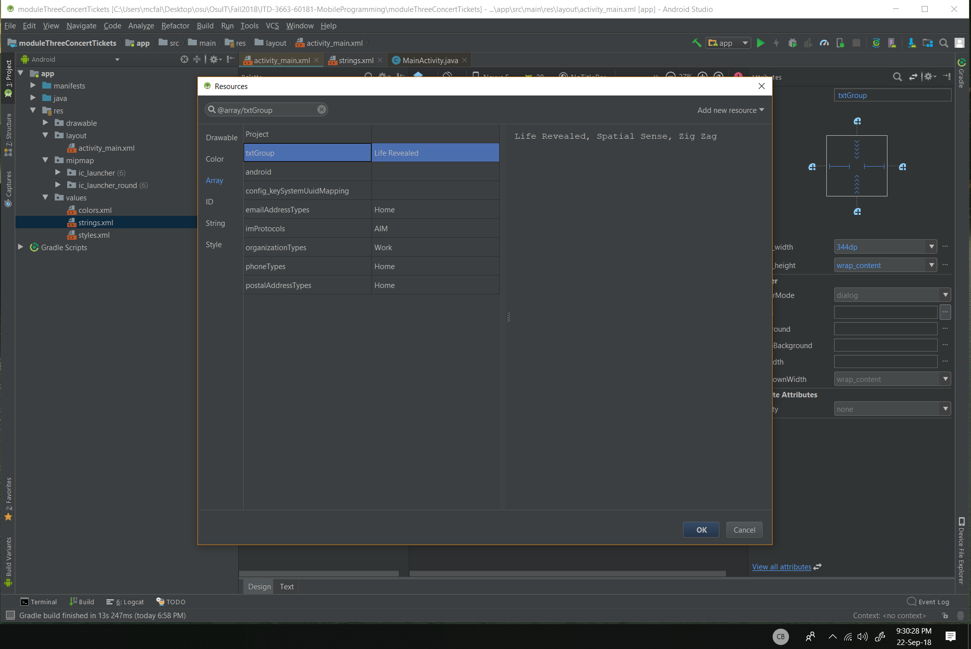

This step seemed a little different from what was shown in the book but I think it is to be expected that updated software happens so often there is no way this could match exactly the book. The prompt property wasn’t there so I just skipped it. Also the dialog option was set by default. Maybe they realized the most frequently used options should just be default.

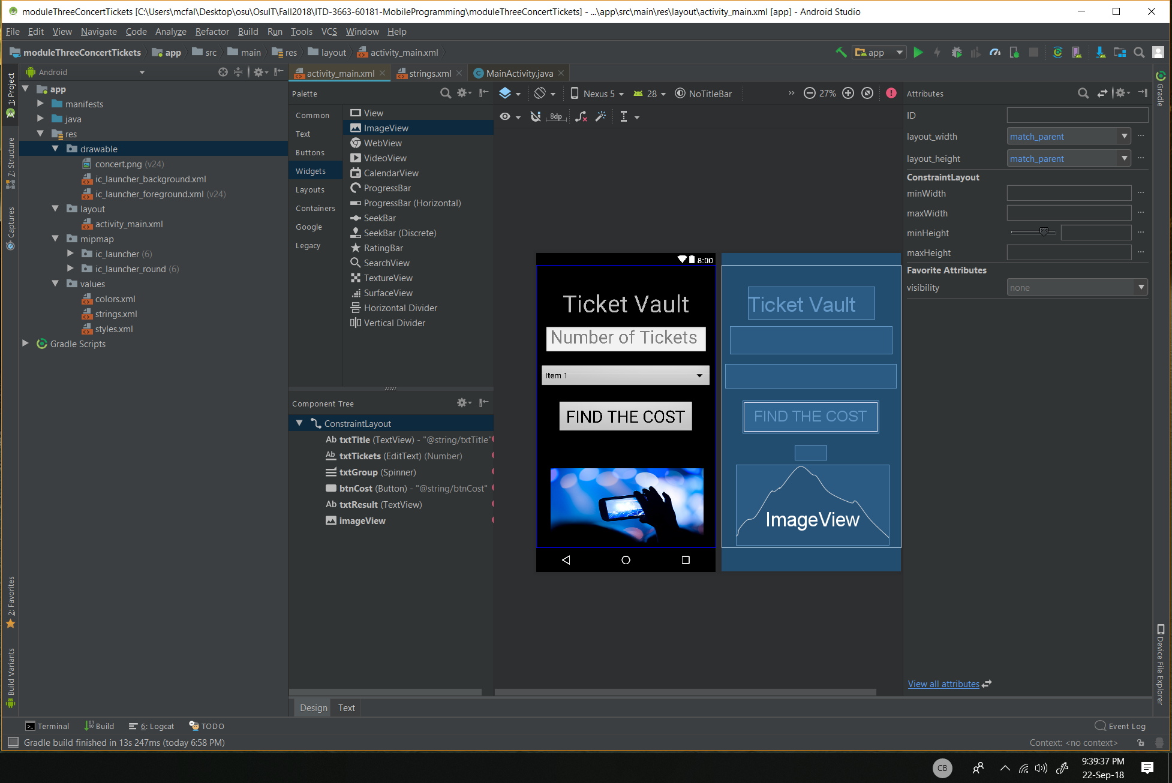

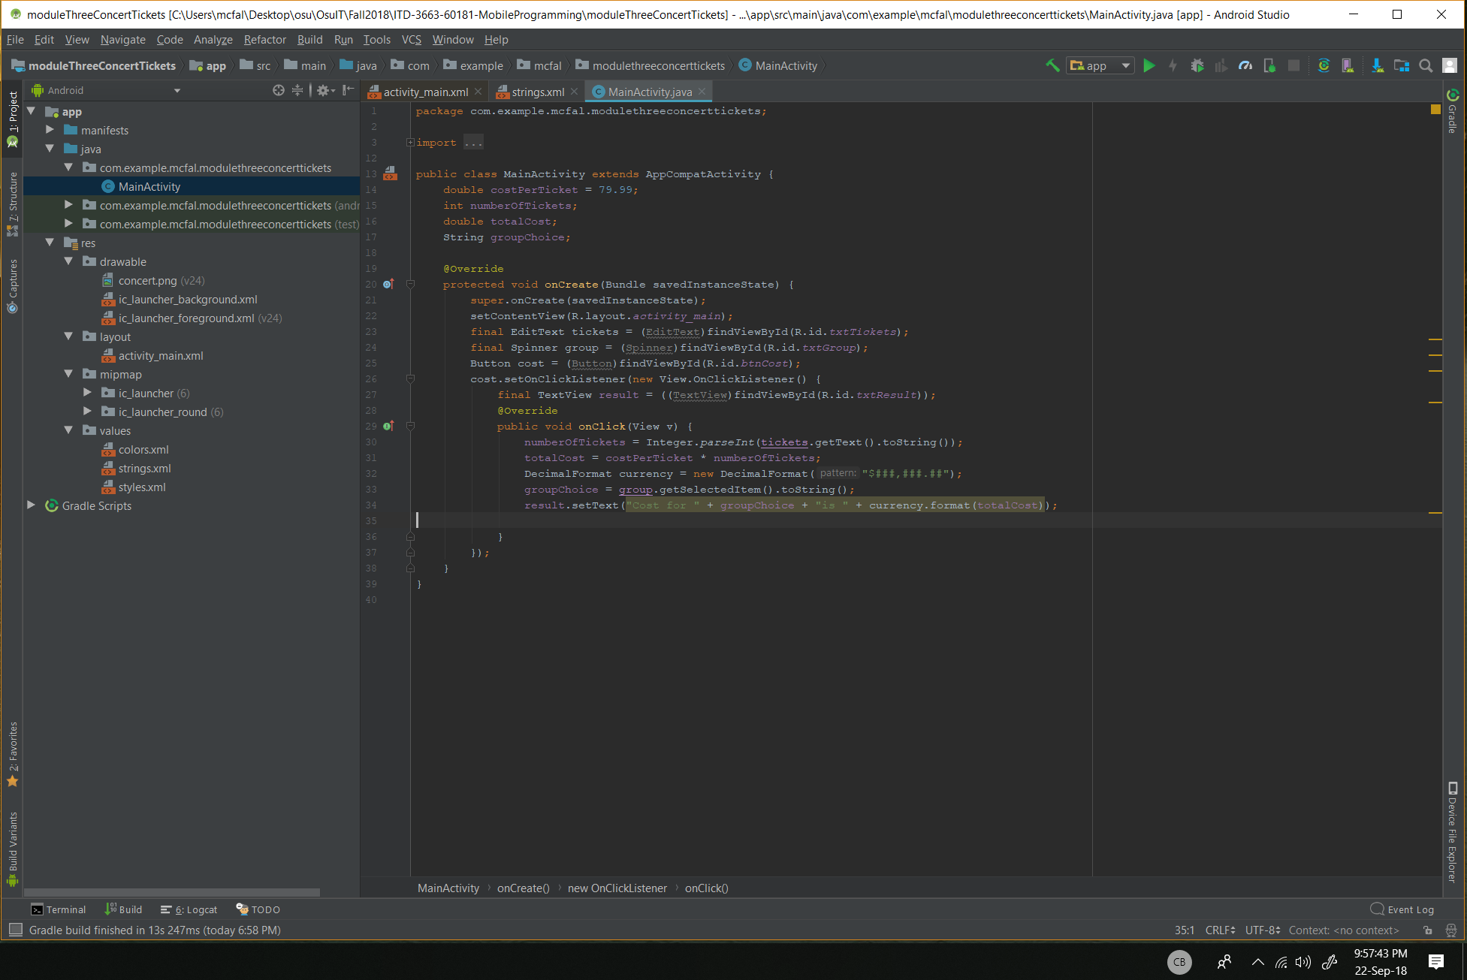

Got a warning here,

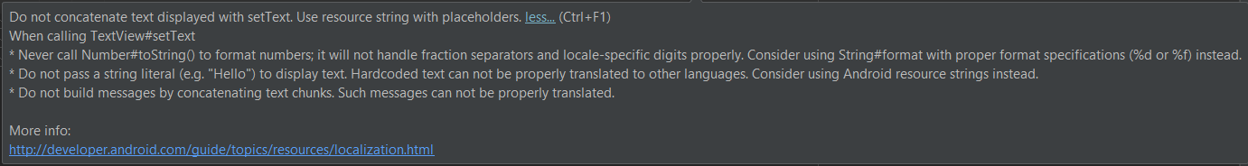

About concatenating text displayed with setText. Will ignore for now.

