ITD 3663 Mobile Programming Grade **__100__**

Instructor: J. Strother

Student Name: Derrick McFall

Due Date: November 25, 2018

Gradebook Comments: nice job

## Locale Module Twelve

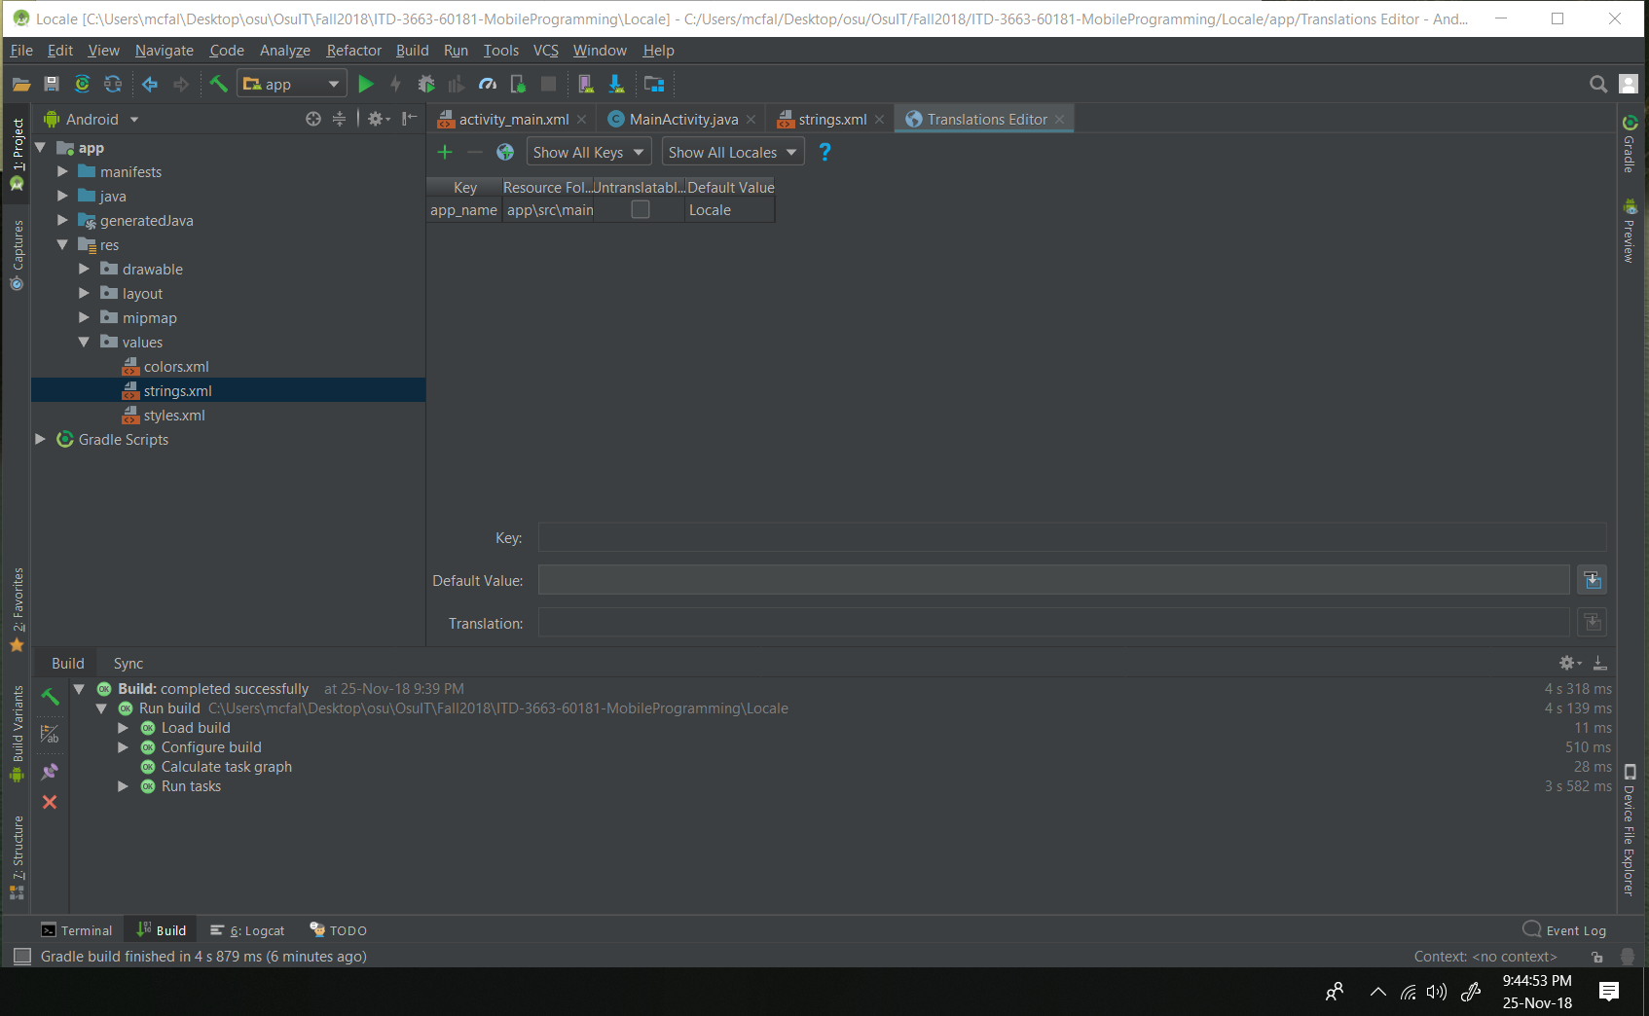

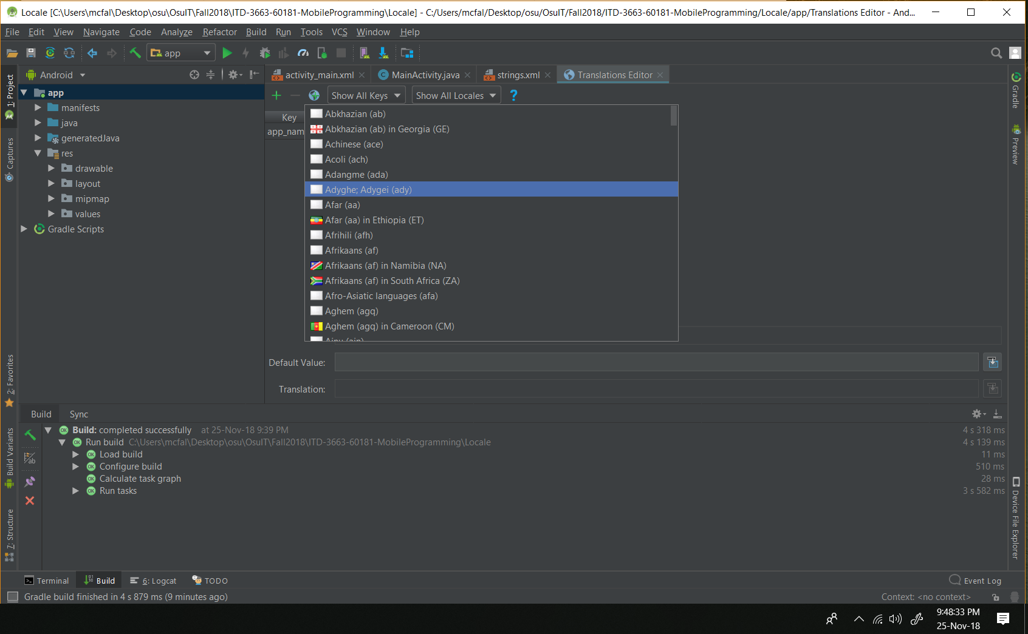

Pg 460:

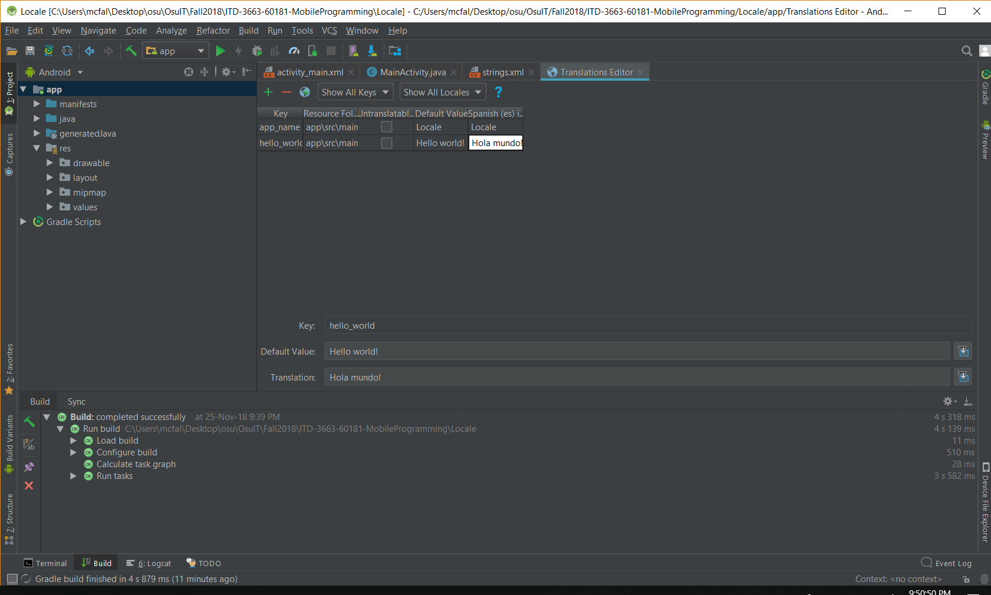

Pg. 462: generate signed bundle.

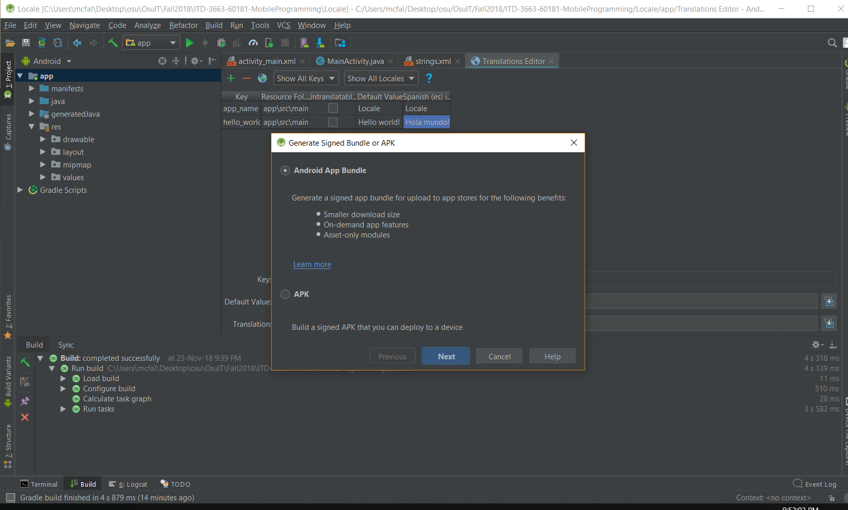

Pg. 463-465:

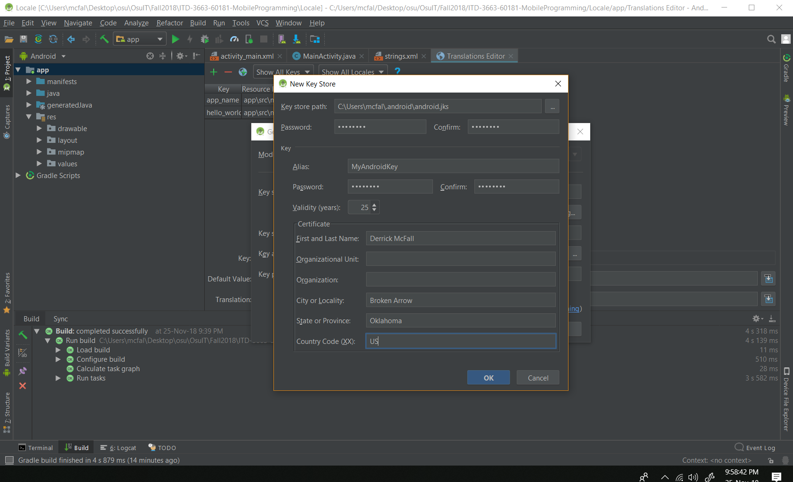

Pg. 471:

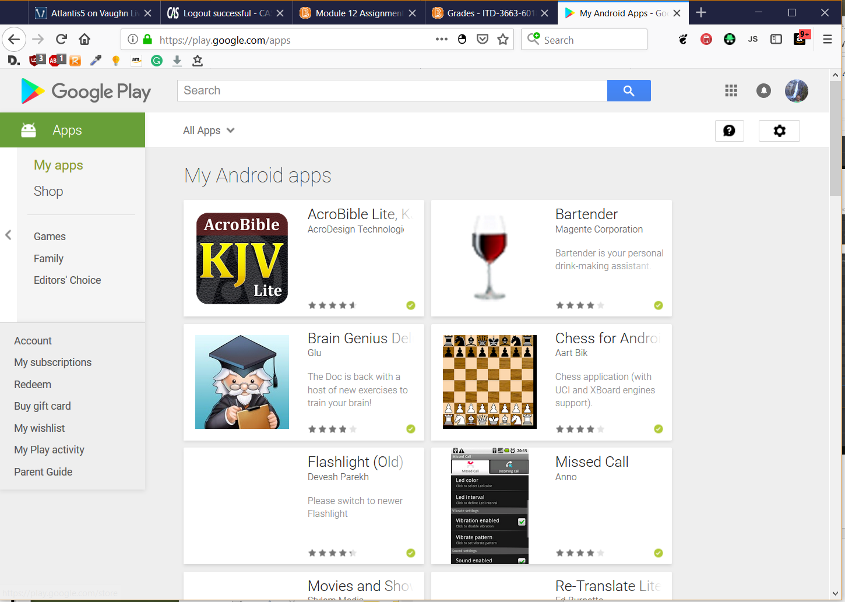

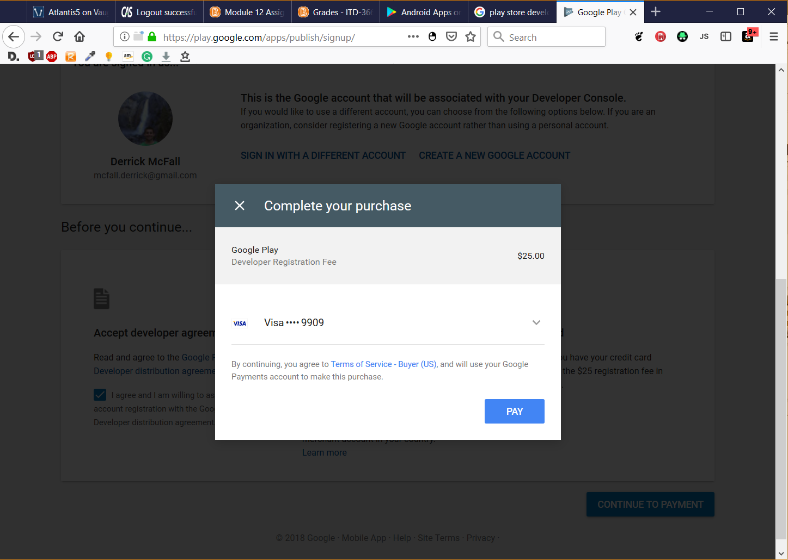

I didn’t go through with the payment but whenever I get an app that I would like to publish I will go back to the book and go through this part again.

