|  |  |
| --- | --- |
| Course Name | ITD 3243 – Server Side Programming |
| Instructor | Mark L. Pranger |
| Student Name | Derrick McFall |
| Due date | <assignment due date here> |
| Grade | <grade earned here> |
| Grading Comments | <instructor comments here> |

Exercise 1.1

Step 3:

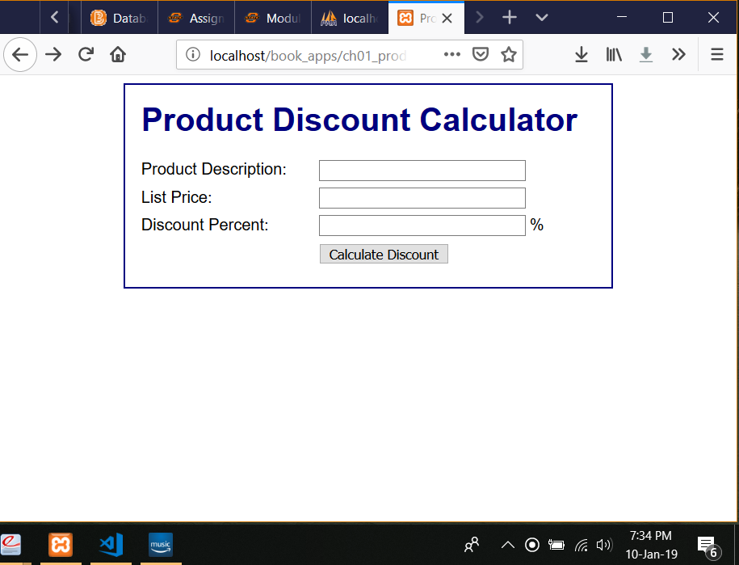

Step 4

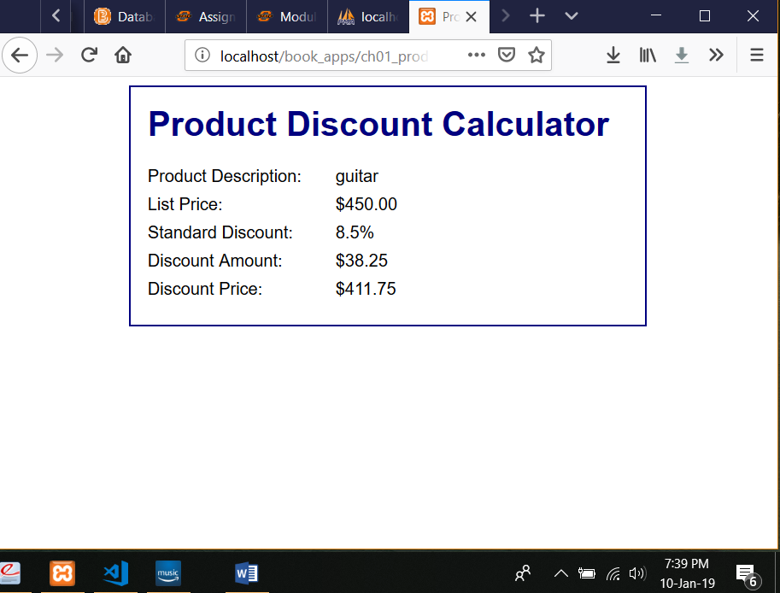

Step 5

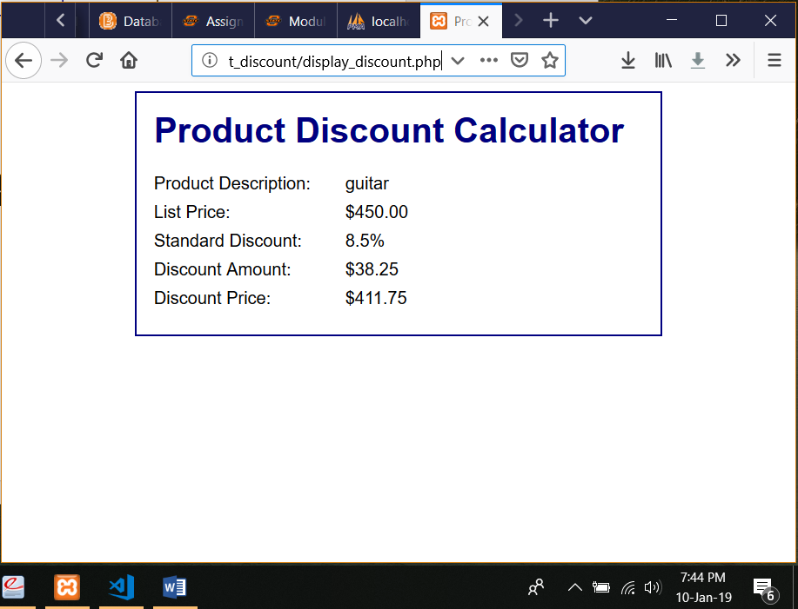

Step 7

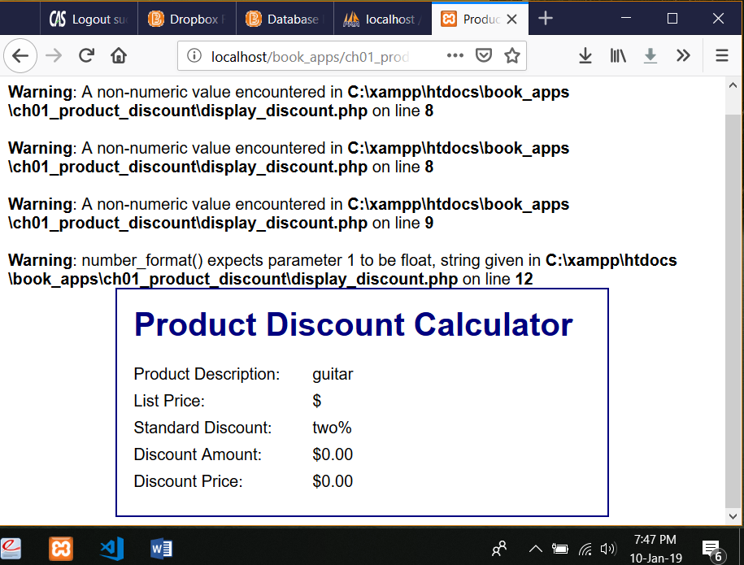

Step 8

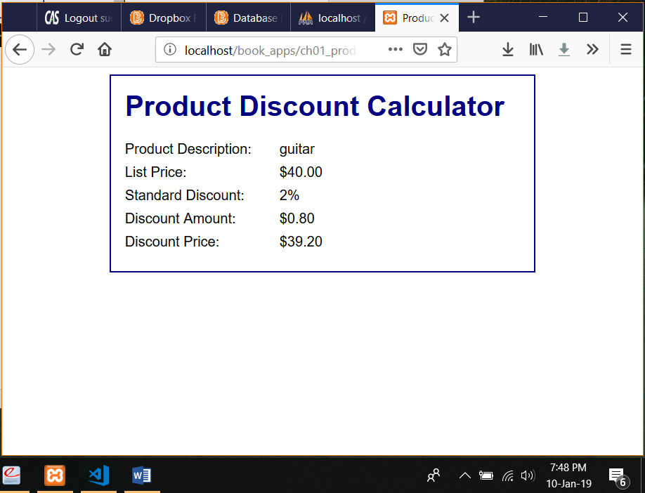

Exercise 1.2:

Step 1:

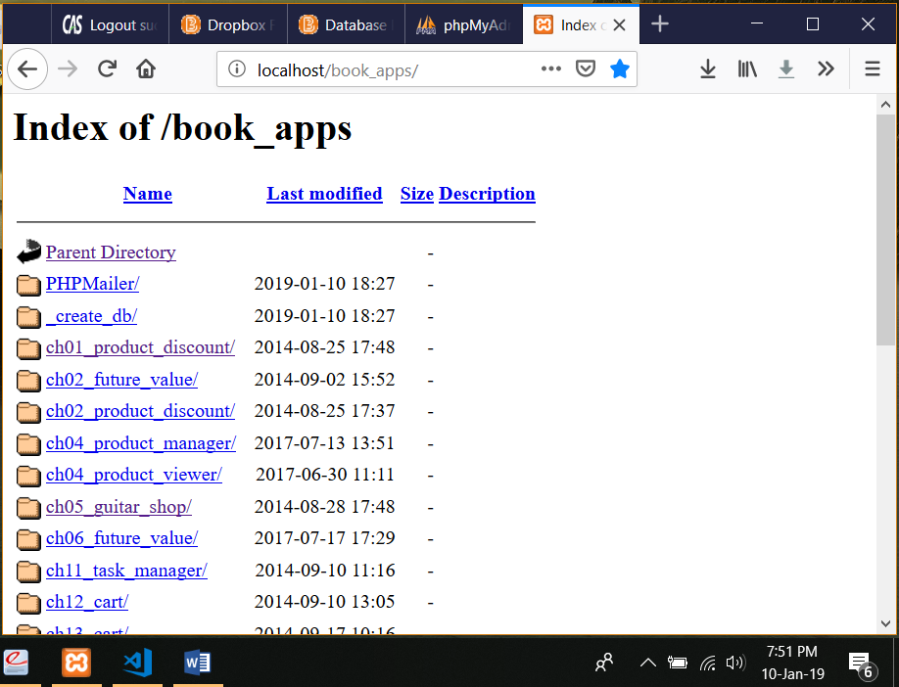

Step 4:

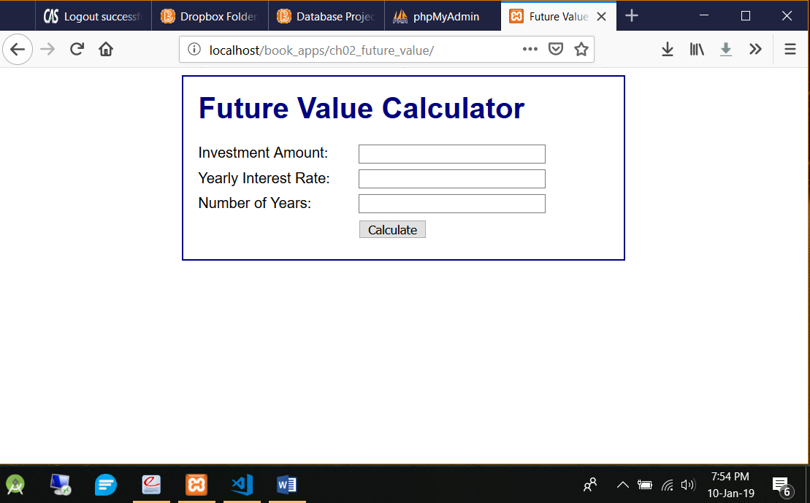

Step 5:

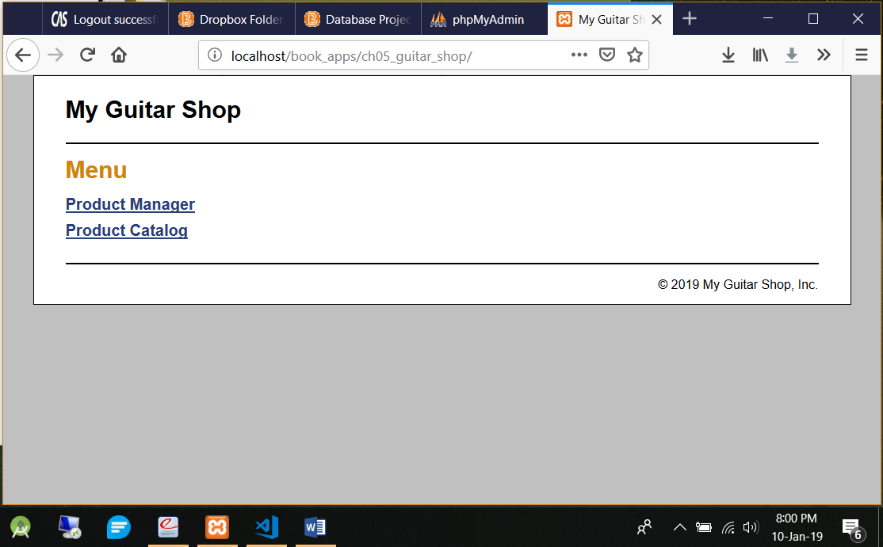

Step 6:

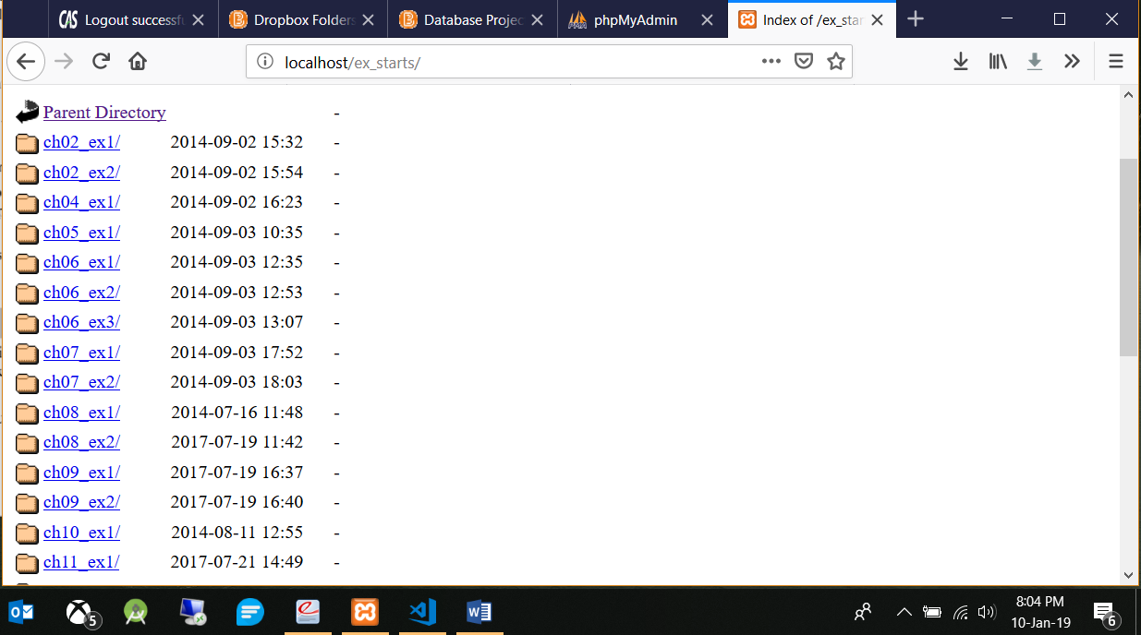

Step 8:

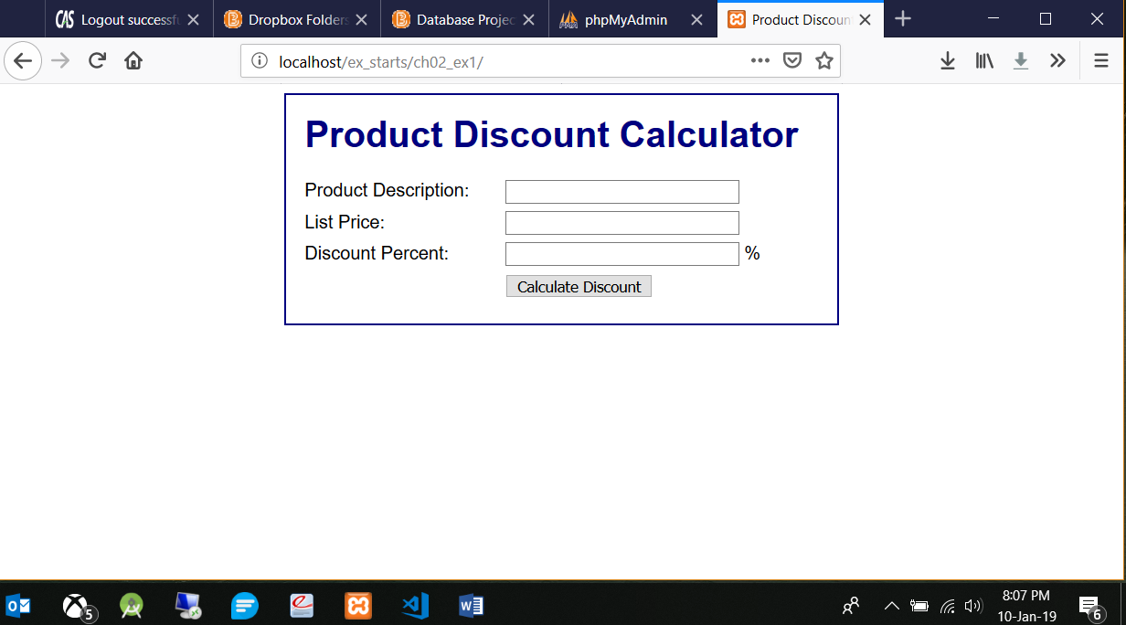

Exercise 1-3:

Step 3:

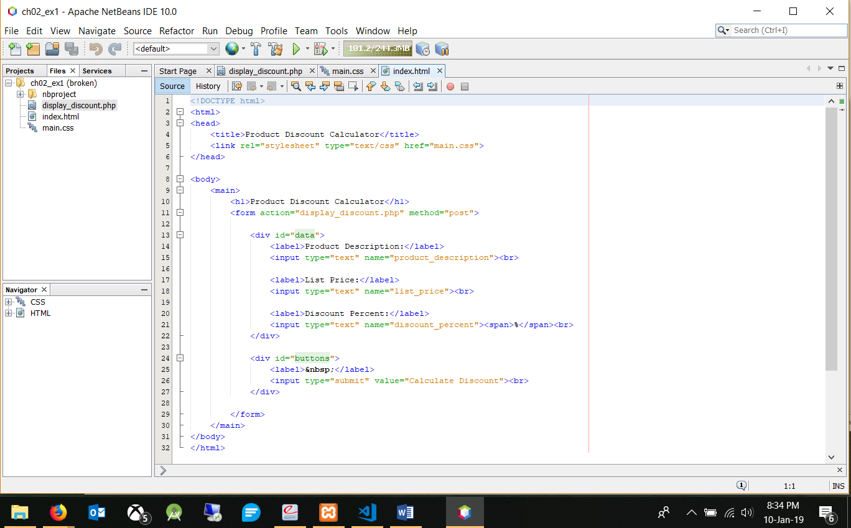

Step 4:

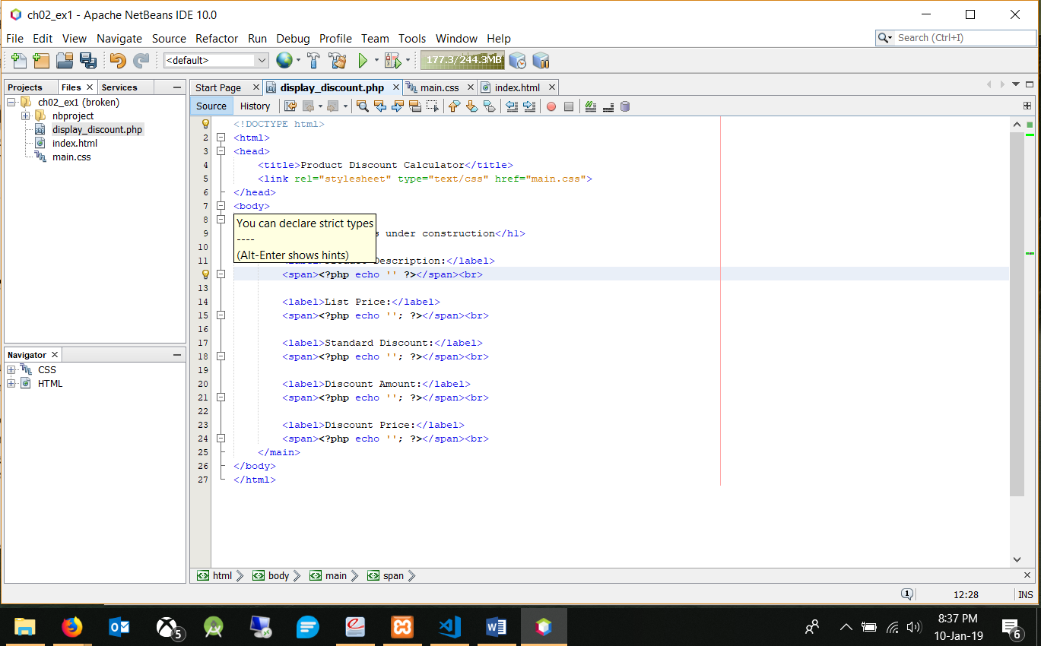

Step 7:

