|  |  |
| --- | --- |
| Course Name | ITD 3243 – Server Side Programming |
| Instructor | Mark L. Pranger |
| Student Name | Derrick McFall |
| Due date | 23Jan19 |
| Grade | <grade earned here> |
| Grading Comments | <instructor comments here> |

Module 3

1. Start the Firefox browser and run the application in the ex_starts/ch04_exl directory. To do that, you can use this URL: <http://localhost/ex_starts/ch04_exl/> This should display the products for the first category in the database named my_guitar_shop 1.

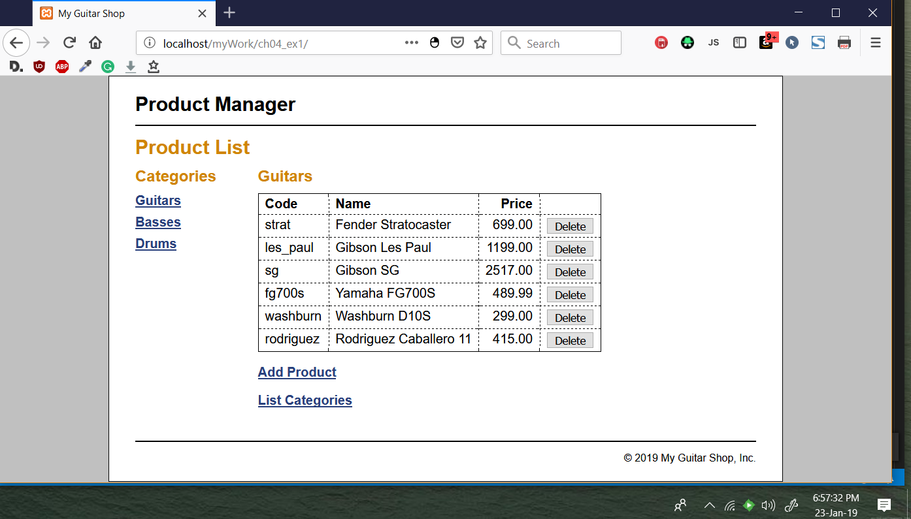

1. View the products in each of the categories.

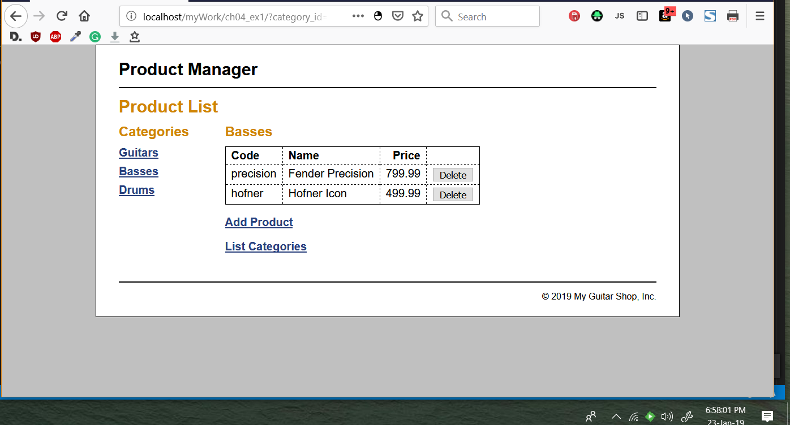

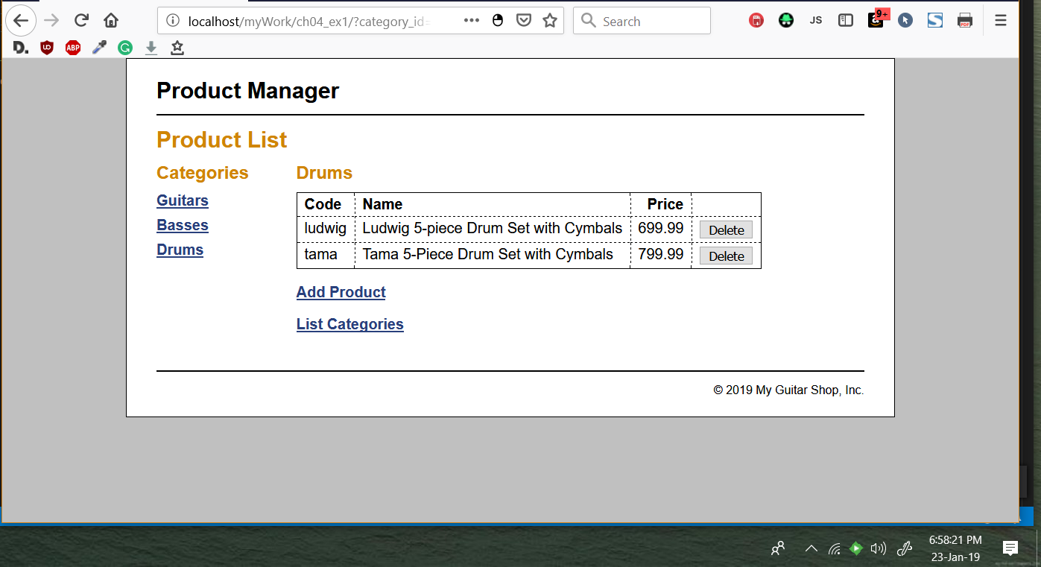

1. Add a new product to the database. When you add this product, make sure to enter valid values for a product. Then, delete the product you just added from the database.

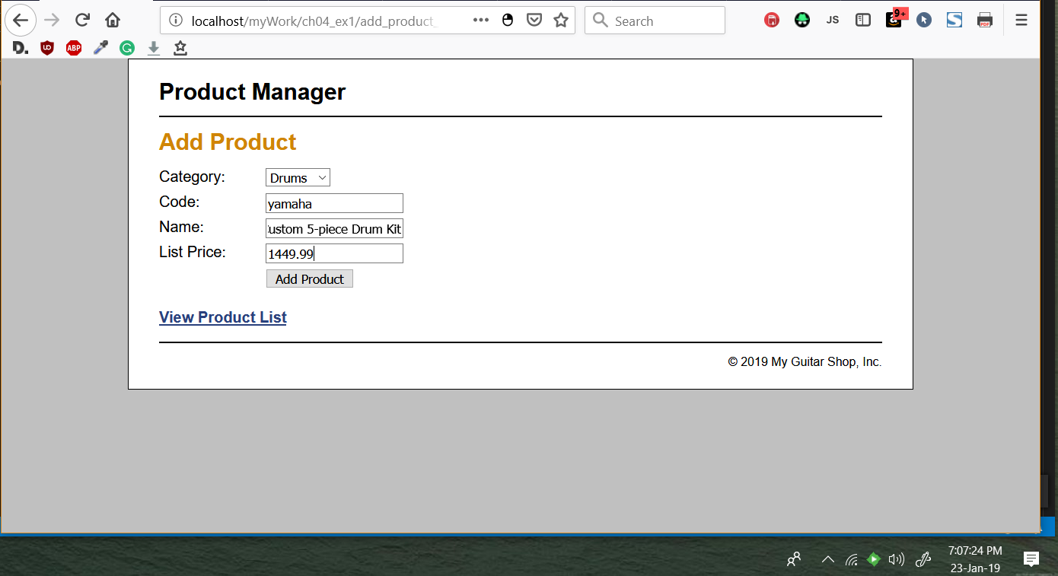

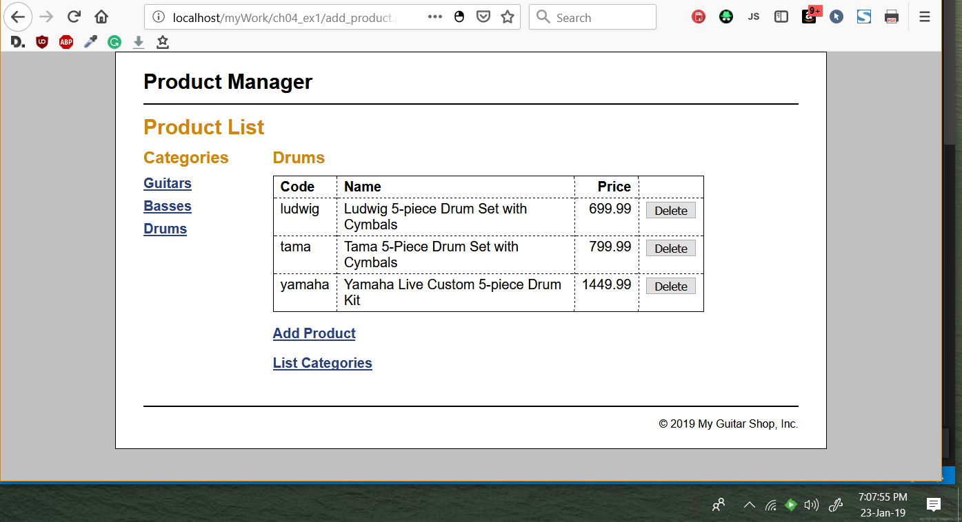

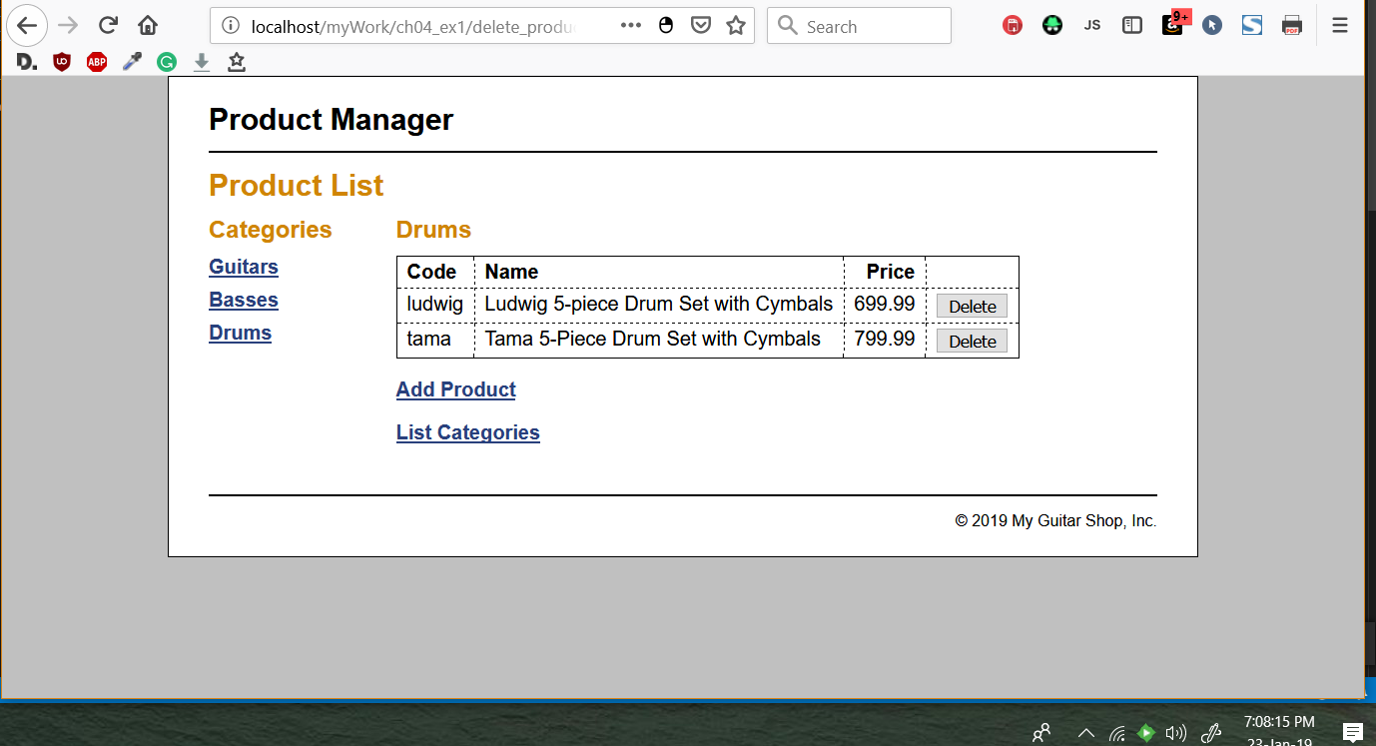

1. Click on the List Categories link at the bottom of the page. Note that this link leads to a page that’s under construction. However, the link back to the Product List page does work.

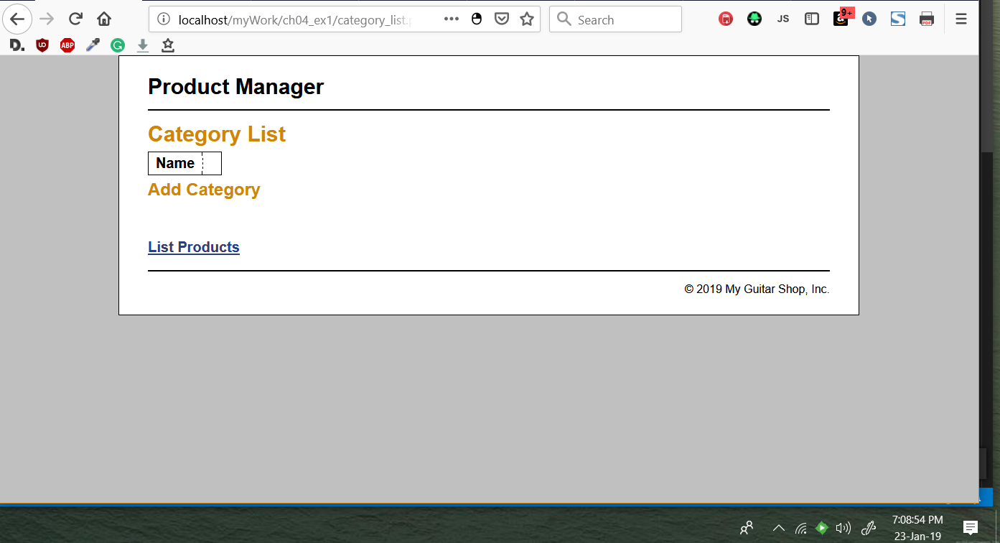

1. 5. Open the category_list.php file that’s in the directory for this application. It contains some of the headings that you’ll need for this page, and a link back to the Product List page.

Step 5 - Show the code page they have you open in a screen shot.

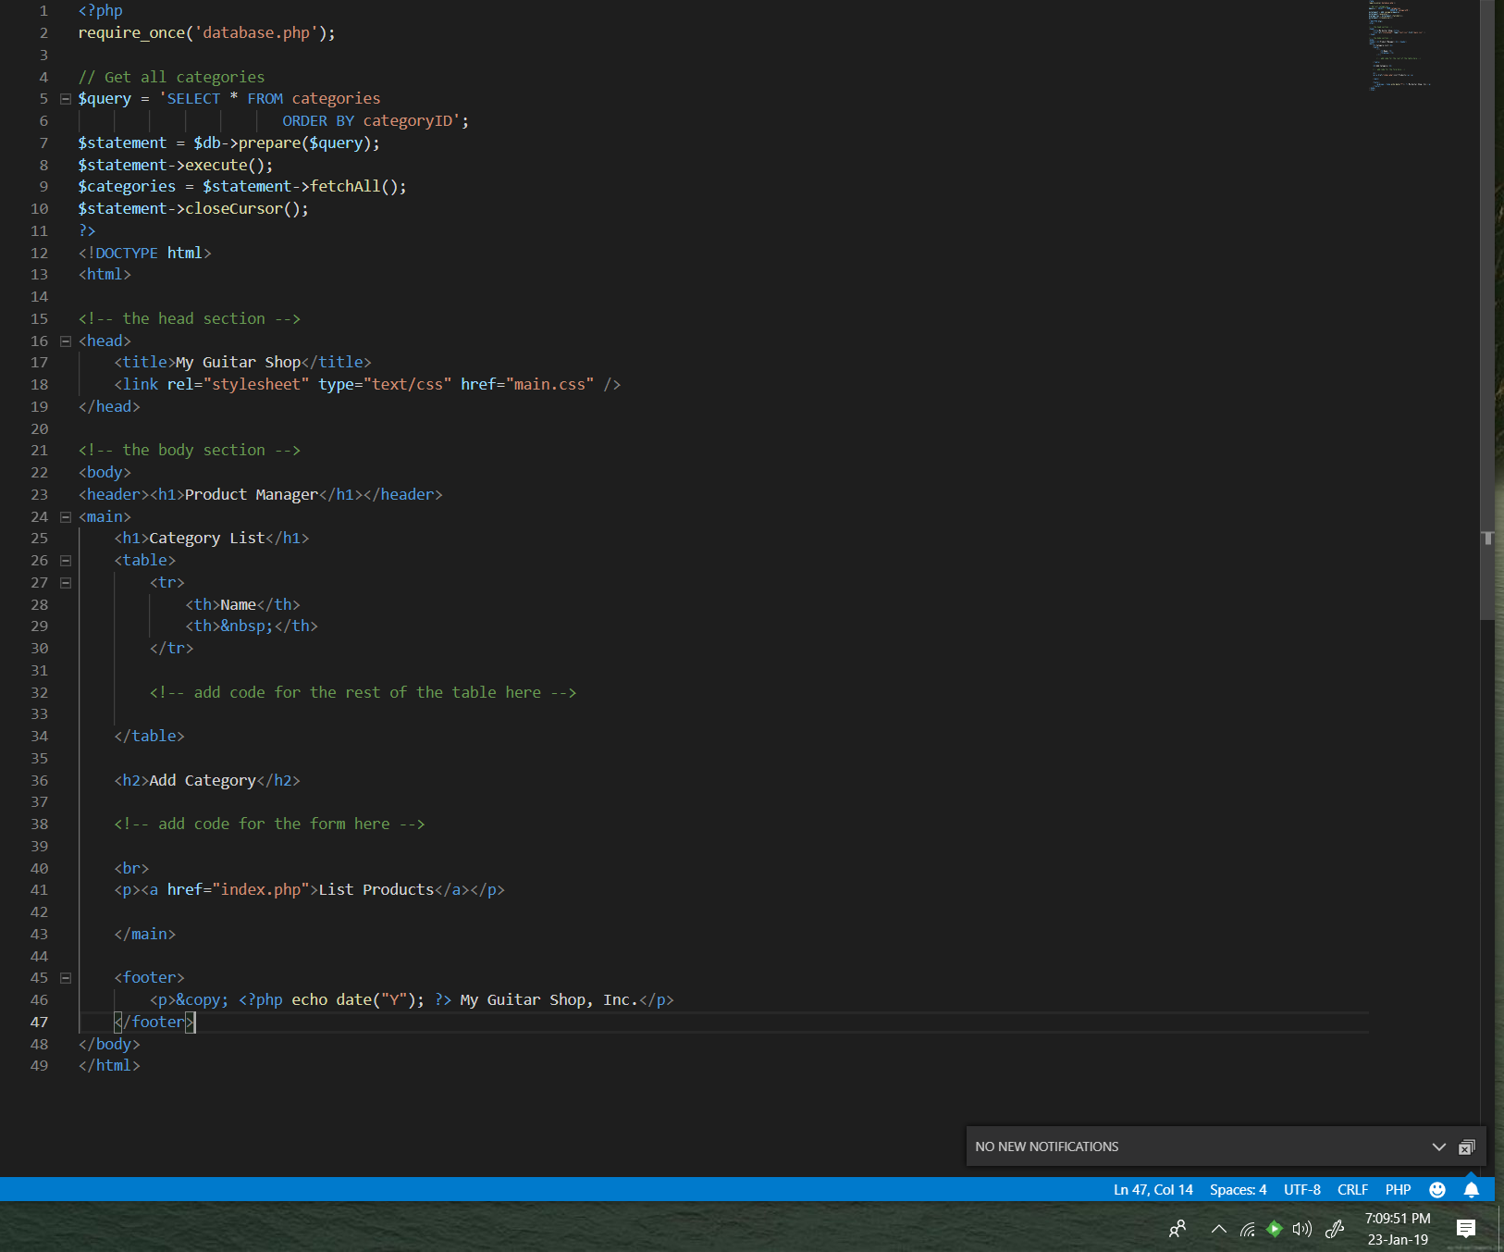

1. 6. Create an add_category.php file that adds a category to the database and a delete_category.php file that deletes a category from the database. These files should display the Category List page after they add or delete a category.

Step 6 - First show the code you had added, highlighting in your editor and then show the resulting page.

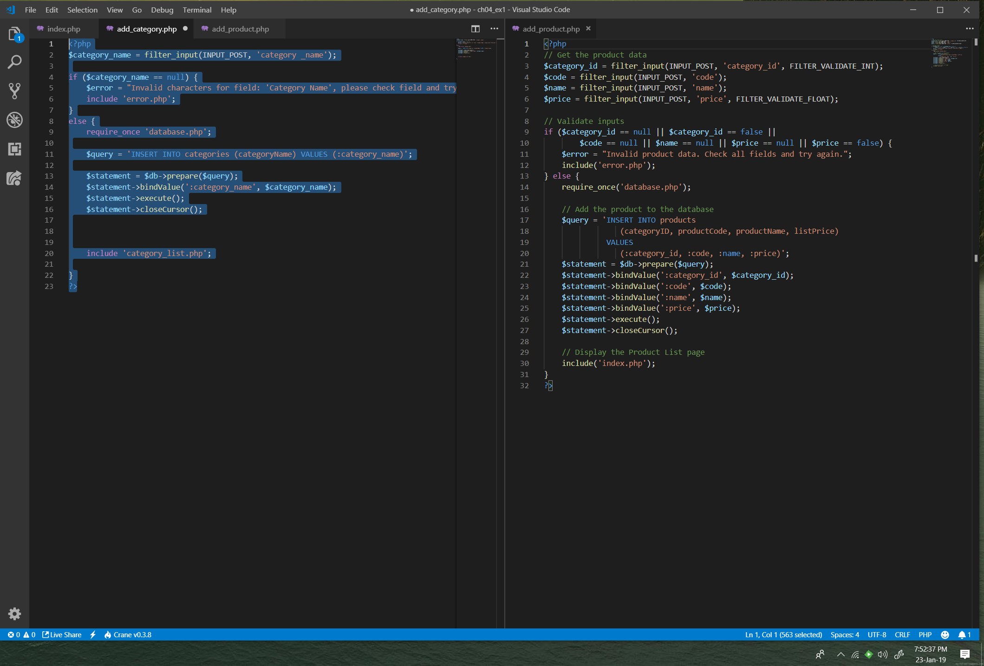

1. 7. In the category_list.php file, write the code that creates the category table shown above with all of the category names in the first column and Delete buttons in the second column. Then, test that this table is displayed correctly.

Step 7 - First show the code that you added, again highlighting it and then show the resulting form in use.

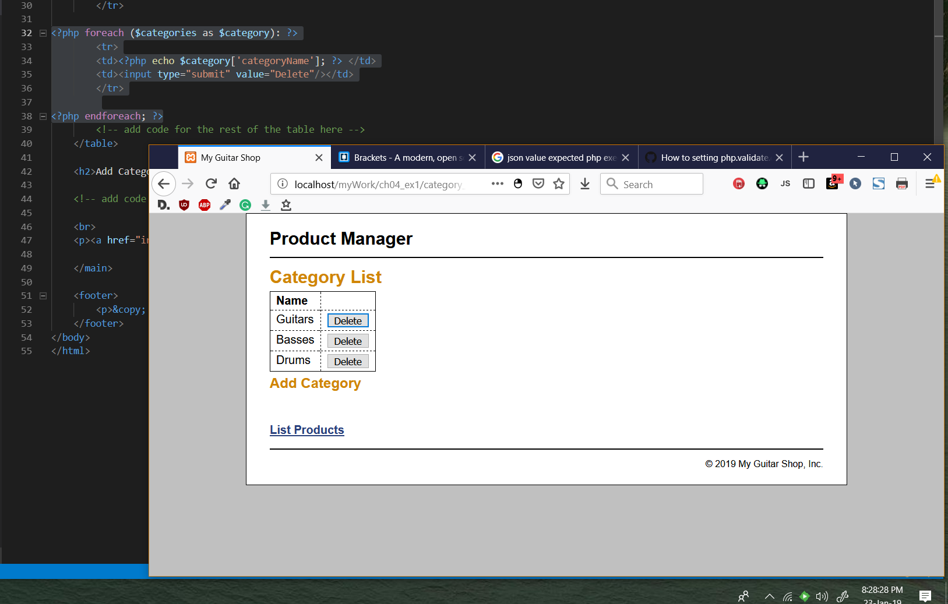

1. 8. In the category_list.php file, write the code that lets the user add a category to the database. This code should consist of a form that accepts the name for a new category followed by a Submit button that displays “Add”.

Step 8 - Show code that you write for both the Add and the Delete and then show that the Add and Delete functionality is working. This should be a series of screen shots showing the addition of a Category and then its deletion.

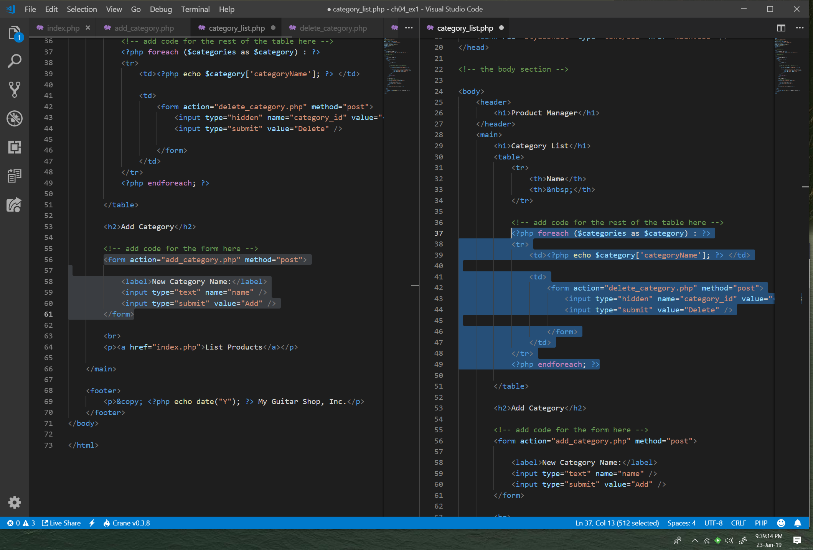

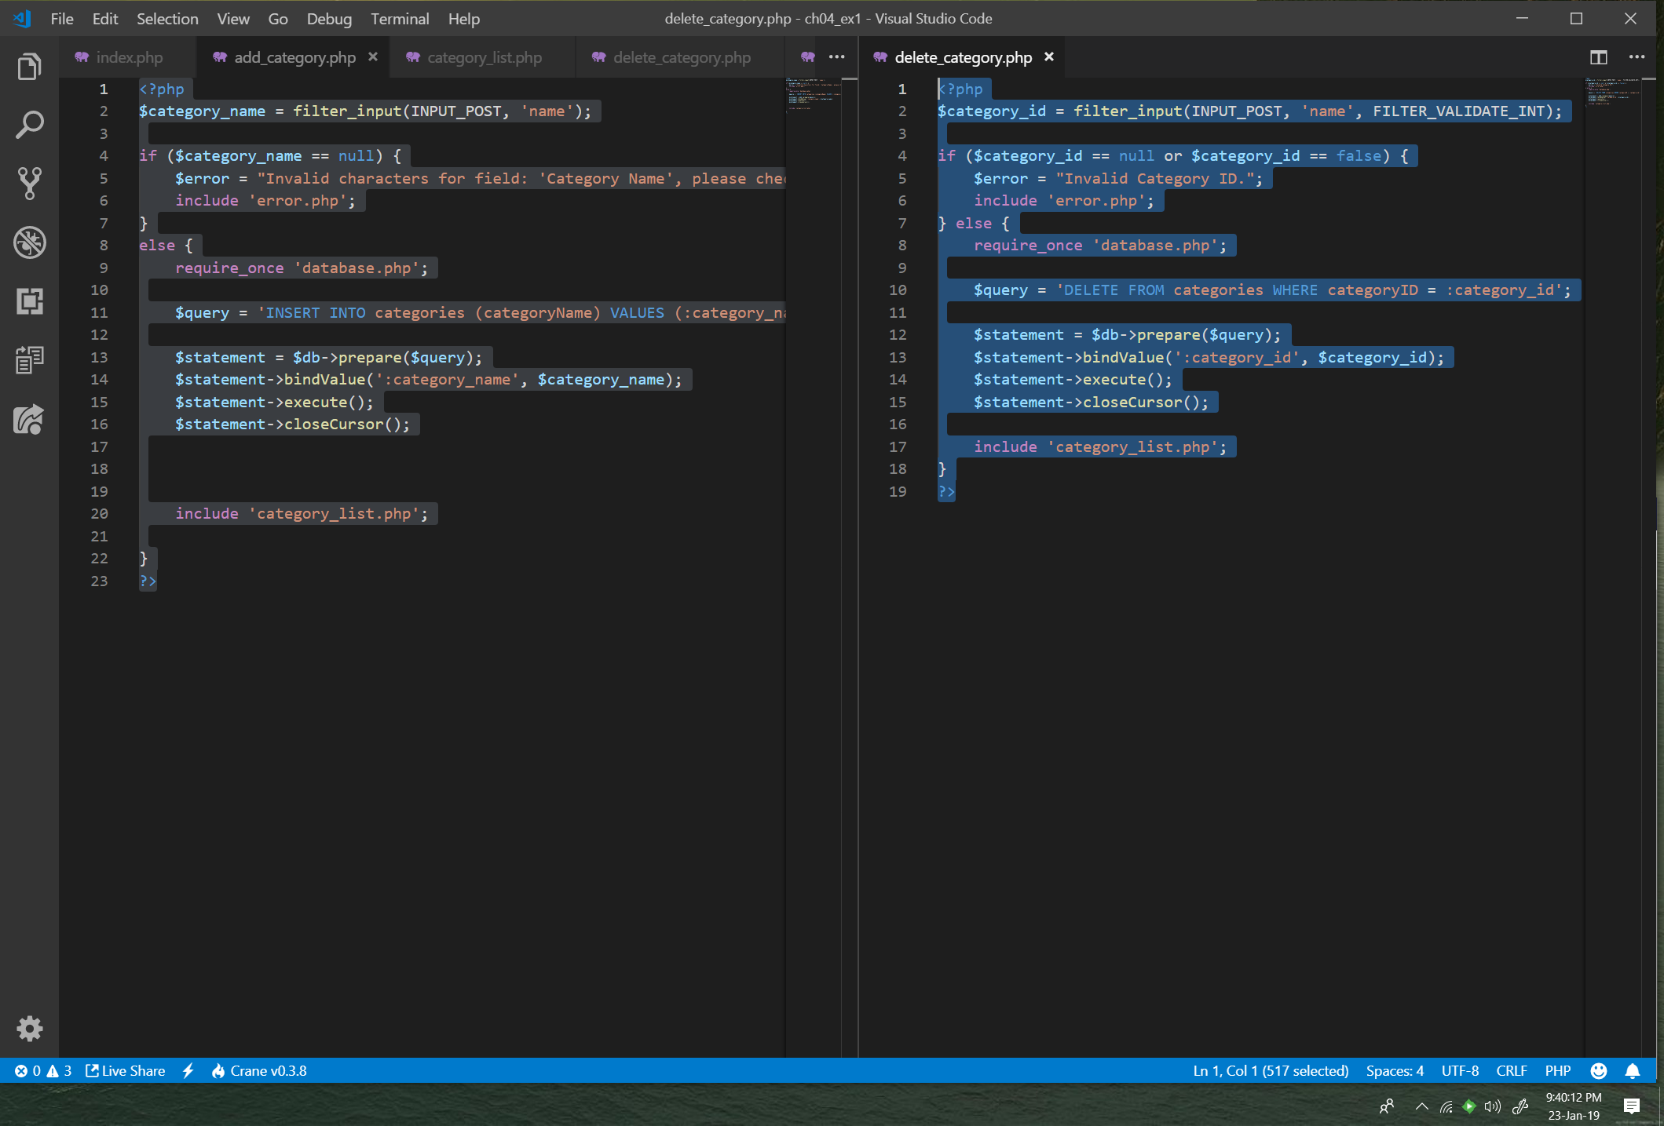

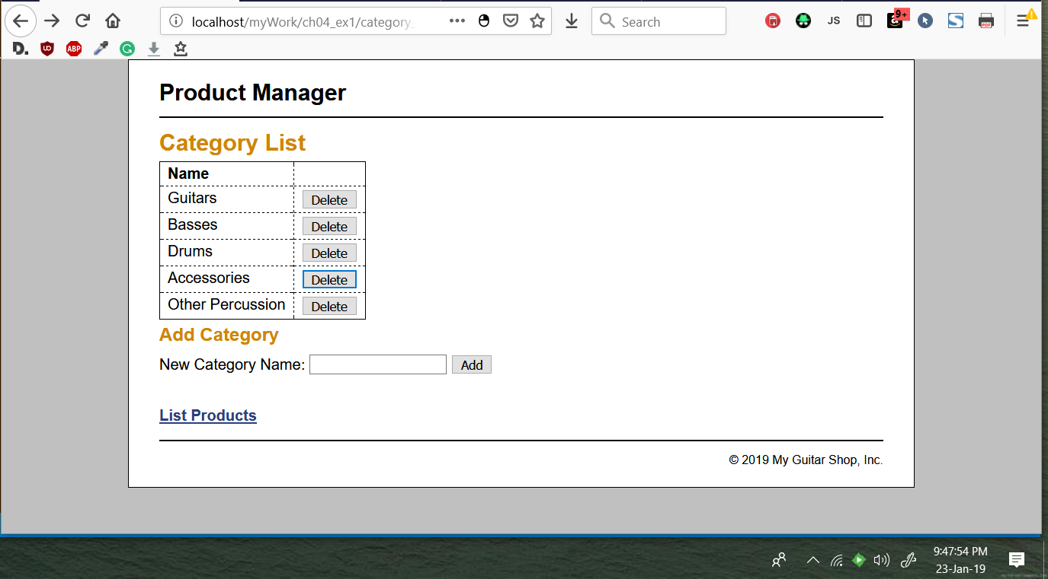

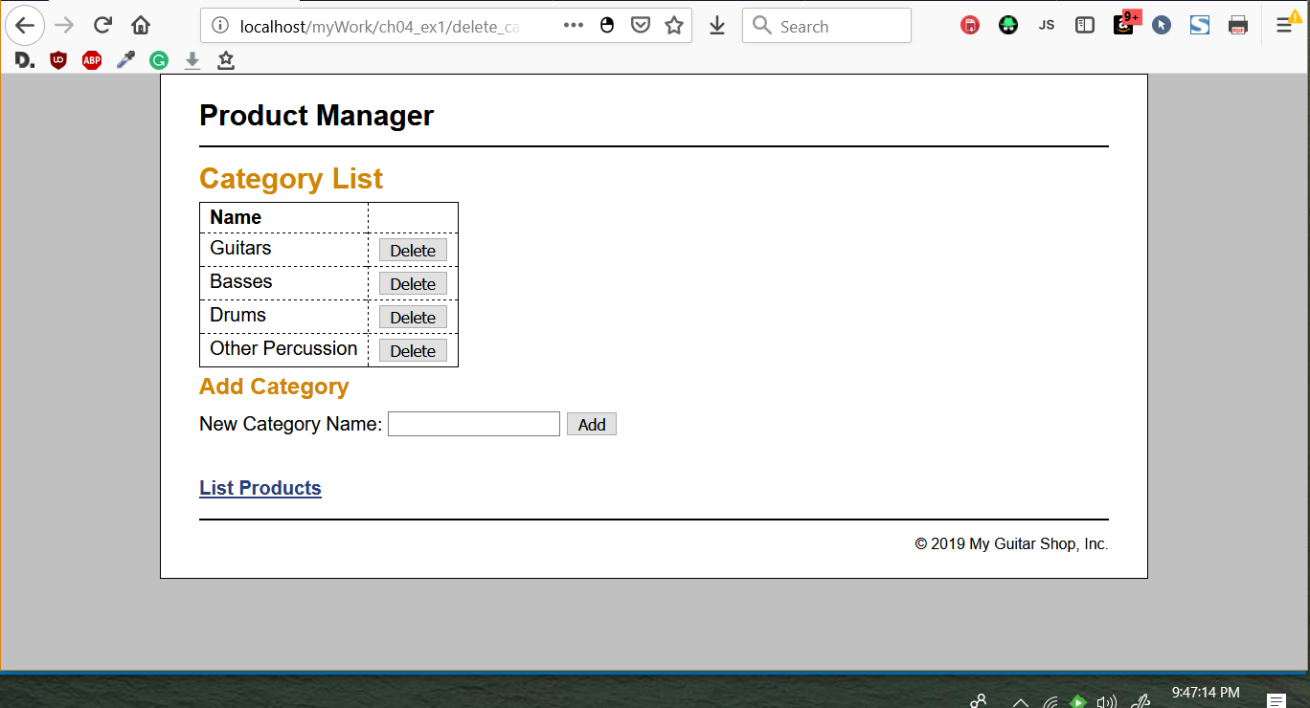

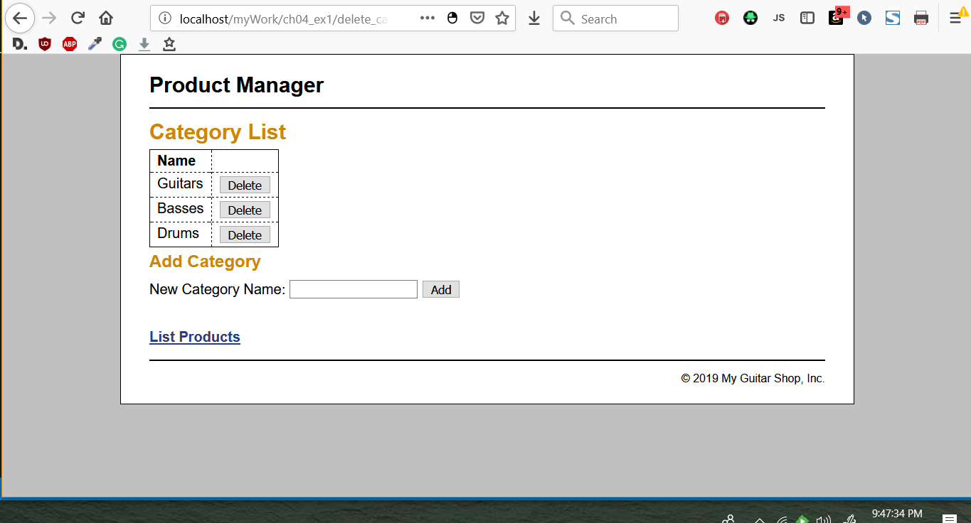

1. 9. Test the application by adding two categories. Then, navigate to the Add Product page and note that the drop-down list includes the new categories.

Step 9 - Show the two pages with the categories additional as they have noted in the text.  The page for one and the drop down for the other.

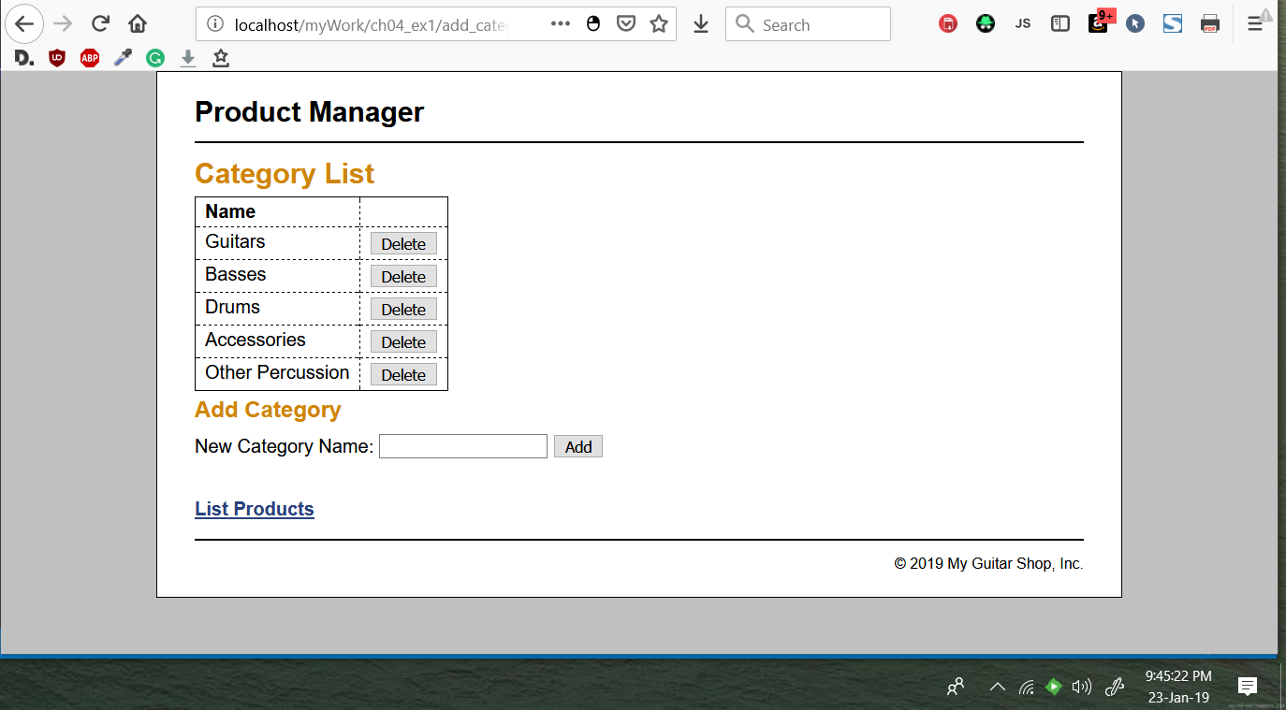

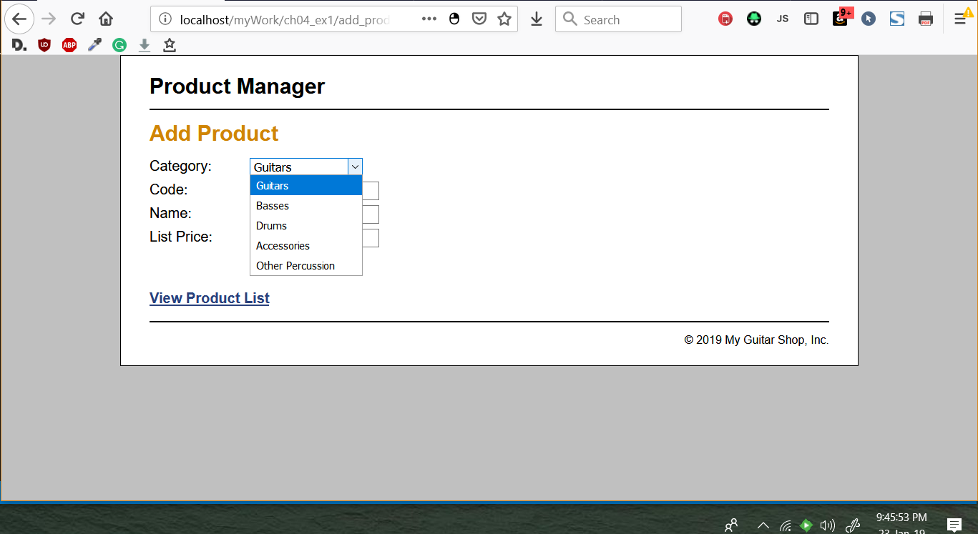

1. 10. Test the application by deleting the categories that you just added. However, don’t delete any of the existing categories because that will lead to products without categories. If necessary, though, you can restore the database by running the create_db.sql script again as described in the appendix.

Step 10 - You actually should have shown this step in your series for Step 8.  So no new screen shots here.