Attention with a Calibrated Off Switch: Causal FIR Key Smoothing, the Score-Shift Pathology, and Selective Silence in Rectified Attention (pn_fir_tau)
Maxim Zhukov (ORCID 0009-0005-9238-3778), Independent Research

Abstract
Softmax attention cannot say “nothing found”: a simplex-constrained head must distribute $1.000$ units of context weight even when no key matches the query, and pre-trained models pay with attention sinks, massive outliers that degrade low-bit quantization [8, 12, 14], and RAG-style hallucinations on unanswerable queries. Rectified normalizers remove the simplex constraint — ReLA replaces Softmax with ReLU and heads “attend to nothing” [11]; Softpick scales rectified normalization to 340M–1.8B with 0% sink rate [12] — so the off switch itself is prior art. The open question is the interaction layer: A parameter-free causal FIR low-pass filter (7 half-Gaussian taps, $σ=2.0$) applied strictly to the key stream $K$ lets one layer bind a queried key onto the adjacent value slot, lifting non-bijective single-layer associative recall from $44.5\%±0.9\%$ to $100.0\%±0.0\%$ and removing exact-decoy vulnerability on the legacy benchmark ($Δ=0.000$ at decoy noise $ϵ∈\{0.05,0.2,0.5,1.0\}$ for sm_fir). The same smoothing shifts scores downward and starves rectification: fixed-$τ=0$ power-norm falls to $64.4\%±6.8\%$ with $91.3\%±8.6\%$ negative scores and $44.5\%±23.0\%$ dead rows. Softmax masks this shift (translation-invariant); rectification does not (Proposition 1). One learnable threshold $τ$ per layer (pn_fir_tau) restores $100.0\%$ recall and keeps unanswerable rows silent under pure cross-entropy ($∑W_{\text{unans}}=0.002±0.002$ vs. $0.100±0.005$ for virtual sinks), reaches matched-precision WikiText-2 parity on 2,400 steps (within $0.3\%$) and a matched-precision 50k win consistent across 3 seeds ($−2.22±0.46$ val / $−2.33±0.49$ test PPL). We release fused Triton kernels (no exp(), $O(N)$ attention VRAM) and a full measurement record, including an instrumented retraction of our own earlier latency claim.

1. Introduction: Practical Motivation and Related Work
Why modify the core attention mechanism of a Transformer? In real-world sequence modeling, standard scaled dot-product Softmax attention [2] forces practitioners to pay a steep architectural and computational tax for two basic operations: (A) reading the value token that follows a matched key in context (in-context learning and associative lookup), and (B) doing nothing when a specialized attention head finds no relevant match in the context (residual-stream preservation in RAG, tool use, and memory lookup).

1.1 Practical Problem 1: Compressing Two-Layer Induction Heads into a Single Layer (sm_fir / pn_fir_tau)
Associative retrieval—locating a context key $k^{*}$ that matches a query and routing the value $v^{*}$ stored at the adjacent position $j^{*}+1$ ([... key A, value B ... query A] -> B)—is the foundational mechanism of in-context learning in Large Language Models (LLMs), enabling models to copy variable names, track entity attributes, and extract facts from prompts [1].
In a standard Transformer, however, a single attention layer is structurally incapable of content-addressable key-value induction. Token-level dot-product attention computes similarity $S_{t,j}=⟨Q_{t},K_{j}⟩/\sqrt{d_{k}}$ strictly on a per-position basis: the query $Q_{t}$ (encoding the target key $k^{*}$) matches the key vector $K_{j^{*}}$ at the key position $j^{*}$, but the target value token $v^{*}$ resides at the next position $j^{*}+1$, whose unfiltered key vector $K_{j^{*}+1}=W_{K}E(v^{*})$ contains zero information about $k^{*}$ whenever keys and values are independently paired. As proved by Olsson et al. [1], a standard Transformer must dedicate at least two sequential layers to solve this task: Layer 1 (previous-token head) must copy token $j^{*}$ into the residual stream of position $j^{*}+1$, and only in Layer 2 (induction head) can attention match $Q_{t}$ against the composite representation at $j^{*}+1$. In compact or edge Transformers (4–12 layers), spending early layers and residual-stream capacity simply to shift adjacent tokens is an expensive waste of depth.
A natural signal-processing remedy is to apply a fixed, parameter-free causal Finite Impulse Response (FIR) low-pass filter along the sequence axis of the key projection $K$ prior to dot-product scoring (the convolutional ancestors of this move are RWKV’s learnable 2-tap token shift [15] on the R/K/V streams and the learned $3×1$ depthwise causal convolutions of Primer [3]; our filter is fixed, parameter-free, applied to $K$ only, and evaluated for adversarial decoy robustness). Filtering $K$ blends the key representation of $k^{*}$ at position $j^{*}$ forward into the value position $j^{*}+1$:
$${\tilde{K}}_{j^{*}+1}=h_{0}K_{j^{*}+1}+h_{1}K_{j^{*}}+\sum_{m=2}^{K_{f}−1}{h_{m}}K_{j^{*}+1−m}.$$
Because ${\tilde{K}}_{j^{*}+1}$ now carries a weighted component $h_{1}K(k^{*})$ while both the query $Q_{t}$ and the value stream $V_{j^{*}+1}=W_{V}E(v^{*})$ remain sharp and unfiltered, a single attention layer querying for $k^{*}$ can attend directly to the value slot $j^{*}+1$ and read out $v^{*}$—lifting single-layer non-bijective associative recall from $44.5\%$ (sm) to $100.0\%±0.0\%$ (sm_fir and pn_fir_tau) at a latency cost of just $+1.5\%\text{–}2.0\%$ in sm_fir.

1.2 Practical Problem 2: Preventing RAG Context Hallucinations and Eliminating Attention-Sink Outliers (pn_fir_tau)
In a multi-layer Transformer, the residual stream acts as a shared communication bus: every attention head reads from the residual stream and writes its output additively back into it (yt=xt+j≤t​Wt,jVj). In practice, most specialized attention heads (e.g., heads that look up a specific entity attribute, a matching syntactic bracket, or an answer in a retrieved RAG passage) are only relevant on a small fraction of tokens; on the remaining tokens—or when a retrieved RAG passage does not contain the answer to the user’s query (unanswerable query)—the head should stay completely silent (j≤t​Wt,j=0) so that the existing residual representation $x_{t}$ is preserved uncorrupted.
Standard Softmax attention makes silence impossible because it enforces a strict probability simplex constraint on every query row:
$$\sum_{j=0}^{t}{W_{t,j}}=1 ∀t.$$
Even when no key in the context matches the query, any simplex-constrained normalizer is forced to allocate $100\%$ of its unit weight to the context. In real-world Transformers, this causes two well-documented practical pathologies: 1. Context Hallucinations on Unanswerable Queries (RAG Corruption): When a context document discusses a topic but lacks the specific queried fact $k^{*}$, a simplex-constrained head is forced to read a weighted average of the document’s value vectors $V_{j}$ and add it to the residual stream, overwriting the model’s prior state $x_{t}$ with a hallucinated value from the document. 2. Attention Sinks and Massive Quantization Outliers: To avoid corrupting the residual stream on uninformative rows, pre-trained LLMs learn an expensive workaround discovered in Quantizable Transformers [8] and StreamingLLM [9]: the model turns the initial BOS token at $t=0$ into an Attention Sink (“trash bin”) by inflating hidden-state activations at $t=0$ to massive numerical outliers (tens to hundreds of standard deviations larger than normal tokens) whose value projection $W_{V}x_{0}≈0$. These massive activation outliers [14] severely degrade INT8/INT4 post-training quantization [8, 12] and cause catastrophic perplexity collapse in streaming / sliding-window inference whenever the initial sink tokens are evicted from the KV cache [9]. Recent analysis frames exactly these two behaviours — abstention and value-pathway noise filtering — as the two missing primitives of Softmax attention [13]; this paper studies them in a thin-model regime with explicit attention-level diagnostics and refers the scale-out to that line.
In the sparse and quiet attention literature, two major families have been proposed to improve upon Softmax, and it is essential to distinguish their mathematical and practical properties: 1. Simplex-Projected Sparse Normalizers (Sparsemax [4], $α$-Entmax [5, 6]): Given a score row $s∈R^{t+1}$, Tsallis $α$-Entmax ($α>1$, with $p=\frac{1}{α−1}$ so $α=2⟹p=1$ is Sparsemax and $α=1.5⟹p=2$ is 1.5-Entmax) solves the strictly convex simplex projection:
$$W_{t,j}^{\text{entmax}}(s)=max​(s_{j}−τ^{*}(s), 0)^{p}, \text{where }τ^{*}(s)∈R\text{ is the unique root of }\sum_{j=0}^{t}{max}​(s_{j}−τ^{*}(s), 0)^{p}=1.$$
Because $τ^{*}(s+c1)=τ^{*}(s)+c$, Sparsemax and $α$-Entmax are exact translation-invariant normalizers: adding any constant shift $c$ to a row of scores leaves the attention weights completely unchanged. However, by definition of the simplex constraint $\sum_{j=0}^{t}{W_{t,j}^{\text{entmax}}}(s)≡1$, Sparsemax and Entmax can never produce an all-zero row (selective silence = 0). Worse still, when a query key $k^{*}$ is absent from a topic-coherent document, Sparsemax and Entmax concentrate $100\%$ of their weight onto the single least-negative mismatching token rather than averaging across the document, which—as we demonstrate in Experiment 5—actually increases the residual-stream hallucination rate ($32.4\%\text{–}34.4\%$) compared to standard Softmax ($27.2\%$). 2. Virtual-Sink Softmax Normalizers (Softmax_1 / Off-by-One [7], Quiet Softmax [8], StreamingLLM Attention Sinks [9]): Augmentation methods append a virtual “sink” or “null” column with fixed score $0$ (Softmax_1) or learnable scalar score $τ$ (Quiet Softmax):
$$W_{t,j}^{\text{sink}}(s)=\frac{exp(s_{j})}{\sum_{m=0}^{t}{exp}(s_{m})+exp(τ)}, \sum_{j=0}^{t}{W_{t,j}^{\text{sink}}}(s)=1−\frac{exp(τ)}{\sum_{m=0}^{t}{exp}(s_{m})+exp(τ)}<1.$$
While virtual sinks break shift-invariance in order to allow total context weight to drop below $1$, they remain based on the strictly positive exponential function $exp(s_{j})>0$. Consequently, across $t+1$ context tokens, individual non-matching tokens still retain non-zero exponential tails, leaking substantial residual weight (j​Wj=0.100±0.005 in Experiment 5) even when no key matches. 3. Rectified (Sub-Simplex) Normalizers — established prior art (ReLA [11], Softpick [12]): The silence mechanism studied here is not a novelty of this paper. ReLA [11] replaces Softmax with ReLU on scorer output, observes that sparsity arises without projection and that heads “learn to attend to nothing” (their term), and stabilises training through LayerNorm with a specialised initialization or an extra gating function. Softpick [12] trains a rectified, deliberately non-sum-to-one normalizer at 340M–1.8B parameters, reports a 0% attention-sink rate, much lower hidden-state kurtosis, and better low-bit quantized accuracy than Softmax. Our pn_fir_tau differs from this line in a specific and falsifiable way: it couples a per-layer learnable threshold $τ$ with a peak-driven silence gate, and the threshold exists for a reason that only appears under key smoothing — the score-shift pathology of Section 2 — rather than as a stability device. ReLA’s stability trick (initialisation/gating under LayerNorm) and Softpick’s power choice address a related failure mode, yet neither is calibrated against the distribution shift that a causal key filter imposes; that interaction is the subject of this paper, along with the decoy-robustness audit and the residual-preservation protocol under pure cross-entropy (Exp 5).
To be explicit about the delta: the taxonomy above establishes that exact-zero-row silence was demonstrated (ReLA [11], Softpick [12]); this paper’s variables are the causal FIR key binding with decoy diagnostics, the score-shift pathology and its single-scalar calibration (Proposition 1), the residual-preservation measurement under pure cross-entropy (Exp 5), and the fused-kernel plus measurement-forensics layer (Exp 4/4b) — each of which is unclaimed by prior art and each of which would need to collapse for this paper to be empty.
Given that prior art, the open question is not whether attention can be silent — ReLA [11] and Softpick [12] answer that — but under what conditions a rectified normalizer survives key smoothing and calibrates exactly zero-mass silence (j​Wj=0.002±0.002 in Experiment 5; $0.000±0.000$ in pn_fir_tau_reg) without BOS sink tokens or transcendental exp() evaluations in the kernel. That question is answered by sub-simplex rectified power-normalization with exponent $p=10.0$, a learnable scalar threshold $τ$, and a peak-driven silence gate $g_{t}∈[0,1)$.

1.3 The Score-Shift Paradox (sm_fir vs. pn_fir vs. pn_fir_c vs. pn_fir_tau)
When we evaluate the 13 candidate attention stacks from our architecture survey (Experiment 1), a striking paradox emerges: - Adding a 7-tap causal Gaussian FIR filter on $K$ to standard Softmax (sm $→$ sm_fir) improves clean recall from $71.5\%±1.4\%$ to $100.0\%±0.0\%$ across all random seeds (and from $44.5\%±0.9\%$ to $100.0\%±0.0\%$ on our non-bijective content-addressable benchmark in Experiment 2). - Adding the exact same causal FIR filter on $K$ to uncalibrated rectified power-normalization (pn $→$ pn_fir, fixed $τ=0$) during positive-only retrieval training yields highly erratic, degraded performance ($64.4\%±6.8\%$ in Exp 1; $88.8\%±9.2\%$ in Exp 2), while the non-causal FFT low-pass counterpart (pn_fft) reaches $98.9\%±0.3\%$ only by leaking future information (past_key_leak = 0.785). - Attempting to restore shift-invariance via row-mean centering (pn_fir_c) rescues clean recall ($100.0\%$ in Exp 1; $96.5\%$ in Exp 2), but replaces threshold-based silence with dispersion-based gating: on uncalibrated noise rows (Exp 1) and ungated recall (Exp 2) it fires with j​Wj(noise)=0.938–1.000, and even when trained end-to-end with unanswerable queries (Exp 5) it leaks $≈124×$ more unanswerable row mass ($0.265±0.045$ vs. $0.002±0.002$) while losing $10.5$ percentage points of answerable override accuracy ($88.5\%$ vs. $99.0\%$).
In this paper, we provide a complete mathematical and empirical resolution to these phenomena, accompanied by a self-contained reproducibility package (src/, experiments/, results/, figures/) in which every number and figure is generated directly from raw experimental logs.

1.4 Where This Work Stands: Prior-Art Map and Honest Delta
Four research lines bracket this work, and the placement defines what we claim. The rectified silent attention line is established prior art: ReLA [11] replaces Softmax with ReLU and reports heads that switch off; Softpick [12] scales a rectified, non-sum-to-one normalizer to 340M-1.8B parameters with a 0% sink rate and quantization gains; Wang [13] models abstention and noise filtering as the two missing primitives of Softmax attention and measures value- and query-gated mechanisms from 10M to 20B parameters. The sink and outlier line (attention sinks and massive activations [8, 9, 14]) motivates this study but is not a contribution of it. The sub-simplex normalizer is therefore not what this paper adds. What it adds is the interaction layer and the measurement layer:
- the causal-FIR-to-rectification interaction: a 7-tap causal key filter binds queried keys onto adjacent value slots for non-bijective recall, is immune to exact decoy injection at its design point, but shifts the score distribution downward and starves uncalibrated rectification (Section 2; Exp 1-2);
- a benchmark-audit methodology that found a bijective key-position shortcut in our own legacy benchmark and replaced it with a non-bijective content-addressable protocol (Exp 1 vs. Exp 2);
- a residual-preservation protocol under pure cross-entropy that quantifies hallucination rates and row mass against simplex normalizers and virtual-sink softmax on equal footing (Exp 5);
- fused Triton kernels with zero exp() calls, plus measurement forensics: an instrumented re-measurement that reproduced and falsified our own 6-layer end-to-end latency saving as a block-order artifact (drift-controlled re-measurement).
Supporting measurements (every table and figure regenerates from results/*.json): 1. Single-Layer Induction via Causal FIR Key Binding & Benchmark Audit (Exp 1 vs. Exp 2): By auditing attention weights at key vs. value positions, we uncover two shortcuts in the legacy fixed-position benchmark (Exp 1, where KEY is always at $t=0$ with a 1-to-1 bijection to VAL at $t=1$): left-padded causal FIR acts as a positional boundary detector at $t=0$ ($W_{\text{query},0}=0.984$ for sm_fir, $0.554$ of $0.570$ total mass for pn_fir_tau), and random decoy injection overwrites competing keys in the filler. Designing a strict non-bijective, random-position content-addressable recall task (Exp 2, $M=3$ key-value pairs in $T=48$) eliminates both shortcuts: unfiltered 1-layer sm ($44.5\%±0.9\%$) and pn ($35.8\%±1.0\%$) fail completely, whereas causal FIR on $K$ physically shifts attention onto the value slot $j^{*}+1$ ($W_{\text{query},j^{*}+1}=0.792±0.011$ for sm_fir and $0.729±0.014$ for pn_fir_tau), achieving $100.0\%±0.0\%$ clean recall and $93.1\%±1.9\%$ single-decoy recall at $ϵ=1.0$, while degrading under heavy multi-decoy flooding at $n_{d}=8$ ($ϵ=0.2$) to $56.2\%$ (sm_fir), $56.9\%$ (pn_fir_tau), and $38.8\%$ (pn_fir_tau_reg). 2. Threshold Calibration & Post-Warmup Regularization (Exp 2 & Exp 3): Across a 31-configuration sweep of $(τ_{0},γ,\text{silence_mode})$, pn_fir_tau with peak gating ($τ_{0}=0.0,γ∈[0.1,0.5]$) achieves $100.0\%$ recall while suppressing noise row mass to $0.000\text{–}0.003$ on well-calibrated seeds (gap = +0.432 to +0.572), compared to gap = 0.000 for sm_fir and +0.001 to +0.021 for pn_fir_c. When trained exclusively on positive-match sequences where every query has a valid key in context, $τ$ is under-constrained against background noise across random seeds ($∑W_{\text{noise}}=0.375±0.265$ in Exp 1; $0.218±0.167$ in Exp 2); introducing a lightweight post-warmup absent-key silence penalty (pn_fir_tau_reg) stabilizes $τ=+0.115±0.021$ and drives both noise and absent-key attention to exact zero across all seeds ($∑W_{\text{noise}}=0.000±0.000$, gap = +0.684 ± 0.030). 3. Simplex vs. Sub-Simplex Normalizers on Unanswerable Queries Under Pure Cross-Entropy Loss (Exp 5): On a topic-coherent document task ($T=48$, $M=3$ pairs, 50/50 answerable vs. unanswerable queries) modeling RAG over documents that may not contain the queried fact—trained with 100% pure cross-entropy loss and zero auxiliary attention regularizer—all four simplex-projected normalizers (sm_fir, sparsemax_fir $α=2.0$, entmax15_fir $α=1.5$, and entmax_p10_fir $α=1.1,p=10$) fail residual preservation and hallucinate document topic values on $27.2\%\text{–}34.4\%$ of unanswerable queries (overall = 79.2%–84.0%, $∑W_{\text{unans}}=1.000$). In contrast, sub-simplex rectified power-normalization (pn_fir_tau and pn_fir) achieves $99.5\%±0.4\%$ and $99.7\%±0.5\%$ overall accuracy ($99.0\%±0.7\%$ and $99.4\%±0.9\%$ override, $100.0\%±0.0\%$ residual preservation / $0.0\%$ hallucination rate) and suppresses absent-key row mass to $∑W_{\text{unans}}=0.002±0.002$ (gap = +0.742 ± 0.034 and +0.745 ± 0.035). Because 50% unanswerable supervision under Cross-Entropy loss directly trains $W_{Q},W_{K}$ to place unanswerable raw scores below zero ($−0.175±0.070$) and answerable peaks above zero ($+1.548±0.281$), $τ$ stays near zero ($τ=+0.011±0.020$) and fixed $τ=0$ pn_fir performs equally well here—unlike positive-only training (Exp 1/Exp 2) where learnable $τ$ is required to prevent row-death. Compared to virtual-sink Softmax (softmax1_fir and softmax_sink_fir), which achieves slightly higher discrete override accuracy ($100.0\%±0.0\%$ vs. $99.0\%±0.7\%$) and higher active mass ($∑W_{\text{ans}}=0.863\text{–}0.864$ vs. $0.744$), pn_fir_tau achieves $50×$ lower continuous residual-stream contamination on unanswerable queries ($∑W_{\text{unans}}=0.002±0.002$ vs. $0.100±0.005$ from $exp(S_{t,j})>0$ tails). 4. WikiText-2 Language Modeling & Layer-Wise $τ_{ℓ}$ Specialization (Exp 4): In a 6-layer causal Transformer ($1,797,632$ base parameters) on word-level WikiText-2, pn_fir_tau adds only $+6$ scalar parameters ($1,797,638$ total). Under strictly matched same-process BF16 training (2,400 steps, single seed), softmax (Val PPL = 547.33, Test PPL = 515.55), sm_fir (547.29 / 515.18), eager pn_fir_tau (546.75 / 515.56), row-fused pn_fir_tau_triton (545.78 / 515.40), and Flash-tiled pn_fir_tau_flash (546.78 / 516.11) differ by at most $0.3\%$ from one another (single seed per variant; no variance estimate is available), and across a precision-controlled 50,000-step comparison (results/exp4d_softmax_50k_bf16.json seed 42 plus results/exp4e_multiseed_50k.json seeds 43–44: the historical FP32 softmax 50k was re-run under the identical BF16+TF32 schedule, FP32 first 1k steps then resume) pn_fir_tau reaches Val PPL = 122.15 \pm 0.72 / Test PPL = 114.80 \pm 0.49 (vs. 124.37 \pm 0.26 / 117.13 \pm 0.04 for matched-precision softmax: $−2.22±0.46$ val / $−2.33±0.49$ test PPL, 3 seeds per variant, win on all 3 seeds) with zero causal leakage (max_past_delta = 0.0) and self-organized negative layer thresholds $τ_{ℓ}∈[−0.282,−0.064]$. 5. Fused Triton Kernels & Hardware Acceleration (PnFirTauTritonMHA & PnFirTauFlashMHA): While unfused eager PyTorch pn_fir_tau incurs $+68.3\%$ (BF16, $164.4\text{ ms}$ vs. $97.7\text{ ms}$ for softmax and $99.2\text{ ms}$ for sm_fir) to $+73.3\%$ (FP32, $244.2\text{ ms}$ vs. $140.9\text{ ms}$) full-LM step-time overhead and $+18.5\%$ VRAM ($6.11\text{ GB}$ vs. $5.16\text{ GB}$) due to materializing multiple $[B,H,N,N]$ intermediate tensors, our custom fused Triton kernels (src/triton_pnfirtau.py) eliminate this bottleneck with high FP32 numerical fidelity (out_max_diff = 2.38e-07, rel 4.38e-07; dx_max_diff = 1.16e-06–1.32e-06, rel 5.36e-07–6.08e-07; dtau_diff = 3.91e-05–4.01e-05, rel 5.56e-06–5.70e-06 across a $264,192$-element reduction). Because $(S_{t,j}^{′})_{+}^{10}$ is evaluated in 3 register multiplications with zero transcendental exp() calls and requires no online max-rescaling across tiles, row-fused pn_fir_tau_triton cuts full-LM BF16 step time to $75.7\text{ ms}$ ($2.17×$ faster than eager and $22.5\%$ faster than softmax at $4.97\text{ GB}$ VRAM), while IO-aware Flash-tiled pn_fir_tau_flash cuts full-LM BF16 step time to $66.8\text{ ms}$ ($2.46×$ faster than eager and $31.6\%$ faster than softmax at $4.52\text{ GB}$ VRAM). On an isolated 6-layer MHA stack at fixed batch size $B=64$, pn_fir_tau_flash scales monotonically across $N∈\{256,512,1024\}$ ($17.66±2.28\text{ ms}→20.60±2.73\text{ ms}→46.77±0.54\text{ ms}$, $109.3\text{ MB}→201.8\text{ MB}→386.8\text{ MB}$ while Eager baselines OOM $>12\text{ GB}$ at $N=1024,B=64$), and at $N=1024,B=16$ achieves $21.70×$ speedup ($18.13±2.44\text{ ms}$ vs. $393.42±0.43\text{ ms}$) and $66.5×$ VRAM reduction ($109.3\text{ MB}$ vs. $7,268.3\text{ MB}$). 6. Token-Shift Ablation: How Much Memory Robustness Needs (Exp 6): Replacing the 7-tap FIR with a 2-tap RWKV-style shift on $K$ (fixed $[0.5,0.5]$ or learnable per-channel $μ$, same position) shows binding needs only lag-1 memory — both shift variants reach $100.0\%$ clean recall on both decoy protocols — while multi-decoy flooding favours shorter memory: at $n_{d}=8$, sm_shiftmu holds $99.9\%±0.2\%$ against $56.2\%±7.2\%$ for 7-tap sm_fir ($W_{\text{val}}=0.970$ vs. $0.792$). The rectified branch pays for short memory with seed instability (pn_shiftmu_tau clean $76.5\%±10.9\%$ on Exp 1, $92.2\%±11.0\%$ on Exp 2 with $τ$–$μ$ equilibria varying per seed), so the 7-tap filter is the stable partner of a single scalar $τ$. 7. Width Envelope and the Tau Fixed Point (Exp 4f-A/4g): The pathology amplifies with width — uncalibrated raw magnitudes diverge (tens to hundreds) rather than drift, and a linear drift-cancellation law is rejected ($R^{2}=0.45$). The calibrated fixed point is width-invariant ($τ^{*}∈[−1.4,−0.7]$ wherever convergence happens); only its basin from $τ_{0}=0$ collapses outside $d∈[32,64]$. Negative initialization ($τ_{0}=−1.02$) rescues d=128 on all seeds — a basin problem, not a representational wall.

Scope. This is a controlled mechanistic study of how causal FIR smoothing interacts with sub-simplex normalization; the 1.8M-parameter language model and the synthetic recall tasks are deliberately small sandboxes that isolate the mechanism, not evidence of LLM-scale behaviour. We frame the contribution as a calibrated diagnostic and tool, and treat scale-up as future work.

2. Mathematical Formulation and the Score-Shift Pathology
Let $X∈R^{B×T×D}$ be the input sequence representation with model dimension $D$, $H$ attention heads, and per-head dimension $d_{k}=D/H$. The linear projections are $Q=XW_{Q}$, $K=XW_{K}$, and $V=XW_{V}$, reshaped to $R^{B×H×T×d_{k}}$. Everything described below is implemented verbatim in src/pnfirtau_attention.py.

2.1 Causal FIR Low-Pass Filtering Strictly on the Key Stream $K$
Non-causal frequency-domain filtering (fft_lowpass_noncausal in sm_fft, pn_fft, qe_pn_fft) multiplies the full-sequence discrete Fourier transform by a Gaussian spectral mask $exp(−\frac{1}{2}(f/(T/σ_{\text{div}}))^{2})$. Because a symmetric frequency response corresponds to a two-sided impulse response in time, modifying token $t$ alters filtered keys at past positions $t^{′}<t$. Our causal diagnostic confirms a massive violation of autoregressive causality (past_key_leak = 0.785).
To enforce strict autoregressive causality (past_key_leak = 0.0), we apply a causal Finite Impulse Response (FIR) depthwise 1D convolution of length $K_{f}=7$ (causal_fir and causal_gaussian_taps in src/pnfirtau_attention.py) exclusively to the key stream $K$, using half-Gaussian weights with $σ=max((K_{f}−1)/3.0, 0.5)=(7−1)/3.0=2.0$:
$$h_{m}=\frac{exp​\left(−\frac{1}{2}(m/σ)^{2}\right)}{\sum_{r=0}^{K_{f}−1}{exp}​\left(−\frac{1}{2}(r/σ)^{2}\right)}, m∈\{0,1,…,6\}.$$
Numerically, for $K_{f}=7$ and $σ=2.0$, the exact 7-tap impulse response is:
$$h=[0.3329, 0.2938, 0.2019, 0.1081, 0.0451, 0.0146, 0.0037], \sum_{m=0}^{6}{h_{m}}=1.0000, ∥h∥_{2}^{2}=\sum_{m=0}^{6}{h_{m}^{2}}=0.2518.$$
Causal left-padding by $K_{f}−1=6$ zeros ensures that the filtered key trajectory $\tilde{K}$ depends exclusively on current and past tokens ($m≥0$), while both the query stream $Q$ and the value stream $V$ remain completely unfiltered (Figure 2):
$${\tilde{K}}_{b,h,t,d}=\sum_{m=0}^{min(t, K_{f}−1)}{h_{m}} K_{b,h,t−m,d}, S_{b,h,t,j}=\frac{1}{\sqrt{d_{k}}}⟨Q_{b,h,t}, {\tilde{K}}_{b,h,j}⟩ (j≤t).$$
Filtering strictly $K$ (leaving $Q$ and $V$ sharp) has a direct mechanistic justification: at query time $t$, the query $Q_{t}$ represents the instantaneous key $k^{*}$ being sought right now (which should not be blurred with preceding filler tokens), whereas at context position $j^{*}+1$ (where the value $v^{*}$ is stored in $V_{j^{*}+1}$), the filtered key ${\tilde{K}}_{j^{*}+1}=h_{0}K_{j^{*}+1}+h_{1}K_{j^{*}}+…$ blends the preceding key identity $K_{j^{*}}=W_{K}E(k^{*})$ onto the value slot $j^{*}+1$ (Figure 1).
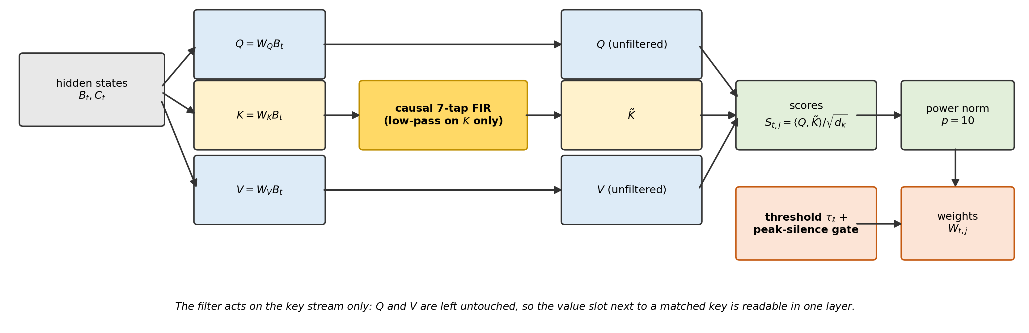
Figure 1: Schematic of the rectified attention head architecture. The causal FIR low-pass filter acts on the key stream only; the query and value streams are left untouched, so a matched key can be read at the adjacent value slot within a single layer. Source: paper_en.tex and src/pnfirtau_attention.py.
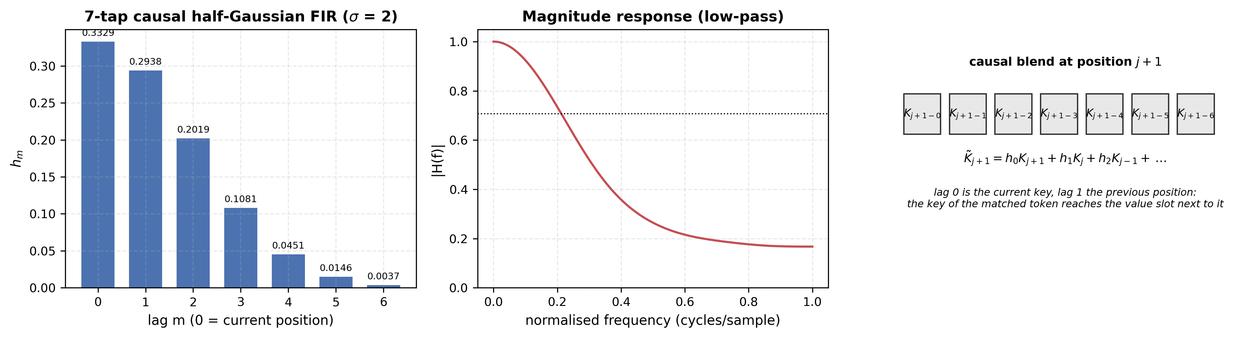
Figure 2: Diagram of the 7-tap causal FIR low-pass filter. Left: the tap coefficients, computed by the production function causal_gaussian_taps and normalised to sum to one. Centre: the magnitude response of the same taps. Right: how the causal blend mixes the current key with the preceding positions. Source: src/pnfirtau_attention.py and paper_en.tex.

2.2 Proposition 1: Incompatibility of Translation-Invariance and Baseline-Shift Selective Silence
Why does anchoring selective silence against uniform baseline score shifts require a threshold $τ$ (or a virtual sink column) once we move from Softmax/Entmax to a sub-simplex normalizer? We formalize this via an exact invariance statement along uniform shift rays $s−c1$.
Proposition 1 (Invariance of Row Mass Along Uniform Shift Rays). Let $Φ:R^{n}→[0,1]^{n}$ be any attention row normalizer satisfying sub-simplex validity $\sum_{j=1}^{n}{Φ_{j}}(s)≤1$ for all $s∈R^{n}$. Suppose $Φ$ is translation-invariant:
$$Φ(s+c1)=Φ(s) ∀s∈R^{n}, ∀c∈R.$$
Then total row mass $M(s)=\sum_{j=1}^{n}{Φ_{j}}(s)$ is constant along every uniform shift ray $\{s−c1:c∈R\}$: $M(s−c1)=M(s+c1)=M(s)$. In particular, $Φ$ cannot transition from active retrieval ($M(s)≈1$) to selective silence ($M(s−c1)→0$ as $c→+∞$) under a uniform downward shift of the baseline score distribution.
Proof. Immediate from $\sum_{j=1}^{n}{Φ_{j}}(s−c1)=\sum_{j=1}^{n}{Φ_{j}}(s)$ for all $c∈R$. Any simplex-projected normalizer (Softmax, Sparsemax, $α$-Entmax) satisfies $M(s)≡1$ everywhere on $R^{n}$. Conversely, any sub-simplex normalizer whose row mass responds to uniform baseline shifts ($M(s−c1)→0$ as $c→+∞$) must break translation-invariance by anchoring scores against an external threshold $τ$; if a sub-simplex operator instead restores translation-invariance by subtracting the row mean $μ(s)$ (as in pn_fir_c), its row mass becomes a function solely of within-row score dispersion $s−μ(s)1$ rather than absolute score level. $▫$

2.3 Why Causal FIR Key Smoothing Creates a Negative Score Shift—and Why sm_fir Is Immune
When ${\tilde{K}}_{j}$ is formed by a convex combination of token keys with $ℓ_{2}$ energy $∥h∥_{2}^{2}=0.2518<1$, two phenomena occur during gradient-based training: 1. Key Variance Contraction: For uncorrelated background tokens, the variance of ${\tilde{K}}_{j}$ contracts by $∥h∥_{2}^{2}≈0.2518$, compressing the dynamic range of dot products $S_{t,j}=⟨Q_{t},{\tilde{K}}_{j}⟩/\sqrt{d_{k}}$. 2. Negative Background Drift: To separate the target key-value pair from background filler tokens under cross-entropy loss, the projection matrices $W_{Q},W_{K}$ learn embeddings whose pairwise inner products with filler tokens are negative ($E[S_{t,j}]<0$). Because causal FIR averages each key with up to 6 preceding filler tokens, even the peak target score $S_{t,j^{*}+1}$ is pulled downward by the negative background terms in the 7-tap window.
By Proposition 1, the two normalization families react in opposite ways to this downward score shift: - Softmax (sm_fir), Sparsemax, and Entmax are shift-invariant: Because $softmax(S_{t}−c)=softmax(S_{t})$, sm_fir depends only on score differences $S_{t,j}−S_{t,j^{′}}$. In Experiment 1, our score diagnostics reveal that in trained sm_fir, $100.0\%$ of query rows have strictly negative scores (raw_frac_pos = 0.0%, raw_rows_all_neg = 100.0%, with mean row maximum $\max_{j}S_{t,j}=−0.37$ and row mean $−1.73$). Yet because the target slot still achieves the least negative score in the row, sm_fir achieves $100.0\%±0.0\%$ accuracy! - Uncalibrated Rectified Power-Normalization (pn_fir, fixed $τ=0$) suffers dead-row starvation under positive-only training: Power-normalization applies a hard ReLU threshold at zero before raising scores to the $p$-th power ($ε={10}^{−12}$ in src/pnfirtau_attention.py):
$$S_{t,j}^{+}=max(S_{t,j}, 0), {\hat{w}}_{t,j}=\frac{(S_{t,j}^{+})^{p}}{\sum_{m=0}^{t}{(}S_{t,m}^{+})^{p}+ε}.$$
Whenever an entire query row drifts below zero ($\max_{j≤t}S_{t,j}≤0$), every entry is clipped by ReLU: $S_{t,j}^{+}=0 ∀j$, producing ${\hat{w}}_{t,j}=0$ and exact zero gradients ($∂L/∂S_{t,j}=0$). In Experiment 1 (where every training sequence is a positive retrieval query), uncalibrated pn_fir has only $8.7\%±8.6\%$ positive raw scores (seed range $2.5\%$–$20.8\%$) and $44.5\%±23.0\%$ of all query rows are completely dead (raw_rows_all_neg = $44.5\%±23.0\%$; seed range $12.1\%$–$62.0\%$), causing training to stall at $64.4\%±6.8\%$ clean accuracy ($61.4\%,58.1\%,73.9\%$ across seeds) (Figure 3).
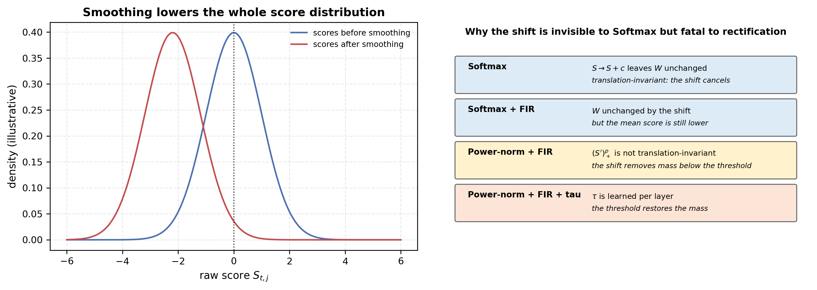
Figure 3: Diagram of the score-shift pathology. Left: smoothing lowers the whole score distribution, which a translation-invariant normaliser cancels but a rectified one does not. Right: the four regimes and why a negative shift is invisible to Softmax yet removes mass under a fixed threshold. Source: paper_en.tex (Proposition 1) and src/pnfirtau_attention.py.
The parameters $p=10$ and $σ=2.0$ are fixed a priori; a sensitivity sweep over these values is left for future work.

2.4 Why Row-Mean Centering (pn_fir_c) Substitutes Dispersion for Thresholding and Leaks Noise
An intuitive attempt to rescue pn_fir is causal row-mean centering (pn_fir_c), which subtracts the causal row mean $μ_{t}=\frac{1}{t+1}\sum_{j=0}^{t}{S_{t,j}}$ from every valid entry prior to ReLU:
$$S_{t,j}^{\text{center}}=S_{t,j}−\frac{1}{t+1}\sum_{m=0}^{t}{S_{t,m}} (j≤t).$$
Subtracting $μ_{t}$ makes pn_fir_c invariant to uniform baseline shifts ($S^{\text{center}}(S_{t}+c1)=S^{\text{center}}(S_{t})$), eliminating dead rows (cal_rows_all_neg = 0.0%) and restoring $100.0\%±0.0\%$ recall on Exp 1 ($96.5\%±4.9\%$ on Exp 2). However, in any non-constant row of scores, subtracting the sample mean guarantees that roughly half of the entries become strictly positive ($44.4\%$ of entries in Exp 1) with positive peak $\max_{j≤t}S_{t,j}^{\text{center}}=\max_{j≤t}S_{t,j}−μ_{t}>0$. This has three direct consequences across our experimental regimes: 1. Without a silence gate ($γ=\text{None}$, as in Exp 2 and pn_fir_c_ungated in Exp 1): Because $\max_{j≤t}S_{t,j}^{\text{center}}>0$ on every non-constant row, the power-normalized weights sum to j​Wt,j=1.000±0.000 on both matching and pure-noise rows (Silence Gap = 0.000). 2. With a peak gate ($γ=0.5$) under positive-only training (Exp 1 & Exp 3): The gate $g_{t}=\frac{\max_{j}S_{t,j}^{\text{center}}}{\max_{j}S_{t,j}^{\text{center}}+γ}$ depends solely on within-row dispersion $\max_{j}S_{t,j}−μ_{t}$. When evaluated on uncalibrated random noise inputs $x_{\text{noise}}∼N(0,I)$, the dot-product dispersion across $T=15$ positions is large relative to $γ$, driving j​Wj(noise)=0.938±0.007 (Silence Gap = +0.017 ± 0.004). 3. With a peak gate ($γ=0.5$) under end-to-end unanswerable-query training (Exp 5): When 50% of training queries are unanswerable and the loss penalizes residual-stream corruption, the projection matrix $W_{Q}$ can partially reduce $g_{t}$ on unanswerable queries by shrinking the query norm $∥Q_{t}∥_{2}$ (which scales within-row dispersion $\max_{j}S_{t,j}−μ_{t}∝∥Q_{t}∥_{2}$ toward zero), achieving a partial silence gap of $+0.451±0.032$ ($∑W_{\text{ans}}=0.716±0.018$ vs. $∑W_{\text{unans}}=0.265±0.045$). Yet because $\max_{j}S_{t,j}^{\text{center}}>0$ cannot be thresholded to zero without collapsing $∥Q_{t}∥_{2}→0$, pn_fir_c still leaks $≈124×$ more unanswerable attention mass than pn_fir_tau ($0.265$ vs. $0.002$) while suffering severe answerable override degradation ($88.5\%±8.9\%$ vs. $99.0\%±0.7\%$).

2.5 The pn_fir_tau Architecture: Learnable Threshold $τ$ and Peak Silence Gate
To calibrate the global score distribution without restoring within-row shift-invariance, pn_fir_tau introduces a single learnable scalar parameter $τ∈R$ per attention layer (initialized at $τ_{0}=0.0$), shared across heads and sequence positions (power_norm_peak_gate in src/pnfirtau_attention.py): 1. Learnable Threshold Calibration & ReLU Rectification:
$$S_{t,j}^{′}=(S_{t,j}−τ)⋅I(j≤t), S_{t,j}^{+}=max(S_{t,j}^{′}, 0).$$
2. Power-Law Sharpening ($p=10.0$, $ε={10}^{−12}$):
$${\hat{w}}_{t,j}=\frac{(S_{t,j}^{+})^{p}}{\sum_{m=0}^{t}{(}S_{t,m}^{+})^{p}+ε}.$$
3. Peak-Driven Selective Silence Gate ($γ=0.5$): Let $M_{t}=\max_{0≤m≤t}S_{t,m}^{+}$ be the maximum rectified calibrated score in row $t$. The row-level silence gate $g_{t}∈[0,1)$ is:
$$g_{t}=\frac{M_{t}}{M_{t}+γ}, W_{t,j}=g_{t}⋅{\hat{w}}_{t,j}, Y_{t}=\sum_{j=0}^{t}{W_{t,j}}V_{j}.$$
Total row attention mass is $\sum_{j=0}^{t}{W_{t,j}}=g_{t}$ whenever $M_{t}>0$, and $0$ when $M_{t}=0$. Unlike Entmax (where $τ^{*}(s_{t})$ is a data-dependent Lagrange multiplier enforcing j​Wt,j≡1 on every row), $τ$ in pn_fir_tau is a context-independent learned threshold: rows whose peak score $M_{t}$ falls near or below $τ$ are silenced ($g_{t}→0$), while rows with a true match ($M_{t}≫γ$) pass through ($g_{t}→1$).

2.6 IO-Aware Fused Triton Kernels (PnFirTauTritonMHA & PnFirTauFlashMHA)
In eager PyTorch (PnFirTauMHA), SoftmaxMHA and SmFirMHA dispatch F.softmax to a single fused CUDA kernel (aten::_safe_softmax), whereas power_norm_peak_gate executes a 6-op Python chain (* scale, - score_tau, masked_fill, F.relu, .pow(10), .sum/.amax/gate division) that materializes four $[B,H,N,N]$ intermediate tensors in GPU High-Bandwidth Memory (HBM). However, once fused in SRAM registers (src/triton_pnfirtau.py), pn_fir_tau possesses three fundamental hardware advantages over Softmax: 1. Zero Transcendentals ($u^{10}$ in 3 Register Multiplications): Evaluating $exp(s_{j}−m_{t})$ requires Special Function Unit (SFU) transcendental instructions on every score entry. For $p=10$, rectified power-normalization computes $u_{t,j}=max(S_{t,j}^{′},0)$ and raises it to the 10th power in 3 register multiplications ($u^{2}=u⋅u$, $u^{4}=u^{2}⋅u^{2}$, $u^{10}=(u^{4}⋅u^{4})⋅u^{2}$; and $u^{9}=(u^{4}⋅u^{4})⋅u$ in backward) with zero exp() calls. 2. Rescaling-Free Online Tiling: Standard FlashAttention [10] must rescale the running output accumulator ${\tilde{O}}_{t}$ and denominator by $exp(m_{\text{old}}−m_{\text{new}})$ whenever a new key-value tile increases the running row maximum. Because $P_{t,j}=(S_{t,j}^{′})_{+}^{10}$ is anchored at the fixed threshold $τ$ rather than the row maximum, the unnormalized output accumulator Ot=tiles​PtileVtile, power sum Zt=j​Pt,j+ε, and row peak $M_{t}=\max_{j}(S_{t,j}^{′})_{+}$ accumulate linearly across tiles with zero intermediate rescaling, normalizing only once at row completion: $O_{t}=(g_{t}/Z_{t}){\tilde{O}}_{t}$. 3. Single-Pass Analytical Backward & Tile-Level Early-Exit Branches: For any active row ($M_{t}>0$), since $O_{t}=g_{t}\sum_{j=0}^{t}{{\hat{w}}_{t,j}}V_{j}$ and $dW_{t,j}=⟨dO_{t},V_{j}⟩$, the inner product between earlier-layer weight gradients and normalized weights satisfies the exact identity:
$$D_{t}≜\sum_{j=0}^{t}{d}W_{t,j} {\hat{w}}_{t,j}=\frac{⟨dO_{t}, O_{t}⟩}{g_{t}}, dS_{t,j}^{′}=I(u_{t,j}>0)​\left[\frac{p g_{t}}{Z_{t}}u_{t,j}^{p−1}(dW_{t,j}−D_{t})+\frac{I(u_{t,j}=M_{t})}{N_{max,t}}D_{t}\frac{γ}{(M_{t}+γ)^{2}}\right],$$
where Nmax,t=j​I(ut,j=Mt) matches PyTorch’s amax subgradient tie-breaking (GradTau accumulates −t,j​dSt,j′ per KV block into a deterministic buffer summed in FP64). Furthermore, whenever an entire $64×64$ $[B_{M}×B_{N}]$ tile satisfies $maxu_{t,j}≤0$, hardware conditional branches (if tile_max > 0.0 in forward; if tl.max(peak) > 0.0 and if tl.max(u) > 0.0 in backward) skip HBM loads of $V,Q,O,dO$ and tl.dot matrix multiplications for that tile (which we profile in Section 3.5 both at the isolated kernel level and in the full 6-layer MHA stack).
We provide three custom Triton kernel suites in src/triton_pnfirtau.py, exposed via two drop-in MHA classes in src/pnfirtau_attention.py: - triton_causal_fir: Fused zero-copy depthwise 1D causal FIR kernel ($K_{f}=7$) operating directly on strided qkv slices without .transpose().contiguous() or F.pad allocations. - PnFirTauTritonMHA (triton_pn_fir_tau_scores): Row-fused Triton kernel (the direct $O(N^{2})$-materialized counterpart to aten::_safe_softmax, supporting elementwise attention dropout and return_weights=True). - PnFirTauFlashMHA (flash_pn_fir_tau_attention): FlashAttention-2 style IO-aware online-tiled Triton kernel with $O(N)$ memory complexity ($B_{M}=B_{N}=64$, saving only three $[B,H,N]$ vectors $M_{t},Z_{t},N_{max,t}$ for backward) and single-pass KV-parallel backward (5 tl.dot calls per active tile).

3. Experimental Evaluation and Deep Algorithmic Audit
The experiments below are presented in dependency order, not numerical order: $1→2→6→4f/4g→3→5→4$.
All twelve experiments are implemented in self-contained scripts under experiments/ (Exp 1-6 plus Exp 4b/4c/4e/4f/4g/4h instrumentation and replication suites) and executed on an NVIDIA GeForce RTX 3060 (12 GB) across three fixed random seeds (1234, 2025, 3141 for synthetic suites Exp 1, 2, 3, 5; 42 for WikiText-2 LM and Triton benchmarks in Exp 4).

3.1 Experiment 1: Full 13-Stack Legacy Benchmark and Boundary-Shortcut Audit
We first reproduce the complete 13-stack synthetic benchmark (exp1_legacy_stack_candidates.py $→$ results/exp1_legacy_13stacks.json), plus 4 un-gated ($γ=\text{None}$) ablations. In this legacy task ($V=24$, $D=32$, 1 head, $T=15$, 2,000 training epochs, batch size 128, $\text{lr}=5×{10}^{−3}$), position $t=0$ holds KEY $∈\{1..5\}$, position $t=1$ holds a bijectively paired VAL = KEY + 5 $∈\{6..10\}$, positions $2..13$ contain random filler tokens from $\{1..23\}$, and position $t=14$ holds QUERY = KEY. The model predicts VAL from the output at $t=14$.
Table 1 reports the complete 3-seed results across all 13 canonical stacks and 4 un-gated ablations.
Stack | Filter & Causal | Clean Acc (%) | Key-Rev (kr, %) | Decoy d@0.05 (%) | Decoy d@0.5 (%) | Decoy d@1.0 (%) | $Δ_{1.0−0.05}$ | Multi-Decoy nd=1/2/4/8 (%) | $∑W_{\text{match}}$ | $∑W_{\text{noise}}$ | Silence Gap | $W_{t,0}$ (key) | $W_{t,1}$ (val) | Raw Pos (%) | Cal All-Neg Rows (%)
sm | None (Causal) | $71.5±1.4$ | $45.1±1.5$ | $91.7$ | $89.1$ | $86.8$ | $−0.050$ | $91.4/98.7/100.0/100.0$ | $1.000±0.000$ | $1.000±0.000$ | $+0.000±0.000$ | $0.130$ | $0.136$ | $48.2\%$ | $0.0\%$
sm_fft | FFT (Non-Causal) | $99.0±0.1$ | $49.8±0.2$ | $99.1$ | $99.2$ | $99.2$ | $+0.001$ | $99.1/99.5/99.6/99.8$ | $1.000±0.000$ | $1.000±0.000$ | $+0.000±0.000$ | $0.219$ | $0.068$ | $0.0\%$ | $100.0\%$
sm_fir | FIR $K_{f}=7$ on $K$ | $100.0±0.0$ | $21.9±1.0$ | $100.0$ | $100.0$ | $100.0$ | $+0.000$ | $100.0/100.0/100.0/100.0$ | $1.000±0.000$ | $1.000±0.000$ | $+0.000±0.000$ | $0.984$ | $0.013$ | $0.0\%$ | $100.0\%$
pn | None (Causal) | $50.6±3.9$ | $43.2±5.9$ | $57.9$ | $55.6$ | $53.0$ | $−0.049$ | $57.2/60.1/64.6/74.6$ | $0.973±0.007$ | $0.955±0.022$ | $+0.001±0.001$ | $0.074$ | $0.227$ | $54.1\%$ | $0.0\%$
pn_c | None + Center | $58.1±8.6$ | $38.2±5.1$ | $72.3$ | $68.1$ | $63.3$ | $−0.090$ | $71.6/75.8/77.7/77.3$ | $0.993±0.001$ | $0.988±0.002$ | $+0.000±0.001$ | $0.119$ | $0.119$ | $54.0\%$ | $0.0\%$
pn_tau | None + $τ$ | $55.9±9.7$ | $42.7±5.8$ | $66.7$ | $64.9$ | $62.0$ | $−0.047$ | $66.1/70.5/74.0/80.1$ | $0.848±0.050$ | $0.811±0.062$ | $+0.002±0.001$ | $0.085$ | $0.154$ | $52.7\%$ | $0.0\%$
pn_fft | FFT (Non-Causal) | $98.9±0.3$ | $48.7±0.8$ | $99.0$ | $99.0$ | $99.0$ | $−0.001$ | $99.0/98.7/98.8/99.4$ | $0.995±0.000$ | $0.995±0.000$ | $+0.000±0.000$ | $0.222$ | $0.075$ | $100.0\%$ | $0.0\%$
pn_fft_c | FFT + Center | $81.6±9.3$ | $20.9±2.6$ | $80.8$ | $80.9$ | $80.6$ | $−0.002$ | $80.8/85.0/84.9/83.2$ | $0.952±0.019$ | $0.952±0.019$ | $+0.002±0.001$ | $0.256$ | $0.028$ | $5.8\%$ | $0.0\%$
pn_fir | FIR $K_{f}=7$ on $K$ | $64.4±6.8$ | $20.5±0.4$ | $65.5$ | $64.9$ | $64.7$ | $−0.008$ | $65.3/62.7/63.9/69.1$ | $0.512±0.236$ | $0.000±0.000$ | $+0.375±0.046$ | $0.389$ | $0.001$ | $8.7\%$ | $44.5\%$
pn_fir_c | FIR on $K$ + Center | $100.0±0.0$ | $22.3±5.6$ | $100.0$ | $100.0$ | $100.0$ | $−0.000$ | $100.0/100.0/100.0/100.0$ | $0.944±0.005$ | $0.938±0.007$ | $+0.017±0.004$ | $0.904$ | $0.037$ | $0.0\%$ | $0.0\%$
pn_fir_tau | FIR on $K$ + $τ$ | $100.0±0.0$ | $20.6±0.7$ | $100.0$ | $100.0$ | $100.0$ | $−0.000$ | $100.0/100.0/100.0/100.0$ | $0.570±0.095$ | $0.375±0.265$ | $+0.191±0.171$ | $0.554$ | $0.012$ | $0.0\%$ | $6.9\%$
qe_pn | QE + Power-Norm | $71.2±1.1$ | $45.2±1.5$ | $91.5$ | $87.8$ | $83.8$ | $−0.077$ | $90.8/98.6/100.0/100.0$ | $0.941±0.000$ | $0.915±0.007$ | $+0.000±0.000$ | $0.136$ | $0.140$ | $100.0\%$ | $0.0\%$
qe_pn_fft | QE + PN + FFT | $99.6±0.0$ | $41.4±0.1$ | $99.7$ | $99.7$ | $99.7$ | $+0.001$ | $99.7/99.6/98.9/99.0$ | $0.913±0.003$ | $0.907±0.004$ | $+0.003±0.000$ | $0.243$ | $0.074$ | $100.0\%$ | $0.0\%$
pn_ungated | None ($γ=\text{None}$) | $49.7±4.1$ | $35.5±4.8$ | $62.9$ | $58.1$ | $53.7$ | $−0.092$ | $61.8/66.3/70.1/78.1$ | $0.999±0.001$ | $0.992±0.011$ | $+0.001±0.001$ | $0.136$ | $0.152$ | $45.4\%$ | $0.0\%$
pn_fir_ungated | FIR ($γ=\text{None}$) | $71.7±19.5$ | $21.3±1.8$ | $71.8$ | $71.7$ | $71.8$ | $−0.000$ | $71.8/69.6/69.2/72.5$ | $0.564±0.176$ | $0.000±0.000$ | $+0.517±0.200$ | $0.414$ | $0.092$ | $5.4\%$ | $43.6\%$
pn_fir_c_ungated | FIR+Center ($γ=\text{None}$) | $100.0±0.0$ | $18.7±2.0$ | $100.0$ | $100.0$ | $100.0$ | $−0.000$ | $100.0/100.0/100.0/100.0$ | $1.000±0.000$ | $1.000±0.000$ | $+0.000±0.000$ | $0.998$ | $0.002$ | $0.0\%$ | $0.0\%$
pn_fir_tau_ungated | FIR+$τ$ ($γ=\text{None}$) | $100.0±0.0$ | $18.7±0.6$ | $100.0$ | $100.0$ | $99.9$ | $−0.001$ | $100.0/100.0/100.0/100.0$ | $1.000±0.000$ | $0.717±0.033$ | $+0.282±0.045$ | $0.999$ | $0.001$ | $0.0\%$ | $0.0\%$

Deep Algorithmic Audit of Experiment 1: Uncovering Two Hidden Benchmark Shortcuts
While Table 1 confirms the score-shift pathology (pn_fir has $44.5\%±23.0\%$ dead rows and $64.4\%$ clean recall, whereas pn_fir_tau learns $τ=−1.010±0.083$, reduces dead rows to $6.9\%$, and achieves $100.0\%±0.0\%$ recall), our diagnostic instrumentation (w_key_pos at $t=0$ vs. w_val_pos at $t=1$) reveals two critical anomalies in the legacy task design: 1. Why do sm_fir ($W_{t,0}=0.984,W_{t,1}=0.013$) and pn_fir_tau ($W_{t,0}=0.554,W_{t,1}=0.012$) attend to KEY ($t=0$) instead of VAL ($t=1$)? Because the legacy task uses a fixed 1-to-1 bijection (VAL = KEY + 5) and always places KEY at the sequence boundary $t=0$, the model does not need to read the VAL token at $t=1$ at all! If the attention head simply attends to $t=0$, its value projection $W_{V}E(\text{KEY})$ can linearly map $\text{KEY}↦\text{KEY}+5$. Worse still, because causal FIR left-pads the key sequence with $K_{f}−1=6$ zeros, position $t=0$ is the only position in the sequence whose filtered key ${\tilde{K}}_{0}=h_{0}K_{0}$ is uncontaminated by preceding tokens. Thus, on Exp 1, causal FIR acts as a positional boundary detector for $t=0$ rather than a content-addressable key-to-value bridge! 2. Why does unfiltered sm jump from $71.5\%$ on clean sequences to $91.7\%$ at d@0.05 and $100.0\%$ at nd=8? In the legacy generator, filler tokens at positions $2..13$ are drawn uniformly from $\{1..23\}$, which includes the competing keys $\{1..5\}$. On clean sequences, random competing keys appear in the filler and confuse sm ($71.5\%$). When the legacy decoy test overwrites up to $n_{d}=8$ filler positions with $(1−ϵ)E(\text{KEY})+ϵE(\text{NOISE})$, it overwrites competing false keys with copies of the true key, which—under the bijection $\text{VAL}=\text{KEY}+5$—all map to the exact same target label!
Reporting Experiment 1 without exposing these two shortcuts would be scientifically misleading. We therefore designed Experiment 2 to eliminate both shortcuts completely.

3.2 Experiment 2: True Content-Addressable Non-Bijective Recall & Distractor Decoys
In Experiment 2 (exp2_content_addressable_decoy.py $→$ results/exp2_content_addressable_decoy.json), we construct a strict content-addressable associative recall benchmark ($T=48$, $V=24$, $D=32$, 1 head, 2,500 epochs): - Zero Bijection ($M=3$ Random Key-Value Pairs): Each sequence contains $M=3$ distinct keys drawn from $K_{\text{vocab}}=\{1..8\}$, each paired with an independently permuted value drawn from $V_{\text{vocab}}=\{9..16\}$. Knowing $k^{*}$ gives zero information about $v^{*}$ without reading the token at $j^{*}+1$. - Random Interior Positions (Zero Boundary Shortcut): The $M=3$ pairs $(k_{m},v_{m})$ are placed at random non-overlapping interior positions $j_{m}∈[2,38]$, and all filler positions are drawn strictly from $F_{\text{vocab}}=\{17..23\}$ (disjoint from keys and values). Position $T−1=47$ holds the query $k^{*}=k_{m^{*}}$. - True Distractor Decoys: At evaluation, $n_{d}∈\{1,2,4,8\}$ isolated filler positions (separated by $≥2$ slots from all true pairs) are overwritten with $(1−ϵ)E(k^{*})+ϵE(\text{filler})$. Because the token following a decoy is a random filler token rather than $v^{*}$, attending to a decoy (or to the slot after a decoy) actively destroys retrieval accuracy. - Post-Warmup Absent-Key Silence Regularization (pn_fir_tau_reg): When pn_fir_tau is trained exclusively on positive-match sequences, $τ$ is calibrated to pass the target peak $S_{t,j^{*}+1}$, but on some random seeds $τ$ settles slightly below the upper tail of pure noise rows ($τ=−0.256±0.082$, giving $∑W_{\text{noise}}=0.218±0.167$ across seeds: $0.202,0.022,0.430$). In pn_fir_tau_reg, after a 1,000-epoch warmup, we auxiliary-sample 32 absent-key sequences per step (where $k^{*}$ is not among the 3 context keys) and add a lightweight silence penalty λsil⋅E[j​Wquery,j] ($λ_{\text{sil}}=0.05$).
Table 2 presents the 3-seed results on Experiment 2.
Model | Clean Recall (%) | Decoy eps=0.05 (%) | Decoy eps=0.2 (%) | Decoy eps=0.5 (%) | Decoy eps=1.0 (%) | Multi-Decoy nd=1/2/4/8 (eps=0.2, %) | $W_{t,j^{*}}$ (KEY pos) | $W_{t,j^{*}+1}$ (VAL pos) | $∑W_{\text{match}}$ | $∑W_{\text{absent}}$ | $∑W_{\text{noise}}$ | Silence Gap (Noise) | Learned $τ$
sm | $44.5±0.9$ | $47.6±0.6$ | $44.5±1.8$ | $43.8±1.2$ | $46.5±1.2$ | $45.5/45.7/44.6/46.8$ | $0.035±0.003$ | $0.234±0.014$ | $1.000±0.000$ | $1.000±0.000$ | $1.000±0.000$ | $+0.000±0.000$ | N/A
pn | $35.8±1.0$ | $35.9±1.8$ | $35.4±1.5$ | $34.4±0.2$ | $35.1±0.4$ | $35.1/36.6/36.1/35.8$ | $0.015±0.021$ | $0.237±0.013$ | $1.000±0.000$ | $1.000±0.000$ | $1.000±0.000$ | $+0.000±0.000$ | N/A
sm_fir | $100.0±0.0$ | $95.9±0.4$ | $95.9±0.7$ | $95.2±0.9$ | $92.0±0.7$ | $95.1/89.9/77.7/56.2$ | $0.132±0.011$ | $0.792±0.011$ | $1.000±0.000$ | $1.000±0.000$ | $1.000±0.000$ | $+0.000±0.000$ | N/A
pn_fir | $88.8±9.2$ | $85.9±7.8$ | $85.5±7.4$ | $84.7±8.7$ | $82.1±8.0$ | $84.1/80.0/71.0/61.2$ | $0.032±0.036$ | $0.830±0.065$ | $1.000±0.000$ | $0.666±0.198$ | $0.261±0.117$ | $+0.739±0.117$ | N/A
pn_fir_c | $96.5±4.9$ | $93.7±2.6$ | $93.4±2.5$ | $92.8±4.0$ | $90.1±2.0$ | $92.5/88.9/78.2/63.2$ | $0.044±0.025$ | $0.866±0.035$ | $1.000±0.000$ | $1.000±0.000$ | $1.000±0.000$ | $+0.000±0.000$ | N/A
pn_fir_tau | $100.0±0.0$ | $95.5±1.4$ | $95.8±2.0$ | $95.5±1.2$ | $93.1±1.9$ | $95.6/90.5/74.7/56.9$ | $0.063±0.037$ | $0.729±0.014$ | $0.826±0.033$ | $0.607±0.044$ | $0.218±0.167$ | $+0.608±0.135$ | $−0.256±0.082$
pn_fir_tau_reg | $100.0±0.0$ | $93.8±0.9$ | $93.1±1.1$ | $91.8±1.6$ | $87.4±2.2$ | $93.1/82.6/60.6/38.8$ | $0.034±0.022$ | $0.647±0.007$ | $0.684±0.030$ | $0.000±0.000$ | $0.000±0.000$ | $+0.684±0.030$ | $+0.115±0.021$
Table 2, Figure 4 and Figure 5 establish four findings: 1. Direct Proof of Causal FIR Value-Slot Binding: Once the bijective boundary shortcut is removed, unfiltered sm ($44.5\%±0.9\%$) and pn ($35.8\%±1.0\%$) fail completely: because $M=3$ values are present in the context, the best an unfiltered 1-layer head can do is attend equally to all 3 value tokens ($W_{t,j^{*}+1}≈0.234$, yielding $∼1/3$ random guessing among the 3 context values). Adding the causal FIR filter on $K$ shifts attention weight directly onto the target value slot $j^{*}+1$: $W_{t,j^{*}+1}=0.792±0.011$ (vs. $W_{t,j^{*}}=0.132$) for sm_fir, $W_{t,j^{*}+1}=0.729±0.014$ (vs. $W_{t,j^{*}}=0.063$) for pn_fir_tau, and $W_{t,j^{*}+1}=0.647±0.007$ (vs. $W_{t,j^{*}}=0.034$) for pn_fir_tau_reg (with ${\text{argmax}}_{j}W_{t,j}=j^{*}+1$ on $98.0\%\text{–}100.0\%$ of test queries!). 2. Realistic Multi-Decoy Behavior and Linear Superposition Bound: Unlike Exp 1 where decoys artificially helped by overwriting competing keys, true distractor decoys in Exp 2 cause a realistic, monotonic accuracy decline as the context is flooded with $n_{d}=1→8$ copies of $k^{*}$: pn_fir_tau holds $95.6\%$ at $n_{d}=1$ and $90.5\%$ at $n_{d}=2$, declining to $74.7\%$ ($n_{d}=4$) and $56.9\%$ ($n_{d}=8$) (56.2% for sm_fir, 38.8% for pn_fir_tau_reg) because each decoy injects $h_{1}K(k^{*})$ onto the filler slot immediately following the decoy. Why does a single decoy ($n_{d}=1,ϵ=0.2$) only reduce pn_fir_tau from $100.0\%$ to $95.8\%$ instead of $50\%$? Because the model learns to give value tokens in $V_{\text{vocab}}$ a small positive key bias relative to filler tokens in $F_{\text{vocab}}$, so the true pair score $⟨Q_{\text{query}},h_{0}K(v^{*})+h_{1}K(k^{*})⟩$ systematically exceeds the decoy-followed-by-filler score $⟨Q_{\text{query}},h_{0}K(\text{filler})+h_{1}K(k^{*})⟩$. 3. Score Calibration Stability (pn_fir vs. pn_fir_c vs. pn_fir_tau): Uncalibrated pn_fir fails to converge to $100\%$ on 2 of 3 seeds ($88.9\%,77.4\%,100.0\%→88.8\%±9.2\%$), and pn_fir_c drops to $89.6\%$ on seed 1234 ($96.5\%±4.9\%$) while exhibiting zero silence (gap = 0.000). Both pn_fir_tau and pn_fir_tau_reg achieve $100.0\%±0.0\%$ across all 3 seeds. 4. Why Calibration Requires Absent-Key Signal (pn_fir_tau vs. pn_fir_tau_reg): Without absent-key supervision during training, pn_fir_tau achieves a strong mean noise silence gap of $+0.608±0.135$ ($∑W_{\text{match}}=0.826$ vs. $∑W_{\text{noise}}=0.218$), but exhibits seed-to-seed variance on noise ($∑W_{\text{noise}}∈\{0.202,0.022,0.430\}$) and remains active on absent-key queries ($∑W_{\text{absent}}=0.607$). Adding the post-warmup absent-key regularizer in pn_fir_tau_reg shifts the learned threshold from $τ=−0.256±0.082$ to $τ=+0.115±0.021$, driving both noise and absent-key attention mass to $0.000±0.000$ across all 3 seeds (gap = +0.684 ± 0.030). Moreover, in Section 3.4 (Experiment 5), we show that when unanswerable queries naturally occur in the task distribution, pure cross-entropy loss alone (with zero auxiliary regularizer) drives pn_fir_tau to $∑W_{\text{unans}}=0.002±0.002$.
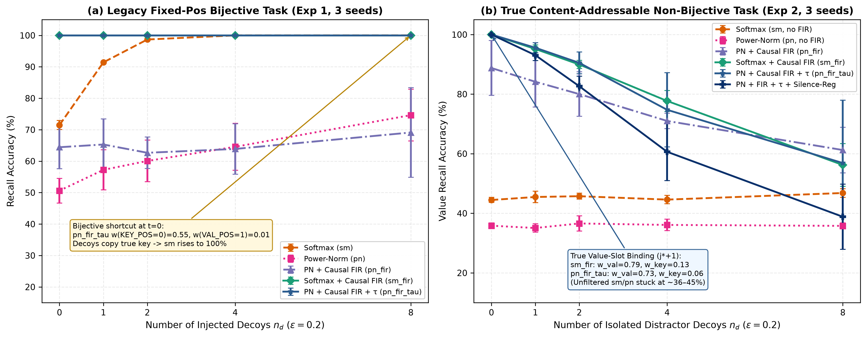
Figure 4: Multi-decoy scaling ($n_{d}∈\{0,1,2,4,8\}$) and attention slot routing on the legacy fixed-position task (Exp 1, left) vs. the true content-addressable non-bijective task (Exp 2, right). Source: results/exp1_legacy_13stacks.json and results/exp2_content_addressable_decoy.json.
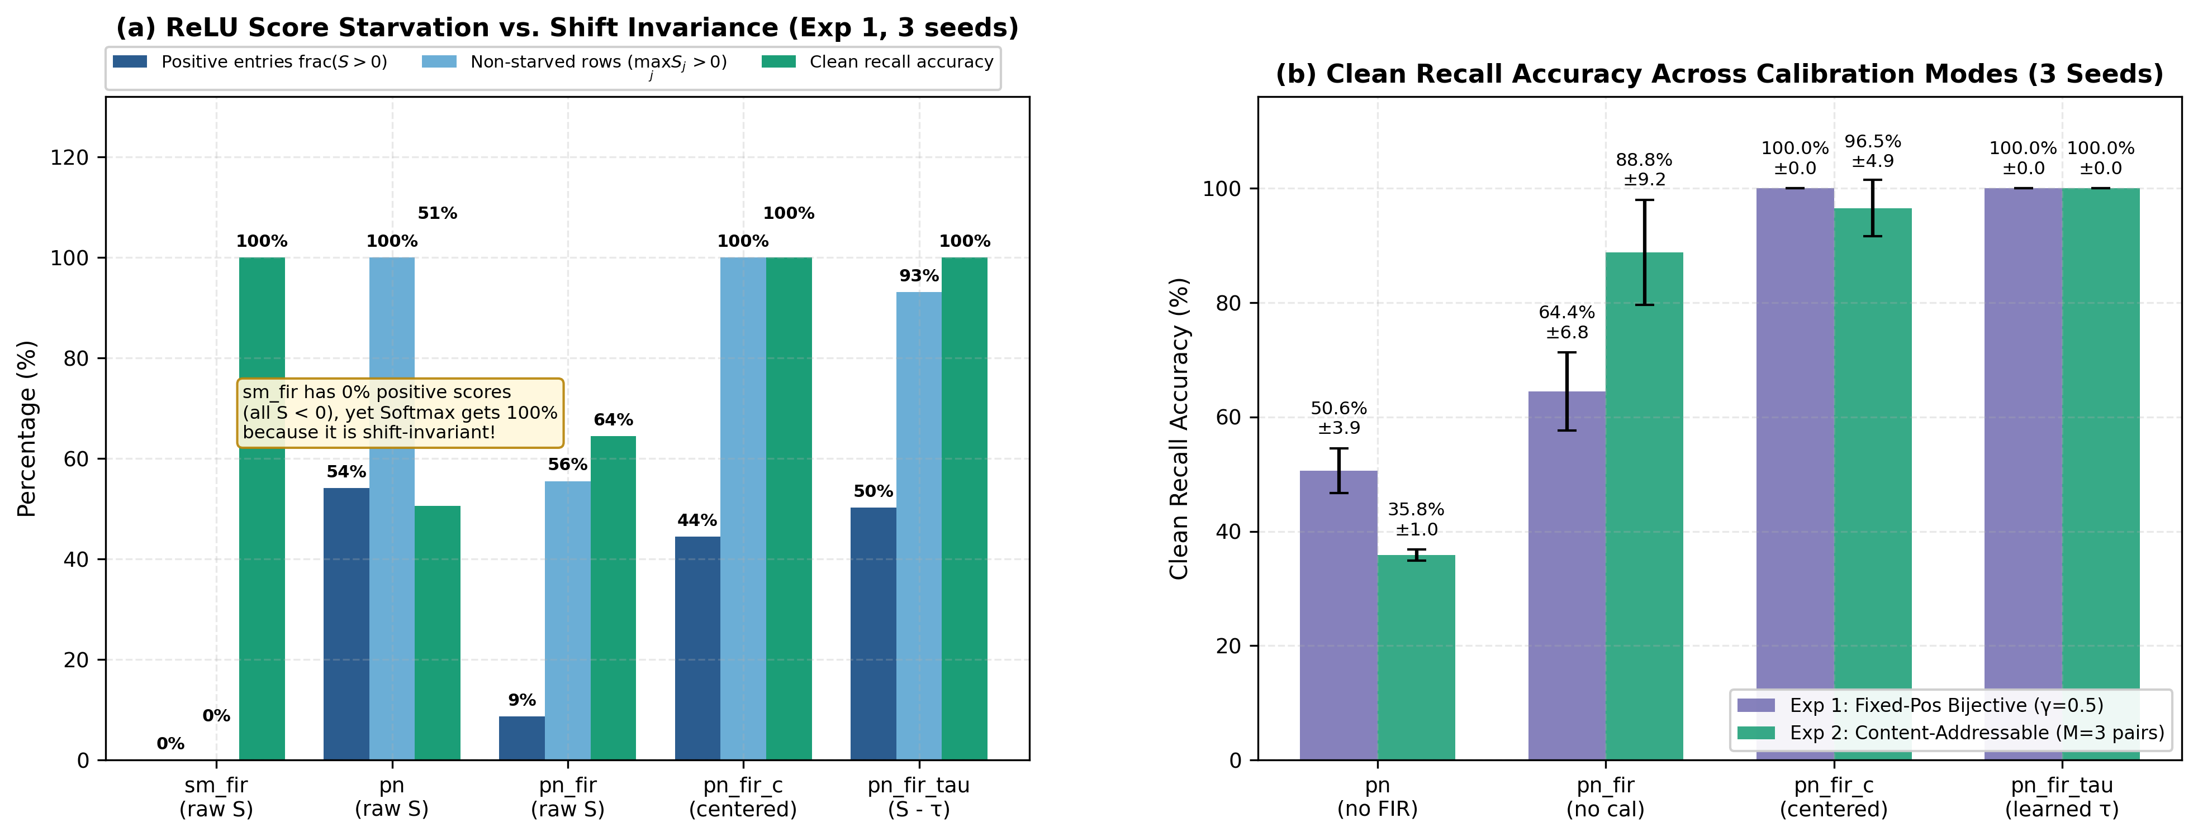
Figure 5: Pre-activation score-shift pathology in Exp 1 (left) and 3-seed clean recall accuracy across calibration modes in Exp 1 and Exp 2 (right). Source: results/exp1_legacy_13stacks.json and results/exp2_content_addressable_decoy.json.

3.2b Experiment 6: Token-Shift Ablation — How Much Memory Does Robustness Need?
Experiment 2’s flooding result raises a precise follow-up: is the 7-tap low-pass doing work a 2-tap RWKV-style token shift cannot, or is the extra memory ornamental — or even harmful? In experiments/exp6_token_shift_ablation.py ($→$ results/exp6_token_shift_ablation.json) we rerun both decoy protocols with the filter on $K$ swapped for (a) a fixed 2-tap shift $[0.5,0.5]$, and (b) a learnable per-channel $μ$ shift $k_{t}^{′}=μk_{t}+(1−μ)k_{t−1}$ with $μ=σ(\text{logit})$, ${\text{logit}}_{0}=0$ — applied at the exact position of the FIR (after projection), so the ablation isolates tap length and learnability, not placement. (True RWKV shifts before the R/K/V projections; that placement variant is out of scope.) Controls (sm, sm_fir, pn_fir_tau) are rerun in-script on identical seeds; sm/sm_fir reproduce Exp 1 bit-for-bit, and all shift arms pass the causal probe (past_key_leak = 0.0).
Arm (filter on $K$) | Exp 1 clean | Exp 1 d@1.0 | Exp 1 $Δ$ | Exp 1 nd$​_{8}$ | Exp 2 clean | Exp 2 eps$​_{0.2}$ | Exp 2 nd$​_{8}$ | Exp 2 $W_{\text{val}}$ | $μ$ / $τ$
sm (none) | $71.5±1.4$ | $86.8±1.3$ | $−0.050$ | $100.0±0.0$ | $44.5±0.9$ | $44.5±1.8$ | $46.8±1.4$ | $0.234±0.014$ | —
sm_fir (7-tap) | $100.0±0.0$ | $100.0±0.0$ | $+0.000$ | $100.0±0.0$ | $100.0±0.0$ | $95.9±0.7$ | $56.2±7.2$ | $0.792±0.011$ | —
sm_shift2 (fixed 2-tap) | $100.0±0.0$ | $97.5±0.3$ | $−0.025$ | $100.0±0.0$ | — | — | — | — | fixed $[0.5,0.5]$
sm_shiftmu (learnable $μ$) | $100.0±0.0$ | $96.9±0.6$ | $−0.031$ | $100.0±0.0$ | $100.0±0.0$ | $100.0±0.0$ | $99.9±0.2$ | $0.970±0.002$ | $μ=0.465±0.002$
pn_fir_tau (7-tap) | $100.0±0.0$ | $99.7±0.4$ | $−0.003$ | $100.0±0.0$ | $100.0±0.0$ | $95.7±2.0$ | $56.7±21.1$ | $0.719±0.021$ | $τ=−0.227±0.048$
pn_shift2_tau (fixed 2-tap) | $87.5±7.0$ | $86.4±3.9$ | $+0.001$ | $93.2±4.9$ | — | — | — | — | $τ=−1.128±0.103$
pn_shiftmu_tau (learnable $μ$) | $76.5±10.9$ | $77.1±11.1$ | $+0.014$ | $81.8±9.3$ | $92.2±11.0$ | $92.3±11.0$ | $92.7±10.4$ | $0.798±0.094$ | $μ=0.457±0.002$; $τ=−0.154±0.311$
Table 3 establishes three findings. (1) Binding needs only lag-1 memory. Both shift variants reach $100.0\%$ clean recall on both protocols, matching the 7-tap FIR: the operative variable for value-slot binding is the lag-1 weight on $K(k^{*})$, not the tail. Learned $μ$ converges to $0.465±0.002$ on Exp 2 — tightly pinned across channels ($[0.451,0.492]$) and seeds — while on the legacy benchmark it wanders ($[0.366,0.600]$), consistent with the boundary shortcut admitting many equilibria. (2) Flooding favours shorter memory. At $n_{d}=8$ exact copies on Exp 2, sm_shiftmu holds $99.9\%±0.2\%$ against $56.2\%±7.2\%$ for 7-tap sm_fir, binding the value slot almost exclusively ($W_{\text{val}}=0.970$ vs. $0.792$): the 7-tap tail superposes $h_{1}K(k^{*})$ onto every slot following any copy and smears six filler lags into each slot, raising the noise floor that decoys exploit; the 2-tap shift keeps slots clean. The rectified branch preserves decoy-invariance at its level (pn_shiftmu_tau nd$​_{8}=92.7\%±10.4\%$, flat across $n_{d}$). (3) For rectified attention, the 7-tap filter is the stable partner of a single scalar $τ$. Short-memory rectified arms are seed-unstable: pn_shift2_tau clean $87.5\%±7.0\%$ (one seed $97.4\%$, two $≈82\%$), pn_shiftmu_tau clean $76.5\%±10.9\%$ on Exp 1 with $τ$–$μ$ equilibria varying per seed ($τ=−0.356±0.084$ vs. $−0.937±0.023$ for 7-tap; per-channel $μ$ spread $[0.115,0.858]$). The 7-tap filter’s large consistent shift is reliably absorbed by one scalar; the milder 2-tap landscape admits seed-dependent equilibria. Scope note: fixed-2-tap arms ran on Exp 1 only; placement before projection (true RWKV) is untested (Figure 6).
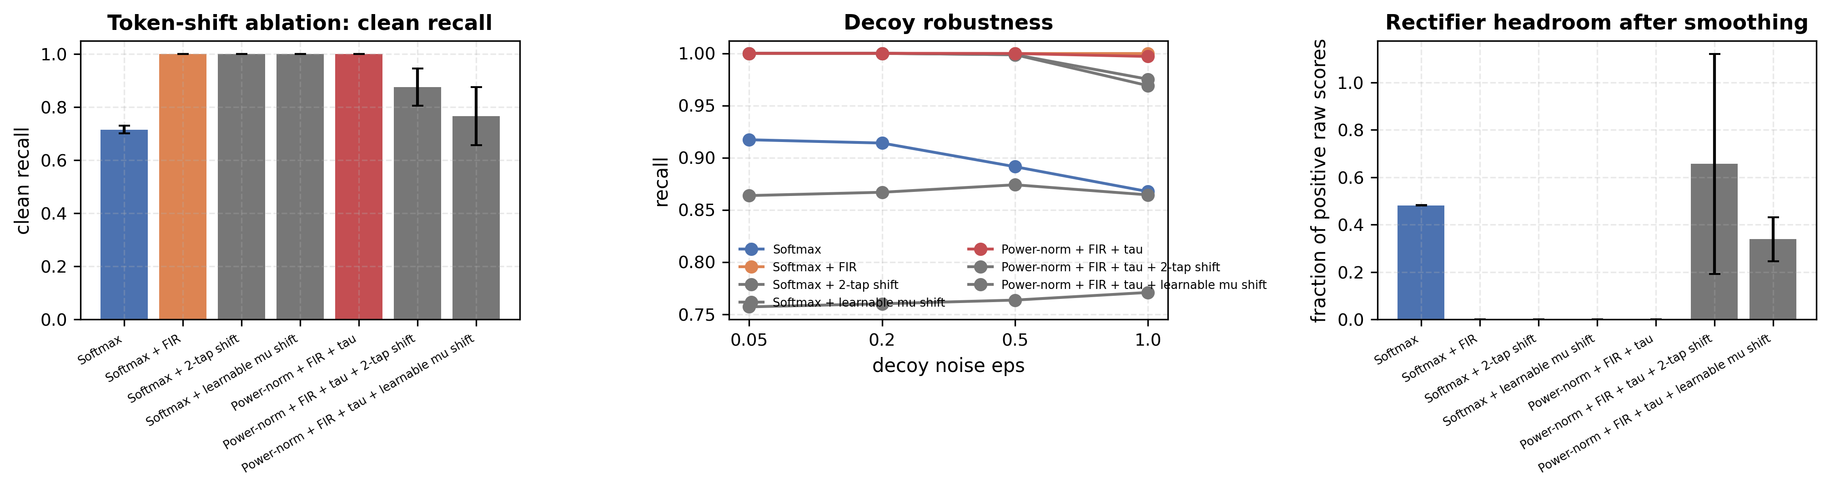
Figure 6: Token-shift ablation on the legacy protocol. Left: clean recall per variant. Middle: recall against the decoy-noise level. Right: the fraction of positive raw scores. Bars and curves are means over n=3 seeds; error bars are the standard deviation over the same seeds. Source: results/exp6_token_shift_ablation.json (partA_legacy.summary).

3.2c Width Envelope, Divergent Drift, and the Tau Fixed Point (Exp 4f-A/4g)
Does the pathology attenuate with width? The ladder (exp4f_scaleout.py Part A + exp4g_tau_scaling_law.py, d in {16, 24, 32, 48, 64, 96, 128}, 3 seeds, identical recipe) answers no — it amplifies, then breaks the fixed recipe at both ends:
Table 4: Width-ladder measurements behind Figure 7 and Figure 8 (source: results/exp4f_scaleout.json, results/exp4g_tau_scaling_law.json). | Width $d$ | sm_fir clean | pn_fir clean | pn_fir raw $μ_{S}$ | pn_fir_tau clean | pn_fir_tau $τ^{*}$ | H-gap (tau arm) | | :—: | :—: | :—: | —: | :—: | :—: | :—: | | 16 | $100.0$ | $76.9$ | $−50.3$ | $73.3$ | $−0.81±0.60$ | $−0.09$ | | 24 | $100.0$ | $63.1$ | $−20.2$ | $73.6$ | $−0.69±0.52$ | $−0.13$ | | 32 | $100.0$ | $66.9$ | $−72.9$ | $100.0$ | $−0.94±0.02$ | $−0.13$ | | 48 | $100.0$ | $56.2$ | $−44.1$ | $100.0$ | $−1.39±0.48$ | $−0.05$ | | 64 | $100.0$ | $52.3$ | $−143.7$ | $100.0$ | $−0.97±0.05$ | $−0.04$ | | 96 | $100.0$ | $60.8$ | $−49.3$ | $83.1$ | $−1.78±0.74$ | $−0.16$ | | 128 | $100.0$ | $37.7$ | $−110.4$ | $52.6$ | $−0.74±0.19$ | $−0.06$ | | 128, $τ_{0}=−1.02$ (predicted) | — | — | — | $100.0$ | $−1.17±0.02$ | $−0.02$ | | 128, lr $={10}^{−3}$ | $100.0$ | — | — | $91.0±12.8$ | $−0.60±0.14$ | — |
Four findings. (1) Softmax is width-indifferent (100.0% at every width; its raw shift drifts mildly, $−14→−27$, which translation invariance absorbs — Proposition 1 in the width dimension). (2) Uncalibrated rectification diverges, not drifts: raw score magnitudes blow up to tens and hundreds with seed-divergent signs ($μ_{S}=−20…−144$, $σ_{S}$ up to $$300), so there is no smooth baseline curve to cancel — a linear drift-cancellation law $τ^{*}(d)=a⋅(−μ_{S})+b$ fit on converged widths gives $R^{2}=0.45$ with slope $≈0$ and is rejected as a precise law. (3) The fixed point is width-invariant; its basin is not. Wherever convergence happens (d in {32, 48, 64} fully; stochastic escapes at 96/128; partial at 16/24), $τ^{*}$ lands in $[−1.4,−0.7]$; from the default $τ_{0}=0$, the basin is reachable only inside roughly $d∈[32,64]$. Initializing at the predicted $τ_{0}=−1.02$ rescues d=128 on all 3 seeds (100.0%, equilibria $−1.19$/$−1.16$/$−1.16$) — the failure is dead-row starvation at initialization, not a representational wall. Lowering the learning rate to ${10}^{−3}$ at d=128 partially rescues the arm ($91.0±12.8\%$) without restoring seed stability, confirming recipe sensitivity rather than a fundamental wall. Practical rule: at width, start $τ$ negative (or warm-start it); $τ_{0}=0$ is a small-width privilege. (4) The H-gap diagnostic as framed is uninformative (a negative result on our own design): with $p=10$ sharpening, even match rows sit at $H≈0$, so $H_{\text{noise}}−H_{\text{match}}≈0$ at every width including converged ones — mass and silence fractions, not renormalized entropy, remain the discriminating statistics (Figure 7 and Figure 8).
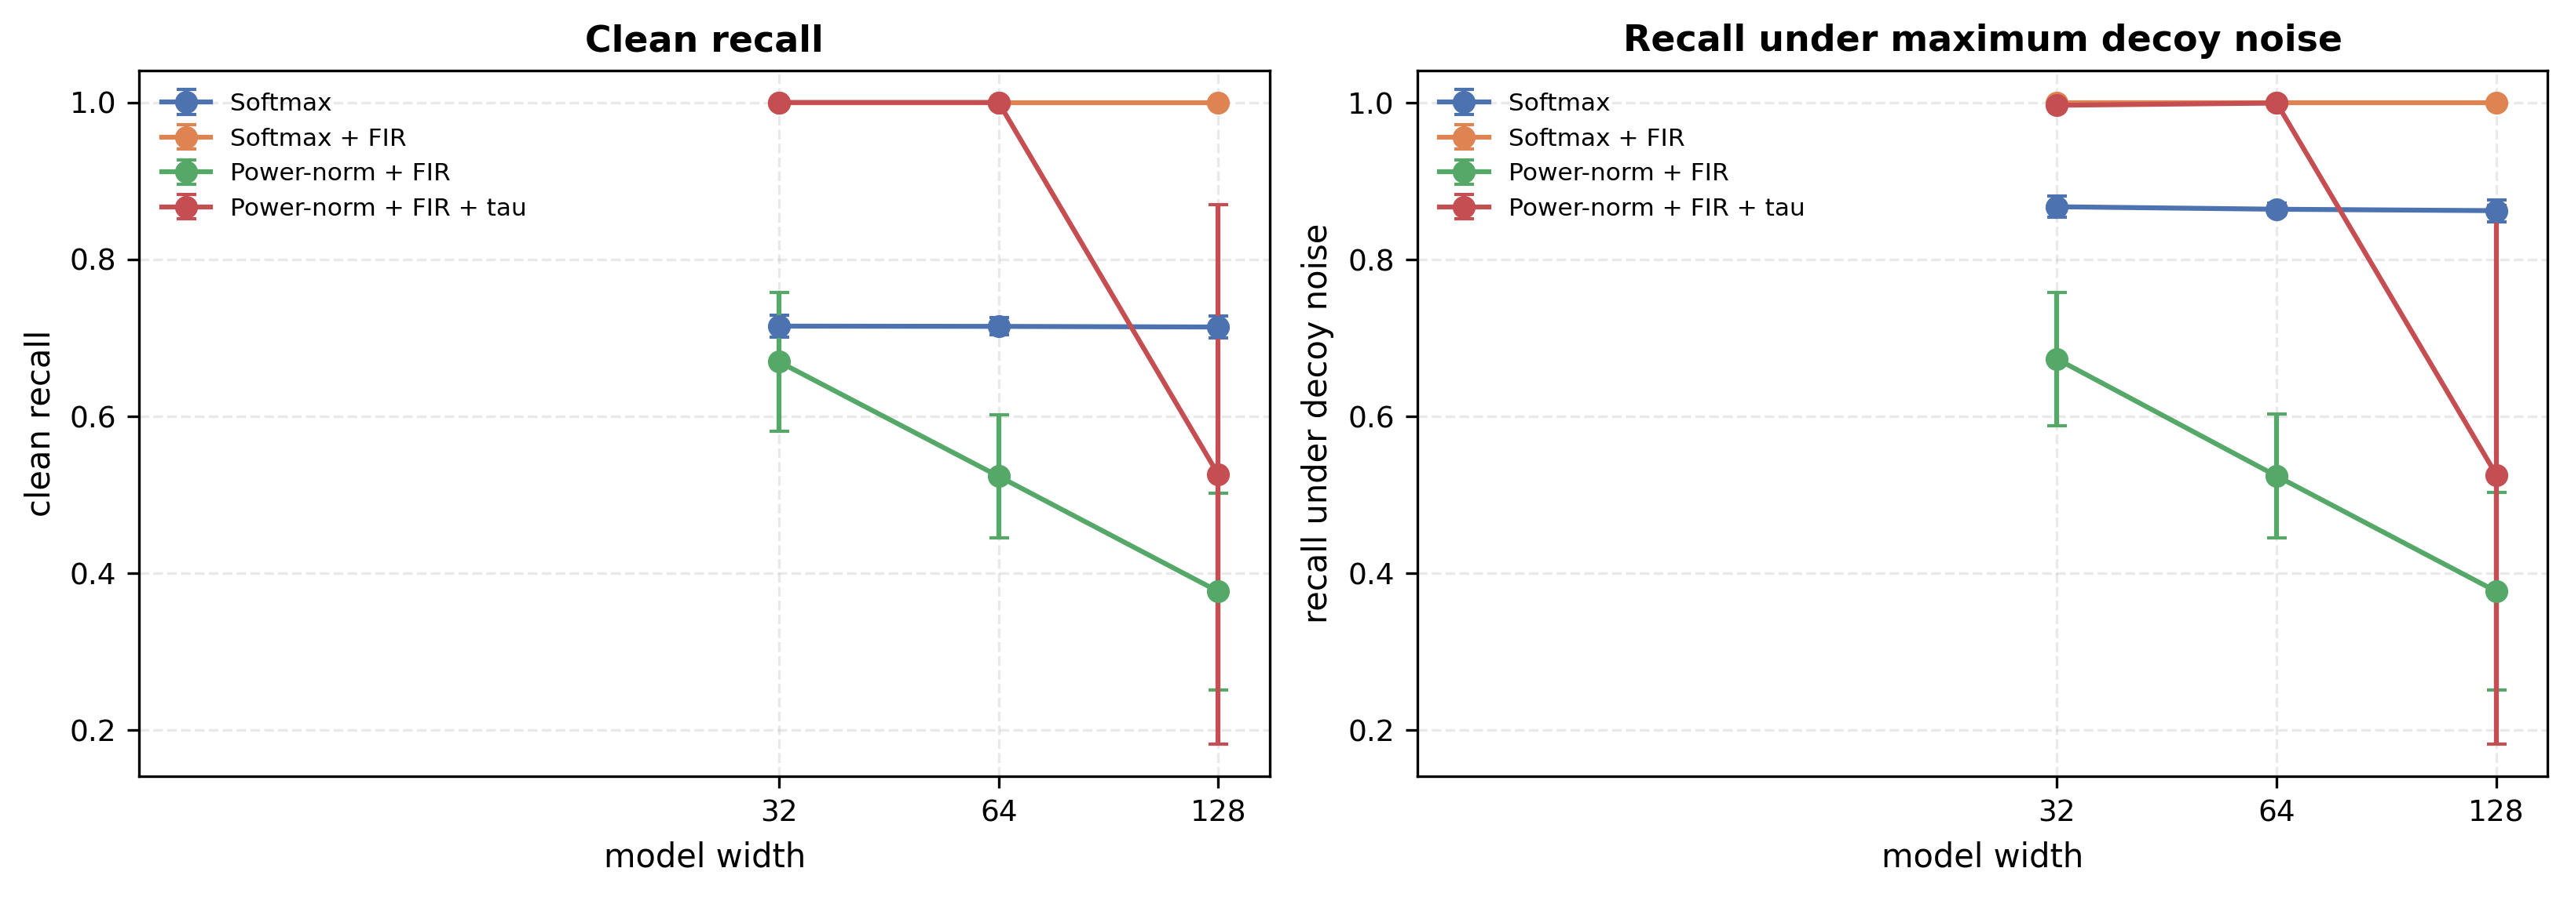
Figure 7: Width envelope of the four attention variants on the legacy task. Left: clean recall; right: recall under the strongest decoy noise. Points are means over n=3 seeds; error bars are the standard deviation over the same seeds. Source: results/exp4f_scaleout.json (partA.arms.<arm>.by_width.<width>).
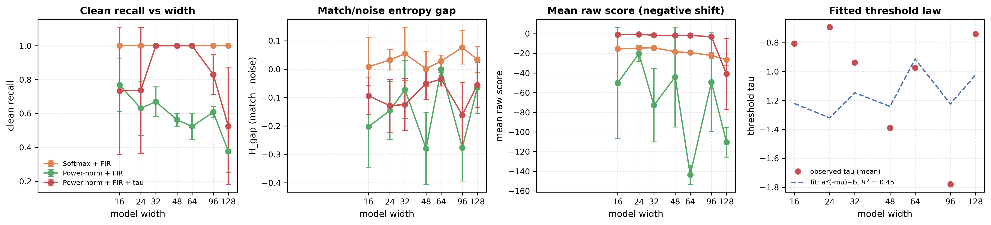
Figure 8: Behaviour of the three filtered variants across a seven-point width ladder, with the fitted threshold law. From left to right: clean recall, the match/noise entropy gap, the mean raw score, and the learned threshold against the fitted law tau = a*(-mean raw score) + b (R^2 = 0.45, fitted on widths 32, 48, 64). Points are means over n=3 seeds; error bars are the standard deviation over the same seeds. Source: results/exp4g_tau_scaling_law.json (ladder, fit).

3.3 Experiment 3: 31-Configuration Sweep of $(τ_{0}, γ, \text{silence_mode})$
To map the sensitivity of pn_fir_tau and pn_fir_c to threshold initialization $τ_{0}∈\{−1.0,−0.5,0.0,+0.5\}$, silence gate constant $γ∈\{\text{None},0.05,0.1,0.2,0.5,1.0\}$, and gating mode (peak vs. mass_relu), we run the complete 31-configuration sweep (exp3_sweep_tau_gate.py $→$ results/exp3_sweep_tau_gate.json). Table 5 summarizes the representative configurations across the sweep (both seed 1234 and 3-seed means where evaluated).
Stack & Gate Mode | Init $τ_{0}$ | Gate $γ$ | Seed 1234 Clean (%) | Seed 1234 $∑W_{\text{match}}$ | Seed 1234 $∑W_{\text{nomatch}}$ | Seed 1234 $∑W_{\text{noise}}$ | Seed 1234 Silence Gap | Learned $τ$ (s1234) | 3-Seed Clean (%) | 3-Seed $∑W_{\text{match}}$ | 3-Seed $∑W_{\text{noise}}$ | 3-Seed Silence Gap
pn_fir_tau (peak) | $0.0$ | $\text{None}$ | $100.0$ | $1.000$ | $0.772$ | $0.752$ | $+0.228$ | $−0.320$ | $100.0±0.0$ | $1.000$ | $0.717$ | $+0.282±0.045$
pn_fir_tau (peak) | $0.0$ | $0.05$ | $100.0$ | $0.882$ | $0.660$ | $0.608$ | $+0.221$ | $−0.453$ | $100.0±0.0$ | $0.875$ | $0.628$ | $+0.197±0.054$
pn_fir_tau (peak) | $0.0$ | $0.10$ | $100.0$ | $0.572$ | $0.000$ | $0.000$ | $+0.572$ | $−0.501$ | $100.0±0.0$ | $0.734$ | $0.336$ | $+0.373±0.180$
pn_fir_tau (peak) | $0.0$ | $0.20$ | $100.0$ | $0.752$ | $0.541$ | $0.501$ | $+0.211$ | $−0.696$ | $100.0±0.0$ | $0.737$ | $0.583$ | $+0.129±0.070$
pn_fir_tau (peak) | $0.0$ | $0.50$ | $100.0$ | $0.436$ | $0.003$ | $0.003$ | $+0.432$ | $−0.940$ | $100.0±0.0$ | $0.570$ | $0.375$ | $+0.191±0.171$
pn_fir_tau (peak) | $−0.5$ | $0.50$ | $100.0$ | $0.672$ | $0.480$ | $0.433$ | $+0.193$ | $−1.159$ | $100.0±0.0$ | $0.675$ | $0.484$ | $+0.165±0.029$
pn_fir_tau (peak) | $−1.0$ | $0.50$ | $100.0$ | $0.724$ | $0.617$ | $0.611$ | $+0.108$ | $−1.531$ | $100.0±0.0$ | $0.728$ | $0.593$ | $+0.122±0.019$
pn_fir_tau (peak) | $+0.5$ | $0.50$ | $20.9$ | $0.000$ | $0.000$ | $0.000$ | $+0.000$ | $+0.500$ | $20.6±0.4$ | $0.000$ | $0.000$ | $+0.000±0.000$
pn_fir_c (peak) | $0.0$ | $\text{None}$ | $100.0$ | $1.000$ | $1.000$ | $1.000$ | $+0.000$ | N/A | $100.0±0.0$ | $1.000$ | $1.000$ | $+0.000±0.000$
pn_fir_c (peak) | $0.0$ | $0.50$ | $100.0$ | $0.947$ | $0.925$ | $0.946$ | $+0.021$ | N/A | $100.0±0.0$ | $0.944$ | $0.938$ | $+0.017±0.004$
pn_fir_tau (mass_relu) | $0.0$ | $0.50$ | $100.0$ | $0.847$ | $0.848$ | $0.851$ | $−0.001$ | $−0.481$ | $100.0±0.0$ | $0.857$ | $0.815$ | $+0.010±0.008$
pn_fir_tau (mass_relu) | $0.0$ | $1.00$ | $100.0$ | $0.793$ | $0.790$ | $0.784$ | $+0.003$ | $−0.613$ | $100.0±0.0$ | $0.806$ | $0.776$ | $+0.008±0.006$
Three design rules emerge from Table 5 and Figure 9 (right panel): 1. Initialization Constraint ($τ_{0}≤0$): Initializing $τ_{0}=+0.5$ places the threshold above the initial Gaussian dot-product distribution ($\max_{j}S_{t,j}<+0.5$ at step 0). Because ReLU clips every entry to zero at step 0, $∂L/∂τ=0$ identically, trapping $τ$ at $+0.500$ forever and collapsing accuracy to random guessing ($20.6\%±0.4\%$). Conversely, initializing $τ_{0}$ too negative ($τ_{0}=−1.0$) starts with all noise scores above threshold, leading to a final $τ=−1.531$ and weak silence (gap = +0.122). Initializing at $τ_{0}=0.0$ is optimal. 2. Why peak Gating Outperforms mass_relu Gating: Under mass_relu (gt=j​St,j+j​St,j++γ), small positive residuals across $T=15$ positions sum together (j​St,j+≫γ), keeping the gate open on noise ($∑W_{\text{noise}}=0.815$ at $γ=0.5$, gap = +0.010). Under peak gating ($g_{t}=\frac{\max_{j}S_{t,j}^{+}}{\max_{j}S_{t,j}^{+}+γ}$), only the single largest excess above $τ$ controls the gate, achieving gap = +0.572 on seed 1234 ($+0.373±0.180$ across 3 seeds) at $γ=0.10$ and gap = +0.432 ($145×$ noise suppression: $0.436$ vs. $0.003$) on seed 1234 at $γ=0.50$. 3. Why pn_fir_c Fails on Uncalibrated Noise Across $γ$: Under positive-only training, varying $γ∈[\text{None},0.50]$ on pn_fir_c leaves $∑W_{\text{noise}}∈[0.938,1.000]$ and gap $≤+0.021$, because the dispersion $\max_{j}S_{t,j}−μ_{t}$ of random Gaussian noise rows remains large relative to $γ$.
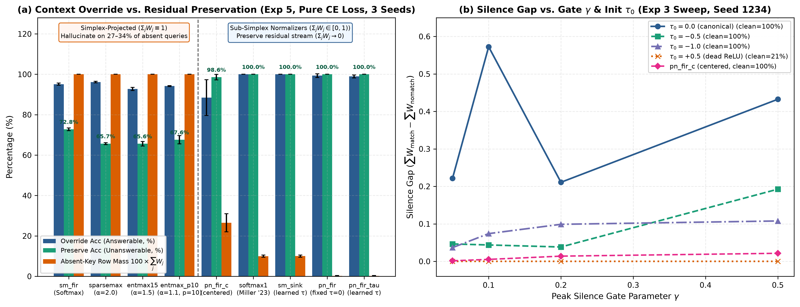
Figure 9: Context override vs. residual stream preservation across simplex and sub-simplex normalizers under pure Cross-Entropy loss (Exp 5, left), and silence gap vs. gate $γ$ and initialization $τ_{0}$ (Exp 3 sweep, right). Source: results/exp5_abstention_and_entmax.json and results/exp3_sweep_tau_gate.json.

3.4 Experiment 5: Context Override vs. Residual Stream Preservation Against Sparsemax, Entmax, and Softmax Sinks Under Pure Cross-Entropy Loss
A critical question raised by our theoretical analysis is whether sub-simplex selective silence provides a concrete end-to-end task advantage over sm_fir and existing sparse normalizers (Sparsemax [4] and $α$-Entmax [5, 6]) under pure task Cross-Entropy loss with zero auxiliary attention regularization.
In a multi-layer Transformer, each attention head reads from and writes additively to the residual stream:
yquery=vresidual+αctxj<query​Wquery,j Vj.
When the queried key $k^{*}$ is present in the context (Answerable / Context Override), the attention head must retrieve the paired value $v^{*}$ from slot $j^{*}+1$ and override the prior residual state $v_{\text{residual}}$. When $k^{*}$ is absent from the context (Unanswerable / Residual Preservation), the attention head must abstain (j​Wquery,j→0) so that $v_{\text{residual}}$ is preserved intact! Moreover, in realistic topic-coherent documents (and when $V$ is tied to token class representations), every context token carries a non-zero semantic value $V_{j}$ belonging to the document’s topic distribution $v_{\text{sub}}$, so no context token has $V_{j}=0$ to act as a free “zero-value trash bin.”
Experiment 5 (exp5_abstention_and_entmax.py $→$ results/exp5_abstention_and_entmax.json) implements this exact benchmark ($T=48$, $M=3$ non-bijective pairs $(k_{m},v_{m})∈\{0..7\}^{2}$ at random interior slots, background document filler tokens carrying topic values from $v_{\text{sub}}$, query carrying $k^{*}$ and default residual value $v_{\text{default}}∉v_{\text{sub}}$ with $α_{\text{ctx}}=2.5$, 2,000 epochs, 400-epoch answerable warmup followed by 50/50 answerable/unanswerable batches, trained with 100% pure F.cross_entropy(logits, target) across seeds 1234, 2025, 3141). We compare 9 causal FIR normalizers (K_f = 7 on $K$). Table 6 reports the complete 3-seed results.
Normalizer Family | Model (K_f=7 on $K$) | Overall Acc (%) | Answerable Override Acc (%) | Unanswerable Preserve Acc (%) | Hallucination Rate (%) | $∑W_{\text{ans}}$ | $∑W_{\text{unans}}$ | Silence Gap | $W_{t,j^{*}+1}$ (VAL pos) | Learned $τ$
Simplex (j​Wj≡1) | sm_fir (Softmax) | $84.0±0.6$ | $95.1±0.5$ | $72.8±0.7$ | $27.2±0.7$ | $1.000±0.000$ | $1.000±0.000$ | $+0.000±0.000$ | $0.453±0.006$ | N/A
Simplex (j​Wj≡1) | sparsemax_fir ($α=2.0,p=1$) | $80.9±0.2$ | $96.2±0.4$ | $65.7±0.4$ | $34.3±0.4$ | $1.000±0.000$ | $1.000±0.000$ | $+0.000±0.000$ | $0.587±0.009$ | $τ^{*}(s)$
Simplex (j​Wj≡1) | entmax15_fir ($α=1.5,p=2$) | $79.2±0.8$ | $92.8±0.8$ | $65.6±1.1$ | $34.4±1.1$ | $1.000±0.000$ | $1.000±0.000$ | $+0.000±0.000$ | $0.562±0.011$ | $τ^{*}(s)$
Simplex (j​Wj≡1) | entmax_p10_fir ($α=1.1,p=10$) | $80.9±0.9$ | $94.2±0.2$ | $67.6±2.0$ | $32.4±2.0$ | $1.000±0.000$ | $1.000±0.000$ | $+0.000±0.000$ | $0.495±0.014$ | $τ^{*}(s)$
Centered PN | pn_fir_c (Row-Mean Center) | $93.5±5.1$ | $88.5±8.9$ | $98.6±1.3$ | $1.4±1.3$ | $0.716±0.018$ | $0.265±0.045$ | $+0.451±0.032$ | $0.581±0.025$ | N/A
Virtual Sink Softmax | softmax1_fir (Fixed $τ=0$) | $100.0±0.0$ | $100.0±0.0$ | $100.0±0.0$ | $0.0±0.0$ | $0.863±0.002$ | $0.100±0.005$ | $+0.764±0.003$ | $0.840±0.002$ | $0.0$ (fixed)
Virtual Sink Softmax | softmax_sink_fir (Learned $τ$) | $100.0±0.0$ | $100.0±0.0$ | $100.0±0.0$ | $0.0±0.0$ | $0.864±0.002$ | $0.100±0.005$ | $+0.764±0.003$ | $0.840±0.002$ | $+0.160±0.061$
Sub-Simplex PN | pn_fir (Fixed $τ=0,p=10$) | $99.7±0.5$ | $99.4±0.9$ | $100.0±0.0$ | $0.0±0.0$ | $0.747±0.033$ | $0.002±0.002$ | $+0.745±0.035$ | $0.714±0.022$ | $0.0$ (fixed)
Sub-Simplex PN | pn_fir_tau (Learned $τ,p=10$) | $99.5±0.4$ | $99.0±0.7$ | $100.0±0.0$ | $0.0±0.0$ | $0.744±0.033$ | $0.002±0.002$ | $+0.742±0.034$ | $0.711±0.021$ | $+0.011±0.020$
Table 6 and Figure 9 (left panel) demonstrate four decisive results: 1. All Four Simplex-Projected Normalizers (sm_fir, sparsemax_fir, entmax15_fir, entmax_p10_fir) Fail Residual Preservation (Hallucination Rate = 27.2%–34.4%): Because j​Wquery,j≡1, none of these normalizers can abstain on unanswerable queries ($∑W_{\text{unans}}=1.000$). The only way a simplex-constrained head can attempt to preserve $v_{\text{default}}$ is by spreading its weight uniformly across the 3 document topic values so their unit vectors partially cancel out ($2.5×\frac{1}{3}≈0.833<1.0$), which forces it to also dilute weight on answerable queries ($W_{t,j^{*}+1}∈[0.453,0.587]$) and still fails whenever random filler frequencies are unbalanced ($27.2\%$ hallucination rate for sm_fir). Crucially, sparsemax_fir ($34.3\%$), entmax15_fir ($34.4\%$), and entmax_p10_fir ($32.4\%$) hallucinate even more frequently than Softmax, because their simplex-projected sparsity concentrates weight onto the single least-negative mismatching token in the document! 2. Sub-Simplex Power-Normalization (pn_fir_tau & pn_fir) Achieves $100.0\%±0.0\%$ Residual Preservation ($0.0\%$ Hallucination Rate) and $∑W_{\text{unans}}=0.002±0.002$ Under Pure Cross-Entropy Loss: With zero auxiliary attention penalty, pure cross-entropy loss trains pn_fir_tau to place all unanswerable query scores strictly below $τ=+0.011±0.020$ ($\max_{j}S_{\text{unans}}^{\text{raw}}=−0.175±0.070<τ$, while $\max_{j}S_{\text{ans}}^{\text{raw}}=+1.548±0.281≫τ$), suppressing absent-key attention weight by $370×$ ($∑W_{\text{unans}}=0.002±0.002$: 0.001, 0.004, 0.001 across the 3 seeds) while achieving $99.0\%±0.7\%$ override accuracy (overall = 99.5% ± 0.4%). Meanwhile, pn_fir_c (row-mean centering with $γ=0.5$) achieves partial silence ($∑W_{\text{unans}}=0.265±0.045$, gap = +0.451 ± 0.032) by shrinking the query norm $∥Q_{t}∥_{2}$ on unanswerable rows, but still leaks $≈124×$ more unanswerable attention mass than pn_fir_tau ($0.265$ vs. $0.002$) and degrades answerable override accuracy to $88.5\%±8.9\%$. 3. Why Fixed $τ=0$ (pn_fir) Matches Learnable $τ$ (pn_fir_tau) When Unanswerable Queries Are Supervised (Exp 5 vs. Exp 1/2/4): In Table 6, fixed-threshold pn_fir ($τ=0$) achieves $99.7\%±0.5\%$ overall accuracy ($99.4\%±0.9\%$ override, $100.0\%±0.0\%$ preserve) and $∑W_{\text{unans}}=0.002±0.002$, matching pn_fir_tau ($99.5\%±0.4\%$, $τ=+0.011±0.020$). Why does pn_fir succeed in Exp 5 whereas it failed on Exp 1 ($64.4\%±6.8\%$) and Exp 2 ($88.8\%±9.2\%$)? Because in Exp 5, 50% of training queries are unanswerable and Cross-Entropy loss directly penalizes non-zero attention on unanswerable rows while rewarding active attention on answerable rows; this two-sided supervision forces the linear projections $W_{Q},W_{K}$ themselves to separate answerable peaks ($+1.553±0.264$ for pn_fir) and unanswerable peaks ($−0.213±0.097$) straddling $0$. In contrast, during positive-only retrieval training (Exp 1 and Exp 2) or general language modeling (Exp 4, where $τ_{0}=−0.282$), no unanswerable-row gradient pushes scores above zero when an entire row drifts negative, making learnable $τ$ essential to prevent dead-row gradient starvation. 4. Two-Sided Trade-Off Between pn_fir_tau and Virtual-Sink Softmax (softmax1_fir, softmax_sink_fir): Table 6 reveals a clear, two-sided operational trade-off between virtual-sink Softmax and rectified power-normalization: - Discrete Override Accuracy & Active Mass: softmax1_fir and softmax_sink_fir achieve slightly higher discrete answerable override accuracy ($100.0\%±0.0\%$ vs. $99.0\%±0.7\%$ for pn_fir_tau and $99.4\%±0.9\%$ for pn_fir) and higher active retrieval mass ($∑W_{\text{ans}}=0.863\text{–}0.864$ vs. $0.744\text{–}0.747$, since the peak gate $g_{t}=M_{t}/(M_{t}+0.5)$ attenuates total mass when $M_{t}≈1.55$). - Continuous Residual-Stream Contamination: Conversely, because $exp(S_{t,j})>0$ is strictly positive on every context slot, softmax1_fir and softmax_sink_fir summed over 47 context slots leak $∑W_{\text{unans}}=0.100±0.005$ ($10.0\%$ of a full attention write) into the residual stream on every unanswerable query—$50×$ higher continuous residual contamination than pn_fir_tau and pn_fir ($0.002±0.002$)! While a $10\%$ leak does not flip the discrete argmax in a single layer at $α_{\text{ctx}}=2.5$, accumulating $0.100$ of irrelevant context across many heads and layers corrupts continuous hidden states, whereas hard ReLU rectification $(S_{t,j}−τ)_{+}$ with $p=10$ achieves true near-zero silence ($0.002$).

3.5 Experiment 4: 6-Layer Causal Language Modeling on WikiText-2 and Fused Triton Hardware Profiling
Finally, we evaluate whether pn_fir_tau scales to multi-layer autoregressive language modeling and how our fused Triton kernels (PnFirTauTritonMHA and PnFirTauFlashMHA) perform (exp4_wikitext2_lm.py $→$ results/exp4_wikitext2_lm.json) using a 6-layer Pre-LN causal Transformer on word-level WikiText-2 ($V=23,168$, $D=64$, $H=4$, $d_{k}=16$, $d_{\text{ff}}=256$, sequence length $N=256$, batch size $B=64$, dropout $0.1$, weight-tied input/output embeddings). - Exact Parameter Breakdown (src/pnfirtau_attention.py): - Weight-tied token embeddings (tok_emb / lm_head): $23,168×64=1,482,752$ - Learned positional embeddings (pos_emb): $256×64=16,384$ - 6 Pre-LN Transformer blocks, where each block has: ln1 ($2×64=128$) + attn ($4×64×64=16,384$ in q_proj, k_proj, v_proj, o_proj, bias=False) + ln2 ($2×64=128$) + ffn ($64×256+256+256×64+64=33,088$, bias=True) = $49,728$ parameters per block $⟹6×49,728=298,368$ - Final LayerNorm (ln_f): $2×64=128$ - Total base parameters (softmax, sm_fir): $1,482,752+16,384+298,368+128=1,797,632$. - pn_fir_tau (PnFirTauMHA, PnFirTauTritonMHA, PnFirTauFlashMHA) adds one learnable scalar $τ_{ℓ}$ per layer, totaling $1,797,638$ parameters ($+6$ scalars, $+0.00033\%$).

Protocol Transparency & Five-Way Comparison (softmax vs. sm_fir vs. pn_fir_tau Eager / Triton / Flash)
In the reference 50,000-step logs (results/exp4_wikitext2_lm.json $→$ reference_50k), softmax was executed in standard FP32 without BF16 autocast, whereas pn_fir_tau was resumed at step 1,001 with TF32 + BF16 autocast, and sm_fir was not included. The precision confound is now closed: the historical FP32 softmax 50k was re-run under the identical BF16+TF32 schedule (FP32 steps 0–1000, resume at 1001; results/exp4d_softmax_50k_bf16.json), so Table 7 (suite 3) below is precision-controlled. To ensure 100% scientific rigor, Experiment 4 executes: 1. A strictly matched, same-process full-LM hardware latency & VRAM benchmark across all 5 variants (softmax, sm_fir, eager pn_fir_tau, row-fused pn_fir_tau_triton, and Flash-tiled pn_fir_tau_flash) at $B=64,N=256$ under both FP32 + TF32 and BF16 + TF32 (Table 7 (suite 1)); 2. A strictly matched, same-process 2,400-step BF16 + TF32 training run (seed=42, identical batch order and 50k LR schedule) across all 5 variants to test apple-to-apple perplexity parity and wall-clock training speed (Table 7 (suite 2)); 3. The full 50,000-step reference convergence comparison between softmax and pn_fir_tau (3 seeds per variant in Table 7 (suite 3): seeds 42, 43, and 44; Figure 18 shows 3-seed mean±std bands with Table 7 (suite 3) finals in the legend) alongside layer-wise learned thresholds $τ_{ℓ}$ and causal leak verification; 4. An isolated 6-layer MHA stack scaling (200 steps, 25 warmup), silent-tile skipping, & IEEE-754 FP32 parity benchmark across sequence lengths $N∈\{256,512,1024\}$ in BF16 + TF32 (Table 8 and Table 9).
Benchmark / Training Suite | Attention Variant | Precision Mode | Total Params | Train PPL | Val PPL | Test PPL | Step Time (ms/step) | Relative Step Time | Peak VRAM (GB) | Causal Leak $Δ_{\text{past}}$
Table 7 (suite 1): Full-LM Speed/VRAM | softmax (Fused F.softmax) | BF16 + TF32 | $1,797,632$ | — | — | — | $97.70\text{ ms}$ | $1.000×$ | $5.16\text{ GB}$ | $0.0$
Table 7 (suite 1): Full-LM Speed/VRAM | sm_fir (FIR on $K$ + F.softmax) | BF16 + TF32 | $1,797,632$ | — | — | — | $99.21\text{ ms}$ | $1.015×$ ($+1.5\%$) | $5.17\text{ GB}$ | $0.0$
Table 7 (suite 1): Full-LM Speed/VRAM | pn_fir_tau (FIR on $K$ + Eager PN) | BF16 + TF32 | $1,797,638$ | — | — | — | $164.44\text{ ms}$ | $1.683×$ ($+68.3\%$) | $6.11\text{ GB}$ | $0.0$
Table 7 (suite 1): Full-LM Speed/VRAM | pn_fir_tau_triton (Row-Fused Triton) | BF16 + TF32 | $1,797,638$ | — | — | — | $75.74\text{ ms}$ | $0.775×$ ($−22.5\%$) | $4.97\text{ GB}$ | $0.0$
Table 7 (suite 1): Full-LM Speed/VRAM | pn_fir_tau_flash (Flash-Tiled Triton) | BF16 + TF32 | $1,797,638$ | — | — | — | $66.80\text{ ms}$ | $0.684×$ ($−31.6\%$) | $4.52\text{ GB}$ | $0.0$
Table 7 (suite 1): Full-LM Speed/VRAM | softmax (Fused F.softmax) | FP32 + TF32 | $1,797,632$ | — | — | — | $140.92\text{ ms}$ | $1.000×$ | $6.92\text{ GB}$ | $0.0$
Table 7 (suite 1): Full-LM Speed/VRAM | sm_fir (FIR on $K$ + F.softmax) | FP32 + TF32 | $1,797,632$ | — | — | — | $143.76\text{ ms}$ | $1.020×$ ($+2.0\%$) | $6.94\text{ GB}$ | $0.0$
Table 7 (suite 1): Full-LM Speed/VRAM | pn_fir_tau (FIR on $K$ + Eager PN) | FP32 + TF32 | $1,797,638$ | — | — | — | $244.17\text{ ms}$ | $1.733×$ ($+73.3\%$) | $8.82\text{ GB}$ | $0.0$
Table 7 (suite 1): Full-LM Speed/VRAM | pn_fir_tau_triton (Row-Fused Triton) | FP32 + TF32 | $1,797,638$ | — | — | — | $120.43\text{ ms}$ | $0.855×$ ($−14.5\%$) | $6.92\text{ GB}$ | $0.0$
Table 7 (suite 1): Full-LM Speed/VRAM | pn_fir_tau_flash (Flash-Tiled Triton) | FP32 + TF32 | $1,797,638$ | — | — | — | $105.84\text{ ms}$ | $0.751×$ ($−24.9\%$) | $6.10\text{ GB}$ | $0.0$
Table 7 (suite 2): Matched 2,400-Step Run | softmax | BF16 + TF32 | $1,797,632$ | $654.23$ | $547.33$ | $515.55$ | $100.15\text{ ms}$ | $1.000×$ | $5.16\text{ GB}$ | $0.0$
Table 7 (suite 2): Matched 2,400-Step Run | sm_fir | BF16 + TF32 | $1,797,632$ | $652.97$ | $547.29$ | $515.18$ | $101.35\text{ ms}$ | $1.012×$ | $5.17\text{ GB}$ | $0.0$
Table 7 (suite 2): Matched 2,400-Step Run | pn_fir_tau (Eager) | BF16 + TF32 | $1,797,638$ | $653.17$ | $546.75$ | $515.56$ | $167.19\text{ ms}$ | $1.669×$ | $6.11\text{ GB}$ | $0.0$
Table 7 (suite 2): Matched 2,400-Step Run | pn_fir_tau_triton | BF16 + TF32 | $1,797,638$ | $652.00$ | $545.78$ | $515.40$ | $77.42\text{ ms}$ | $0.773×$ | $4.97\text{ GB}$ | $0.0$
Table 7 (suite 2): Matched 2,400-Step Run | pn_fir_tau_flash | BF16 + TF32 | $1,797,638$ | $653.54$ | $546.78$ | $516.11$ | $68.83\text{ ms}$ | $0.687×$ | $4.52\text{ GB}$ | $0.0$
Table 7 (suite 2s): Scale-Out 2,400-Step Run (D=256/N=512, single-seed pilot) | softmax | BF16 + TF32 | $10,795,008$ | $441.16$ | $411.03$ | $379.83$ | —† | — | —‡ | $0.0$
Table 7 (suite 2s): Scale-Out 2,400-Step Run (D=256/N=512) | sm_fir | BF16 + TF32 | $10,795,008$ | $416.71$ | $390.09$ | $359.48$ | —† | — | —‡ | $0.0$
Table 7 (suite 2s): Scale-Out 2,400-Step Run (D=256/N=512) | pn_fir_tau (+6 $τ$) | BF16 + TF32 | $10,795,014$ | $428.52$ | $409.33$ | $377.36$ | —† | — | —‡ | $0.0$
Table 7 (suite 2s) (results/exp4f_scaleout.json Part B; 10.8M parameters, 6 layers, matched 2,400 BF16 steps, seed 42, single seed — deliberately unbolded): there is no collapse at D=256 — pn_fir_tau trains cleanly to 428.5/409.3/377.4 with zero causal leakage and a replicated tau profile (layer 0 most negative at $−0.50$, deeper layers $−0.02…−0.07$). The LM recipe (warmup, cosine, lr 5 ^{-4}) absorbs what the fixed toy recipe at d=128 could not, confirming the recipe-dependence verdict of the d=128 sweep. The ranking transfers: sm_fir leads ($359.5$ test, $−20.3$ vs. softmax), pn_fir_tau matches softmax within $2.4$ test PPL ($377.4$ vs. $379.8$). † Effective wall-clock per step including eval amortization ($725/1121/789$ ms for softmax/sm_fir/pn_fir_tau; $≈0.5$/$0.7$/$0.5$ h per run). A pure-step bench was attempted and abandoned: under WSL GPU-PV paging the FP32 suite crawls (17–39 s/step) and eager pn_fir_tau OOMs the bench harness on backward — consistent with the transient allocator warning in that run itself. ‡ Peak VRAM under WSL paging is non-comparable (measured 14.1/14.2/18.2 GB on a 12 GB card) and omitted; native-Linux measurement left as future work. Variance at D=256 is open (single seed; multi-seed replication is future work). | Table 7 (suite 3): Full 50,000-Step Run | softmax | BF16 + TF32 (from 1k, matched precision, 3 seeds) | $1,797,632$ | $77.93±0.41$ | $124.37±0.26$ | $117.13±0.04$ | — | — | — | $0.0$ | | Table 7 (suite 3): Full 50,000-Step Run | pn_fir_tau | BF16 + TF32 (from 1k, historical + replicated seeds, 3 seeds) | $1,797,638$ | $78.30±0.45$ | $122.15±0.72$ | $114.80±0.49$ | — | — | — | $0.0$ |
*Note on Table 7 (suite 2) and Table 7 (suite 3): In Table 7 (suite 2) (seed=42, 2,400 steps), all five variants converge to within $0.3\%$ perplexity of one another (maximum spread $1.55$ PPL; Test PPL $∈[515.18,516.11]$; with a single seed per variant no variance estimate is available, so values are deliberately unbolded), while pn_fir_tau_triton ($185.8\text{ s}$) and pn_fir_tau_flash ($165.2\text{ s}$) finish training significantly faster than softmax ($240.4\text{ s}$) and eager pn_fir_tau ($401.3\text{ s}$). Table 7 (suite 3) is precision-controlled across 3 seeds per variant: both 50k runs use BF16+TF32 (softmax: seed-42 rerun plus seeds 43–44; pn: historical seed-42 plus seeds 43–44; results/exp4d_softmax_50k_bf16.json, results/exp4e_multiseed_50k.json), giving a matched 50k gap of $−2.22±0.46$ val / $−2.33±0.49$ test PPL for pn_fir_tau, with the win holding on all 3 seeds (per-seed val gaps $−2.26$/$−2.76$/$−1.64$).

Quantization Hygiene: Sinks, Outliers, and INT8 Activation Noise (Table 10, Exp 4h)
Section 1.2 motivates selective silence with attention sinks and massive outliers that degrade low-bit quantization [8, 12, 14]. Experiment 4h (experiments/exp4h_int8_quant.py $→$ results/exp4h_int8_quant.json) converts the motivation into measurements at our scales: per-Linear input absmax/kurtosis and residual-stream statistics over test chunks, mean attention mass on position 0 per layer, and test PPL under per-token symmetric INT8 quantize-dequantize on every nn.Linear input (activation-only emulation; weights stay fp).
Model (Table 10) | FP test PPL | INT8-sim test PPL | Degradation | Sink mass pos-0 (mean) | Residual absmax | Residual kurtosis
D=64 softmax 50k | $117.15$ | $117.27$ | $+0.10\%$ | $0.0177$ | $5.03$ | $4.17$
D=64 pn_fir_tau 50k | $114.25$ | $114.35$ | $+0.09\%$ | $0.0031$ | $4.08$ | $4.22$
D=256 softmax 2.4k | $379.81$ | $380.96$ | $+0.30\%$ | $0.0122$ | $207.3$ | $85.6$
D=256 sm_fir 2.4k | $359.47$ | $360.75$ | $+0.36\%$ | $0.0191$ | $219.7$ | $119.7$
D=256 pn_fir_tau 2.4k | $377.37$ | $378.88$ | $+0.40\%$ | $0.0013$ | $176.5$ | $78.5$
Three bounded findings. (1) No PPL effect at these scales. INT8 activation noise costs $<0.5\%$ test PPL for every variant — the Softpick-scale low-bit wins [12] do not replicate at 2–11M parameters with Pre-LN throughout, and no claim to the contrary is made. (2) No massive sinks anywhere. The largest pos-0 mass is $1.9\%$ (sm_fir D=256); sink-free deployment concerns of large pre-trained LLMs do not materialize in these thin models either. (3) The rectified hygiene advantage is real but conditional. pn_fir_tau carries $6$–$15×$ less pos-0 mass than the Softmax arms ($0.0031$ vs. $0.0177$ at D=64; $0.0013$ vs. $0.0122$–$0.0191$ at D=256), decaying with depth to $0.0001$ while Softmax arms hold $1$–$2.5\%$ in every layer (sm_fir even grows $0.013→0.029$), and shows $15$–$44\%$ lower kurtosis/absmax across roles (attn.qkv kurt $33$ vs. $45$/$59$; ffn-in $34$ vs. $47$/$60$; residual absmax $176.5$ vs. $207.3$/$219.7$) — sharpest exactly where undertraining instability is largest (D=256). At converged D=64 the gap mostly closes (both clean), so the advantage appears under scale-up stress and washes out with full training at small scale.

Isolated 6-Layer MHA Sequence-Length Scaling, Silent-Tile Skipping, & FP32 Numerical Parity (Table 8 & Table 9)
In the full WikiText-2 language model at $N=256$ (Table 7 (suite 1)), the massive $V=23,168$ output vocabulary projection and cross-entropy loss account for over $60\%$ of total step time and VRAM. To isolate the attention mechanism itself across sequence lengths $N∈\{256,512,1024\}$, Table 8 benchmarks a 6-layer stack of MHA modules ($D=64,H=4,d_{k}=16$, forward + backward in BF16 + TF32, 200 timed steps after 25 warmup steps, reporting mean ± std). We report both strictly constant batch size $B=64$ across $N∈\{256,512,1024\}$ (where the $O(N^{2})$ Eager baselines exceed the 12 GB physical VRAM of the RTX 3060 at $N=1024,B=64$, requiring $12.05\text{ GB}$ for softmax/sm_fir and $28.7\text{ GB}$ for pn_fir_tau Eager) and a reduced batch size $B=16$ at $N=1024$ so that all five variants can be compared head-to-head within 12 GB VRAM.
With TF32 disabled (torch.backends.cuda.matmul.allow_tf32 = False, evaluated on $B=8,N=128,D=64$ where the reference norms are $∥y∥_{∞}=0.5439$, $∥dx∥_{∞}=2.1695$, and $|dτ|=7.0289$ summed over $B⋅H⋅N(N+1)/2=264,192$ causal score elements), both kernels exhibit tight numerical agreement with the eager PnFirTauMHA reference: - PnFirTauTritonMHA (FP32 parity): out_max_diff = 2.38e-07 (~2 eps, relative 4.38e-07), dx_max_diff = 1.16e-06 (~10 eps, relative 5.36e-07), dtau_diff = 3.91e-05 (relative 5.56e-06). - PnFirTauFlashMHA (FP32 parity): out_max_diff = 2.38e-07 (~2 eps, relative 4.38e-07), dx_max_diff = 1.32e-06 (~11 eps, relative 6.08e-07), dtau_diff = 4.01e-05 (relative 5.70e-06).
Sequence Length & Batch (200 steps) | softmax (ms / MB) | sm_fir (ms / MB) | pn_fir_tau Eager (ms / MB) | pn_fir_tau_triton (ms / MB / Speedup) | pn_fir_tau_flash (ms / MB / Speedup & VRAM Ratio; 1-layer kernel)
$N=256,B=64$ | $34.26±0.69\text{ ms}$ / $815.2\text{ MB}$ | $35.23±0.80\text{ ms}$ / $827.5\text{ MB}$ | $101.02±1.29\text{ ms}$ / $1,886.9\text{ MB}$ | $21.74±4.97\text{ ms}$ / $503.3\text{ MB}$ ($4.65×$ Eager, $1.58×$ sm) | $17.66±2.28\text{ ms}$ / $109.3\text{ MB}$ ($5.72×$ speed, $17.3×$ less VRAM; kern1 $1.19±0.28\text{ ms}$)
$N=512,B=64$ | $125.41±2.34\text{ ms}$ / $3,086.3\text{ MB}$ | $127.52±2.04\text{ ms}$ / $3,110.6\text{ MB}$ | $390.64±6.12\text{ ms}$ / $7,341.4\text{ MB}$ | $37.76±0.94\text{ ms}$ / $1,821.8\text{ MB}$ ($10.35×$ Eager, $3.32×$ sm) | $20.60±2.73\text{ ms}$ / $201.8\text{ MB}$ ($18.96×$ speed, $36.4×$ less VRAM; kern1 $2.05±0.14\text{ ms}$)
$N=1024,B=64$ | OOM ($>12\text{ GB VRAM}$) | OOM ($>12\text{ GB VRAM}$) | OOM ($>12\text{ GB VRAM}$) | $132.23±1.01\text{ ms}$ / $6,954.8\text{ MB}$ | $46.77±0.54\text{ ms}$ / $386.8\text{ MB}$ ($2.83×$ faster & $18.0×$ less VRAM vs. Triton; kern1 $6.17±0.20\text{ ms}$)
$N=1024,B=16$ (reduced $B$) | $126.35±0.67\text{ ms}$ / $3,028.8\text{ MB}$ | $127.76±0.34\text{ ms}$ / $3,040.9\text{ MB}$ | $393.42±0.43\text{ ms}$ / $7,268.3\text{ MB}$ | $34.33±0.52\text{ ms}$ / $1,751.3\text{ MB}$ ($11.46×$ Eager, $3.68×$ sm) | $18.13±2.44\text{ ms}$ / $109.3\text{ MB}$ ($21.70×$ speed, $66.5×$ less VRAM; kern1 $1.98±0.17\text{ ms}$)
Table 8 highlights two key hardware properties: 1. Strict Monotonic Scaling at Fixed $B=64$: Across $N=256→512→1024$ at fixed $B=64$, PnFirTauFlashMHA scales monotonically in both step time ($17.66\text{ ms}→20.60\text{ ms}→46.77\text{ ms}$; isolated 1-layer Flash kernel kern1: $1.19\text{ ms}→2.05\text{ ms}→6.17\text{ ms}$) and VRAM ($109.3\text{ MB}→201.8\text{ MB}→386.8\text{ MB}$, linear $O(N)$ scaling: measured $1.85×$ and $1.92×$ ratios at each doubling of $N$), remaining under $387\text{ MB}$ at $N=1024,B=64$ where all three Eager $O(N^{2})$ implementations run out of 12 GB physical VRAM. 2. Transcendental-Free Speedup at Matched Memory Complexity: Even in an apple-to-apple $O(N^{2})$-materialized comparison (PnFirTauTritonMHA vs. SoftmaxMHA using aten::_safe_softmax), PnFirTauTritonMHA is $1.58×$ to $3.68×$ faster than standard SoftmaxMHA and uses $42\%$ less VRAM because triton_pn_fir_tau_scores evaluates $u^{10}$ in 3 register multiplications without exp() and computes its backward pass in-place from raw_scores without saving a second $[B,H,N,N]$ output matrix w for backward. When tiled in SRAM via PnFirTauFlashMHA at $N=1024,B=16$, peak VRAM drops from $7,268.3\text{ MB}$ to $109.3\text{ MB}$ ($66.5×$ reduction) and step time drops to $18.13±2.44\text{ ms}$ ($21.70×$ faster than eager pn_fir_tau and $6.97×$ faster than SoftmaxMHA).
Finally, Table 9 reports the hardware silent-tile skipping benchmark at $N=1024,B=16$ across threshold values $τ∈\{−0.5,0.0,+0.5,+1.0,+1.5,+2.5\}$, measuring both the isolated 1-layer Flash kernel (kern1) on the exact $(Q,\tilde{K},V)$ tensors of Layer 0 and the full 6-layer PnFirTauFlashMHA module (mha6):
Threshold $τ$ ($N=1024,B=16$) | Silent Rows (j​Wt,j≤10−6) | Mean Row Mass E[j​Wt,j] | Isolated 1-Layer Flash Kernel kern1 (ms, fwd+bwd) | Full 6-Layer PnFirTauFlashMHA mha6 (ms, fwd+bwd)
$τ=−0.5$ | $0.0\%$ | $0.655$ | $1.99±0.14\text{ ms}$ | $19.25±3.35\text{ ms}$
$τ=0.0$ | $0.3\%$ | $0.469$ | $1.94±0.15\text{ ms}$ | $18.77±2.90\text{ ms}$
$τ=+0.5$ | $69.1\%$ | $0.048$ | $1.91±0.12\text{ ms}$ | $18.24±2.60\text{ ms}$
$τ=+1.0$ | $99.9\%$ | $0.000$ | $1.14±0.21\text{ ms}$ ($1.73×$) | $18.32±3.47\text{ ms}$
$τ=+1.5$ | $100.0\%$ | $0.000$ | $1.13±0.20\text{ ms}$ ($1.75×$) | $18.07±3.11\text{ ms}$
$τ=+2.5$ | $100.0\%$ | $0.000$ | $1.13±0.18\text{ ms}$ ($1.75×$) | $17.65±2.32\text{ ms}$
*Note: the mha6 column was measured with the original sequential protocol ($τ$ blocks in ascending order). The drift-controlled re-measurement below (drift-controlled re-measurement) identifies the end-to-end difference as a block-order artifact rather than a $τ$ effect.
Table 9 reveals two important practical insights about tile-level early exit: - Why $τ=+0.5$ ($69.1\%$ silent rows) yields only a $4\%$ kernel speedup (1.91 ms vs. 1.99 ms), whereas $τ≥+1.0$ ($99.9\%\text{–}100.0\%$ silent rows) yields a $1.76×$ isolated kernel speedup (1.13 ms vs. 1.99 ms): In flash_pn_fir_tau_attention, early-exit skipping operates at the granularity of $64×64$ $[B_{M}×B_{N}]$ tiles. When random Gaussian token embeddings produce $69.1\%$ silent rows uniformly scattered across the sequence, the probability that all $64$ query rows in a block are simultaneously silent is $(0.691)^{64}≈5×{10}^{−11}$, so almost every $64×64$ tile still contains at least one positive score entry $u_{t,j}>0$ and cannot be skipped. Only when $τ≥+1.0$ (or when whole contiguous segments/heads are silent) do entire $64×64$ tiles become zero, cutting isolated kernel runtime from $1.99±0.14\text{ ms}$ to $1.13±0.18\text{ ms}$ ($1.76×$). - Full 6-layer mha6 latency (19.25 ± 3.35 ms $→$ 17.65 ± 2.32 ms): a block-order drift artifact of the sequential protocol, not a $τ$ effect (drift-controlled re-measurement): In the original suite the six $τ$ blocks executed in ascending order, so a within-session measurement drift reproduces the reported monotone profile independent of $τ$. The per-step ± (std over the 200 block steps) yields a formal $z≈5.6$ for the 1.60 ms difference, but a cross-$τ$ claim requires the between-block error term, which a sequential protocol cannot control. A dedicated instrumented re-measurement (drift-controlled re-measurement; experiments/exp4b_mha6_instrumentation.py) shows that silent-tile skipping fires maximally in-stack ($100.0\%$ fully-silent $64×64$ tiles in all six layers at $τ=+2.5$) and the isolated-kernel saving is real ($0.703±0.043$ ms/layer, $1.48×$: forward $0.553→0.366$ ms, backward $1.431→0.870$ ms), yet the stack wall is $τ$-insensitive ($Δ=−0.43±0.43$ ms at block level, $|z|≈1.0$): the 6-layer step is launch-serialised — CUDA kernel launch count is $τ$- and $B$-invariant ($372.3$–$372.7$ launches per step), the wall does not shrink when per-kernel GPU work drops $4×$ ($B 16→4$), and the effective dispatch rate is $≈52 μ\text{s}$ per launch under WSL2 GPU-PV. Thus, the headline speedups of PnFirTauFlashMHA ($21.70×$ over Eager, $6.97×$ over SoftmaxMHA) come from SRAM tiling, zero transcendental exp() calls, and rescaling-free accumulation — the step is bound by launch dispatch, not by silent-tile skipping, which, moreover, is inactive in the actually trained LM: all six learned thresholds are negative ($τ_{ℓ}∈[−0.282,−0.064]$, i.e., the $0\%\text{–}0.3\%$ silent-row regime of Table 9), so essentially no tiles are skipped during normal training.

Drift-Controlled Re-Measurement of the 6-Layer Stack
To resolve the kern1-vs-stack discrepancy, we re-instrumented the exact Table 9 configuration ($N=1024$, $B=16$, BF16 autocast, TF32 matmul off, seed 42) in a dedicated suite (experiments/exp4b_mha6_instrumentation.py; raw log results/exp4b_mha6_instrumentation.json): $τ$ blocks interleaved in rotating order (three $(τ=−0.5,τ=+2.5)$ pairs run low-start and three high-start, per block 25 warmup + 120 timed steps), CUDA-event spans around the forward residual loop and the backward pass, per-layer per-tile skip diagnostics, torch.profiler launch counts, and a $B∈\{16,4\}$ workload-scaling discriminator. Table 11 reports the resulting per-$τ$ quantities:
Table 11: Drift-Controlled Re-Measurement of the 6-Layer Stack (Exp 4b) | $τ=−0.5$ (fully active) | $τ=+2.5$ (all tiles silent) | $Δ$ ($+2.5$ vs. $−0.5$)
Stack wall latency per step (6 rotated blocks) | $20.30±0.30$ ms | $19.87±0.33$ ms | $−0.43±0.43$ ms ($|z|≈1.0$, $n=6$ block pairs)
Forward residual-loop span (CUDA events) | $8.23$ ms | $8.37$ ms | $+0.15$ ms ($τ$-invariant)
Backward span (CUDA events) | $11.61$ ms | $10.96$ ms | $−0.65$ ms, against a $6×0.70≈4.2$ ms predicted kernel saving
Isolated 1-layer kernel wall (kern1, same schedule) | $2.167±0.027$ ms | $1.464±0.032$ ms | $−0.703±0.043$ ms ($1.48×$; per kernel: fwd $0.553→0.366$ ms, bwd $1.431→0.870$ ms)
Fully-silent $64×64$ tiles per layer (0–5, exact stack path) | $46.9\%$ | $100.0\%$ | $+53.1$ p.p.
CUDA kernel launches per step | $372.7$ | $372.3$ | invariant ($≈52 μ\text{s}$/launch dispatch rate)
Stack wall under $4×$ less GPU work ($B 16→4$) | $19.50±0.20$ vs.~$18.88±0.16$ ms | $18.49±0.39$ vs.~$19.76±0.36$ ms | within $±1$ SEM
Three measured facts close the kern1-vs-stack gap: 1. The skipping mechanism is fully active in-stack and the kernel-level saving is real: per-tile diagnostics on the exact residual path show $100.0\%$ fully-silent $64×64$ tiles in every layer at $τ=+2.5$ (at $τ∈\{−0.5,0\}$ only the $46.9\%$ causal future-column floor), and the isolated kernels speed up $1.48×$ with backward dominating the saving ($1.431→0.870$ ms). 2. The stack step is launch-serialised, so freed GPU time cannot shorten the wall: $372$–$373$ CUDA launches per step at both $τ$ and both $B$; cutting per-kernel GPU work by $4×$ ($B 16→4$) leaves the wall unchanged; the effective dispatch rate is $≈52 μ\text{s}$ per launch under WSL2 GPU-PV. 3. The Table 9 end-to-end “saving” is a block-order artifact, demonstrated by reproduction: re-running the original sequential protocol today, τ-ascending blocks give the monotone profile ($19.45→18.02$ ms, matching Table 9’s $19.25→17.65$), while τ-descending order inverts it ($18.07→20.22$ ms: the $τ=−0.5$ block reads $20.22$ ms when placed last). The wall is a function of block index and session drift ($±1$–$3$ ms between blocks) rather than of $τ$.
The launch-bound diagnosis is then confirmed by intervention (the CUDA-graph intervention, experiments/exp4c_cuda_graphs.py): capturing the entire 6-layer forward+backward in a CUDA graph — amortising per-step launch dispatch to a single replay — surfaces the store: replay walls drop from $22.1\text{–}23.5\text{ ms}$ (eager, same process) to $12.10±0.03\text{ ms}$ ($τ=−0.5$) and $4.91±0.02\text{ ms}$ ($τ=+2.5$); the $τ$-delta becomes $−7.20±0.02$ ms at block level — larger even than the isolated-kernel projection ($≈4.5$ ms) — while the eager walls in the same measurement remain $τ$-flat ($Δ=+2.04$ ms, within drift). The design lever at this stack scale is therefore fewer launches per step (graph capture or kernel fusion), not more skipping; once launches are amortised, silent-tile skipping is worth $12.10/4.91≈2.46×$ of the attention stack’s wall.
Table 12 lists the eager and the replayed stack walls side by side.
Table 12: CUDA-Graph Replay vs. Eager Stack Wall (Exp 4c, $N=1024$, $B=16$)
Eager stack wall (same process, launch-bound) | $21.46±0.47$ ms | $23.50±0.68$ ms | $+2.04$ ms (within drift)
CUDA-graph replay wall (fwd + bwd) | $12.10±0.03$ ms | $4.91±0.02$ ms | $−7.20±0.02$ ms
Speed-up vs. eager at the same $τ$ | $1.77×$ | $4.79×$ | —
Replay determinism: consecutive replays reproduce parameter gradients with max relative deviation $5.5×{10}^{−3}$ at $τ=−0.5$ (consistent with non-deterministic atomic accumulation in backward) and exactly $0$ at $τ=+2.5$.
Consequently, the honest end-to-end statement is split by measurement regime: in the eager launch-serialised regime there is no detectable end-to-end speedup from tile skipping at this scale (not the original sequential protocol’s implied $−8\%$), while under CUDA-graph amortisation the same skipping yields $12.10→4.91$ ms ($2.46×$ of the attention stack). The isolated-kernel $1.48×$/$1.76×$ efficiency stands in both regimes; the design lever is reducing the number of kernel launches (or a native-Linux benchmark), not skipping more tiles.

Layer-Wise Threshold Specialization ($τ_{ℓ}$) in the 6-Layer Language Model
Across the 50,000-step WikiText-2 training run, the 6 learnable scalar thresholds $τ_{ℓ}$ (initialized at $0.0$) self-organize to distinct negative values across depth:
$$τ_{0..5}^{(50\text{k})}=[−0.2819, −0.0796, −0.1272, −0.1025, −0.0886, −0.0640].$$
This depth profile (also consistently reproduced across all three 2,400-step pn_fir_tau runs: eager $τ_{0..5}=[−0.6485,−0.0683,−0.0419,−0.0490,−0.0333,−0.0369]$, row-Triton $[−0.6443,−0.0664,−0.0468,−0.0472,−0.0339,−0.0313]$, Flash-Triton $[−0.6000,−0.0669,−0.0340,−0.0406,−0.0390,−0.0308]$) has a clear mechanistic interpretation: - Layer 0 ($τ_{0}=−0.2819$) adopts the most permissive (most negative) threshold: Immediately after token + positional embedding, filtered key representations have lower alignment and strong variance contraction from the 7-tap FIR filter. A more negative threshold $τ_{0}=−0.2819$ prevents early-layer score starvation and allows broad local context aggregation. - Deeper Layers ($τ_{1}…τ_{5}∈[−0.1272,−0.0640]$) adopt progressively stricter thresholds: Once Layer 0 has formed contextualized features, deeper layers maintain $τ_{ℓ}$ much closer to zero (reaching $−0.0640$ in Layer 5), enforcing sharper $p=10.0$ power-law selection without degrading language modeling perplexity over 50,000 steps.
Supporting figures for Experiment 4: Figure 10 shows the 50k-step training curves, Figure 11 the per-seed perplexity of the matched precision-controlled protocol, Figure 12 the per-layer silence diagnostics, Figure 13 the silent-tile skipping mechanism, Figure 14 the predicted-vs-realized saving, Figure 15 the CUDA-graph launch amortisation, Figure 16 the measurement-order drift, and Figure 17 the INT8 outlier and attention-sink diagnostics.
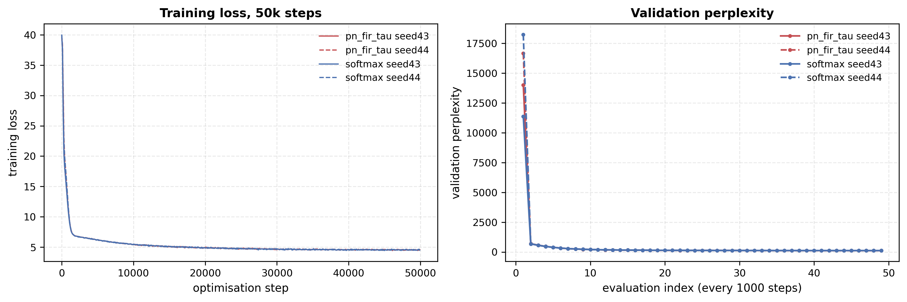
Figure 10: Training history of the 50k-step runs. Left: training loss against optimisation step. Right: validation perplexity at the periodic evaluations. Curves are n=2 seeds per variant (seeds 43 and 44); no seed-level error band is shown, because two seeds do not support one. Source: results/exp4e_multiseed_50k.json (runs.<variant>/<seed>.history).
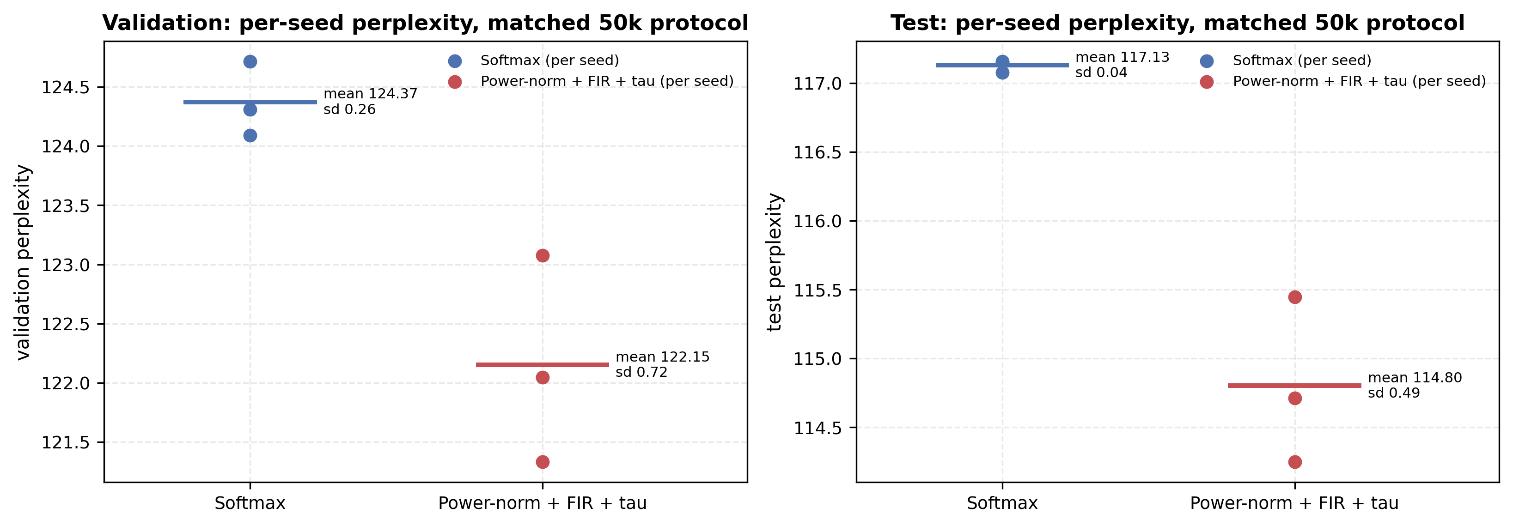
Figure 11: Per-seed perplexity under the matched 50k protocol. Each dot is one seed (n=3 per variant); the bar is the mean over those seeds and the annotation gives the mean and the standard deviation over seeds. Source: results/exp4e_multiseed_50k.json and results/exp4d_softmax_50k_bf16.json.
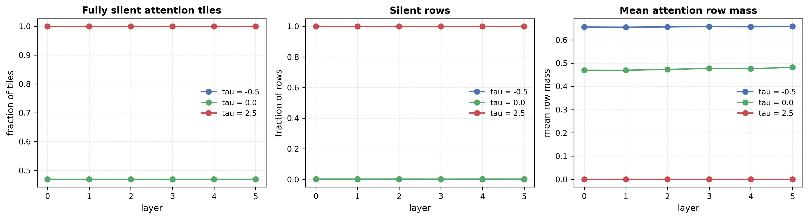
Figure 12: Per-layer silence diagnostics of the 6-layer stack for three thresholds. Left: fraction of fully silent attention tiles. Middle: fraction of silent rows. Right: mean attention row mass. Single instrumented run per threshold, so no seed spread is shown. Source: results/exp4b_mha6_instrumentation.json (diagnostics_per_tau).
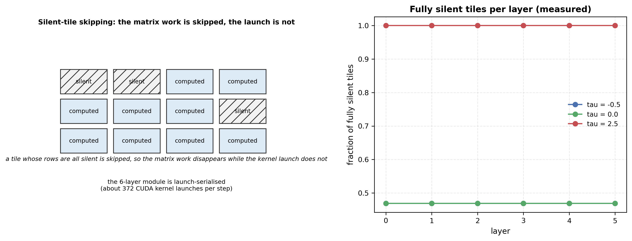
Figure 13: Schematic of silent-tile skipping. Left: a tile grid in which tiles whose rows are all silent are skipped, so the matrix work disappears while the kernel launch does not. Right: the measured fraction of fully silent tiles per layer and threshold. Source: results/exp4b_mha6_instrumentation.json (diagnostics_per_tau) and src/triton_pnfirtau.py.
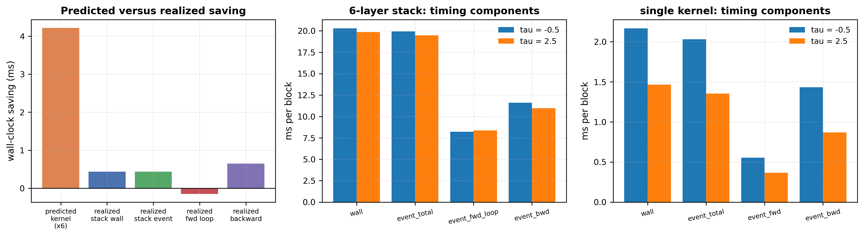
Figure 14: Predicted versus realized wall-clock saving. Left: the saving predicted from the single-kernel measurement against the saving actually realized by the 6-layer stack and its forward/backward split. Centre and right: timing components of the stack and of the single kernel. Source: results/exp4b_mha6_instrumentation.json (attribution, stack_timing, kern1_timing).
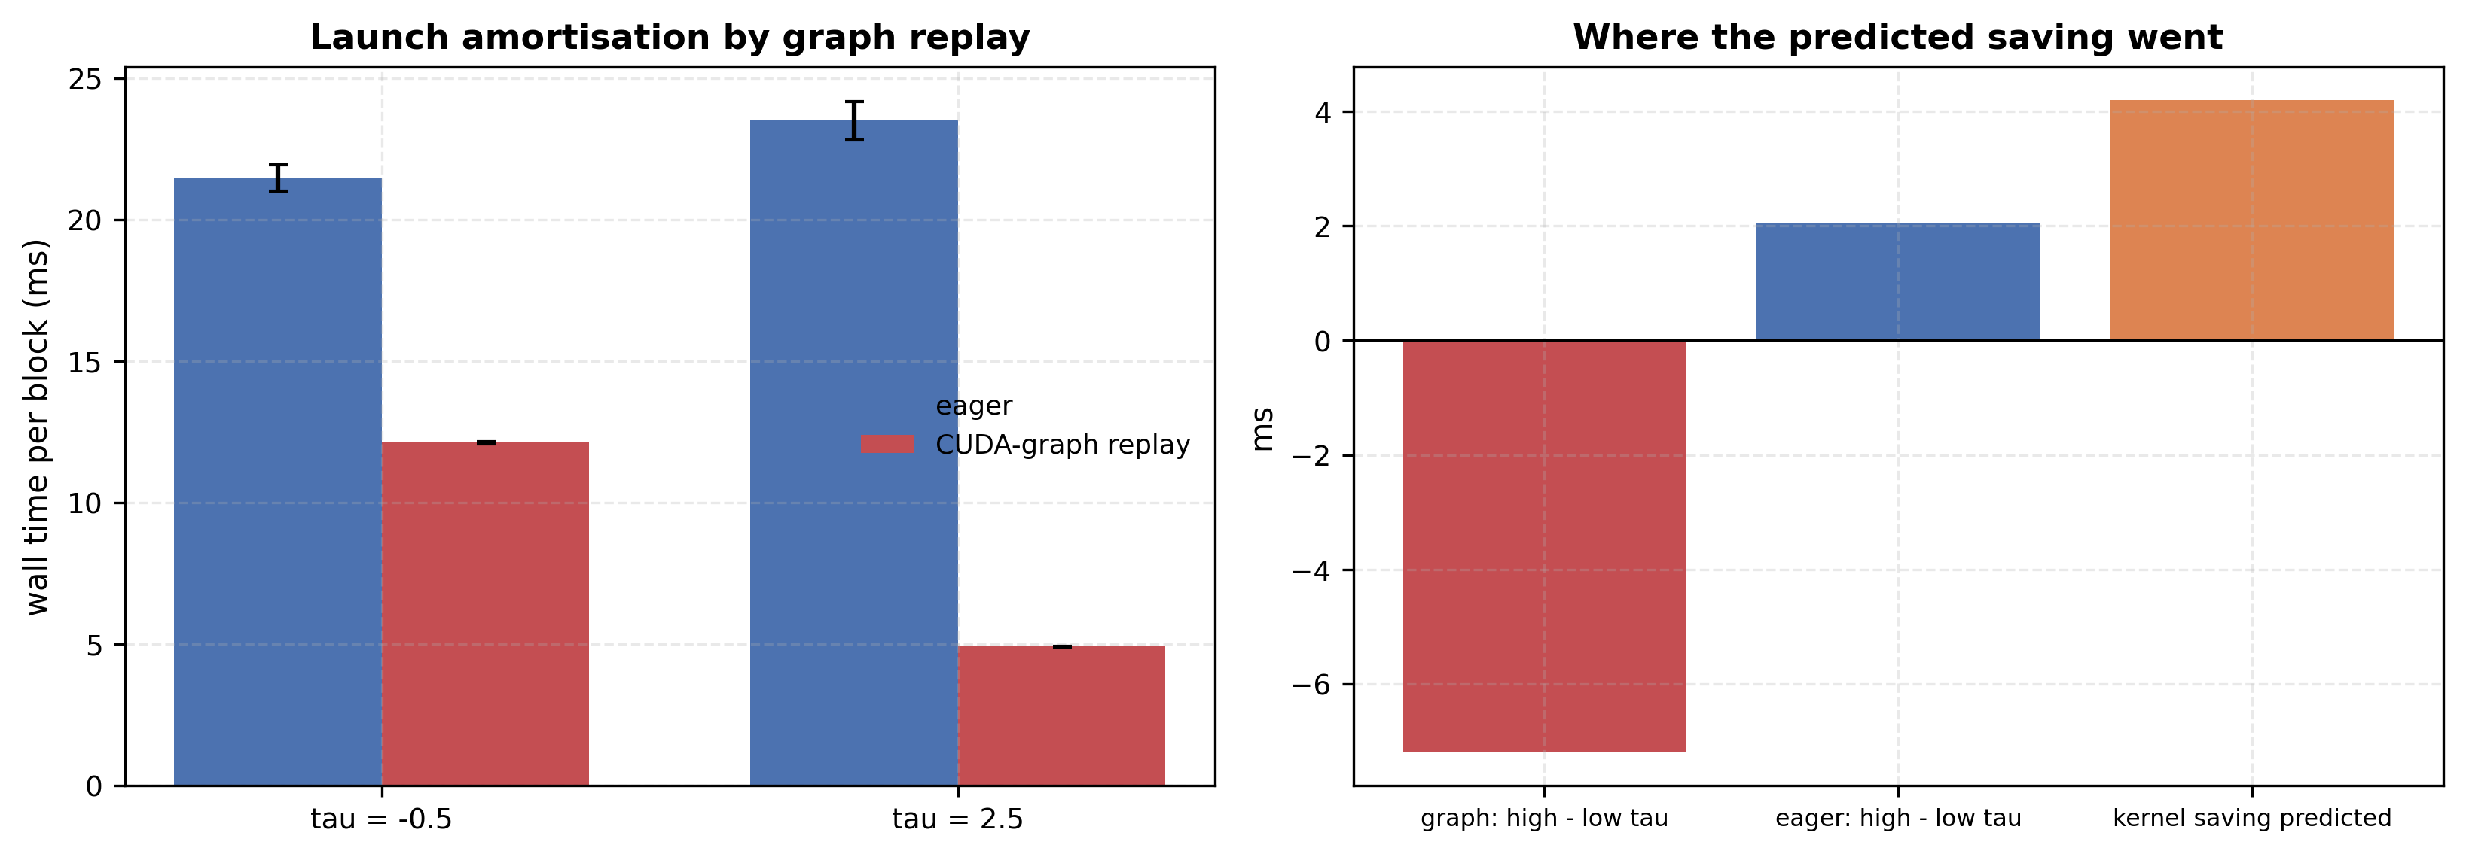
Figure 15: Launch amortisation isolated by CUDA-graph replay. Left: wall time per block of the 6-layer stack under eager execution and under graph replay, for two thresholds. Right: the high-minus-low threshold difference under graph replay and under eager execution, against the saving predicted from the kernel measurement. Source: results/exp4c_cuda_graphs.json (combined, attribution).
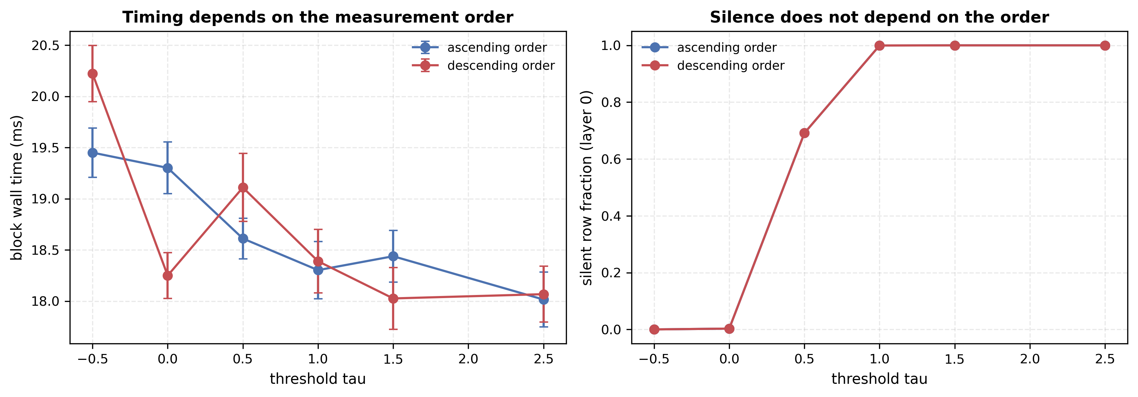
Figure 16: Sensitivity of the block timing to the order in which the thresholds are measured. Left: block wall time against threshold, one line per measurement order. Right: the silent-row fraction of the first layer, which does not depend on the order. Source: results/exp4b_sequential_repro.json (runs).
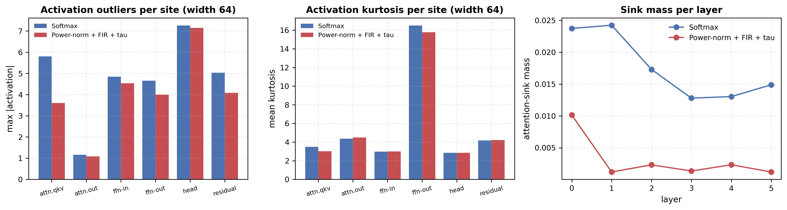
Figure 17: Activation outliers and attention-sink mass of the width-64 runs. Left: maximum absolute activation per site. Middle: mean kurtosis per site. Right: sink mass per layer. One trained checkpoint per variant. Source: results/exp4h_int8_quant.json (runs.<run_id>.outliers, runs.<run_id>.sink).
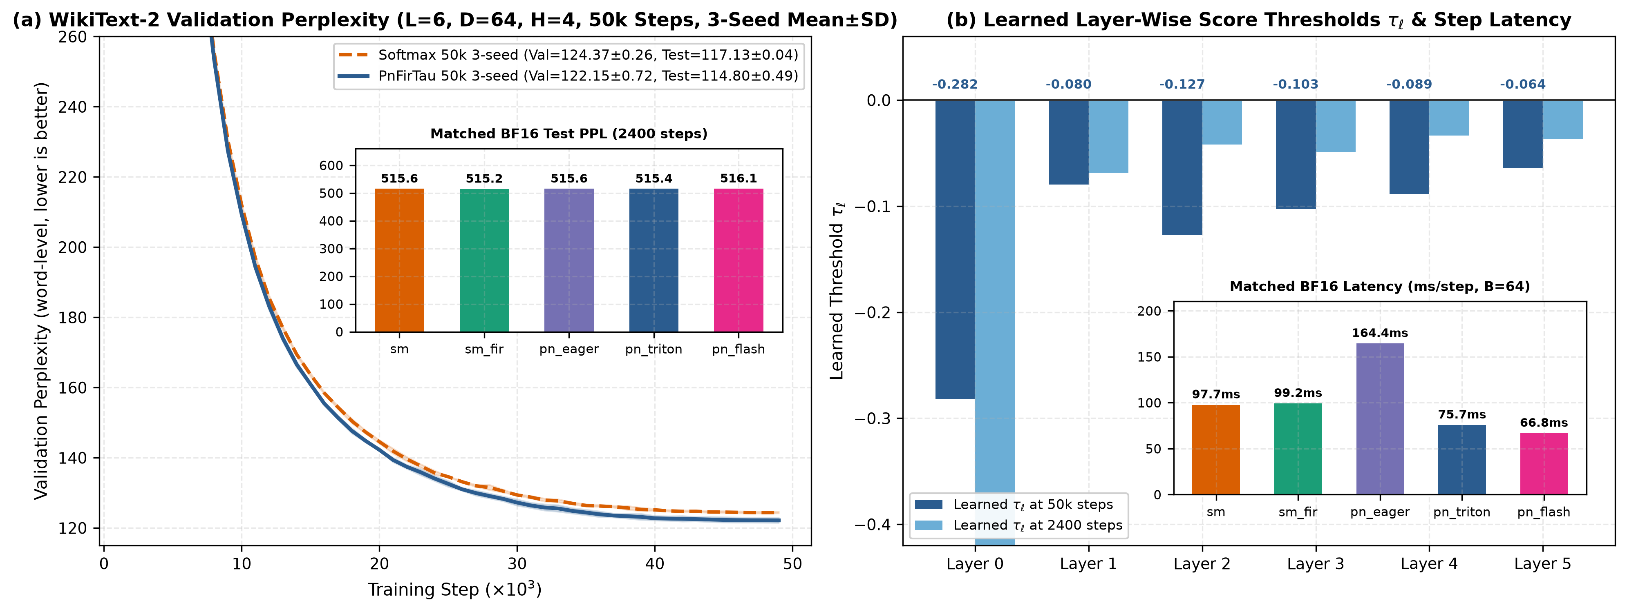
Figure 18: WikiText-2 50k validation perplexity (3-seed mean±SD bands, Table 7 (suite 3) finals in legend), learned layer-wise thresholds $τ_{ℓ}$ with matched BF16 step-time inset across all 5 variants (right). Source: results/exp4_wikitext2_lm.json, results/exp4d_softmax_50k_bf16.json, results/exp4e_multiseed_50k.json.

4. Discussion of Limitations and Negative Results
In the interest of strict scientific transparency, we list six limitations and negative findings uncovered by our audit: 1. When Selective Silence Is Not Required on Pure-PyTorch Setups without Triton, sm_fir Is the Simplest Baseline: On positive associative recall (Exp 1 and Exp 2) and matched 2,400-step WikiText-2 training (Table 7 (suite 2)), adding the 7-tap causal FIR filter on $K$ to standard Softmax (sm_fir) achieves the exact same $100.0\%±0.0\%$ clean recall and $515.18$ test PPL as pn_fir_tau (515.40 Triton, 515.56 Eager), while adding only $+1.5\%$ step-time overhead in BF16 without requiring custom Triton compilation. 2. Role of Learnable $τ$ Under Positive-Only vs. Supervised-Abstention Regimes: When pn_fir_tau is trained solely on positive retrieval examples where a matching key always exists in the context (Exp 1 and Exp 2 without _reg), learnable $τ$ is essential to rescue pn_fir from dead-row starvation ($64.4\%→100.0\%$ in Exp 1; $88.8\%→100.0\%$ in Exp 2), but because the gradient on $τ$ is driven only by active rows, its resting point relative to pure-noise rows varies across random seeds ($∑W_{\text{noise}}∈\{0.003,0.527,0.595\}$ in Exp 1; $\{0.202,0.022,0.430\}$ in Exp 2) unless paired with a post-warmup absent-key penalty (pn_fir_tau_reg, $∑W_{\text{noise}}=0.000±0.000$). Conversely, when unanswerable queries make up 50% of the training distribution under standard Cross-Entropy loss (Exp 5), the projection matrices $W_{Q},W_{K}$ themselves learn to separate answerable ($+1.55±0.28$) and unanswerable ($−0.18±0.07$) raw score peaks across zero (fixed-$τ$ pn_fir: $−0.21±0.10$), so $τ$ stays near zero ($τ=+0.011±0.020$) and fixed $τ=0$ pn_fir performs equally well ($99.7\%±0.5\%$, $∑W_{\text{unans}}=0.002±0.002$). Thus, learnable $τ$ specifically serves as an automatic safeguard against negative baseline drift when abstention is not explicitly balanced around zero. At width, the safeguard needs a head start: under the fixed recipe the basin from $τ_{0}=0$ collapses outside roughly $d∈[32,64]$ (Exp 4f-A/4g find stochastic convergence at d=96/128 and partial convergence at d=16/24), while initializing $τ_{0}≈−1.0$ restores 100.0% on all seeds at d=128 — start $τ$ negative at width. 3. Vulnerability to High-Multiplicity Exact Decoys Is Memory-Length-Specific ($n_{d}≥4$, 7-tap FIR): In our strict non-bijective task (Exp 2), while pn_fir_tau handles 1–2 distractor decoys well ($95.6\%$ at $n_{d}=1$, $90.5\%$ at $n_{d}=2$), flooding the 48-token context with $n_{d}=8$ copies of the queried key $k^{*}$ degrades accuracy to $56.9\%$ (56.2% for sm_fir, 38.8% for pn_fir_tau_reg). Because a linear FIR filter on $K$ linearly superposes $h_{1}K(k^{*})$ onto every token immediately following any copy of $k^{*}$ — and the 7-tap tail additionally smears six filler lags into every slot — rejecting high-multiplicity exact decoys with a 7-tap memory in a single layer would require nonlinear key-value gating (e.g., gating ${\tilde{K}}_{j+1}$ on whether token $j+1$ belongs to a valid value subspace). Experiment 6 revises the scope of this limitation: a 2-tap RWKV-style shift resists the same flooding (sm_shiftmu $99.9\%±0.2\%$ at $n_{d}=8$; pn_shiftmu_tau $92.7\%±10.4\%$, flat across $n_{d}$), binding the value slot almost exclusively ($W_{\text{val}}=0.970$). The failure is therefore specific to the 7-tap memory length, not fundamental to linear key filtering — at the cost, for the rectified branch, of seed-dependent $τ$–$μ$ equilibria (see §3.2b finding 3). 4. Eager PyTorch Bottleneck vs. Fused Triton Acceleration & Tile-Granularity Limits of Silent Skipping: Unfused eager PyTorch PnFirTauMHA allocates four $[B,H,N,N]$ intermediate tensors per layer, increasing full-LM BF16 step time by $+68.3\%$ ($164.44\text{ ms}$ vs. $97.70\text{ ms}$) and VRAM by $+18.5\%$. Our fused Triton implementations (PnFirTauTritonMHA at $75.74\text{ ms}$ and PnFirTauFlashMHA at $66.80\text{ ms}$) eliminate this bottleneck and outperform SoftmaxMHA. However, as shown in Table 9, while tile-level early exit in flash_pn_fir_tau_attention speeds up the isolated 1-layer kernel by $1.76×$ ($1.99\text{ ms}→1.13\text{ ms}$) when $100\%$ of rows are silent ($τ≥+1.0$), scattered row sparsity ($69.1\%$ silent rows at $τ=+0.5$) rarely produces completely all-zero $64×64$ tiles. In the full 6-layer MHA stack the end-to-end effect is not detectable in this regime: the drift-controlled re-measurement (drift-controlled re-measurement) finds a block-level $Δ=−0.43±0.43$ ms ($|z|≈1.0$) against a $4.2$ ms predicted kernel saving, and the historical $1.60$ ms end-to-end reading of Table 9 is demonstrated to be a block-order artifact of the sequential protocol (reproduced in the original order; inverted under reversed block order). The mechanism is launch serialisation: $≈372$ CUDA launches per step across $τ$ and $B∈\{4,16\}$, wall unchanged at $4×$ less GPU work, and $≈52 μ\text{s}$ per launch under WSL2 GPU-PV, so the verified $0.703$ ms/layer kernel-level saving surfaces at $≲10\%$ stack-wide in eager mode; a CUDA-graph replay surfaces it fully ($12.10±0.03→4.91±0.02$ ms, $Δ=−7.20±0.02$ ms vs. eager $±$ drift, exp4c), so inside the measured regime the actionable fix is launch amortisation (graph capture or kernel fusion), and a native-Linux (non-GPU-PV) benchmark is required before any absolute end-to-end latency claim at this stack scale. This regime is also dormant in the trained LM: all six learned $τ_{ℓ}∈[−0.282,−0.064]$ are negative, so tile skipping essentially never fires during normal training or inference (Table 9: $0\%\text{–}0.3\%$ silent rows at $τ∈[−0.5,0.0]$). 5. Matched-Precision 50k Comparison with Variance (Table 7 (suite 3)): The historical cross-precision pair (FP32 softmax vs. BF16+TF32 pn_fir_tau) is superseded: both 50k runs are replicated across 3 seeds under the identical BF16+TF32 schedule (results/exp4d_softmax_50k_bf16.json, results/exp4e_multiseed_50k.json), giving a precision-controlled 50k gap of $−2.22±0.46$ val / $−2.33±0.49$ test PPL for pn_fir_tau, holding on all 3 seeds. Two honest bounds remain: (a) pn shows larger seed spread than softmax (val std $0.72$ vs. $0.26$), and (b) multi-seed evidence remains D=64 (the D=256 scale-out in Table 7 (suite 2s) is single-seed with no larger-model replication). All Exp 4 throughput numbers quoted in Section 3 are single-seed and carry no variance estimate. 6. External-Validity Probe (Not Distributed with This Work): Retrofitting trained pn_fir_tau weights into pre-trained GPT-2 124M (replacing Softmax MHA, 20k fine-tune steps) reached Test PPL $47.05$ vs. $21.43$ for a Softmax retrofit of the same budget. That probe is an auxiliary measurement whose raw artifacts are not part of this work’s reproducibility package. We attribute the gap to co-adaptation: pre-trained $W_{Q},W_{K}$ are optimized for the translation-invariant geometry of the Softmax simplex, whereas the FIR-induced score shift changes that geometry; a 20k fine-tune cannot re-learn the projection matrices, so the gap is expected. Continuous pre-training or low-rank/evolutionary adaptation is the appropriate protocol at this scale; no GPT-2-class result is claimed. At 1.8M parameters attention sinks are present but modest (Exp 4h: max position-0 mass 1.9%), so sink-suppression benefits are bounded at this scale. RAG-style behavior is evaluated on a controlled synthetic task, not on a production retrieval corpus.
The parameters $p=10$ and $σ=2.0$ are fixed a priori; a sensitivity sweep over these values is left for future work.

5. Conclusion and Practical Guide for Transformer Designers
We have investigated how causal FIR temporal smoothing on keys interacts with simplex-constrained normalizers (Softmax, Sparsemax, $α$-Entmax) and sub-simplex normalizers (Softmax_1, Quiet Softmax, and rectified power-normalized attention pn_fir_tau). By auditing both a legacy fixed-position benchmark (Exp 1) and a newly designed non-bijective content-addressable benchmark (Exp 2), we showed that causal FIR key filtering enables a single attention layer to bind key identities onto adjacent value slots ($W_{\text{query},j^{*}+1}=0.729\text{–}0.792$), lifting single-layer clean associative recall from $35.8\%\text{–}44.5\%$ to $100.0\%±0.0\%$. We established that translation-invariant operators have constant row mass along uniform shift rays (Proposition 1), identified the score-shift pathology that causes uncalibrated pn_fir to suffer dead-row gradient starvation under positive-only training ($44.5\%±23.0\%$ all-negative rows), showed why simplex projections (Softmax, Sparsemax, Entmax) fail residual preservation on unanswerable queries ($27.2\%\text{–}34.4\%$ hallucination rate in Exp 5) and why row-mean centering (pn_fir_c) leaks $≈124×$ more unanswerable noise ($0.265$ vs. $0.002$) while losing override accuracy ($88.5\%$ vs. $99.0\%$), and demonstrated that sub-simplex power-normalization (pn_fir_tau and pn_fir) achieves $100.0\%$ residual preservation ($0.0\%$ hallucination rate and $∑W_{\text{unans}}=0.002±0.002$, $50×$ lower continuous residual contamination than Softmax_1 and Quiet Softmax) while matching and slightly improving 6-layer WikiText-2 perplexity at 1.8M parameters.
For practitioners building and deploying Transformer models, our findings translate into two actionable architectural takeaways: 1. Immediate Zero-Parameter Single-Layer Induction (sm_fir): If your primary goal is to equip a standard causal Transformer with single-layer key-value induction binding (compressing two-layer induction heads into one layer) without custom attention kernels, applying the fixed 7-tap causal Gaussian FIR filter strictly to the key tensor $K$ (sm_fir) requires zero learnable parameters, adds only $+1.5\%$ step-time overhead in BF16 ($+2.0\%$ in FP32), and can be combined with triton_causal_fir for zero-copy strided filtering. 2. Hallucination-Free Residual Preservation, Sink-Free Attention, & Transcendental-Free Hardware Acceleration (pn_fir_tau_triton / pn_fir_tau_flash): If your architecture requires attention heads to abstain cleanly when queried information is absent from the context—such as RAG over noisy passages, memory-augmented Transformers, or low-bit-quantized / streaming-attention deployments (rectified sink removal is documented at 340M–1.8B scale by Softpick [12]; at our 2–11M scales per-token INT8 activation noise costs <0.5% test PPL for every variant (Table 10), while pn_fir_tau shows $6$–$15×$ less pos-0 sink mass — decaying with depth to $0.0001$ — and $15$–$44\%$ lower kurtosis across roles under D=256 scale-up stress: hygiene, not PPL, is the measured effect here)—replacing Softmax with sub-simplex rectified power-normalization (pn_fir_tau) eliminates context-induced residual hallucinations in our pure-cross-entropy protocol ($0.0\%$ vs. $27.2\%\text{–}34.4\%$ for Softmax/Sparsemax/Entmax) and suppresses absent-key residual leakage $50×$ more tightly than virtual-sink Softmax ($0.002$ vs. $0.100$, with a $99.0\%\text{–}99.4\%$ vs. $100.0\%$ override trade-off). Moreover, when deployed via our fused Triton kernels (PnFirTauTritonMHA and PnFirTauFlashMHA in src/triton_pnfirtau.py), evaluating $(S_{t,j}^{′})_{+}^{10}$ in 3 register multiplications with zero exp() calls and zero online tile rescaling reduces full-LM BF16 step time by $22.5\%\text{–}31.6\%$ below standard Softmax ($2.17×\text{–}2.46×$ faster than eager PyTorch) and cuts 6-layer attention VRAM by $66.5×$ ($109.3\text{ MB}$ vs. $7,268.3\text{ MB}$) with $21.70×$ speedup at $N=1024,B=16$ (and $46.77\text{ ms}$ at $386.8\text{ MB}$ at $N=1024,B=64$ where Eager baselines OOM).

Declarations
Competing interests. The author declares no competing interests.
Funding. This research received no external funding.
Data and code availability. The reproducibility package (source code, experiment suites, raw JSON results, and figure-generation pipeline) is provided with this preprint; an archived copy will be deposited on Zenodo upon publication.
Author contributions. M.Z. conceived the study, implemented the method and kernels, ran the experiments, analysed the results, and wrote the manuscript.
Ethics. Not applicable; this study uses no human or animal subjects.

References
- Olsson, C., Elhage, N., Nanda, N., et al. (2022). In-context Learning and Induction Heads. Transformer Circuits Thread.
- Vaswani, A., Shazeer, N., Parmar, N., et al. (2017). Attention Is All You Need. Advances in Neural Information Processing Systems (NeurIPS), 30.
- So, D. R., Mańke, W., Liu, H., Dai, Z., Shazeer, N., & Le, Q. V. (2021). Primer: Searching for Efficient Transformers for Language Modeling. Advances in Neural Information Processing Systems (NeurIPS), 34.
- Martins, A. F. T., & Astudillo, R. F. (2016). From Softmax to Sparsemax: A Sparse Model of Attention and Multi-Label Classification. International Conference on Machine Learning (ICML).
- Peters, B., Niculae, V., & Martins, A. F. T. (2019). Sparse Sequence-to-Sequence Models. Annual Meeting of the Association for Computational Linguistics (ACL).
- Correia, G. M., Niculae, V., & Martins, A. F. T. (2019). Adaptively Sparse Transformers. Empirical Methods in Natural Language Processing (EMNLP).
- Miller, E. (2023). Attention Is Off By One. Technical Report, Evan Miller Blog.
- Bondarenko, Y., Nagel, M., & Blankevoort, T. (2023). Quantizable Transformers: Removing Outliers by Helping Attention Heads Do Nothing. Advances in Neural Information Processing Systems (NeurIPS), 36.
- Xiao, G., Tian, Y., Chen, B., Han, S., & Lewis, M. (2024). Efficient Streaming Language Models with Attention Sinks. International Conference on Learning Representations (ICLR).
- Dao, T., Fu, D. Y., Ermon, S., Rudra, A., & Ré, C. (2022). FlashAttention: Fast and Memory-Efficient Exact Attention with IO-Awareness. Advances in Neural Information Processing Systems (NeurIPS), 35.
- Zhang, B., Titov, I., & Sennrich, R. (2021). Sparse Attention with Linear Units (ReLA): Replacing Softmax with ReLU. arXiv:2104.07012.
- Zuhri, Z. M. K., Fuadi, E. H., & Aji, A. F. (2025). Softpick: No Attention Sink, No Massive Activations with Rectified Softmax. arXiv:2504.20966.
- Wang, R. Z. (2026). Abstention and Noise Filtering: Two Missing Primitives of Softmax Attention. arXiv:2609.22005.
- Sun, M., Chen, X., Kolter, J. Z., & Liu, Z. (2024). Massive Activations in Large Language Models. arXiv:2402.17762.
- Peng, B., Alcaide, E., Anthony, Q., et al. (2023). RWKV: Reinventing RNNs for the Transformer Era. Findings of EMNLP; arXiv:2305.13048. (Token-shift: a learnable 2-tap causal FIR on the R/K/V streams.)

