**Half-life of IL-10**

60 min in PBMCs

<http://www.bloodjournal.org/content/bloodjournal/89/11/4112.full.pdf>

Le et al. Blood 1997

**Proliferative rate of bladder cancer**

From: Bunimovich-Mendrazitsky_JTB_2011

Range (in days): 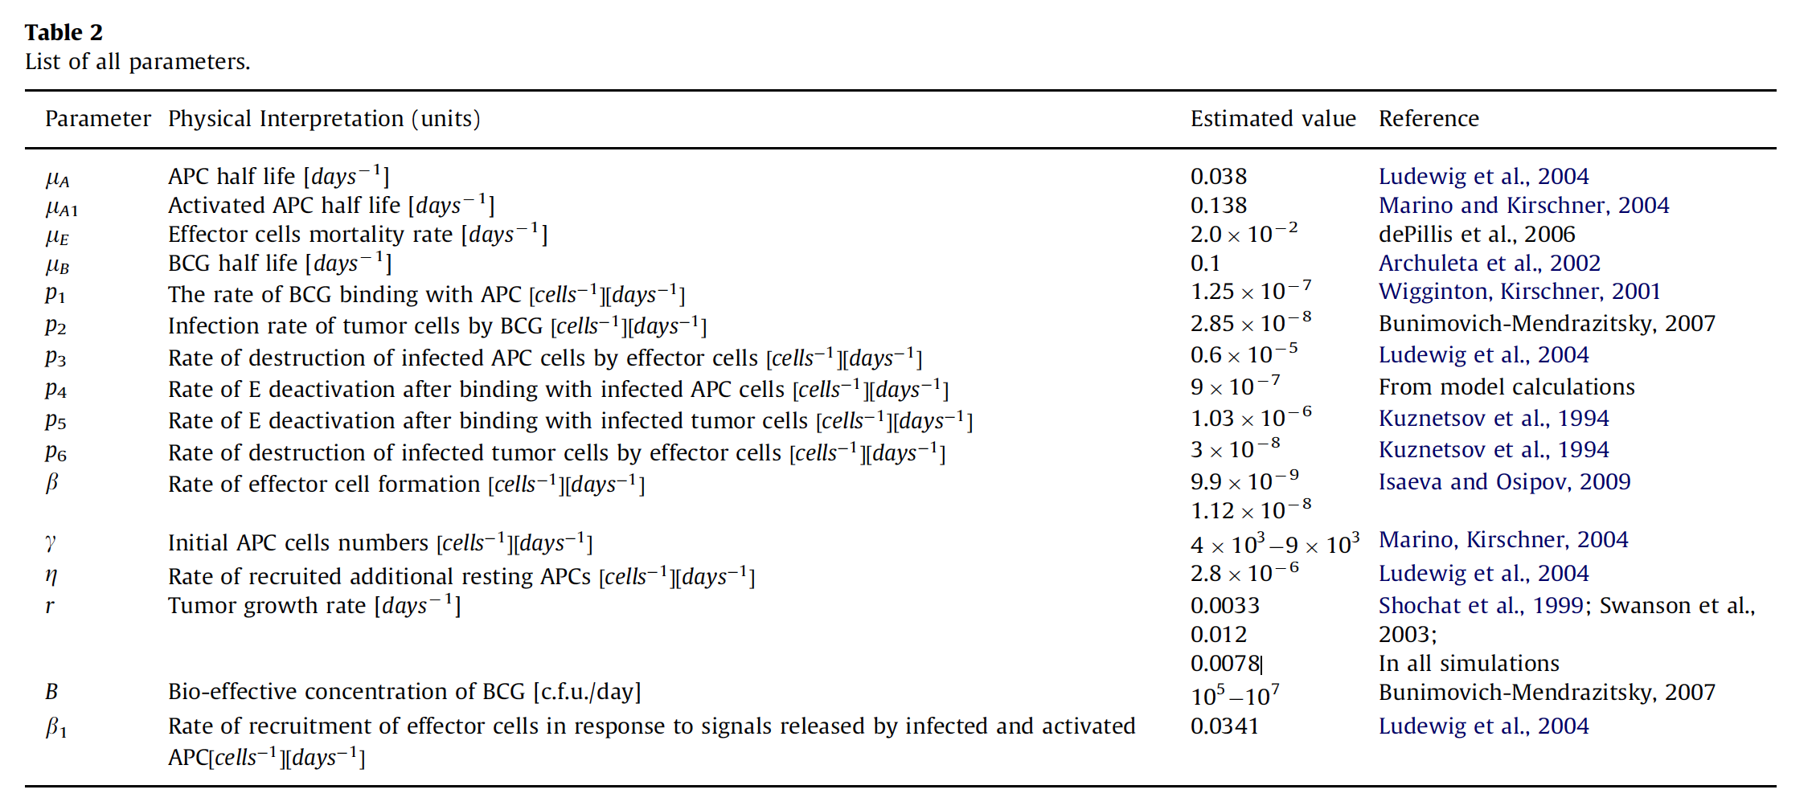

**Production rate of IL-10**

1e-5

http://evoq-eval.siam.org/Portals/0/Publications/SIURO/Vol2_Issue2/A_mathematical_model_of_the_immune_system.pdf?ver=2018-04-02-155921-300