Derivation and application of model used by Pike

This model was proposed for a dimerizing system by Wyman and Gill in Binding and Linkag: Functional Chemistry of Biological Macromolecules pp. 208-210

Critical assumptions:

System is at equilibrium
Receptor only exists as monomer and dimer
Higher aggregates are assumed not to interact

L = free EGF
R = free EGFR monomer
RR = free EGFR dimer
RL = bound monomer
RRL = singly bound dimer
RRLL = fully bound dimer

Equilibrium equations:

[RR] = L₂₀[R]²
[RL] = K₁₁[R][L]
[RRL] = K₂₁[RR][L]
[RRLL] = K₂₂[RR][L]²

Fractional saturation is defined as the concentration of bound ligand divided by the total concentration of receptor.

(1)

Substitution with the equilibrium equations and factoring out [R] yields the following equation which was used by Pike to fit the data. It is presented in her paper in a slightly more factored form but the equations are the same.

(2)

Note that (2) depends on the concentration of free receptor monomer and the concentration of free ligand. The concentration of free ligand is known or approximated, but the concentration of free receptor monomer is not known and must be calculated from the total receptor concentration.

(3)

(4)

[R] can be found quadratically, and the equation for the positive root is simultaneously fit to the data with equation (2) in Pike’s work. The only known values in this case are [L] and [R]_{total}. The values for K_{nn} and L₂₀ are those of best fit. Pike uses “Global Fitting” by which she means nonlinear least squares fitting with shared parameters. Figure 1 is an example of Pike’s data.

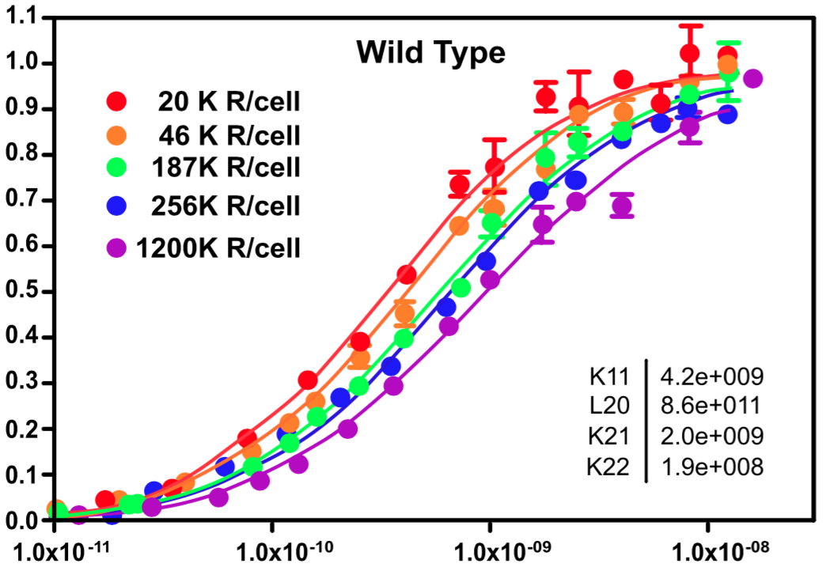
Figure 1

All fits share the same value of K_{nn} and L₂₀ and the shifts in the binding isotherms are driven by the increase in concentration of receptors in the cell, which was controlled experimentally. Pike concludes that the system exhibits negative cooperativity because K₂₂ < K₂₁, yet the binding isotherms show no inflections, and the binding intervals (fsat = 0.1-0.9) appear to span ~2 log units indicating single-site binding behavior [ref]. Pike does not compare this set of data to a model that does not invoke cooperativity, and it is unclear if negative cooperativity is truly present or just overfit to noise.

Establishing criteria for testing if cooperativity is present in the system

In the simplest case of ligand binding where there is only one site with invariant affinity, the fractional saturation is given by equation (5).

(5)

The data could not be fit to this equation with a shared value of the association constant k because it would describe a unique isotherm and not the shifting isotherms that are apparent in the data. This model does not account for cooperativity as it describes only one site.

For the simplest case of binding to a dimeric receptor with two sites, the fractional saturation is given by equation (6). Since there are two sites, the 2 in the denominator normalizes the limit of saturation to 1.

(6)

This model also only describes a unique binding isotherm, but it can account for cooperativity depending on the values of k₁ and k₂.
The criteria for cooperativity can be determined by considering a system of two distinct binding sites:

(7)

This cross-multiplies and factors to:

(8)

If we assign

and

then (8) takes on the same form as (6).

If the two sites are equivalent (k_{a} = k_{b} = k_{actual}), then k₁ = 2k_{actual}, k₁k₂= k_{actual}², and k₁ = 4k₂. Thus (6) collapses to a single site model (5) where k = k_{actual}.

When k₂ < k₁/4 then the binding sites are distinct with one binding at a lower affinity than the other. In the case of a homologous dimer, where the sites are chemically identical, then this defines negative cooperativity – binding at the first site diminishes the binding affinity of the second site. The opposite case is true for positive cooperativity.

Criteria for cooperativity in systems described by equation (8):

- when binding sites are chemically identically (as in the case of an EGFR dimer)
- Negative cooperativity is present if and positive cooperativity if

Extraction of data for analysis and model comparison

Data for binding of EGF to Wild Type EGFR were extracted from Pike et al. 2008 (fig 3), 2009 (fig 1), and 2011 (fig 3b)

Data for binding of EGF to kinase-impaired mutants were extracted from Pike et al. 2008 (fig 5b), 2009 (fig 3a and 3b).

Extraction was done by enlarging pdfs of the publication and creating images of the figures. Those images were uploaded to WebPlotDigitizer (http://arohatgi.info/WebPlotDigitizer) and the data were extracted. All data were scaled to nM concentrations so that extracted values for free EGF concentration ranged approximately from 0.01-10.

Data from wild type and kinase-impaired mutants were chosen for comparison because their binding isotherms shift in opposite directions, and they fit markedly different association constants, but both exhibit negative cooperativity as determined by Pike. The kinase-impaired mutants differed in mutation, but their data was similar and gave similar association constants so they were pooled for comparison. Wild type data was also pooled.
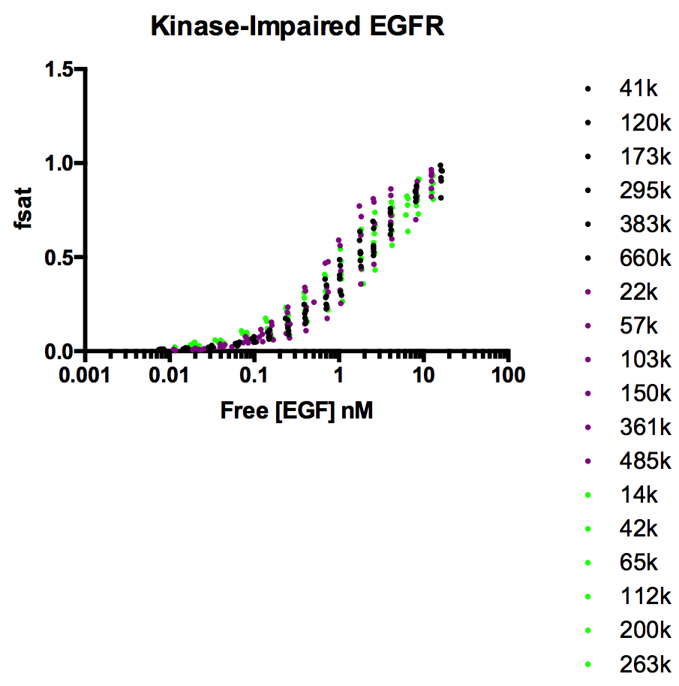
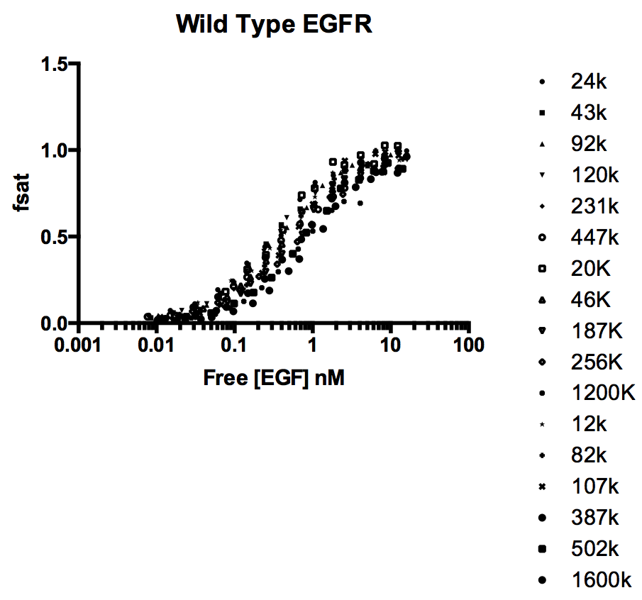
Figure 2

The extracted data sets were reverse fit with the model described by Pike using the fitted association constant values. This was done to determine the total receptor concentration, which were not reported in the publications. The concentrations were checked with estimates using the receptor/cell numbers that were reported. The fitted numbers were within a factor of 2 on average and considered valid (data to be included).

Construction of models for comparison

There is sufficient prior evidence that EGFR does partition between monomer and dimer and it’s reasonable to posit that the dimer may have a different binding affinity than the monomer [ref]. Equations (5) and (6) cannot account for such behavior so we must include a factor to mix binding character of the monomeric and dimeric fractions of the populations. And if we want to probe for cooperativity in the case of the dimer, than we must use a model of the form in equation (6).

The simplest model for such a situation is given by equation (9):

(9)

which has the general form

and describes a system in which the monomer has a single site with an affinity given by k₁ and the dimer has two sites with affinities k₂ and k₃. The coefficient m is the fraction of R_{total} in monomeric form making 1-m the fraction of R in dimeric form, and m is a function of the dimerization equilibrium constant. Assuming a system where the relative populations of monomer and dimer only depend on receptor concentration, then m is given by equation (10).

(10)

This can be derived from the equilibrium equation

and the definition of the fraction of R_{total} that is dimeric

Notice that unlike (4), (10) does not depend on any of the binding associations constants or ligand concentration. Therefore (9) represents an “unlinked” system with a static distribution of monomers and dimers. It is the simplest way to describe a system with monomers and dimers with up to three distinct binding sites. Fitting the data to this model yields values of k₂ and k₃ that suggest positive cooperativity, i.e., k₂/4 < k₃. This is at direct odds with Pike’s conclusions.
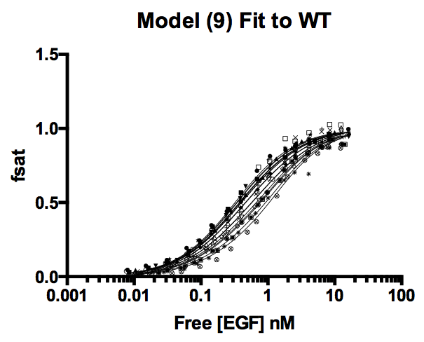

Fitted values (nM⁻¹)
K_{dim} 34.93
k1 3.282
k2 0.8241
k3 0.4473

The model can also be constrained such that k₂ = 4k₃ to fit a system in which the sites on the dimer have sites of the same invariant affinity (no cooperativity). This is useful because the reduced (constrained) model can be compared to the full model using the extra sum of squares test to asses the statistical significance of invoking cooperativity in the model. When we do this test, we observe that data is best fit by the model invoking cooperativity.

However, a major issue with (9) is that it cannot account for shifts in the monomer dimer equilibrium induced by ligand binding. Ligand-induced dimerization has been reported in numerous EGFR studies [ref], so despite this model fitting the data, it’s likely not an accurate description of the system.

