**Refresher - In-Class Activity  
Creating Your VPC**

**Overview:**   
In this in-class activity you will get experience creating your first Virtual Private Cloud (VPC) in the cloud using Amazon Web Services (AWS). You will build upon what you learned earlier in the AWS Cloud Foundations course and what has been discussed in class. You will be doing this on a real AWS network.

The VPC will span two Availability Zones (AZ), us-east-1a and us-east-1b. It will include four subnets, two in each AZ. One of the subnets in each AZ will be a public subnet, that is, accessible from the Internet using an Internet Gateway and public IP addresses. This is where you would put web and application servers that need to be accessed from the outside world. One of the segments in each AZ will be a private segment, that is, not accessible from the Internet. Instances on this segment will not have access to the Internet Gateway and will not have public IP addresses assigned. This is where you would put database servers and other systems that you do not want to be directly accessed from the Internet. Only other machines in other parts of the VPC such as the web and application servers in the public subnets can communicate with machines on these subnets. However, instances on this subnet will have access to a NAT Gateway to get out to the Internet for patches.

**Objectives:**

The objectives of this in-class activity are:

1. Refresher on how to build a VPC (Virtual Private Cloud)
2. Walk you through how to create a virtual server (EC2 instance) running Windows
3. Reminder on how to use RDP (Remote Desktop Protocol) to connect to your EC2 instance.

**Prerequisites:**

1. You must have accepted your Learner Lab invitation.
2. MAC users: You must have installed the Microsoft RDP application from the App Store

**Process:**

1. Login to AWS.
2. Go to the AWS Console.
3. Select “VPC” (for Virtual Private Cloud) under the “AWS services” menu. You may have to select “All services” if “VPC” is not listed under “Recently visited services”.

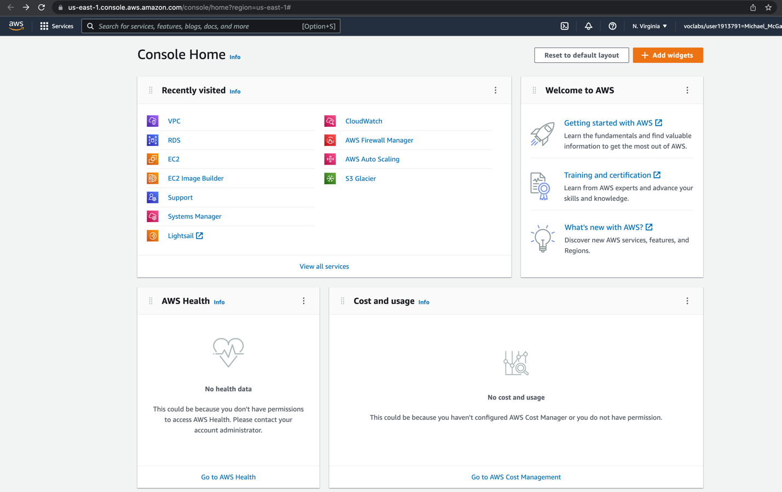

1. Create the VPC using the “VPC Wizard”. We will also create two private and two public subnets. The private subnets will be used to our databases and other sensitive information. Click on the “VPC Dashboard” link on the left side of the screen and then click on the “Create VPC” button.  
     
   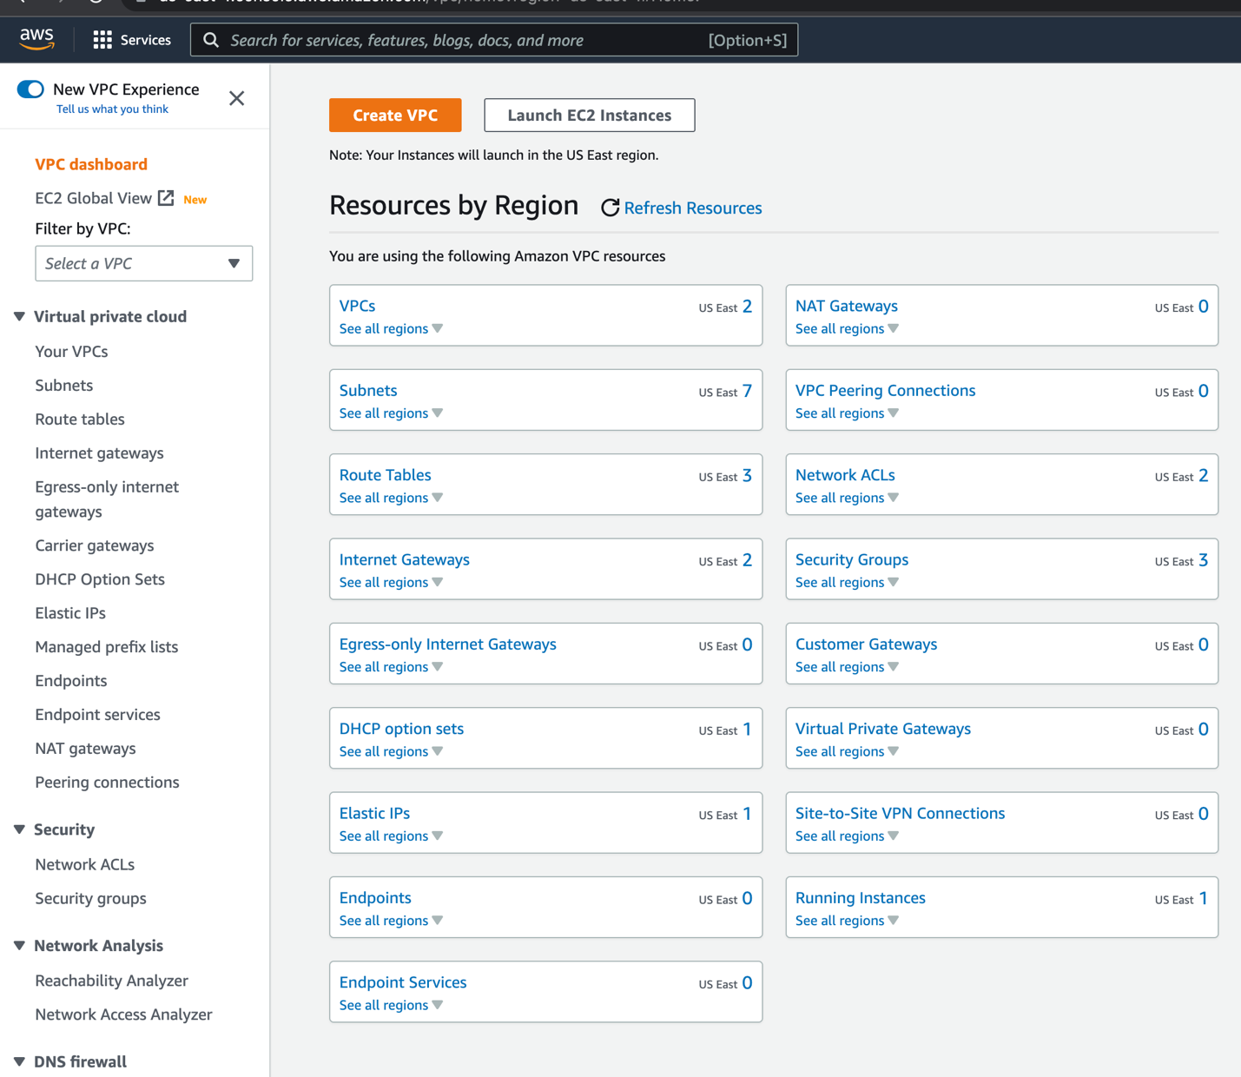  
     
   Select “VPC and more”.

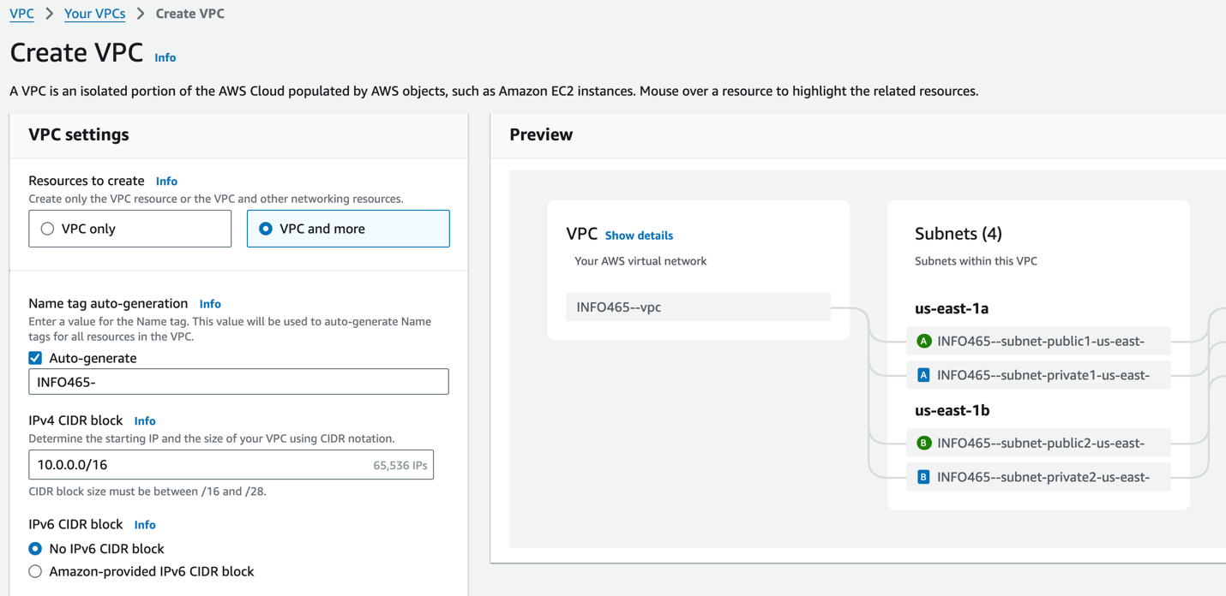

Specify the following:

* For the Name auto-generation, enter INFO465-
* The IPv4 CIDR block should be 10.0.0.0/16
* No IPv6 CIDR block.
* Number of Availability Zones should be set to 2
* Number of Public Subnets should be set to 2
* Number of Private Subnets should be set to 2
* Select customize AZs
* The first “Availability Zone”, select “us-east-1a”
* The second “Availability Zone”, select “us-east-1b”
* Select customize subnets CIDR blocks
* The Public Subnet CIDRs should be 10.0.10.0/24 and 10.0.12.0/24
* The Private Subnet CIDRs should be 10.0.11.0/24 and 10.0.13.0/24
* Select “None” for NAT gateways
* Specify none for VPC endpoints

And click on the “Create VPC” button.

AWS will build your VPC. It may take a few minutes for the NAT Gateway to be built. You will eventually see a “success” message. Click on “View VPC” to continue.

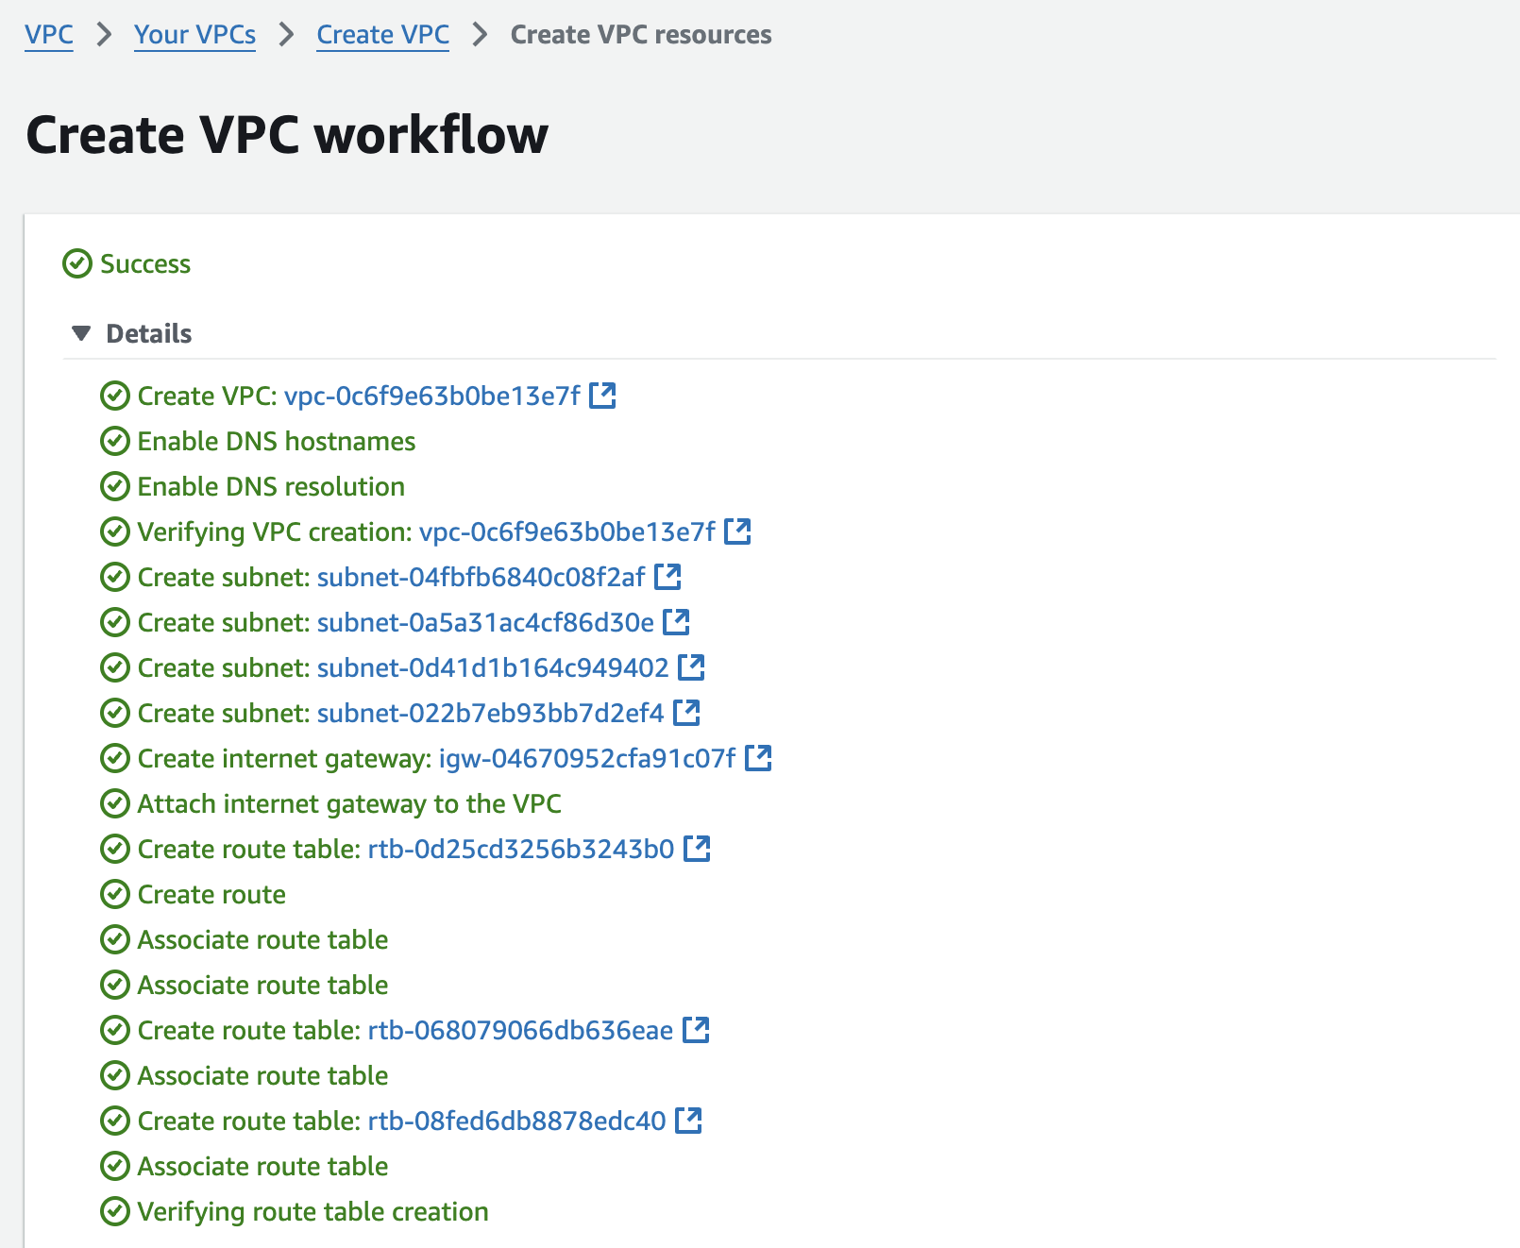

**After your VCP is created:** click on subnets, and change the names to “AZ1 Public”, “AZ2 Public”, “AZ1 Private” and “AZ2 Private”.

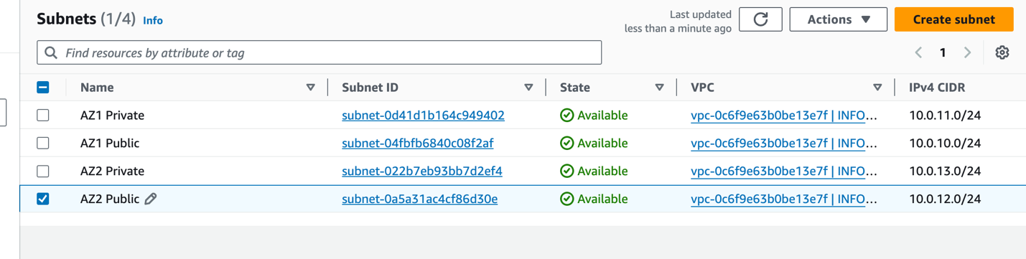

1. Enable auto-assign Public IpV4 addresses
   * Select AZ1 Public and then select Edit Subnet settings from within Actions.
   * Click on the checkbox “Enable auto-assign public Ip 4 addresses”.
   * Repeat for AZ2 Public

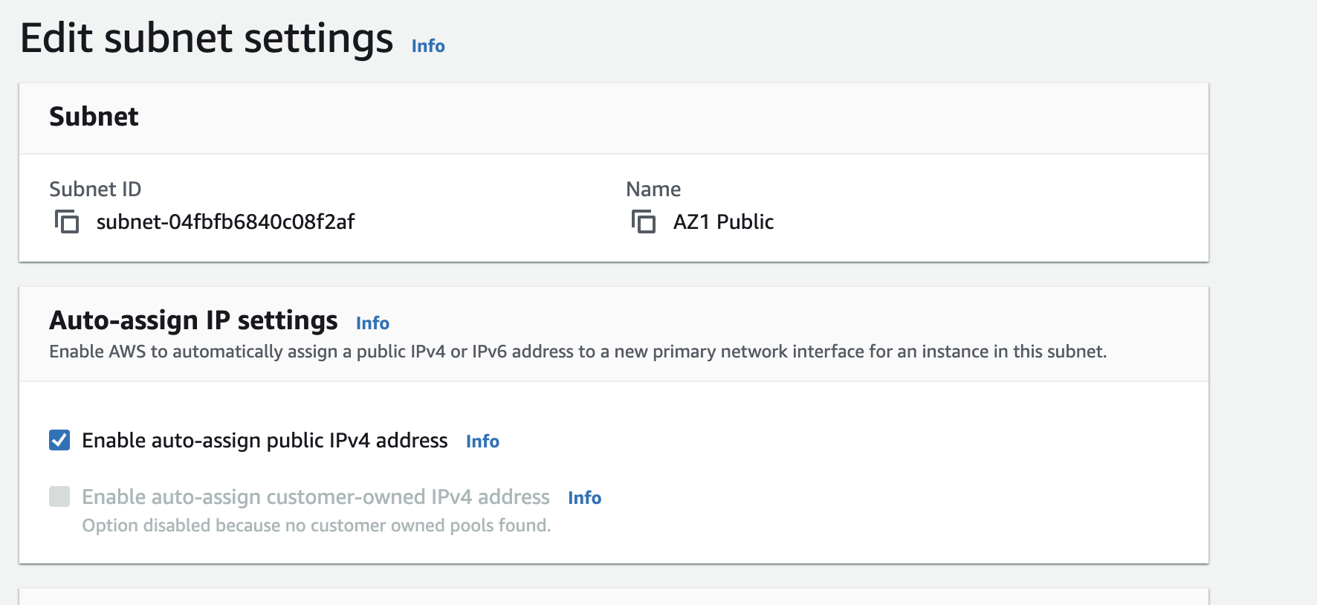

**Part II: Launch and connect to a Windows EC2 instance**

* 1. Enter EC2 in the Search bar. Select “EC2 – Virtual Servers in the cloud” from the search results.

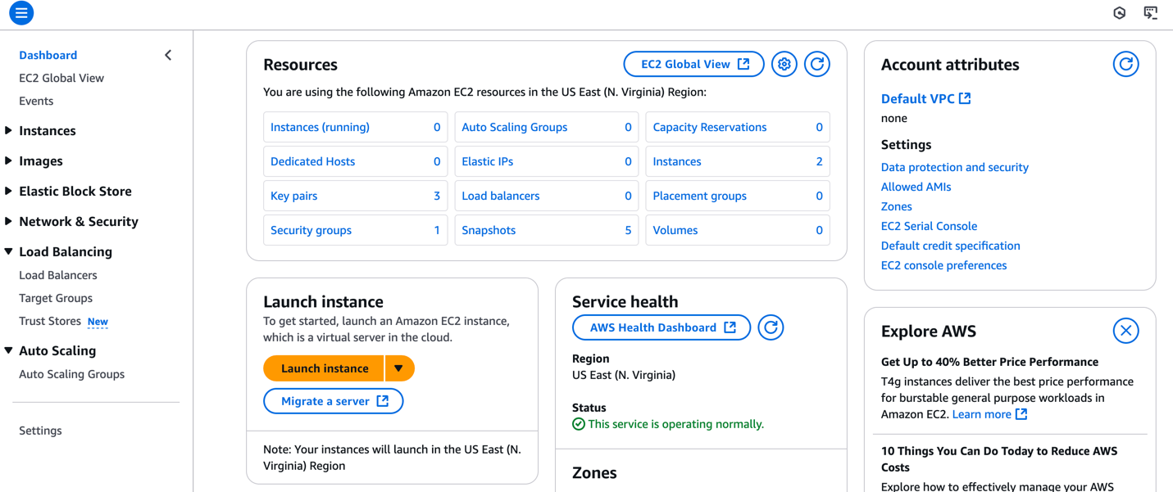

* 1. Click on Instances underneath Resources. Then click on Launch Instances in the Upper Right.

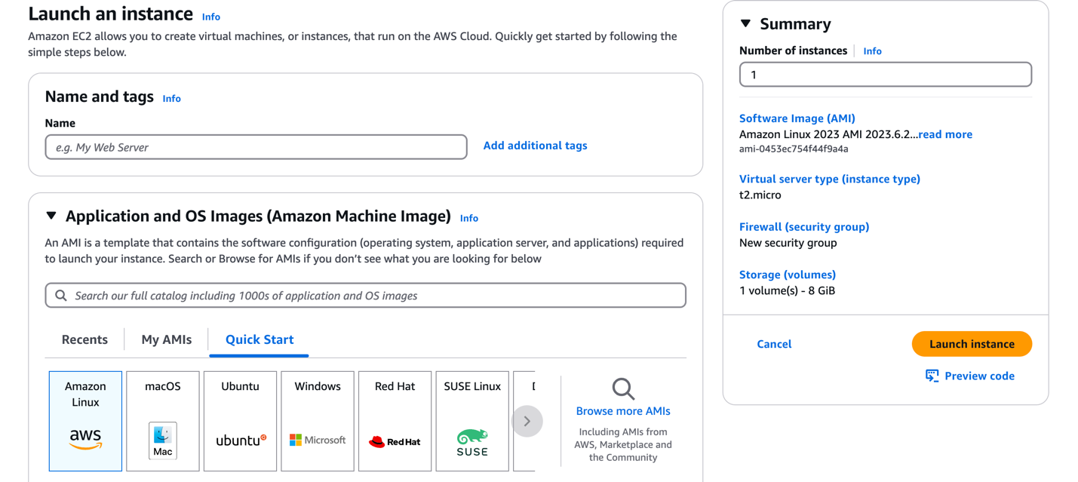

* 1. Select the following:
     + Instance name should INFO465-Instance
     + Select Windows as the Operating system
     + Use the default Amazon Machine Image (Microsoft Windows 2025 Base)
     + Accept the default instance type (t3.micro)
     + Create a key pair
       - Recommend: your vcu username
       - Make sure it is a .pem file
       - Store someplace safe
     + Edit the network settings:
       - Select your VPC
       - Select AZ1 Public as the subnet
     + Accept the defaults for the other selection, and press Launch Instance

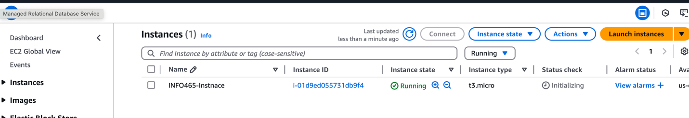

**Part III: Connect to the instance using RDP**

1. Select the instance and click on connect



1. Select the “RDP Client” tab

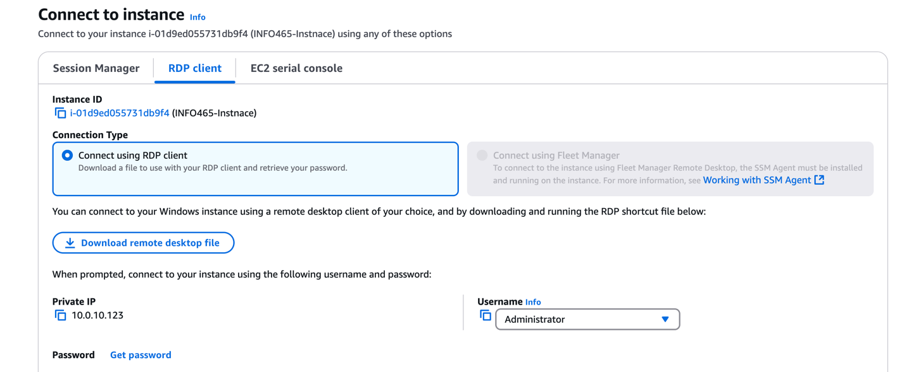

1. Select “Get password”
2. Uploads your .pem file and press Decrypt Password

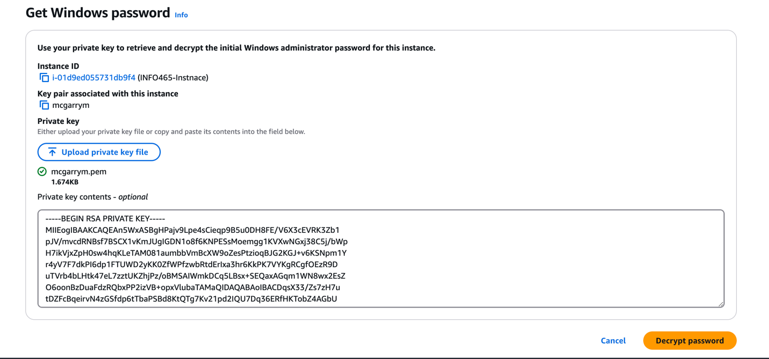

1. Copy the password onto your clipboard
2. Select Download remote desktop file.
3. Open the remote desktop file
4. Copy the password into the authentication screen
5. You should be connected to your instance.

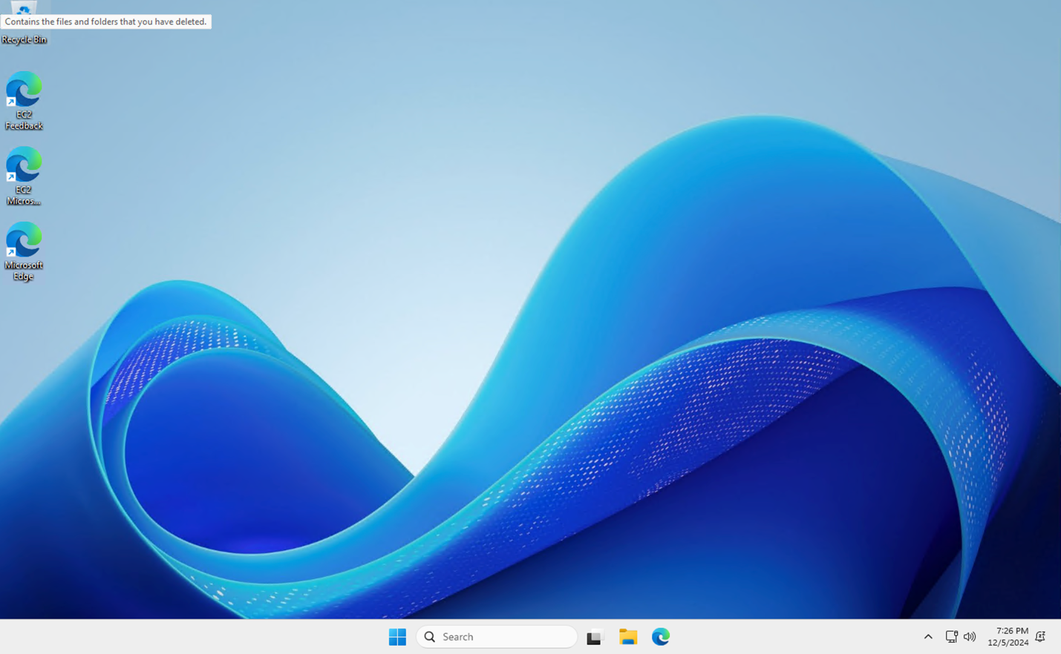

That concludes this activity.