**Infrastructure Build Project**

**Objective:**

This team assignment mirrors real-world processes in cloud infrastructure setup and deployment. The tasks (e.g., VPC creation, subnet setup, and EC2 configuration) are foundational for IT roles like cloud architect, DevOps engineer, or systems administrator.

This assignment, the infrastructure build, is the next step in the class’s sequence (proposal → UI/UX → architecture → infrastructure → database → sprints) which follows a logical project lifecycle, giving students a clear roadmap from conceptualization to implementation.

**Requirements:**

1. **Virtual Private Cloud (VPC) Configuration**
   * Requirement: Include a screenshot of the AWS VPC dashboard showing the configured VPC.
   * Description: Highlight the VPC ID, CIDR block, and any additional settings (e.g., name, tags).
   * Verification Notes: Ensure the VPC matches the design in the architecture document.
2. **Subnet Configuration**
   * Requirement: Include screenshots of the subnet configuration showing two subnets.
   * Description: Clearly label subnets (e.g., public or private) and indicate their associated CIDR blocks and availability zones.
   * Verification Notes: Verify that the subnets are within the VPC defined above and match the design requirements.
3. **Security Groups**
   * Requirement: Provide screenshots of the security groups configuration, including the rules for inbound traffic.
   * Description:
     + Show port numbers, protocols, and source/destination CIDRs.
     + Ensure these align with the specified ports/APIs in the architecture document.
   * Verification Notes: Confirm security group rules meet the project’s authentication, application, and database requirements.
4. **EC2 Instance Configuration**
   * Requirement: Provide a screenshot of the EC2 dashboard showing an instance running with the operating system specified in the architecture document.
     + Include instance details (e.g., instance ID, type, AMI used, and status).
   * Proof of Connection: Include a terminal screenshot demonstrating an SSH connection to the EC2 instance (if a Linux distribution) or an RDP connection (if Windows).
5. **Network Connectivity Verification**
   * Requirement: Provide a terminal screenshot showing the ability to ping the public IPv4 address of the EC2 instance from a local machine.
   * Description: Include the IP address being pinged and the success response.
   * Verification Notes: Ensure the EC2 instance is publicly accessible per the design and security group rules.

**Rubric:** Note – there is no partial credit for any item

* VPC verification: 15 points
* Subnet configuration: 25 points
* Security group configuration: 25 points
* EC2 instance: 20 points
* Network connectivity: 15 points

**\*\*IMPORTANT\*\*** Delete your NAT Gateway and associated EIP address after you have created the VPC so that you do not incur charges for these components which you will not need for the project.

**Example screen shots, can serve as a guide.**

VPC:

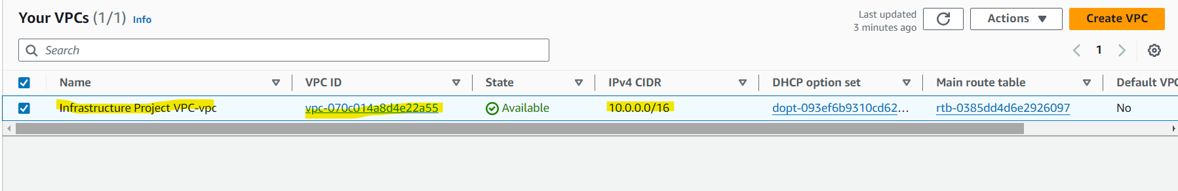

Subnets

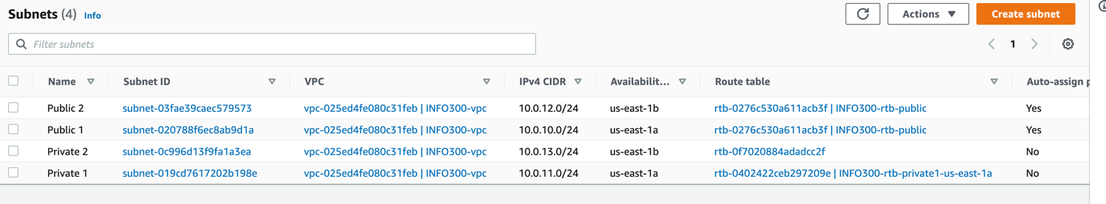

Security Group

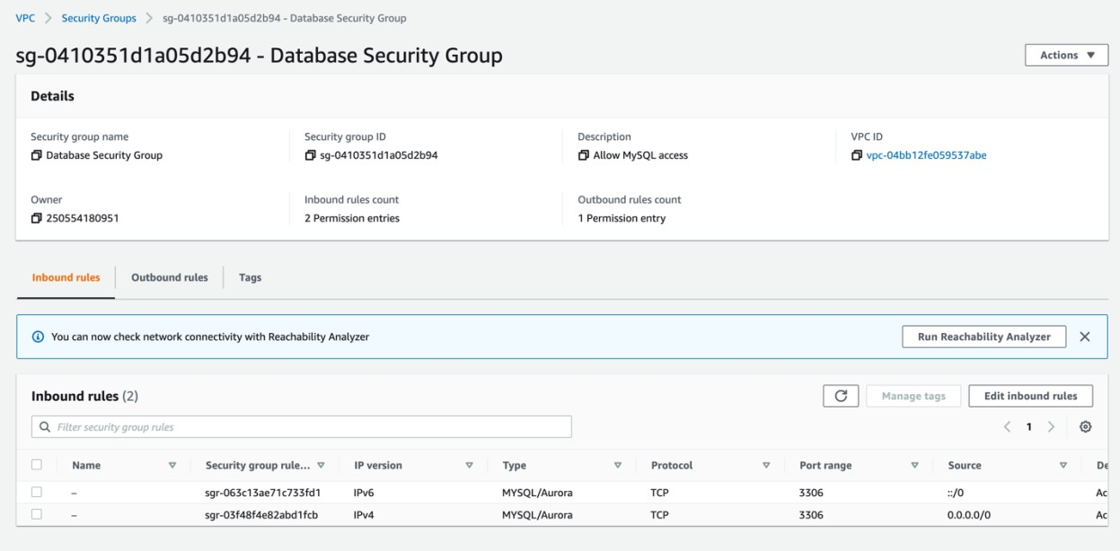

Linux EC2 connection

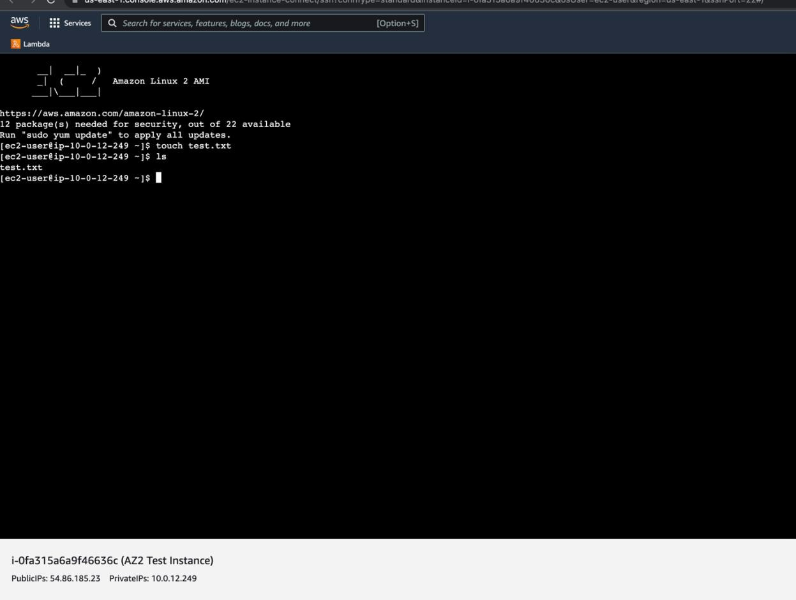

Windows EC2 connection:

