INF 303D:

Academic Success in the Digital University

Ms. Molly McGee

Summer 2018

Syllabus

The syllabus for INF 303D includes course goals and objectives, grading policies, and an overview of assessments. Any announcements made within Canvas (the course Learning Management System) during the semester regarding deadlines, assignments, or other course information should be considered to supersede this syllabus. If, at any time throughout the semester, you have questions about the syllabus, please contact your instructor for clarification.

Contact

Instructor: Molly McGee

Office Hours: By appointment

Email: [mkmcgee@utexas.edu](mailto:mkmcgee@utexas.edu) (or message me through your Canvas inbox)

Office: UTA 5.460

TA: TA Pool - a group of masters students at the iSchool (Please do NOT message individual TAs through Canvas)

Email: [ta_pool@ischool.utexas.edu](mailto:ta_pool@ischool.utexas.edu) (please include “McGee INF303D” in the subject line of your email)

Both the instructor and the TAs will reply to student emails within 24 hours on weekdays and 48 hours on weekends, barring rare and extenuating circumstances. We recommend that you check your Canvas messages at least once a day.

Table of Contents

|  |  |
| --- | --- |
| **Section** | **Page** |
| Teaching Team Information and Contact | 1 |
| Course Description | 2 |
| Course Objectives | 2-3 |
| Course Prerequisites and Expectations | 3 |
| Required Texts and Media | 4 |
| Course and University Policies   * Attendance * Late Assignments * Accessibility * Academic Integrity * Religious Holy Days * Excused Absences | 4-5 |
| Assessment:   * Quizzes * Discussion * Group assignments * Projects * Portfolio website | 5-6 |
| Determining Your Course Grade | 6-7 |
| Course Schedule | 7-9 |

Course Description

Academic Success in the Digital University (INF303D) is a course intended to teach undergraduate students to navigate and use digital information resources, tools, and skills that students should use in order to excel in their studies at a modern “digital” university and to succeed in their personal and professional pursuits as university graduates. The course will expose students to a wide variety of information and academic resources, tools, and skills, with a focus on the digital landscape of higher education. Subjects include features of the primary learning management system used; communication and organizational tools; library resources; basic online research resources; and ethical and safety concerns in the digital environment.

Course Objectives

The primary objective of the course is to help you develop four skills, which will prove valuable in other courses and your professional life in general. Using digital tools, you will learn to:

1. plan, organize, and collaborate with other students on projects using digital tools and workspaces;
2. develop strategies for searching for and accessing information and services;
3. evaluate and analyze information;
4. create or produce information ethically for specific outcomes.

You will demonstrate your development of these skills by:

* Demonstrating thorough understanding of course topics and readings by completing quizzes over module content;
* Analyzing and synthesizing information in discussion posts with information from other students;
* Completing tasks and projects with a range of digital tools available to students for project and schedule planning, collaborative work, creating multimedia, and finding and storing information;
* Effectively organizing and describing your research goals and plan in a professionally written memo;
* Demonstrating understanding the history, technical applications, and protocols that make the Internet possible;
* Understanding and explaining the political, financial, and social implications of creating and sharing content online and in the digital world;
* Demonstrating understanding of methods for balancing and protecting your information privacy and security in the digital world;
* Finding and evaluating information resources using the UT library system on a research topic of your choosing;
* Using digital tools to organize and cite these information resources in order to practice and uphold academic honesty standards at the University of Texas at Austin and other digital ethics practices and intellectual property rules;
* Designing a portfolio website using your choice of a visual content editor with some HTML, or modifying an html template and hosting your website through Github.
* Understanding what is meant by “digital citizenship,” and explaining the significant issues related to information ethics;

Course Prerequisites and Expectations

While there are no prerequisite classes for INF 303D, there are a few things that you should know before starting this course. Online courses require a higher level of self-motivation and self-pacing than most classroom- based course. Accordingly, you should know that:

* You will need to monitor all of your communications through Canvas and through email at least once a day in order to keep up with the course.
* You need to organize your time effectively so that you can spend at least 12 hours a week working on this class.
* Although you will have some degree of freedom in deciding how to pace your work in this course, there are strict deadlines for all assignments that you will be held responsible for meeting.
* Although it is not necessary to be a computer expert to complete this course successfully, you do need to know the basics of operating a personal computer and navigating the Internet in order to access and complete this course. You are additionally expected to know how to:
  + access this course on the Canvas Learning Management Platform;
  + create folders and view the contents of your computer;
  + open an application or program;
  + send and receive email;
  + search the Internet.
* You must participate civilly and ethically with your classmates in discussions and with your groupmates in projects.

If you don't know how to do any of these things, or if you have documented disabilities that prevent you from doing them, let your instructor or the TAs know during the first week of class. We can then decide on the best course of action.

Required Texts and Media

There are no required texts that must be purchased for this course.

All required readings, video, images, and audio files can be found listed and embedded directly on each content page of the course modules. The main content for this course has been developed and collected by several individuals working together within the University of Texas at Austin School of Information and in collaboration with the UT library system.

Course and University Policies

**Attendance:** Because we do not have any regularly scheduled meetings, “attendance” is not part of your final grade in this course. Instead, we have strict deadlines for all of the assignments in this course that you must plan very carefully for. You can always choose to submit your assignments ahead of the deadline in order to avoid any schedule conflicts.

**Late Assignments:** Late quiz and discussion assignments will not be accepted for any credit, except in cases of serious, multi-day (well documented) illness or emergency.

You will receive a zero if you do not submit these assignments on time.

Please note:

* We use the Canvas upload time as the official time of the submission. Please note that if you submit your assignment even one second after the recorded deadline, Canvas will mark your assignment as late and you will receive a zero for that assignment.
* Please submit your assignments well in advance of the deadline: computer problems, network outages, and other “technical” issues will not be considered a valid excuse for submitting an assignment late. Please avoid turning in your assignment at 11:59pm when it is due at midnight.

**Academic Integrity/Plagiarism:** Please abide by the University’s policy on academic integrity. All work that you submit must be your own: "Scholastic dishonesty includes, but is not limited to, cheating and plagiarism... Students who violate University rules on scholastic dishonesty are subject to disciplinary penalties, including the possibility of failure in the course and/or dismissal from the University. University policies on scholastic dishonesty will be strictly enforced." (From: The University of Texas: General Information, Appendix C.)

If we find plagiarism such as copying and pasting from Wikipedia or presenting another student’s work as your own, you will be referred to Student Judicial Services and you will likely fail this course. Plagiarism is one of the most common mistakes students make in an online course. Follow the guidelines provided in this course carefully and ask for help if you are unsure at any point about what might constitute plagiarism.

**Disability Services:** The University of Texas at Austin provides upon request appropriate academic accommodations for qualified students with disabilities. To determine if you qualify, please contact the Dean of Students at 471-6259; 471-4641 TTY. If they certify your needs, then we will happily work with you to make appropriate arrangements. Be sure to let both your instructor and the TAs know about any certified special needs that you may have.

**Religious Holy Days:** We are happy to provide any necessary arrangements for religious or holy day observances. Please be aware that University policy states that "A student who misses classes or other required activities, including examinations, for the observance of a religious holy day should inform the instructor as far in advance of the absence as possible, so that arrangements can be made to complete an assignment within a reasonable time after the absence.” (<http://catalog.utexas.edu/general-information/academic-policies-and-procedures/attendance/>)

**Email:** You are required to check your email regularly for this course, especially because the course is conducted completely through electronic means. For this course, this includes checking your Canvas messaging “inbox,” as well. University policy states that “Electronic mail (email), like postal mail, is a mechanism for official University communication to students. The University will exercise the right to send e-mail communications to all students, and the University will expect that e-mail communications will be received and read in a timely manner.” (<http://catalog.utexas.edu/general-information/appendices/appendix-m/>).

Assessment

* Quizzes over module content in this course are “open-book” and are not timed: you may refer back to the module content and readings while you take the quiz. The quizzes are intended to increase your interaction with course content and test your understanding of key concepts and ideas. Each quiz will be worth up to **10 points**.
* Discussion posts should be seen as opportunities to start conversations with your group of 4-5 students about ideas and questions related to course material and projects. In order for these to be conversations, you must participate in the discussion forum throughout the week, not only at the end of each module. Each discussion will be worth up to 10 points (initial post - 6 points, two replies to peers’ posts - 2 points each, total of 4 points). You can examine the rubric for any discussion in order to learn more details about the grading scheme for that discussion.
* Group assignments are difficult enough in person, but collaborating digitally provides a number of complications and potential issues for students who are not prepared. If you can learn to coordinate and communicate about group assignments in this class, you will be well prepared for future collaborations, both in school and possibly as part of the [43% of Americans](https://www.nytimes.com/2017/02/15/us/remote-workers-work-from-home.html) who spend at least some of their time working remotely. You will be graded on your performance in the group - your contributions, communication, and demonstrated respect and consideration for your teammates. You will also be given the opportunity to evaluate your teammates’ performances. Each of the four group assignments is worth 25 points.
* Individual projects for this course include deliverables in two different formats (one written and one video) , but they will both be opportunities to demonstrate your new skills and synthesize the information you are learning in each module. You will be graded on adherence to instructions and attention to detail – please make sure to proofread before you submit.
* Your portfolio website is the final project in this course. You will be given instructions for the project a few weeks before the end of the semester so you will have time to get used to whichever tool you choose to use to create your website. While the assignment is intended to teach you how to use a website as a platform to talk about what you have learned in the class, you should also consider using this as a place to post any future projects you work on during your time at the University of Texas at Austin and beyond - a well-designed, up-to-date portfolio website is an invaluable resource to show future employers.

Determining your Course Grade

Your course grade will be based on a 500-point scale, with the following point breakdown for each of the tests and assignments in the course. All assignments are always due at 11:59 p.m. on the due date. Attendance is **not** used to determine the final course grade.

|  |  |  |
| --- | --- | --- |
| Test/Assignment | Maximum Points | Comments |
| Quizzes | 100 | Each worth 10 points. (One per module) |
| Discussions | 50 | Each worth 10 points (initial post - 6 points, two replies to peers’ posts - 2 points each, total of 4 points). |
| Group assignments | 100 | Each worth 25 points (4 assignments) |
| Project 1 (Written) | 75 | 40 points for initial submission, 10 points for peer critique |
| Project 2 (Video) | 75 | 40 points for initial submission, 10 points for peer critique |
| Portfolio website | 100 | 90 points for initial submission, 10 points for peer critique |

From the total points, the following grade equivalency will be determined:

466 – 500 points: A

450 – 465 points: A –

433 – 449 points: B +

416 – 432 points: B

400 – 415 points: B -

383 – 399 points: C +

366 – 382 points: C

350 – 365 points: C -

333 – 349 points: D +

316 – 332 points: D

300 – 315 points: D –

0 – 299 points: F

**Percentages**

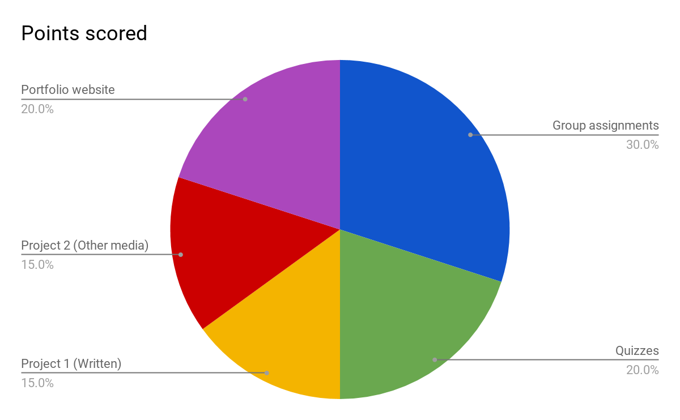

Course Schedule

|  |  |  |  |
| --- | --- | --- | --- |
| **Module** | **Date** | **Key words/topics** | **Reading and Assignments** |
| 1 | 6/7-6/13 | Intro: Guidelines and Topics | Read Module 1  **Due Wed, 6/13 by 11:59pm:**  Quiz 1: Syllabus  Team Questionnaire |
| 2 | 6/14-6/20 | Introduction to Digital Technologies | Read Module 2  **Due Sunday, 6/17, by 11:59pm:**  Discussion  **Due Wed, 6/20 by 11:59pm:**  Quiz 2  Discussion replies |
| 3 | 6/21-6/27 | Information and the Digital University | Read Module 3  **Due Sunday, 6/24, by 11:59pm:**  Group Project  **Due Wed, 6/27 by 11:59pm:**  Quiz 3  Peer review |
| 4 | 6/28-7/4 | Information Security and Privacy | Read Module 4  **Due Sunday, 7/1, by 11:59pm:**  Discussion  Project 1: Video/Written  **Due Wed, 7/5 by 11:59pm:**  Quiz 4  Discussion replies  Peer review |
| 5 | 7/5-7/11 | Information “Life Cycle” and Scholarly Publishing | Read Module 5  **Due Sunday, 7/8, by 11:59pm:**  Group Project  **Due Wed, 7/11 by 11:59pm:**  Quiz 5  Peer review |
| 6 | 7/12-7/18 | Research Process & Evaluating Information | Read Module 6  **Due Sunday, 7/15, by 11:59pm:**  Discussion  **Due Wed, 7/18 by 11:59pm:**  Quiz 6  Discussion replies |
| 7 | 7/19-7/25 | Academic Integrity and Copyright | Read Module 7  **Due Sunday, 7/22, by 11:59pm:**  Group Project  Project 2: Video/Written  **Due Wed, 7/25 by 11:59pm:**  Quiz 7  Peer review |
| 8 | 7/26-8/1 | Web Design | Read Module 8  **Due Sunday, 7/29, by 11:59pm:**  Discussion  **Due Wed, 8/1 by 11:59pm:**  Quiz 8  Discussion replies |
| 9 | 8/2-8/8 | Web Design Part 2 | Read Module 9  **Due Sunday, 8/5, by 11:59pm:**  Group Project  **Due Wed, 8/8 by 11:59pm:**  Quiz 9  Peer review |
| 10 | 8/9-8/15 | Digital Citizenship and Ethics | Read Module 10  **Due Sunday, 8/12 by 11:59pm:**  Discussion  Project 3: Website Portfolio  **Due Wed, 8/15 by 11:59pm:**  Quiz 10  Website peer reviews  Final course survey (extra credit) |
|  | 8/16 - 8/17 | Final project and grades | No reading or assignments, but feel free to use the forums to chat with your fellow students as you prepare for the fall semester!  Grades will be posted by 5pm on Thursday, August 17th. |