
User Guide for Mining & Materials Engineering Lab
Contents
1. Introduction 2
1.1 Welcome 2
1.2 Running a Unity Executable on Windows 2
1.3 Troubleshooting Common Issues 2
2. Setup and Navigation 3
2.1 Navigating in Keyboard and Mouse mode 3
2.2 Navigation Visual Guide 4
2.3 Sample Preparation Safety Video 4
2.4 Common Confusions 5
4. Lab Environment 5
4.1 Safety Equipment and Registration 5
4.2 Key Components 6
4.3 Summarized Process Description 6
4.4 Emergency Scenarios 7
5 Appendix A: Computer Requirements 8
5.3 Minimum Requirements: 8
5.4 Recommended Requirements: 8

- Introduction
  - Welcome
Welcome to the Virtual Reality Bioengineering lab! This activity will help you become more familiar with the safety guidelines of a wet lab.

  - Running a Unity Executable on Windows
- Find the folder where your Unity project was built. This folder will typically contain the executable file (.exe) and a subfolder with the same name as the executable file, which contains additional data required by the executable.
- Make sure the following are in the same directory:
  - The executable file (i.e. Bioengineering.exe)
  - The Bioengineering_Data folder
  - UnityPlayer.dll
- Double-click the executable file (Bioengineering.exe). This will start the application.

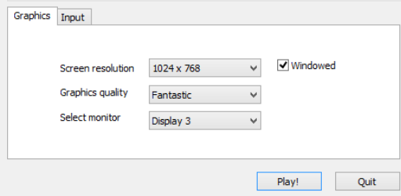

When you run the executable for the first time, you might be prompted with a configuration window where you can set the screen resolution, graphics quality, and input settings. Adjust these settings as needed and click "Play" or "OK" to start the application.

  - Troubleshooting Common Issues
- Missing Files Error: Ensure that the Bioengineering_Data folder is in the same directory as the executable. (Always keep the executable and its associated data folder together when moving or copying the project to avoid missing file errors. Copying-and-pasting the .exe file to a directory without bringing its required components will render it unusable)
- Graphics or Performance Issues: Adjust the graphics quality settings in the configuration window to a lower setting to improve performance.
- Input Issues: Ensure that your keyboard, mouse, or VR controllers are properly connected and configured.

- Setup and Navigation

  - Navigating in Keyboard and Mouse mode
Use the WASD keys or arrow keys for movement.
Use the mouse to click on objects, answer questions, and interact.
Key Functions
- W / Up Arrow: Move forward
- A / Left Arrow: Move left
- S / Down Arrow: Move backward
- D / Right Arrow: Move right
- Esc: Close the Simulator
- X: Show/Hide floating instructions
- Left click: Interact/Pick up object
- Right click: Drop object
Combining Movements
- Diagonal Movement: Press two keys together (e.g., W + A or Up Arrow + Left Arrow to move forward and left).
Colliders
- Definition: Colliders on objects prevent the user from walking through them, and allow the object to interact with other objects and the player.
- In this experience, walls, tables, and lab equipment have colliders, so the user can not walk through them or pass their hand through them.
- If you’re too close to a hard barrier, hold S to walk backwards.
“Pickuppable Objects”
- Many objects can be picked up and moved. Use left click to pick up the object and right click to release it. Some objects will be automatically released when interacting with a green glowing target.
Floating Instruction Menu
- The floating instruction menu will follow the user and give information about the current step and how to proceed. It can be hidden at any time with the X button.

  - Navigation Visual Guide

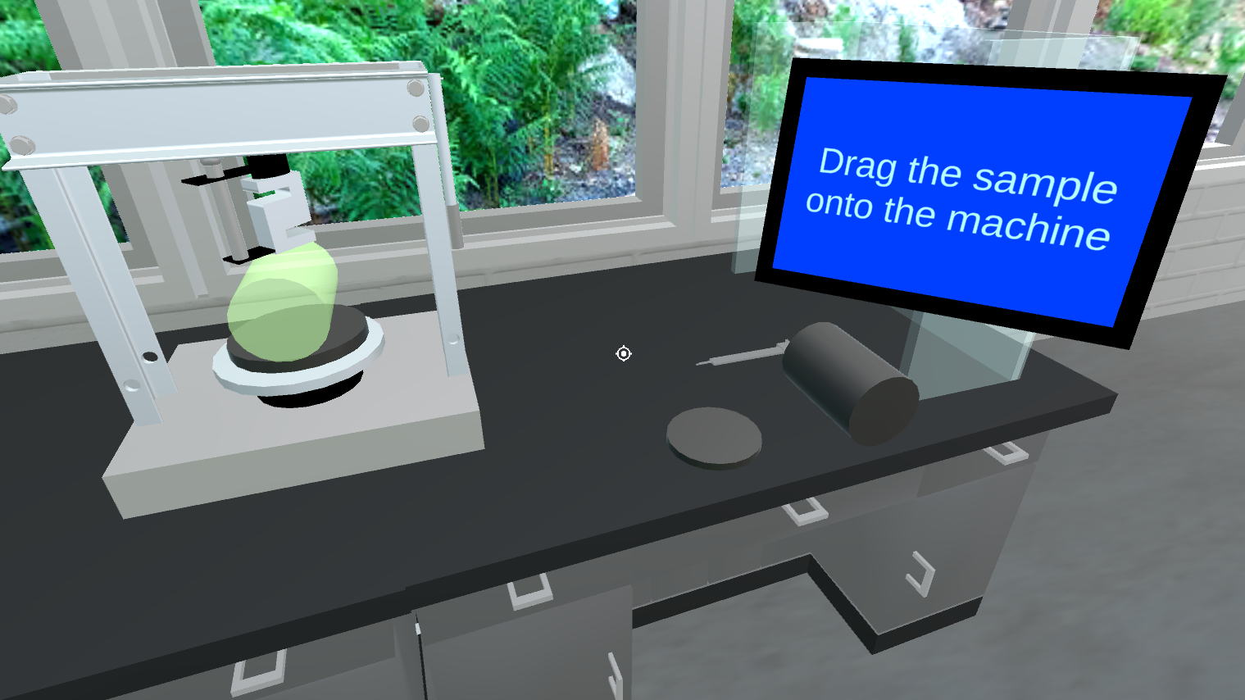
Figure 2: Floating instructions and Splitting Indirect Tensile Strength Test

The floating instructions will guide the user to interact with certain items. Many items are locked until their interaction step is reached. Some objects are interactable at any time, and can be picked up with left click and dropped with right click.

  - Sample Preparation Safety Video
- Once the user reaches the Sample Preparation Safety Video, the mouse will unlock from the centre of the screen.
- Press X to hide the instructions if it is not done automatically.
- Restart: Restart the video from the beginning. Your progress in the interactive quizzes will be saved.
- Pause: Pause the video.
- Skip to quiz: Jump to the next quiz section within the video. However, the knowledge to answer the quiz questions will be within the video, so clicking this button prematurely could cause important information to be missed.
- Back: Return to the rest of the experience.

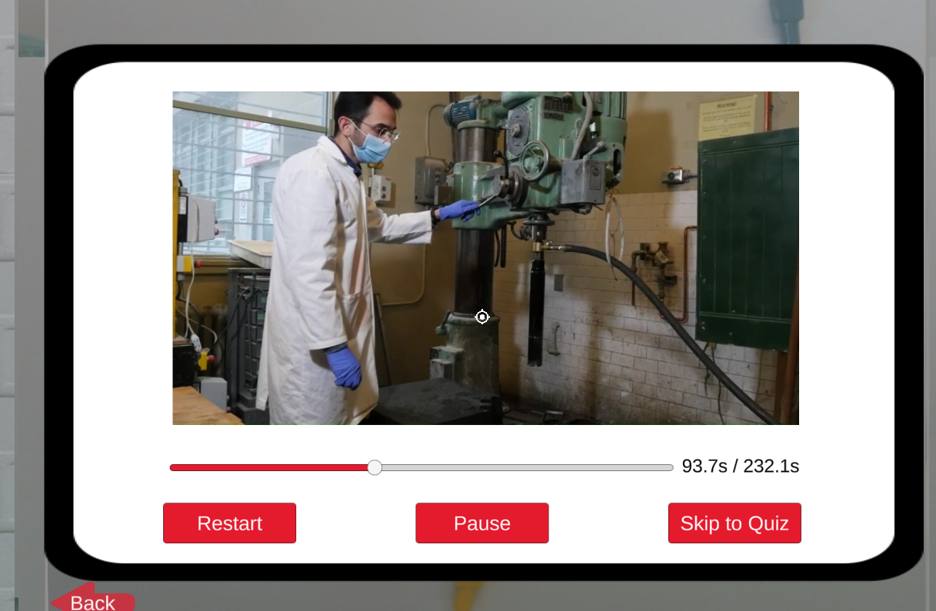
Figure 3: Dropping glass items on the floor with right click will activate spill safety instructions

  - Common Confusions
- If the bottom plate, sample, or top plate are not locking into place, try moving around with WASD. It is possible the character is standing too far from the table. If this still doesn’t work, try dropping the object with right click and picking it up again.
- Click a few times around an object if clicking it doesn’t immediately correctly proceed to the next step.
- If the mouse does not activate upon starting the Sample Preparation video, try hitting Escape.

3. Exploration
You may explore the Bioengineering Solids Lab freely and at your own pace. The lab includes workbenches, biosafety cabinets, analytical instruments, and waste disposal areas. By the end of the exploration, you should be able to:
- List appropriate safety precautions, protective equipment, protocols, and practices specific to the Bioengineering lab.
- Identify the main components of the lab and describe their functions.
- Recognize safe handling procedures for chemicals and waste.

4. Lab Environment

4.1 Safety Equipment and Registration
Proceed to the safety preparation area to collect:
- Lab Coat
- Safety Goggles
Some lab equipment will require:
- Nitrile Gloves
Notes:
- Long hair must be tied back, jewelry removed.
- No eating, drinking, or use of personal items (phones/laptops) inside the lab.
- Certain instruments generate loud noise (e.g., miter saw) — hearing protection is required when in use.

4.2 Key Components
While navigating the lab, take note of the following:
- Emergency Equipment: Eyewash stations, safety shower, first aid kits.
- Biohazard Waste Disposal: Bins for contaminated solids and sharps, autoclave staging for sterilization.
- Glass Waste: Separated into contaminated vs. non-contaminated containers.
- Chemical Storage: Small volumes of solvents and acids (limited use).
Equipment to locate:
- Centrifuges
- Freezers/Refrigerators: Storage of yeast, bacterial samples, and media.
- Glassware & Bottles: Gold-capped bottles (GL bottles) used for yeast induction; require careful cleaning (rinse with water, ethanol/bleach, then water again).
- Dishwasher: For sterilizing glass bottles.
- Biosafety Cabinet: Sterile environment for bacterial/yeast manipulations.
- Shakers/Incubators: For cultivating yeast and bacterial cultures.
- Burners: Used for sterile technique — must be operated with caution to avoid open flame accidents.

  - Summarized Process Description
- Indirect Tensile Strength Test: The indirect tensile strength (ITS) test is a laboratory method used to estimate the tensile strength of brittle or quasi-brittle materials—most commonly asphalt concrete, concrete, and rock—without applying direct tensile loading. In the test, a cylindrical specimen is placed horizontally between two loading strips and subjected to a compressive load applied along its diameter. Although the load is compressive, it induces a uniform tensile stress perpendicular to the load direction at the center of the specimen. The specimen fails when this tensile stress exceeds the material’s tensile capacity. The indirect tensile strength is calculated using the peak applied load, specimen diameter, and thickness, assuming elastic stress distribution. The test is relatively simple to perform and avoids many of the gripping and alignment problems associated with direct tensile tests.
- Sample Preparation: In a student laboratory, a cylindrical sample is typically obtained by placing the large cube of material on a bench-mounted coring or cutting machine and securely clamping it to prevent movement. The desired coring location is marked on the surface, and a core bit is aligned perpendicular to the face of the specimen. The machine is then operated at a slow, steady feed rate with continuous water cooling to limit heat generation and dust while minimizing damage to the material. Once coring is complete, the cylindrical sample is carefully removed and trimmed to the required length using a laboratory saw so that the ends are flat and parallel, making the specimen suitable for standard mechanical testing.

4.4 Emergency Scenarios
In the event of an emergency:
- Exit immediately through the nearest emergency exit.
- Use eyewash stations or safety showers in case of chemical/biological exposure.
- Broken glass must be placed in designated contaminated glass waste containers.
- For fire hazards, shut off the flame immediately and follow evacuation procedures.
- Report all accidents, including glass breakage, water spills, or falls, to the supervisor.

- Appendix A: Computer Requirements
  - Minimum Requirements:
  - Operating System:
- Windows 10 or later (64-bit)
- macOS 10.14 or later (64-bit)
- Linux (Ubuntu 18.04 or CentOS 7)
  - Processor (CPU):
- Intel Core i5 or AMD equivalent
- For very simple games, an Intel Core i3 might suffice, but a Core i5 is safer to ensure smooth performance.
  - Memory (RAM):
- 8 GB of RAM
- For simpler games, 4 GB might work, but 8 GB is a safer baseline for most Unity games.
  - Graphics Card (GPU):
- Dedicated GPU with 2 GB of VRAM (e.g., NVIDIA GeForce GTX 660, AMD Radeon HD 7870)
- Integrated graphics like Intel HD Graphics 4000 may work for very simple or 2D games, but dedicated graphics are recommended for 3D games.
  - Storage:
- At least 20 GB of free disk space for the game and assets.
- SSD is recommended for faster loading times, but an HDD will work for less demanding games.
  - Display Resolution:
- 1280x720 minimum resolution
- Higher resolution is better for clarity, but this will depend on the game's graphical demands.

  - Recommended Requirements:
For a more optimal experience, especially for more complex 3D games:
  - Processor (CPU):
- Intel Core i7 or AMD Ryzen 5
  - Memory (RAM):
- 16 GB of RAM
  - Graphics Card (GPU):
- Dedicated GPU with 4 GB or more VRAM (e.g., NVIDIA GeForce GTX 1060, AMD Radeon RX 580)
  - Storage:
- SSD with at least 50 GB of free space
  - Display Resolution:
- 1920x1080 (Full HD) or higher

