TDD
Test Driven Development
How to create an application using Test Driven Development method ?

Introduction
Here we are going to experiment the TDD method to produce well and full tested code from scratch.
We need some tools to perform such exercises :
- Eclipse 3.6+
- Maven 2+
- Plugin M2Clipse to perform Maven from eclipse
- and for our needs, the EGit Plugin to access Git repository from https://github.com/mcgivrer/JunitTddTutorial

Needs
Our customer need to modelize a user banking account. So we are going to create a BankUser entity and a BankAccount entities.

Use cases

BankAccount
- This entity must follow fluctuation of the account in a value, represented by a “Double” type attribute,
- Default value, at creation time is 0.0,
- User can do a credit operation with a positive value.
  - In case of crediting with a negatoive value, an exception must be thrown.
- User can do debit operation with a negative value,
  - In case of debiting with a positive value, an exception must be thrown.
- BankAccount can rise an exception on 0.0 value, or using a minuxAuthorizedValue.
  - In case of exceeding this threshold, an exception must be thrown.
- This entity can be linked to any currency, according to an existing list of world currencies
  - see iso-4217-currency-codes.csv file to provide such list.

BankUser
A user is identified by
- his first-name,
- his last-name,
- and his birth date.
Some additional administrative information must be provided as:
- Personal postal address
- email
- phone number
Some common use cases concerning BankAccount:
- A BankAccount follow to, at least, one, or more, BankUser,

Address
A BankUser address can be designed through another entity containing the following information:
- street
- number
- postal code
- city
- country (restrained to a well known list).

Part 1, the BankAccount
We have to code the first part with the entity BankAccount, following the TDD principles.
First, create a Maven Project with the contextual menu in the Project Explorer pan:

- GroupId: com.samples.tdd
- ArtifactId: junitTdd
- version: let the 0.0.1-SNAPSHOT default value.

Then, create in the src/test/main source folder the package com.samples.tdd.balance. Add a new class named BankAccountShouldHaveTo. This new class is a test class, bind to the Junit concept to perform “inline” test writing, driving us to code the right BankAccount object to answer to all the use cases explained in the “Needs” chapter.

To perform such class, just use the Junit Wizard :
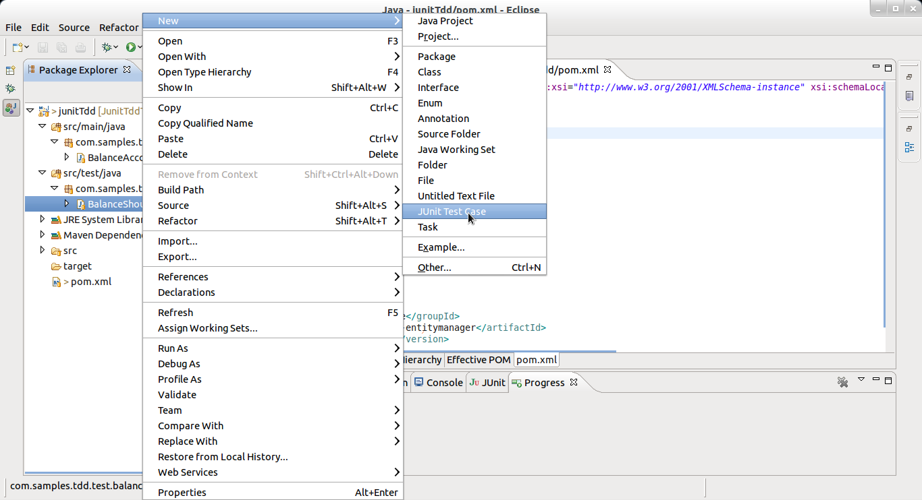Illustration 1: Using the Eclipse JUnit wizard to create a new test case class
The Wizard will provide the following things:
And the produced code is:
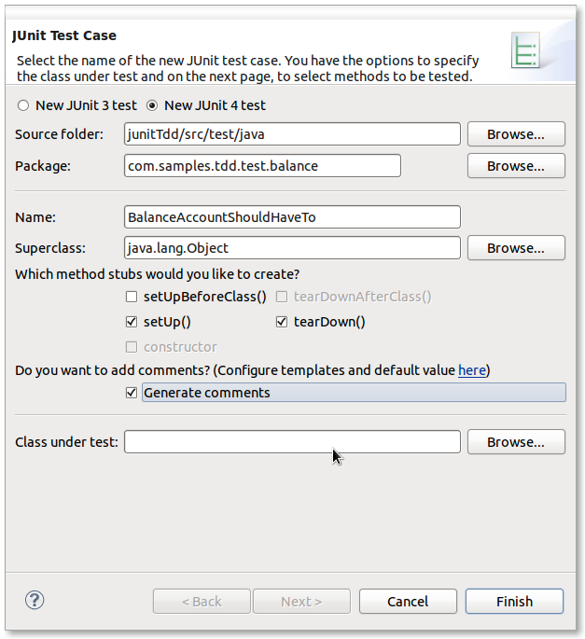Illustration 2: Perform setting for the BankAccountShouldHaveTo test case.

/**
* Test Case implementation for the BankAccount Entity creation.
* @author Frédéric Delorme<frederic.delorme@gmail.com>
*
*/
public class BankAccountShouldHaveTo {

/**
* @throws java.lang.Exception
*/
@Before
public void setUp() throws Exception {
}

/**
* @throws java.lang.Exception
*/
@After
public void tearDown() throws Exception {
}

@Test
public void test() {
fail("Not yet implemented");
}

}
So start with the ordered list of Use Cases, we will first test the zero'ed value at object initialization:

Use cases 1 and 2
Create our first test following these lines of code replacing the default generated test() method:

@Test
public void beInitializedWithAZeroValue() {
BankAccount ba = new BankAccount();
assertEquals("BankAccount is not initialized with a Zero default value !",Double.valueOf(0.0),ba.getValue());
}

Some errors appears in the eclipse “problems” tab. We have to create the class BankAccount.
Just press the CTRL+SHIFT+1 short key and the wizard will propose you to create such a class.

Don't forget to specify the right source folder (src/main.java), change the target generation package to com.samples.tdd.balance and checked the “Generate Javadoc comments”.

You will get such code:

package com.samples.tdd.balance;

/**
* BankAccount Entity definition.
* @author Frédéric Delorme<frederic.delorme@gmail.com>
* @see com.samples.tdd.test.balance.BankAccountShouldHaveTo
*
*/
public class BankAccount {

}
the next step will be to provide the correct implementation for the getValue() method:

public Double getValue() {
return new Double(0.0);
}
This is a temporary implementation, just to perfom the Junit test.

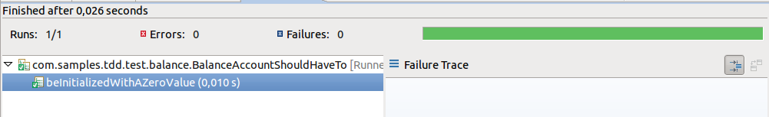Illustration 3: JUnit test case is green at execution: first test is ok.
But this first implementation is not functionally correct: the value must be an attribute of the entity, because value must persist.
So refactoring will drive us to the following code for the BankAccount class:
public class BankAccount {
/**
* Value for this BankAccount.
*/
private Double value;

/**
* Initialization of the instance with default 0.0 value.
*/
public BankAccount(){
value=0.0;
}

/**
* Return BankAccount value.
* @return
*/
public Double getValue() {
// TODO Auto-generated method stub
return value;
}

}

Restart the JUnit execution with the magic keys SHIFT+ALT+X / T and you will get the same result:

BankUser
Write our first method

Now we are going to start with the second part, about Database things.

Part 2
We have to add the BankUser entity and the relation between this entity and the BankAccount with a one-to-many relationship.
So, just add dependencies in our pom.xml file:

- DBunit 2.4.8
- spring-core
- hibernate-entitymanager

Let's start with Spring and Hibernate with the JPA spec.

http://www.eclipse.org/downloads/
http://maven.apache.org/
http://www.eclipse.org/m2e/
http://www.eclipse.org/egit/

