TDD
Test Driven Development
How to create an application using Test Driven Development method ?
Author: Frédéric Delorme<frederic.delorme@gmail.com>
created at: 02/01/2012

Introduction
Here we are going to experiment the TDD method to produce well and full tested code from scratch.
We need some tools to perform such exercises :
- Eclipse 3.6+
- Maven 2+
- Plugin M2Clipse to perform Maven from eclipse
- and for our needs, the EGit Plugin to access Git repository from https://github.com/mcgivrer/JunitTddTutorial

Needs
Our customer need to modelize a user banking account. So we are going to create a BankUser entity and a BankAccount entities.

Use cases

BankAccount
This entity must follow fluctuation of the account in a value, represented by a “Double” type attribute,
- Default value, at creation time is 0.0,
- User can do a credit operation with a positive value.
  - In case of crediting with a negative value, an exception must be thrown.
- User can do debit operation with a negative value,
  - In case of debiting with a positive value, an exception must be thrown.
- BankAccount can rise an exception on 0.0 value, or using a minusAuthorizedValue.
  - In case of exceeding this threshold, an exception must be thrown.
- This entity can be linked to any currency, according to an existing list of world currencies
  - see iso-4217-currency-codes.csv file to provide such list.

BankUser
A user is identified by
- his first-name,
- his last-name,
- and his birth date.
Some additional administrative information must be provided as:
- Personal postal address
- email
- phone number
Some common use cases concerning BankAccount:
- A BankAccount follow to, at least, one, or more, BankUser,

Address
A BankUser address can be designed through another entity containing the following information:
- street
- number
- postal code
- city
- country (restrained to a well known list).

Part 1, the BankAccount
We have to code the first part with the entity BankAccount, following the TDD principles.
First, create a Maven Project with the contextual menu in the Project Explorer pan:
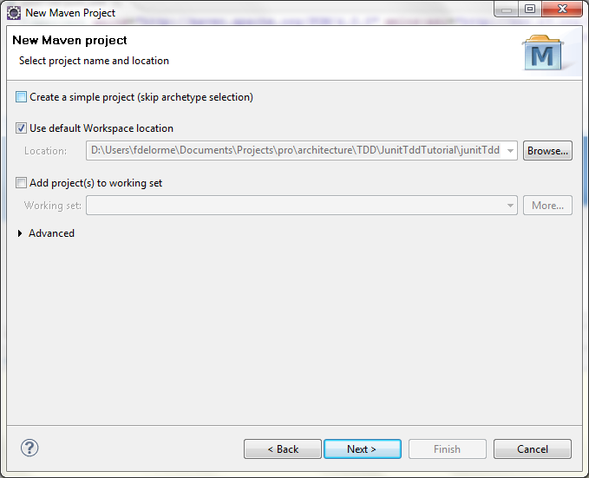Illustration 1: Create a new Maven Project
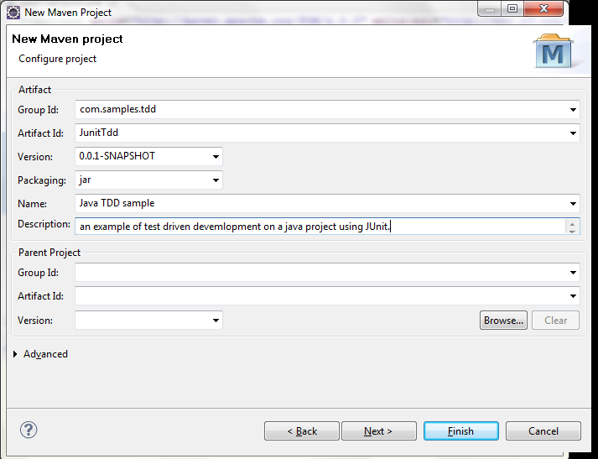Illustration 2: Fill all maven information GroupId, ArtifactId and Version. Packaging would be Jar. Name and Description are not mandatory.
Input following values :
- GroupId: com.samples.tdd
- ArtifactId: junitTdd
- version: let the 0.0.1-SNAPSHOT default value.

You will obtain the following project structure:

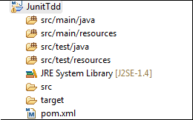Illustration 3: Structure of a maven project
Note:
The information between '[JunitTddTutorial master]' is from the Egit plugin for the source versioning system used on this tutorial.

We need at least one dependency to perform our TDD, JUnit !

Junit is a specific java API to perform Unit testing of java code. (see http://www.junit.org/ for more information).

So just open the pom.xml file and a brand new editor is open to manager Maven things:
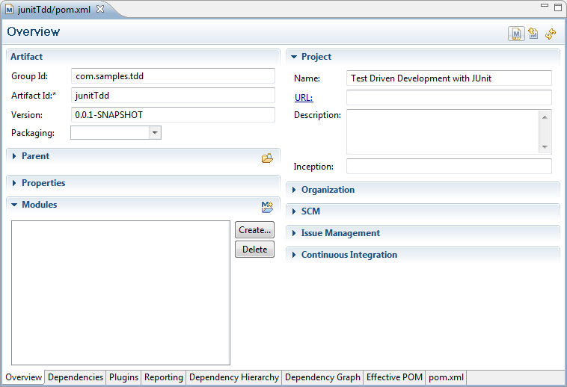Illustration 4: Default view on the maven configuration file: pom.xml

Go to the Dependencies tab (on bottom side) :
Click the upper “Add” button and search for the “Junit” API:
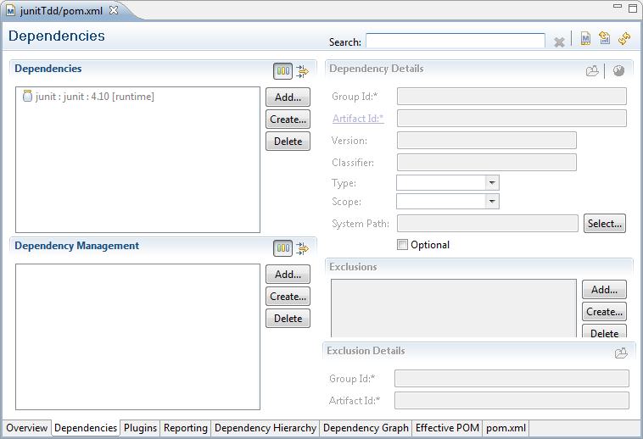Illustration 5: Dependencies editor for our JUnitTdd project
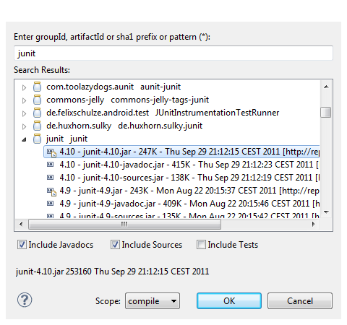Illustration 6: Select the last JUnit version (4.10) to be embbeded in our project
Validate with “OK” button.

Go to the Dependencies tab to edit the scope: switch to “test” scope:

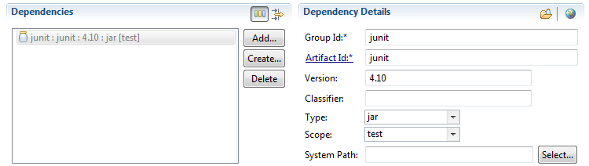Illustration 7: Switch scope to "test"
Note:
Scope indicate to Maven at packaging time wich dependencies must be deploy to production. Test stuff won't be deployed.

Then, create in the src/test/main source folder the package com.samples.tdd.bank. Add a new class named BankAccountShouldHaveTo. This new class is a test class, bind to the JUnit concept to perform “inline” test writing, driving us to code the right BankAccount object to answer to all the use cases explained in the “Needs” chapter.

A new entry appear on the project structure: the “Maven Dependencies”

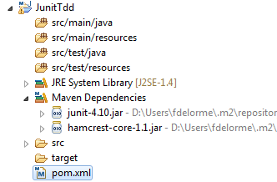Illustration 8: Maven Dependencies listing all jar needed by your brand new maven project.
To perform such class, just use the Junit Wizard :
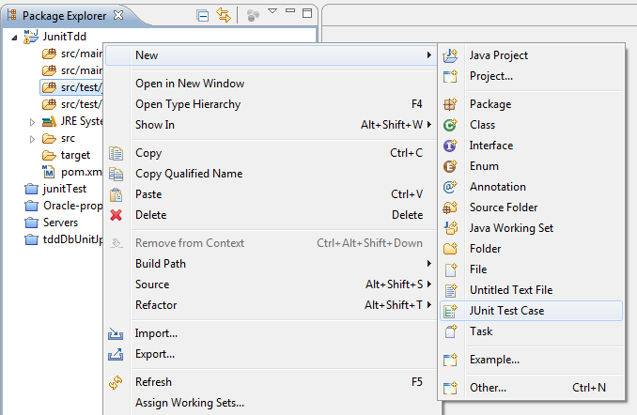Illustration 9: Create a new Junit Test Case
The Wizard will provide the following things:

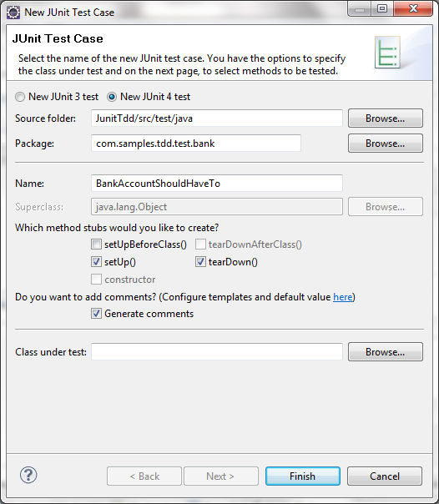Illustration 10: Perform setting for the BankAccountShouldHaveTo test case.

And the produced code is:

/**
* Test Case implementation for the BankAccount Entity creation.
* @author Frédéric Delorme<frederic.delorme@gmail.com>
*
*/
public class BankAccountShouldHaveTo {

/**
* @throws java.lang.Exception
*/
@Before
public void setUp() throws Exception {
}

/**
* @throws java.lang.Exception
*/
@After
public void tearDown() throws Exception {
}
}

So start with the ordered list of Use Cases, we will first test the zero'ed value at object initialization:

Use cases 1
Create our first test following these lines of code replacing the default generated test() method:

@Test
public void beInitializedWithAZeroValue() {
BankAccount ba = new BankAccount();
assertEquals("BankAccount is not initialized “
+ ”with a Zero default value !",
Double.valueOf(0.0),ba.getValue());
}

Some errors appears in the eclipse “problems” tab. We have to create the class BankAccount.
Just press the CTRL+SHIFT+1 short key and the wizard will propose you to create such a class.

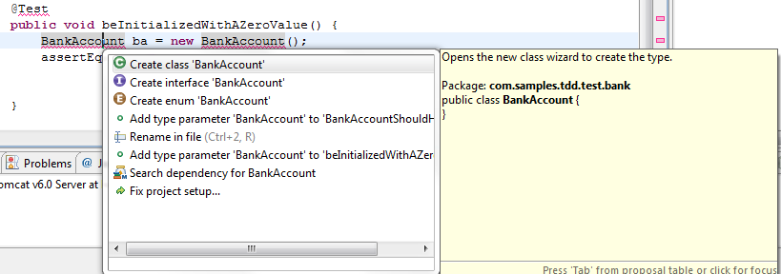Illustration 11: Create the missing class BankAccount with Eclipse wizard !
Don't forget to specify the right source folder (src/main.java), change the target generation package to com.samples.tdd.bank and checked the “Generate Javadoc comments”.
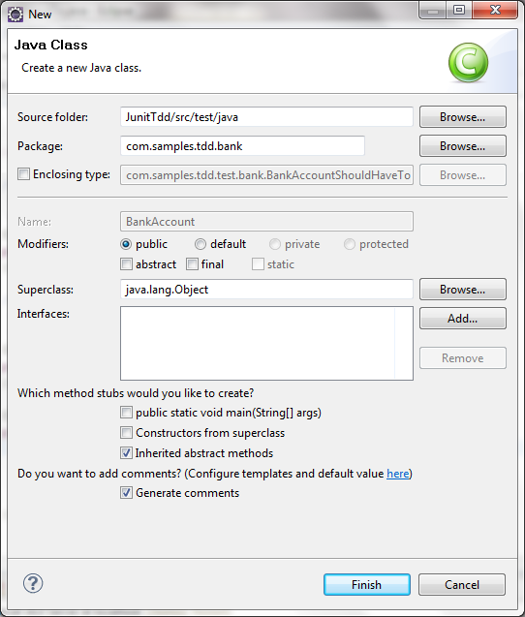Illustration 12: Class wizard to perform creation of our BankAccount in the com.samples.tdd.bank package

You will get such code:

package com.samples.tdd.bank;

/**
* BankAccount Entity definition.
* @author Frédéric Delorme<frederic.delorme@gmail.com>
* @see com.samples.tdd.test.balance.BankAccountShouldHaveTo
*
*/
public class BankAccount {

}

Save the generated file.

And then back to the BankAccountShouldHaveTo test class.

Go to the marked error in the editor window CTRL+SHIFT+1 to perform the method wizard:

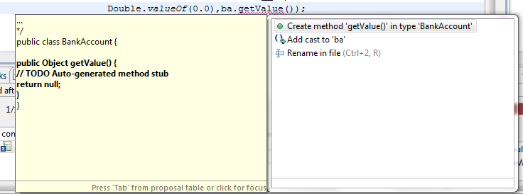Illustration 13: Generate default implementation for getValue().

The Red step
Execute the Junit test through the Run => run as … => 1 Junit Test menu,
or press the ALT+SHIFT+X,T shortcut:

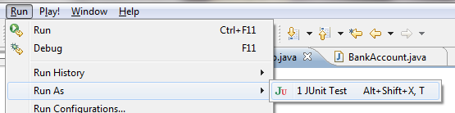
Junit test will failed because default implementation of the getValue() method return null (see message on Junit Panel).

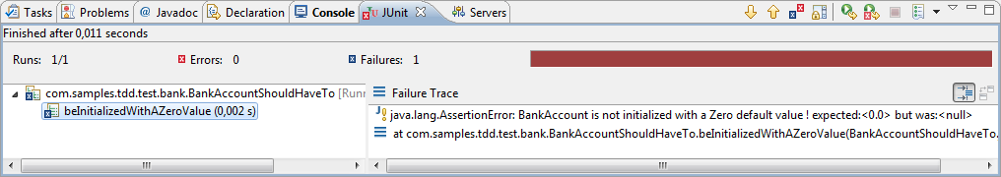Illustration 14: Red Step : test are executed with red error

The Green Step
the next step will be to provide the correct implementation for the getValue() method:

public Double getValue() {
return new Double(0.0);
}
back to the test class BankAccountShouldHaveTo and perform a CTRL+CHIFT+O to organize and complete java import on top of the java file, and a CTRL+SHIFT+F. You will obtain the following clear and well formated code:

package com.samples.tdd.test.bank;

import static org.junit.Assert.assertEquals;

import org.junit.After;
import org.junit.Before;
import org.junit.Test;

import com.samples.tdd.bank.BankAccount;

/**
* Test Case implementation for the BankAccount Entity creation.
* @author Frédéric Delorme<frederic.delorme@gmail.com>
*
*/
public class BankAccountShouldHaveTo {

/**
* @throws java.lang.Exception
*/
@Before
public void setUp() throws Exception {
}

/**
* @throws java.lang.Exception
*/
@After
public void tearDown() throws Exception {
}

@Test
public void beInitializedWithAZeroValue() {
BankAccount ba = new BankAccount();
assertEquals("BankAccount is not initialized "
+ "with a Zero default value !",
Double.valueOf(0.0),ba.getValue());
}
}
This is a temporary implementation, just to run and verify a green Junit test.

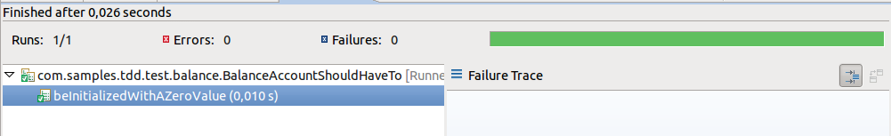Illustration 15: Green Step, JUnit test case is well executed: first implementation is ok.

The Refactor step
But this first implementation is not functionally correct: the value must be an attribute of the entity, because value must persist.
So refactoring will drive us to the following code for the BankAccount class:
public class BankAccount {
/**
* Value for this BankAccount.
*/
private Double value;

/**
* Initialization of the instance with default 0.0 value.
*/
public BankAccount(){
value=0.0;
}

/**
* Return BankAccount value.
* @return
*/
public Double getValue() {
// TODO Auto-generated method stub
return value;
}

}

Restart the JUnit execution with the magic keys SHIFT+ALT+X / T and you will get the same result:

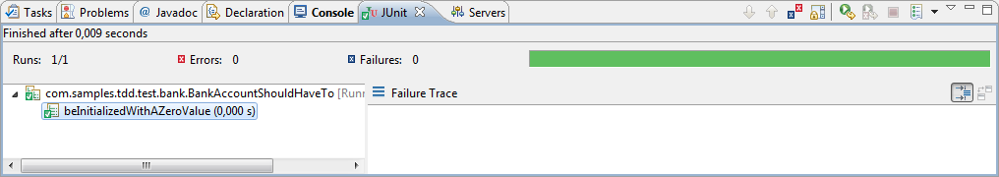Illustration 16: After refactoring, test are green again.

Now let's implement other Use Case.

Use Case 2: Credit()
The credit method must be added. So just add another test.
Just add the followin code :

@Test
public void beCreditedWithAPositiveValue(){
BankAccount ba = new BankAccount();
ba.credit(1000.0);
assertEquals("BankAccount is not creted with 1000.0 bucks !",
Double.valueOf(1000.0));
}

Ok, you have to implement with the Method's wizard (like in previous steps) the credit operation.

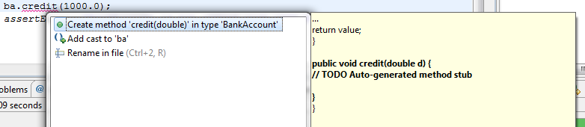Illustration 17: Implement the credit() method with Method's wizard !

Red step:
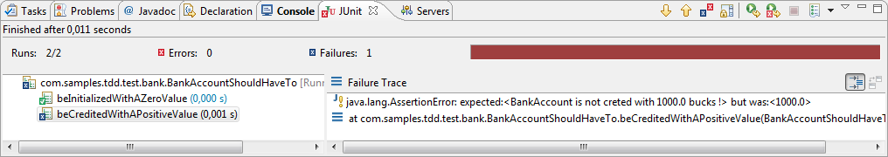Illustration 18: Execute test: the red phase !
Correct implementation :

/**
* Credit <code>creditValue</code> bucks to the BankAccount value.
* @param creditValue
*/
public void credit(double creditValue) {
value+=creditValue;
}

And then execute test again:

Green Step
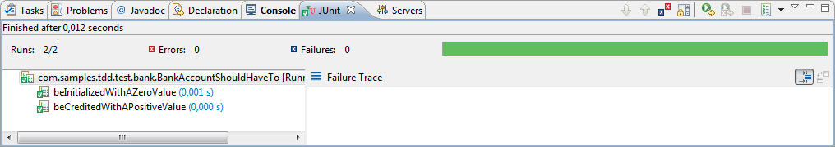Illustration 19: Green: implementation is near OK.
But it's clearly indicate in the use case that our implementation must generate an error in case of negative credit parameter value :

So, complete our test:

@Test
public void beCreditedWithAPositiveValue(){
BankAccount ba = new BankAccount();
try{
ba.credit(1000.0);
assertEquals("BankAccount is not credited “
+”with 1000.0 bucks !",
Double.valueOf(1000.0), ba.getValue());

ba.credit(-500.0);
assertEquals("BankAccount was credited with “
+”a negative value !",
Double.valueOf(500.0),ba.getValue());
}catch (Exception e ){
if(!(e instanceof BankAccountNegativeCreditException)){
fail("BankAccount throw wrong exception”
+” for negative credit value");
}
}
}

Implement our new Exception

Create a new Exception class in the com.samples.tdd.bank.exception package :
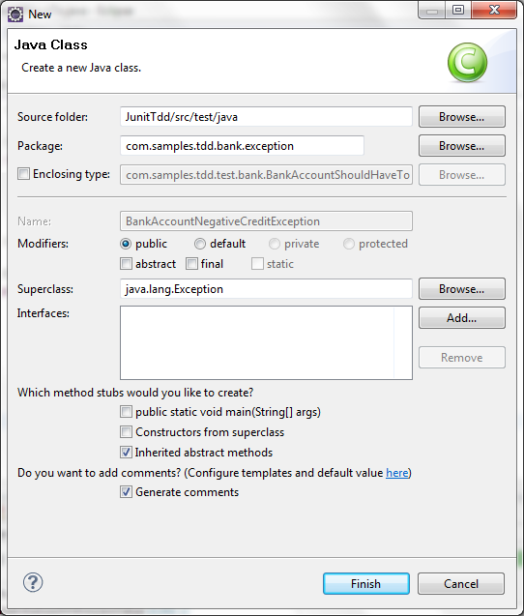
Here is the code :

/**
* Exception thrown on Negative value input to BankAccount.credit() method.
* @author FDELORME
*
*/
public class BankAccountNegativeCreditException extends Exception {

/**
*
*/
private static final long serialVersionUID = -645567821894120585L;

/* (non-Javadoc)
* @see java.lang.Throwable#getMessage()
*/
@Override
public String getMessage() {
return super.getMessage();
}

}

And then implement our new method

/**
* Credit <code>creditValue</code> bucks to the BankAccount value.
* @param creditValue
* @throws BankAccountNegativeCreditException
*/
public void credit(double creditValue) throws BankAccountNegativeCreditException {
if(creditValue<0){
throw new BankAccountNegativeCreditException();
}
value+=creditValue;
}

And confirm after refactoring code, that the test is OK:

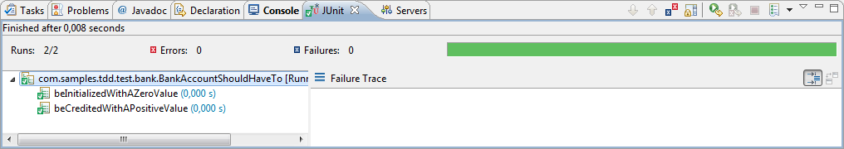Illustration 20: Green state for the test of our new Exception error.

Use Case 3: Debit()
Foe the third Use case, we need to test if our new BankAccount is able to debit a negative value. If a negative value is input, an error is emitted by the BankAccount object:

Here the new test:
@Test
public void beDebitedWithANegativeValue(){
BankAccount ba = new BankAccount();
try{
ba.debit(-200.0);
assertEquals("BankAccount is not debited with 200.0 bucks !",
Double.valueOf(-200.0), ba.getValue());

ba.debit(200.0);
assertEquals("BankAccount was debited with a positive value !", Double.valueOf(-200.0),ba.getValue());
}catch (Exception e ){
if(!(e instanceof BankAccountPositiveDebitException)){
fail("BankAccount throw wrong exception for positive debit value");
}
}
}

So, generate with wizard the new Exception BankAccountPositiveDebitException in the com.samples.tdd.bank.exception in the src/main/java source folder:

public class BankAccountPositiveDebitException extends Exception{

/**
*
*/
private static final long serialVersionUID = -685229677548773214L;

/* (non-Javadoc)
* @see java.lang.Throwable#getMessage()
*/
@Override
public String getMessage() {
// TODO Auto-generated method stub
return super.getMessage();
}

}

Implements the BankAccount.debit(double debitValue) :

/**
* Debit <code>debitValue</code> bucks from the BankAccount value.
* @param debitValue
*/
public void debit(double debitValue) {
debit+=debitValue;
}

And then, run JUnit test case :

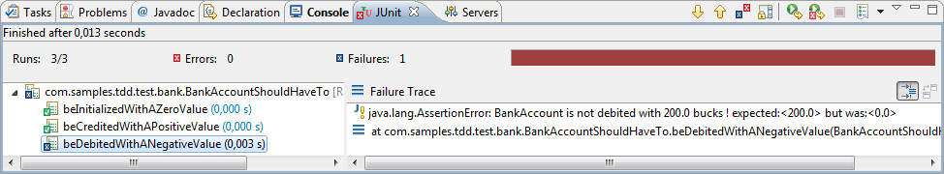Illustration 21: Debit implementation is not ok. functionality are not covered.
So refactor the code to perform Exception throw:

/**
* Debit <code>debitValue</code> bucks from the BankAccount value.
* @param debitValue
* @throws BankAccountPositiveDebitException
*/
public void debit(double debitValue) throws BankAccountPositiveDebitException {
if(debitValue>0){
throw new BankAccountPositiveDebitException();
}
value+=debitValue;
}
And now, you can Run Junit Test Case to verify Green Step :)

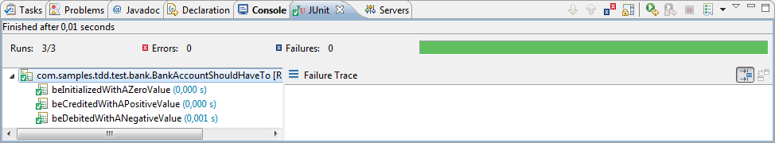Illustration 22: BankAccount.debit() method well implemented.

Use Case 4: threshold !
The last Use case describe a threshold authorizing some over consumption on the BankAccount.
Default value will be 0.0, but another negative value can be authorized. If after debiting the threshold is reach, an error must be emitted by the BankAccount entity.

First, code the first part of the test to verify 0.0 default value of the threshold:

@Test
public void beInitializedWithAZeroThreshold(){
BankAccount ba = new BankAccount();
assertEquals("BankAccount default threshold value is not set to 0",Double.valueOf(0.0), ba.getThreshold());
}

Execute test, you will get a red failure on this test.

So, code the initialization of the threshold in BankAccount class:

public BankAccount(){
value=0.0;
threshold = 0.0;
}

You can directly execute test and now we have the Green lantern ;)

Ok, now, we have to code the test about threshold overflow on debit operation, after creating the BankAccountThresholdOverflowException

/**
* Exception emitted on threshold overflow on <code>BankAccount.debit()</code> operation.
* @author FDELORME
* @see com.samples.tdd.bank.BankAccount#debit(double)
*
*/
public class BankAccountTresholdOverflowException extends Exception {

/**
*
*/
private static final long serialVersionUID = -3781400530800001356L;

/* (non-Javadoc)
* @see java.lang.Throwable#getMessage()
*/
@Override
public String getMessage() {
// TODO Auto-generated method stub
return super.getMessage();
}

}

And the code of the test :

@Test
public void beThresholdOnDebitOperation(){
BankAccount ba = new BankAccount(1000.0);
ba.setThreshold(-500.0);
assertEquals("BankAccount Threshold was not set to 2000.0 bucks !",
Double.valueOf(-500.0),ba.getThreshold());
ba.setValue(1500.0);
try {
ba.debit(-2500.0);
assertEquals("BankAccount threshold exception was not emitted !",Double.valueOf(0.0),ba.getThreshold());
} catch (BankAccountPositiveDebitException pde) {
fail("BankAccount debit error !");
} catch (BankAccountTresholdOverflowException toe) {
if(!(toe instanceof BankAccountThresholdOverflowException)){
fail("BankAccount emit wrong exception on threshold overflow.");
}
}
}

Following the TDD methodology, you will get Red step on executing this part of code,
Then implement correct method BankAccount.debit(double d) to have a green step:

/**
* Debit <code>debitValue</code> bucks from the BankAccount value.
* @param debitValue
* @throws BankAccountPositiveDebitException
* @throws BankAccountTresholdOverflowException
*/
public void debit(double debitValue)
throws BankAccountPositiveDebitException,
BankAccountTresholdOverflowException {
if(debitValue>0){
throw new BankAccountPositiveDebitException();
}else if((value+debitValue)<threshold){
throw new BankAccountTresholdOverflowException();
}else{
value+=debitValue;
}
}

Ok, now you must have the right green step on our JUnit test case execution !

We missed a test, the authorized threshold not reach on debit operation:

@Test
public void notBeThresholdOnAuthorizedDebitOperation(){
BankAccount ba = new BankAccount(1000.0);
try{
ba.debit(-200.0);
assertEquals("BankAccount threshold exception was not emitted !",Double.valueOf(0.0),ba.getThreshold());
}catch(Exception e){

if(!(e instanceof BankAccountTresholdOverflowException)){
fail("BankAccount emit wrong exception on threshold overflow.");
}
}
}

Ok, as we have now totally coded and partially refactored our BankAccount class, we can practice the last step, refactoring the all object and its corresponding test to avoid duplication code:

You can notice that we did'nt use the setUp() dans tearDown() methods in out Test implementation. Here we are !
You probably noticed that on each test, we first instantiate our BankAccount to perform tests:

BankAccount ba = new BankAccount(1000.0);

This instantiation can be performed during the setUp() method, because this method, according to the @Before annotation, is executed before each test method execution !

So refactoring the BankAccountShouldHaveTo test case will simplify and clear a bit the code:

/**
* BankAccount instance used throught mainly all test.
*/
private BankAccount ba;

/**
* @throws java.lang.Exception
*/
@Before
public void setUp() throws Exception {
ba = new BankAccount();
}

Now, you will have to clean all the @Test method to remove,when it's possible, the BankAccount instantiation.

That's It !

BankUser
Write our first method

Now we are going to start with the second part, about Database things.

Part 2
We have to add the BankUser entity and the relation between this entity and the BankAccount with a one-to-many relationship.
So, just add dependencies in our pom.xml file:

- DBunit 2.4.8
- spring-core
- hibernate-entitymanager

Let's start with Spring and Hibernate with the JPA spec.

Références
- Junit : www.junit.org
- DbUnit: www.dbunit.org
- CobolUnit : https://sites.google.com/site/cobolunit/

http://www.eclipse.org/downloads/
http://maven.apache.org/
http://www.eclipse.org/m2e/
http://www.eclipse.org/egit/

