Clinical Guideline for:
Rapid optimisation of Guideline Directed Medical Therapies in Heart Failure with Reduced Ejection Fraction

Author of Clinical Guideline | Lisa Lovedale, Angela Tithecott, Poppy Brooks
Division/ Department responsible for Clinical Guideline | Medicine – Cardiology
Contact details | poppy.brooks@nhs.net  angela.tithecott@nhst.net  lisa.lovedale@nhs.net
Version number | 1.0
Replaces version number | N/A
Date written | 18.9.24
Consultation undertaken with: | Consultant Cardiologists  Dr Andrew Ludman (13.10.2024)  Drugs and Therapeutic Committee  Heart failure nurse specialists  Clinical governance  Cardiology operational group  Non-medical prescribing lead
Approving body and date approved | Cardiology Governance Group, 27/11/2024
Review date | June 2027
Expiry date | 27/11/2027
Date document becomes live | 27/11/2024

SUMMARY
This guideline provides a framework within which the specialist heart failure team can more rapidly, but safely, optimise guideline directed medical therapies in people with Heart Failure and reduced Ejection Fraction (HFrEF).

KEY POINTS
- This guideline is intended to support rapid and remote optimisation of heart failure medication by the community heart failure teams.
- It will be used where clinically applicable and deemed safe to do so by the specialist heart failure nurse/team.

CONTENTS

1. INTRODUCTION 4
2. BACKGROUND 4
3. DEFINITIONS 8
4. CLINICAL GUIDELINE 9
Inclusion Criteria 9
Exclusion Criteria 9
Titration Schedule 10
5. MONITORING COMPLIANCE WITH THIS GUIDELINE 13
6. ASSOCIATED CLINICAL GUIDELINES OR POLICIES/PROCEDURES 14

1. INTRODUCTION

  - This clinical guideline is designed to provide advice, guidance and direction to staff whilst leaving room for professional judgement, and adaptation, to fit individual patient circumstances.
  - In the management of heart failure with reduced ejection fraction (HFrEF), there is a huge body of evidence suggesting that initiation of guideline directed medical therapies (GDMT) vastly improves survival and reduces heart failure hospitalisations (1). One of the primary objectives of heart failure services is to initiate and optimise the four pillars of heart failure therapies.
  - Contemporary evidence from the STRONG-HF trial suggests that it can be safe to initiate therapies more rapidly than previous guidance allows, and that there are significant benefits in patient outcomes when this is possible (2).
  - In response to this new evidence, the European Society for Cardiology (ESC) published a focused update to its Heart Failure guidelines suggesting that GDMT should be implemented and optimised ideally within 6 weeks (3).
  - This local guideline will provide heart failure teams with a framework on how to optimise GDMT in patients with HFrEF in a timely but safe manner.

2. BACKGROUND

  - Heart Failure Services were typically commissioned to provide outpatient / community follow up to deliver individualised care, for people with a diagnosis of Heart Failure with Reduced Ejection Fraction (HFrEF), in an effort to improve quality of life, reduce mortality and reduce admission / readmission risk.
  - Initial evidence-based recommendations supported a ‘start low / go slow’ strategy toward optimisation of Heart Failure Guideline Medical Therapy (HF GDMT), which has been historically provided through a standard outpatient / community follow up care setting.
  - However, an increasing number of evidence-based therapies, that improve both symptoms and survival, has brought greater complexity to the management of heart failure. As a direct consequence, ensuring patients receive HF GDMT in a timely fashion at recommended doses, has become increasingly challenging.
  - Furthermore, clinic waiting times have also increased as a result of complex management, but also due to increasing prevalence and subsequent demand, with time to HF GDMT optimisation sometimes being excessive. Patients reviewed, in the standard outpatient setting, may wait 12 months before their HF GDMT are considered optimised.
  - In recent years, there has been a growing body of evidence supporting a model of ‘rapid initiation and titration’ of the 4 pillars of HF GDMT (namely, ACE I / ARNI, Beta-antagonist, MRA & SGLT2i).
  - Current evidence clearly demonstrates mortality benefits of establishing patients on all 4 pillars of HF GDMT at baseline (prior to hospital discharge) and that these benefits are noted within the first 30 days (2),(4).
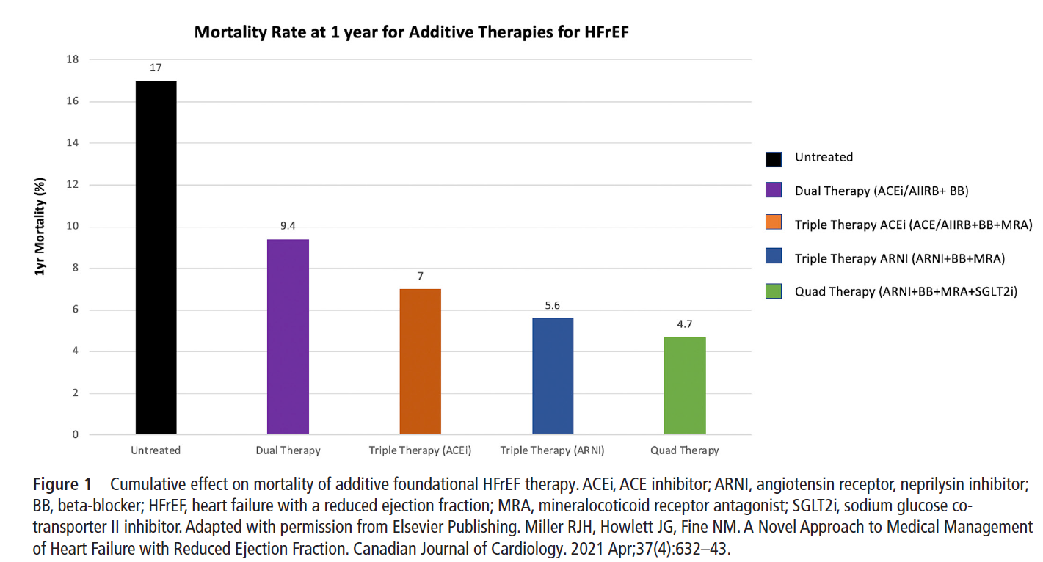

  - The HF teams at both Eastern and Northern sites provide diagnostic clinics, in-patient support and advice and follow-up within out-patient and community settings. Patients are also monitored remotely, offering another mode of optimising treatments, where it is safe to do so.
  - Remote Monitoring options include telephone or video follow up with access to digital platforms and monitoring equipment (using patients own or loaned devices).
  - Remote monitoring with virtual follow-up consultation may prevent frequent visits to the hospital for patients and may be particularly attractive in a large, rural geographic area such as Devon but can still allow safe treatment.
  - The HF service delivery across all patient settings, puts the team in the unique position of directly supporting a pathway of management that works toward:
- all suitable patients admitted, with an acute decompensation of heart failure being established safely on all 4 pillars of HF GDMT (unless contraindicated)
- all suitable patients receiving their diagnosis of HFrEF within the Advanced Heart Failure CNS led diagnostic clinics are established on 2 pillars of treatment at their first encounter
- accelerated, post discharge / following HF diagnosis, optimisation of HF GDMT utilising the titration guideline within this protocol
- significant reduction in time to medication optimisation from months to weeks
- reassessment of LV function (repeat echo or cardiac MRI) following optimisation of 4 pillars of HF therapy to help guide suitability for advanced treatments
- It is the prescribing clinician’s responsibility to review relevant cautions and contraindications prior to making any treatment changes

  - The team will refer to the existing medication guidelines for Chronic Heart Failure with Reduced Ejection Fraction, the Joint formulary and BNF for more information on individual treatments.

3. DEFINITIONS

AE- Adverse Event
AF – Atrial Fibrillation
HFrEF – Heart failure with reduced ejection fraction
e-GFR -estimated Glomerular Filtration Rate
LVEF- Left Ventricular Ejection Fraction
SGLT2i – Sodium-Glucose Transporter 2 Inhibitor
ARNI – Angiotensin Receptor Neprilysin Inhibitor
ARB- Angiotensin Receptor Blocker
ACE-I – Angiotensin Converting Enzyme Inhibitor
BB - Beta blocker
MRA – Mineralocorticoid Receptor Antagonist
HF GDMT – Heart Failure Guideline Directed Medical Therapies
Four Pillars – Four drugs recommended for patients with HFrEF which include; beta blockers, MRAs, SGLT2 inhibitors and either an ACE-I/ARB or ARNI
T1DM- Type 1 Diabetes Mellitus

4. CLINICAL GUIDELINE

Inclusion Criteria
Confirmed diagnosis of HFREF defined as LVEF ≤ 40% who meet the service referral criteria
Over 18 yrs old
Capacity and ability to safely participate in telephone consultations
Ability and consent to having remote monitoring equipment
Able and committed to attending appointments for regular blood tests
Consent to accelerated titration programme
Stable renal function as judged by the heart failure specialist team
HR and BP within titration parameters for each drug group

Exclusion Criteria
Pregnancy
Cardiac amyloid
Severe aortic stenosis
Patients requiring renal replacement therapy or e-GFR <30 mls/min at baseline.
Rockford frailty (CFS) score > 5 (use clinical judgement)

Titration Schedule
4.3 Decision to titrate will be dependent on clinical assessment, signs and symptoms in conjunction with the titration timetable and ‘add a step’ table
4.4 If pauses in titration or deviation from the timetable are clinically required, optimisation will take place over a longer period of time, to ensure 4 pillars are optimised safely and still without avoidable delays.
4.5 Identification of suitable patients will be carried out by a HF CNS, either as an inpatient or at the diagnostic clinic appointment

Order of initiating and titrating will be individualised taking into consideration the patient’s presentation, comorbidities and vital signs

 | IP admission | Diagnostic clinic
initial  bloods  remote monitoring kit  ECG | pre-discharge  4 pillars low dose  (unless contraindicated e.g. SGLT2i in T1 DM) | diagnostic clinic  start 2 pillars low dose
wk 1  phone* | start titrating | add 3rd pillar low dose | bloods
wk 2  phone * | increase 1 pillar | Add 4th pillar low dose or increase a pillar | bloods
wk 3  phone* | increase 1 pillar | Add 4th or increase 1 pillar | bloods
wk 4  phone* | increase 1 pillar | increase 1 pillar | bloods
wk 5  phone* | increase 1 pillar | increase 1 pillar | bloods
wk 6  phone* | further titration if needed | further titration if needed | bloods

*Phone consultation can be switched to face to face where clinically indicated

STEPS TO THE 4 PILLARS
Suggested starting doses and titration stages. To be adjusted as clinically needed.
For simplicity initial medication choices will be standardised but if patients have already been established on alternative medications licensed in heart failure then these can be continued.
Suggested medication choices: beta-blocker, bisoprolol; ACE-inhibitor, ramipril; ARB, candesartan; ARNI, sacubitril/valsartan; SGLT2i, dapagliflozin; MRA, spironolactone; loop diuretic, furosemide
Consider using ARB instead of ARNI first line if SBP <110mm/Hg. Start Candesartan at 2 – 4 mg daily, double at each titration step and once tolerating 8mg consider switching to ARNI
ARNI can be started at mid dose if being switched from ARB or ACEi (48hr washout period if switching from ACEi)
Consider potassium binders for continued optimisation in persistent hyperkalaemia (see chronic heart failure guidelines)

BBlocker (bisoprolol  2.5mg | ARNI (sacubitril/valsartan)  24mg/26mg | SGLT2i (dapagliflozin/ empagliflozin)  10mg | MRA (spironolactone/ eplerenone)  25mg
BBlocker (bisoprolol)  5mg | ARNI (sacubitril/valsartan)  49mg/51mg |  | MRA (spironolactone/ eplerenone)  50mg
BBlocker (bisoprolol)  10mg | ARNI (sacubitiril/valsartan)  97mg/103mg

DECISION TO ADD A STEP (UPTITRATE)
 | CONSIDER UP TITRATION | PAUSE TITRATION
BB | HR ≥ 60bpm or >80bpm in AF  SBP ≥95mmHg | HR <60bpm or <80bpm in AF  SBP <95mmHg
ACE-I/ARB/ARNI | SBP ≥95mmHg +  potassium ≤ 5mmol/l +  eGFR ≥ 30 | SBP <95mmHg  potassium >5mmol/l  eGFR < 30
SGLT2i | SBP ≥95mmHg  eGFR ≥25 | SBP <95mmHg  eGFR <25
MRA | SBP ≥95mmHg +  potassium ≤ 5mmol/l +  eGFR ≥ 30 | SBP <95mmHg  potassium >5mmol/l  eGFR < 30
Loop diuretic | congestion on clinical assessment | no congestion on clinical assessment. Consider dose reduction or cessation

4.7 Outcomes of the pathway will be assessed by
- measuring the number of patients per annum for whom accelerated titration is commenced, the duration in weeks for optimisation
- recording of quad score for each patient at the beginning and end of the pathway, adverse events
- collect data on the number of patients eligible for the pathway who then did not go on to it, and reasons why not

5. MONITORING COMPLIANCE WITH THIS GUIDELINE

Monitoring of this policy will be the responsibility of the Service Leads for Heart Failure:

The policy will be implemented by the Heart Failure clinical nurse specialists (HF CNS), following approval from the Cardiology Operational Group and Divisional Governance.

Compliance will be monitored by the Cardiology Operational Groups. Auditable data for the trust will also be available via EPIC data reporting usage of the policy.

6. ASSOCIATED CLINICAL GUIDELINES OR POLICIES/PROCEDURES

Remote monitoring SOP
Medication Guidelines for Heart Failure
Non-medical prescribing policy
Medicines management policy

REFERENCES

- McDonagh, T.A., Metra, M., Adamo, M., Gardner, R.S., Baumbach, A., Böhm, M., Burri, H., Butler, J., Čelutkienė, J., Chioncel, O., Cleland, J.G.F., Coats, A.J.S., Crespo-Leiro, M.G., Farmakis, D., Gilard, M., Heymans, S., Hoes, A.W., Jaarsma, T., Jankowska, E.A. and Lainscak, M. (2021). 2021 ESC Guidelines for the Diagnosis and Treatment of Acute and Chronic Heart Failure. European Heart Journal, 42(36), pp.3599–3726. doi:https://doi.org/10.1093/eurheartj/ehab368.‌
- Mebazaa, A., Davison, B., Chioncel, O., Cohen-Solal, A., Diaz, R., Filippatos, G., Metra, M., Ponikowski, P., Sliwa, K., Voors, A.A., Edwards, C., Novosadova, M., Takagi, K., Damasceno, A., Saidu, H., Gayat, E., Pang, P.S., Celutkiene, J. and Cotter, G. (2022). Safety, tolerability and efficacy of up-titration of guideline-directed medical therapies for acute heart failure (STRONG-HF): a multinational, open-label, randomised, trial. The Lancet, [online] 0(0). doi:https://doi.org/10.1016/S0140-6736(22)02076-1.
- McDonagh, T.A., Metra, M., Adamo, M., Gardner, R.S., Baumbach, A., Böhm, M., Burri, H., Butler, J., Jelena Čelutkienė, Ovidiu Chioncel, John G.F. Cleland, Crespo-Leiro, M.G., Farmakis, D., Gilard, M., Heymans, S., Hoes, A.W., Jaarsma, T., Jankowska, E.A., Mitja Lainscak and Carolyn S.P. Lam (2023). 2023 Focused Update of the 2021 ESC Guidelines for the diagnosis and treatment of acute and chronic heart failure.European Heart Journal, 44(37).doi:https://doi.org/10.1093/eurheartj/ehad195.
- Miller, R.J.H., Howlett, J.G. and Fine, N.M. (2021). A Novel Approach to Medical Management of Heart Failure With Reduced Ejection Fraction. Canadian Journal of Cardiology. doi:https://doi.org/10.1016/j.cjca.2020.12.028.

‌

