

IoT Project 2 - Deliverables

Project 2 Due: Friday 20th May 2016

**Student Name:** Brian McGowan

**Course:** Computing L8

**Student ID Number:** S00165159

**Project Title**: Heating Controller

**Github Username:** mcgowanb [link](https://github.com/mcgowanb/iot/tree/master/project1)

**Background / Introduction**Now that the initial iteration has been completed, I was looking to expand some functionality that the board has to make it more user friendly, and more interactive for the user.

**Requirements**

There were a few small requirements for this aspect of the project

Adding a timer to check how long the heating has been running for.

Implementing a temperature sensor to read ambient room temperature

If the room temperature rises above the baseline temperature that was set, it would switch off. In addition I would also add the ability to update the baseline temperature from the user.

**Methodology**

In order to make the board more interactive, I had to look at ways of returning more data to the ajax request so it could be displayed to the user. I could have easily added this data as a standard string in the boards return, but the downside of this would be the amount of time that I would need to spend parsing the string on the client side. Another alternative was to return the data in JSON format. Since JSON is easily understood and handled by javascript, this would make parsing the data much easier, but also more reliable. With this in mind, I implemented a JSON library on the Arduino board which then allowed me to easily return as much data to the client request as I wanted without negatively impacting on the existing data.

The first step was to add a timer. When the heating was switched on a timer within the board started counting the milliseconds from when it was on until now() and returned this to the client. This allowed the user to then read how long the heating was running for. If and when the heating was turned off, this was reset to 0 and displayed on the web interface.

Next step was to implement a sensor for the temperature and return data in the same fashion as previous. I implemented some methods to convert the raw voltage from the sensor into a human readable temperature. At this point I also added a baseline temperature to the board, which if exceeded would also switch the board off. I then added the ability to update this temperature from the web page so users could pick the baseline temperature they wished. When the baseline temperature was double-clicked, it would change to a text box and give the user the ability to change the text value. Once return or the field was clicked away from an ajax request queried the board and updated the baseline temperatre

Tracking of this project was done on an iterative basis with the main benchmark for each stage being UAT testing.

**Success Criteria for Project Completion**

Success was measured on an iterative basis, testing each change as I went to ensure that each one was working before moving on.

I have included some images of the web api, along with a photo of the assembled project to demonstrate some of the stages.

* Trello Link <https://trello.com/b/r3xJWDzx>
* Github Link <https://github.com/mcgowanb/iot/tree/master/project1>

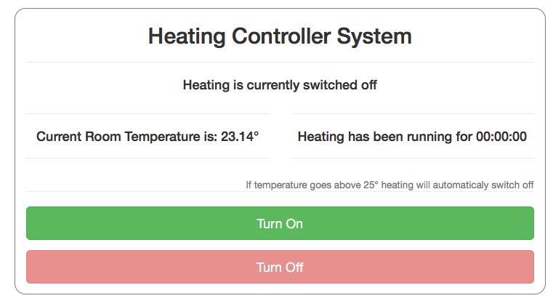

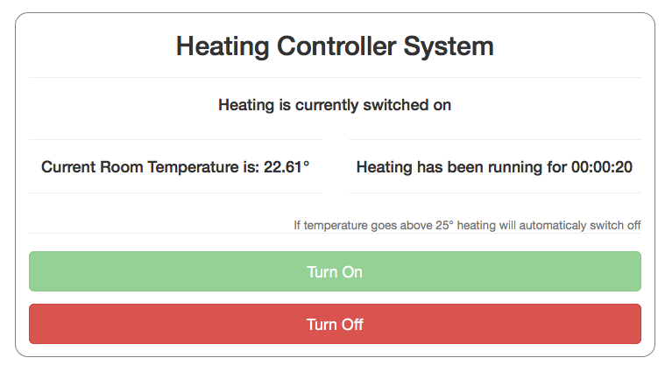

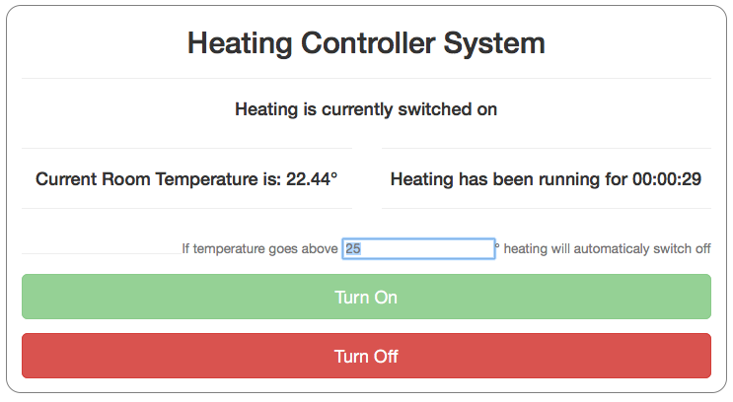

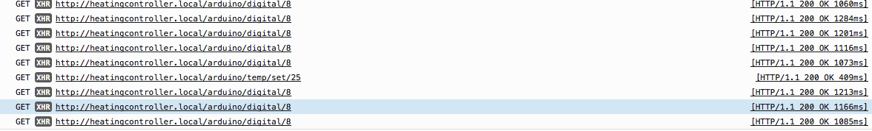

**What were your main learnings in implementing this project**

What learnings will you apply to future project work?

*Future personal projects will be done with the API for the Arduino, as an easy way to interact with the board*

What were your main learnings during this module about the Internet of Things?

*Arduino boards have become much more novice friendly with the use of the grove kit. More awareness about the usefulness of cloud services*

What were your main learnings about yourself and your own creative and design process during this module?

*Once fundamental principles are grasped for a particular technology, try something to see if it works. If not, try something else.be creative, try something to solve a particular problem*

What aspects of your approach to project work were developed as a result of this module?

*Start small and build up. One aspect at a time*

What areas do you think you need to work on for future creative projects?

*Lose the fear. Fear of tackling something because it’s so large. Start small, one issue at a time and build up as you go.*

What skills do you feel you developed during this module?

**References**

Bootstrap: <http://getbootstrap.com/>

jQuery: <https://jquery.com/>

Arduino JSON <https://github.com/bblanchon/ArduinoJson>

Conversion from Voltage to Temp: <http://computers.tutsplus.com/tutorials/how-to-read-temperatures-with-arduino--mac-53714>