**Web Dev 202 - Angular2 Project**

**S00165159 – Brian McGowan**

**Project Name: JustHealth**

Table of Contents

Design: 1

Components: 3

The components used are listed below, with a brief outline of their use: 3

CSS 5

Reflection 5

Marking 5

# **Design:**

**The aim of the project is to create a SPA for a website to display a list of Medical Service Providers, with the option of sorting by rating, type or general serach (not in scope**

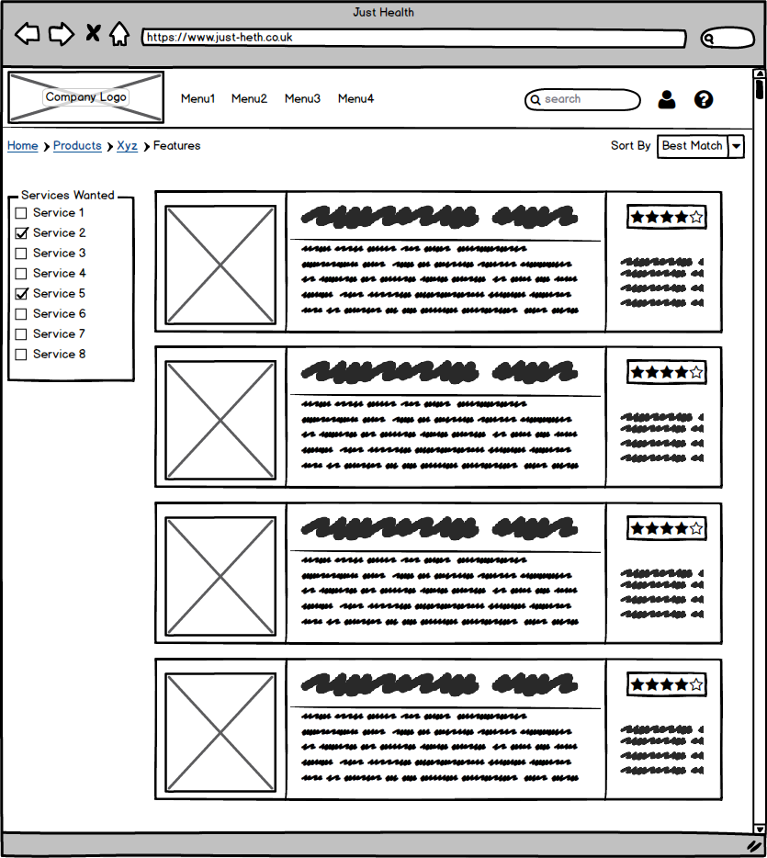

# Components:

## The components used are listed below, with a brief outline of their use:

* main-page
  + The purpose of the main-page component is to be the base layer for all other sub components for the main page in the project. The index.html file adds the menu as a component and the router-outlet. All elements of the router outlet are managed by this component. It creates all objects and passes them to relevant components for display. It is also used to handle all filter clicks and option changes form a higher level than their own components
* menu-component
  + The menu-component is used to hold the menu and all references to routes
* provider-group
  + The provide-group component is responsible for holding the checkboxes for the service provider groups, to allow users to filter by specific categories. It also binds the click event for the checkboxes to an event emitter
* provider-row
  + The provider-row component draws each provider as a checkbox with whatever properties it needs
* service-provider
  + This component is responsible for drawing the providers. It firstly inserts an order list to allow users to order their results, and then passes the list of providers to the service-provider-row component to draw within the page. This component also catches the change event for the order list, and emits an event to the parent components for action
* service-provider-categories
  + Is responsible for drawing the list of service provider categories as a sub component of the service-provider-row component

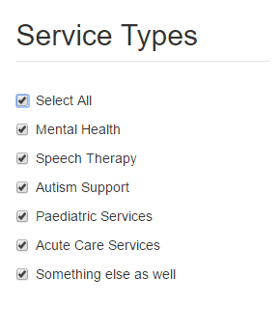

Provider Row Component

Provider Group Component



Menu Component



Order Component

Service Provider Categories Component

Service Provider Component

# CSS

The main css class that was used was bootstrap, Since I’m familiar with it, it was easy for me to implement without any concerns. I have used minimal additional css, and when I have, I’ve used it in the component css fle. For example, in the menu component.css file

# Reflection

Reflection, something I’m not particularly good at, but here goes. Overall, it was a good project to work on, albeit frustrating at times. Then again, I’ve yet to work on any technology stack where it doesn’t drive you around the bend every now and again.

Having worked with PHP in the past, I can clearly see the benefits of using something like angular2. In particular the two-way binding is a massive plus and can save you a lot of boilerplate code in the long run. It’s not always been a benefit to me in this project though.

Angular has a complete different way of thinking with directives, so manipulating the DOM depending on user interactions isn’t as straight forward as it would have been in my head to do it the “old fashioned” way. Getting to grips with directives isn’t that easy.

From starting the project, seeing the logic of components and how they sit together is easy to grasp as a concept, but working with them can be a bit tougher initially. At this stage, I would be more comfortable with them that at the start, but that’s to be expected really, with the time spent on the project

Overall, the main area I’ve struggled with is directives. I’ve installed bootstrap as a plugin for the project, but I cannot get the dropdown lists on menus to work. I’ve spent some time on it, and I think the issue is around having directives applied to specific elements to hook into the JavaScript, but trying to find out in the documentation isn’t always that clear.

# Marking

Difficult one, what mark do I give myself? Whilst I’m by no means perfect, I do believe I’ve made extensive use of CSS and OO principles in terms of separation of concerns and so on. I’ve not gone overboard with the use of components and there is some functionality within the project that wasn’t covered as part of the classwork (sorting, filtering). There may be some issues that I’ve missed, but I’m not necessarily aware of them. I would give myself roughly 95% for this project. I don’t know what I’d mark myself down on necessarily, but I don’t think it’s perfect either.