**Open the web application you worked on last week. We will add pages to this web application.**

Edit the cshtml you used to add take two numbers and add them together.

# Task 2:

Add a set of radio buttons to your HTML as follows.

You want to achieve the following.

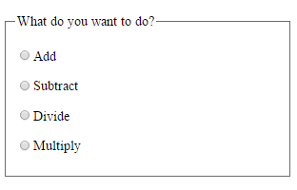

# Task 3:

Edit your cshtml code so that the answer is based on the operation which was chosen. Use a switch statement.

The operation which was chosen will be returned to the form with the key “operation”.

# Task 4

Create a new page called calculatorGET. Copy the code across and edit it so that the form uses the GET method rather than the post method.

You will need to change the method attribute of the form element.

You will also need to get the values from the Request.QueryString collection rather than from the Requst.Form collection.

What else do you need to change?

Look at the URL of the submitted form, what do you notice.

# Task 5

Play with CSS to style your radio buttons differently.