**Task 1:**

Create a new web application. Add a cshtml page called time.

**Task 2:**

Put a form on the page with a radio button list that contains the names of the week. Add a submit button which uses the GET method. Add some code so that when the user submits the form they get a message saying what day they have chosen.

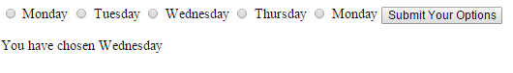

**Task 3:**

In the same form add a drop down list with the months of the year. 

Add a second message so that the month chosen will display.

**Task 4:**

Add a list box with the seasons.

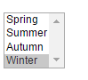

Add a third message so that the season chosen will display.

**Task 5:**

Change the list box so that the user can select more than one season and change the message so that it tells the user how many seasons have been selected.

Also add a loop so that each of the selected seasons is printed out separately.

**Task 6:**

Add a text box which asks for the user’s location. Use a datalist to suggest the following locations:

Sligo, Dublin, Derry, Donegal, Kerry, Kildare, Leitrim, Longford, Laois, Limerick and Louth. Add a message telling the user where they are located.

**Task 7: A Stretch Task**

Currently when you press submit the values you filled in on the form disappear. Edit your form so that these values stay after the form is submitted.