# Task 1: Submit a form to another page

Create a new empty web application called multipage.

Create a cshtml page called page1.cshtml.

Create a form within that has a text box with the name inputstring and a submit button. Set the action attribute of the form to page2.cshtml and the method to post.

Create a cshtml page called page2.cshtml.

If the page is called by a post then display what was input otherwise display a message saying nothing was submitted.



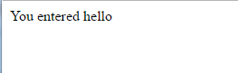

# Task 2: Override the form action attribute.

Add a second submit button to the page with the attribute fromaction=”page3.cshtml” and add a page3.cshtml page to your application which takes and displays the input value.

# Task 3: Use Response Redirect

Add a page4.cshtml page to your application. Add a text box and a submit button to the page.

Add code which checks the value which was submitted and takes the user to another page if the string submitted is a number less than 10.

Task 4: Create and use a layout page.

Add a folder called Shared to the application. Add a layout page to this folder called _MyLayout.cshtml.

Add a <h1>element to the <body> with the text “This is from the Layout Page”.

Create a new page5.cshtml with the following:

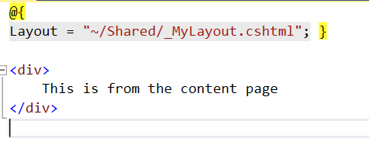

Run the page5 then inspect it. Can you see where all the HTML comes from?

Add a <head> section to page5.cshtml with a <title> tag and the text “This is unique to page 5”.

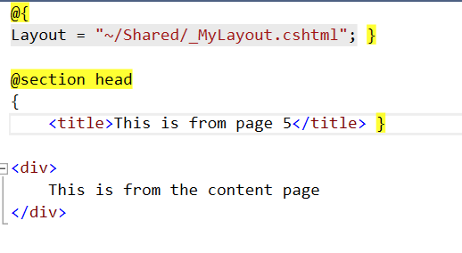

Task 4: Use Data from the Content Page in the Layout Page.

You can have data defined in a content page that you need to refer to in a layout page. If so, you need to pass the data from the layout page to the content page.

The content page has a property called PageData which is a collection of Objects. You can add data to this collection on the content page and use it on the layout page.

