November Meeting - Appendix

## Addition of total cholesterol as an additional covariate.

It appears that adding *baseline total cholesterol* to the model does not account for the increased HR found in the Vascular dementia subgroup. In fact, the addition of *baseline total cholesterol* above the covariates already controlled for

Co-variates controlled for: *age, sex, coronary artery disease, coronary bypass surgery, cardiovascular disease, charlson index, IMD20-10, consultation rate, alcohol (ever), smoking (ever), BMI, peripheral arterial disease, & hypertension.*

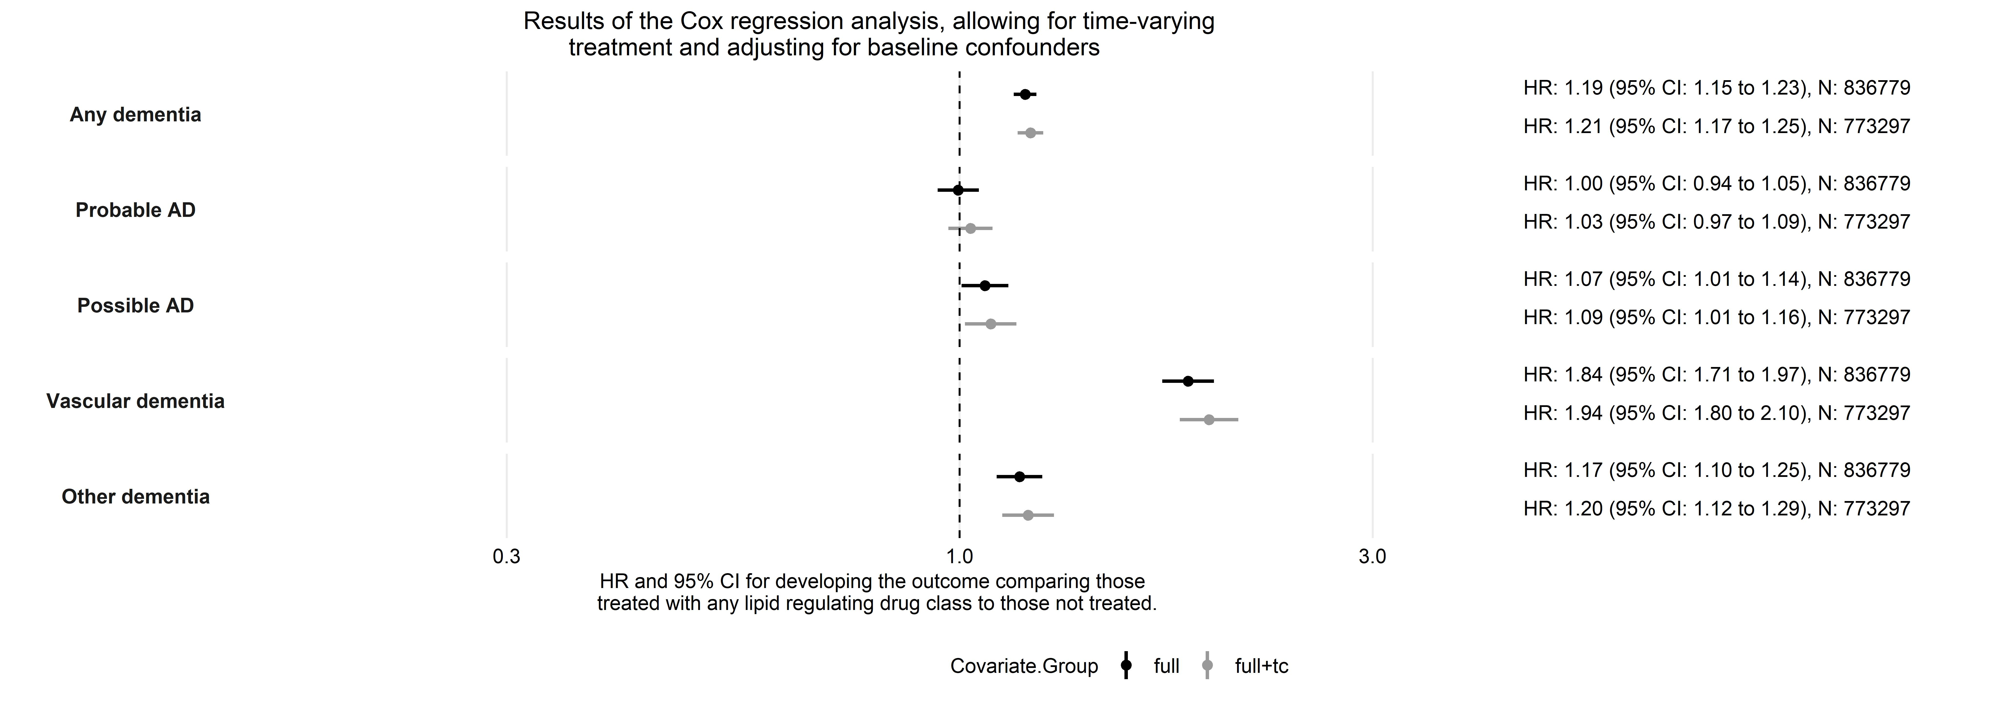

Figure 1: Results of analysis for effect of any lipid regulating agent across dementia subtypes

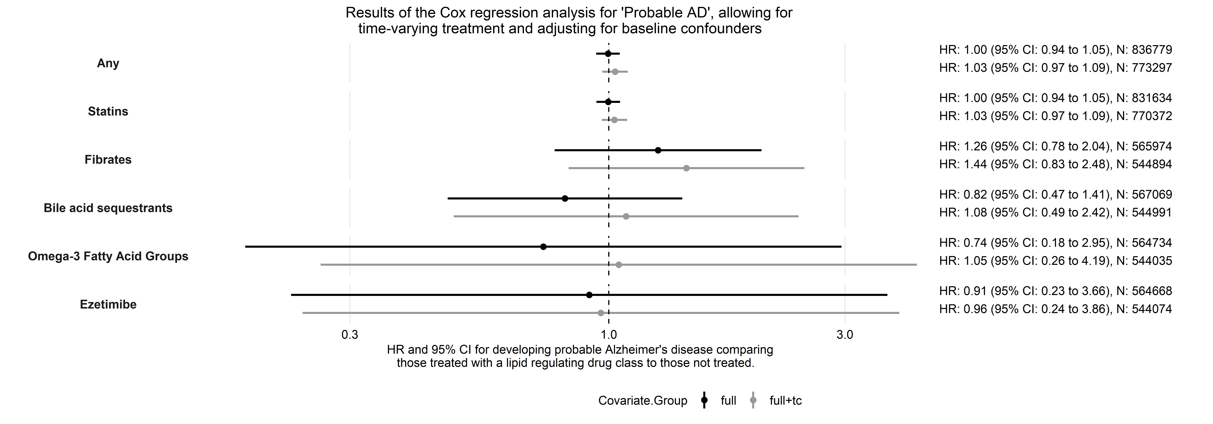

Figure 2: Results of analysis for effect of different drug classes within the ‘Probable AzD’ subgroup